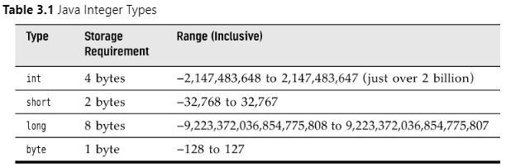

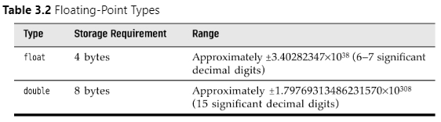

char, boolean
declare variable:
- double salary;
- int days;
- boolean done;
- long earthPopulation;
initialize variable:
- days = 7;
constants
- use final to declare constant
- final double CM_PER_INCH = 2.54;
enumerated types:
- restricted values
- enum ShirtSize = { S, M, L, XL };
- ShirtSize s = ShirtSize.XL;

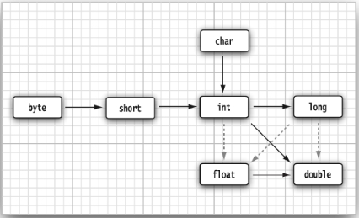

casts
- double x = 9.997;
int nx = (int) x;

assignment
increment decrement

x < y ? x: y

switch expressions
- int numLetters = switch (seasonName)
{
case 'Spring', 'Summer', 'Winter' -> 6;
case 'Fall' -> 4;
default -> -1;
};

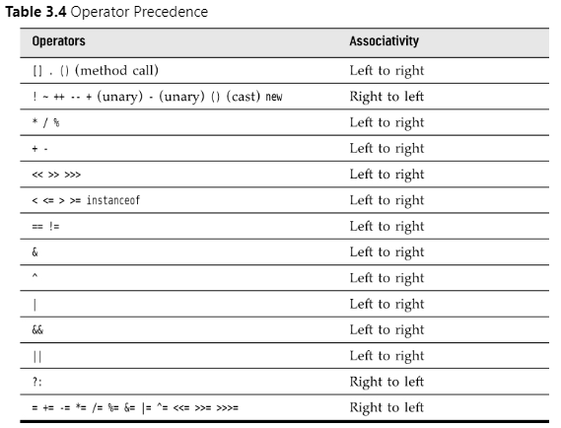

Strings
- String e = “”;
Substrings
- String greet = “hello”;
- String s = greet.substring(0, 3);
Concatenation
- String a = “a”;
- String b = “b”;
- String ab = a + b;

