Type of variables:
- Instance variables (non-static fields)
Technically speaking, objects store their individual states in “non-static fields”, that is, fields declared without the Static keyword. Non-static fields are also known as instance variables because their values are unique to each instance of a class (to each object, in other words); for example, the currentSpeed of one bicycle is independent from the currentSpeed of another.
- Class variables (Static fields)
A class variable is any field declared with the static modifier; this tells the compiler that there is exactly one copy of this variable in existence, regardless of how many times the class has been instantiated. For example, a field defining the number of gears for a particular kind of bicycle could be marked as Static since conceptually the same number of gears will apply to all instances. The code Static int numGears = 6; would create such a static field. Additionally, the keyword final could be added to indicate that the number of gears will never change.
- Local variables
Similar to how an object stores its state in fields, a method will often store its temporary state in local variables. The syntax for declaring a local variable is similar to declaring a field (for example, int count = 0). There is no special keyword designating a variable as local; that determination comes entirely from the location in which the variable is declared—which is between the opening and closing braces of a method. As such, local variables are only visible to the methods in which they are declared; they are not accessible from the rest of the class.
- Parameters
You’ve already seen examples of parameters, both in Bicycle the class and in the main method of the “Hello World!” application. Recall that the signature for the main method is public static void main(String[] args). Here, the args variable is the parameter to this method. The important thing to remember is that parameters are always classified as “variables,” not “fields”. This applies to other parameter-accepting constructs as well (such as constructors and exception handlers) that you’ll learn about later in the tutorial.
If your variable stores a constant value, such as static final int NUM_GEARS = 6, the convention changes slightly, capitalizing every letter and separating subsequent words with the underscore character.

Primitive data types
- byte,
- short,
- char,
- boolean,
- int,
decimal: base 10
hexadecimal: base 16, 0x1a, starts with 0x
binary: base 2, 0b11010, stars with 0b
- long,
- float,
float f1= 1.234f, end with f
double d2 = 1.234
- double
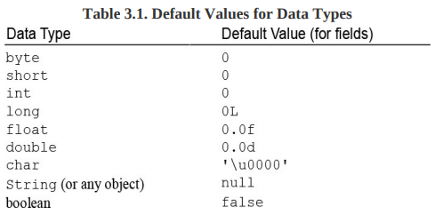

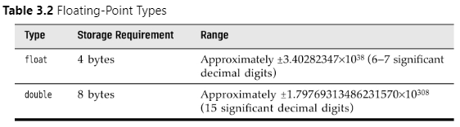
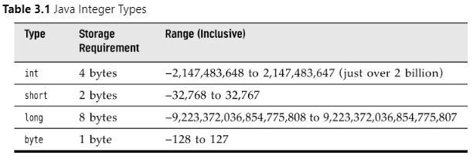
declare variable:
- double salary;
- int days;
- boolean done;
- long earthPopulation;
initialize variable
- int vacationDays;
- vacationDays = 12;
constants
- use final to declare constant
- final double CM_PER_INCH = 2.54;
enumerated types:
- restricted values
- enum ShirtSize = { S, M, L, XL };
- ShirtSize s = ShirtSize.XL;

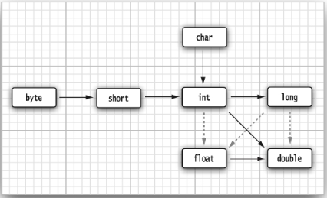
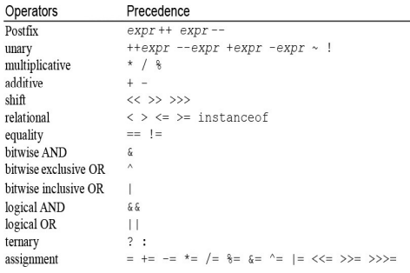
casts
- double x = 9.997;
int nx = (int) x;
assignment
increment decrement
relational and boolean operator
- 1 && 1
- The && and || operators are evaluated in “short circuit” fashion: The second argument is not evaluated if the first argument already determines the value. If you combine two expressions with the && operator
Conditional operator
- x < y ? x: y
switch expressions
- int numLetters = switch (seasonName)
{
case 'Spring', 'Summer', 'Winter' -> 6;
case 'Fall' -> 4;
default -> -1;
};

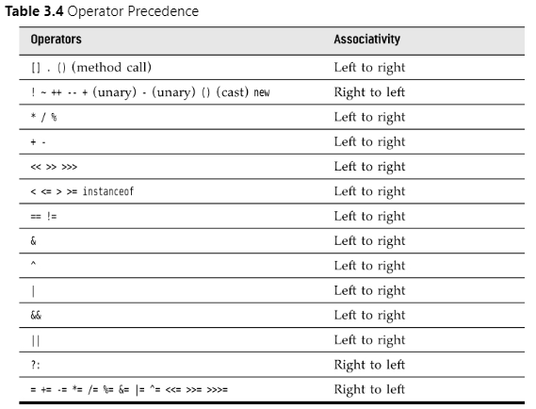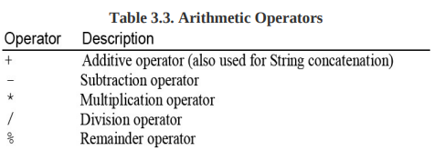
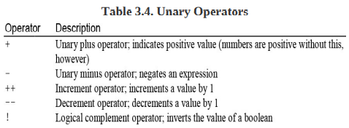

Strings (Immutable)
- strings are immutable, to change string use substring
- String e = “”;
Substrings
- String greet = “hello”;
- String s = greet.substring(0, 3);
Concatenation
- String a = “a”;
- String b = “b”;
- String ab = a + b;
Testing strings for equality
- “hello”.equals(“hello”)
- Don’t use == to compare string. It only determines whether or not the strings are stored in same location
Empty and Null strings
- “jack”.length() == 0
- “jack”.equals(“”)

Code points and Code units
- int cpCount = greeting.codePointCount(0, greeting.length());
- char first = “Hello”.charAt(0); // first is 'H'
String API
Building strings
- build up strings from shorter strings
- It would be inefficient to use string concatenation
- Using the StringBuilder class avoids this problem
Input and output
- System.out.print('What is your name? ');
- String name = in.nextLine();
- System.out.println('Hello, ' + name)
Formatting output
- System.out.printf('%2.2f', x);
- System.out.printf('Hello, %s. Next year, you'll be %d', name, age);

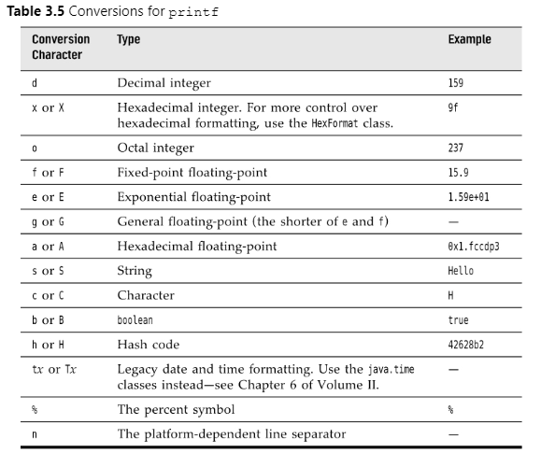

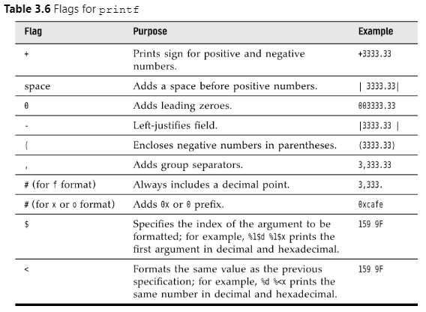
String format without printing
- String message = String.format('Hello, %s. Next year, you'll be %d', name, age + 1);
File input and output
- Scanner in = new Scanner(Path.of('myfile.txt'), StandardCharsets.UTF_8);
- Use PrintWriter to write file
- PrintWriter out = new PrintWriter('myfile.txt', StandardCharsets.UTF_8);
Control flow
- If, else, elseif, while, for, foreach, break, continue, dowhile, switch
Arrays
- smallPrimes = new int[] { 17, 19, 23, 29, 31, 37 };
- int[] a = new int[100];
- for (int i = 0; i < 100; i++){
a[i] = i; // fills the array with numbers 0 to 99
}
- System.out.println(Arrays.toString(a)); //easy way to print array
Foreach
- for (int element : a){
System.out.println(element);
}
Array copying
- you can copy one array variable to another, but then both variables refer to the same array
- int[] luckyNumbers = smallPrimes;
- luckyNumbers[5] = 12; // now smallPrimes[5] is also 12
- if you want copy all values of one array into new array, use copyOf method
- int[] copiedLuckyNumbers = Arrays.copyOf(luckyNumbers, luckyNumbers.length);
Array sorting
- Arrays.sort(a);
Multidimensional array
- Int[][] magicSquare = {
{16,2},
{2,4},
{3,44}
};

