**DB_COMPANY (PostgreSQL)**

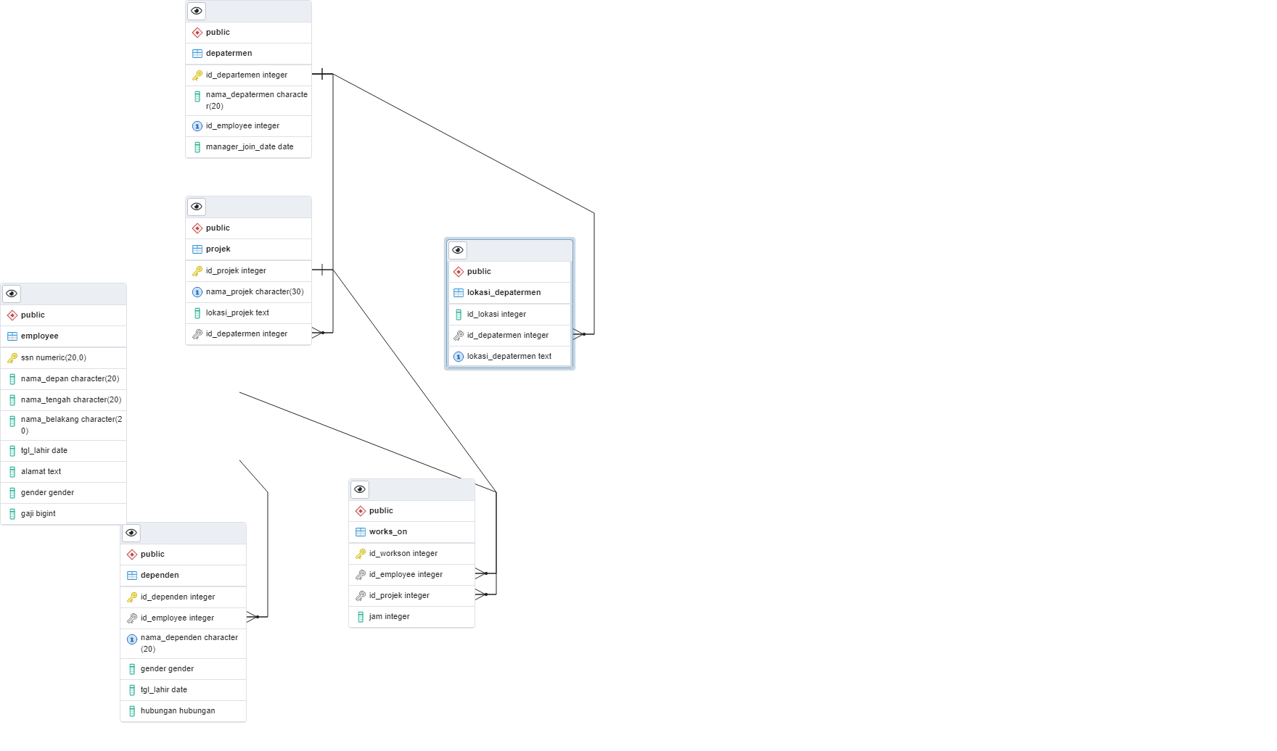

Gambar 1. DB_COMPANY (ERD)

**1. CREATE SCRIPT**

**1. depatermen**

-- Table: public.depatermen

-- DROP TABLE IF EXISTS public.depatermen;

CREATE TABLE IF NOT EXISTS public.depatermen

(

id_departemen integer NOT NULL DEFAULT nextval('depatermen_id_departemen_seq'::regclass),

nama_depatermen character(20) COLLATE pg_catalog."default",

id_employee integer,

manager_join_date date,

CONSTRAINT depatermen_pkey PRIMARY KEY (id_departemen),

CONSTRAINT uq_employee UNIQUE (id_employee)

)

TABLESPACE pg_default;

ALTER TABLE IF EXISTS public.depatermen

OWNER to postgres;

**2. dependen**

-- Table: public.dependen

-- DROP TABLE IF EXISTS public.dependen;

CREATE TABLE IF NOT EXISTS public.dependen

(

id_dependen integer NOT NULL DEFAULT nextval('dependent_id_dependent_seq'::regclass),

id_employee integer,

nama_dependen character(20) COLLATE pg_catalog."default",

gender gender,

tgl_lahir date,

hubungan hubungan,

CONSTRAINT dependent_pkey PRIMARY KEY (id_dependen),

CONSTRAINT uq_nama_dependen UNIQUE (nama_dependen),

CONSTRAINT fk_employee FOREIGN KEY (id_employee)

REFERENCES public.employee (ssn) MATCH SIMPLE

ON UPDATE NO ACTION

ON DELETE NO ACTION

)

TABLESPACE pg_default;

ALTER TABLE IF EXISTS public.dependen

OWNER to postgres;

**3. employee**

-- Table: public.employee

-- DROP TABLE IF EXISTS public.employee;

CREATE TABLE IF NOT EXISTS public.employee

(

ssn numeric(20,0) NOT NULL,

nama_depan character(20) COLLATE pg_catalog."default" NOT NULL,

nama_tengah character(20) COLLATE pg_catalog."default",

nama_belakang character(20) COLLATE pg_catalog."default",

tgl_lahir date,

alamat text COLLATE pg_catalog."default",

gender gender,

gaji bigint,

CONSTRAINT employee_pkey PRIMARY KEY (ssn)

)

TABLESPACE pg_default;

ALTER TABLE IF EXISTS public.employee

OWNER to postgres;

**4. lokasi departemen**

-- Table: public.lokasi_depatermen

-- DROP TABLE IF EXISTS public.lokasi_depatermen;

CREATE TABLE IF NOT EXISTS public.lokasi_depatermen

(

id_lokasi integer NOT NULL,

id_depatermen integer NOT NULL,

lokasi_depatermen text COLLATE pg_catalog."default" NOT NULL,

CONSTRAINT uq_lokasi_depatermen UNIQUE (lokasi_depatermen),

CONSTRAINT fk_depatermen FOREIGN KEY (id_depatermen)

REFERENCES public.depatermen (id_departemen) MATCH SIMPLE

ON UPDATE NO ACTION

ON DELETE NO ACTION

)

TABLESPACE pg_default;

ALTER TABLE IF EXISTS public.lokasi_depatermen

OWNER to postgres;

**5. projek**

-- Table: public.projek

-- DROP TABLE IF EXISTS public.projek;

CREATE TABLE IF NOT EXISTS public.projek

(

id_projek integer NOT NULL DEFAULT nextval('projek_id_projek_seq'::regclass),

nama_projek character(30) COLLATE pg_catalog."default",

lokasi_projek text COLLATE pg_catalog."default",

id_depatermen integer,

CONSTRAINT projek_pkey PRIMARY KEY (id_projek),

CONSTRAINT uq_nama_projek UNIQUE (nama_projek),

CONSTRAINT fk_depatermen FOREIGN KEY (id_depatermen)

REFERENCES public.depatermen (id_departemen) MATCH SIMPLE

ON UPDATE NO ACTION

ON DELETE NO ACTION

)

TABLESPACE pg_default;

ALTER TABLE IF EXISTS public.projek

OWNER to postgres;

**6. works on**

-- Table: public.works_on

-- DROP TABLE IF EXISTS public.works_on;

CREATE TABLE IF NOT EXISTS public.works_on

(

id_workson integer NOT NULL,

id_employee integer NOT NULL,

id_projek integer NOT NULL,

jam integer NOT NULL,

CONSTRAINT works_on_pkey PRIMARY KEY (id_workson),

CONSTRAINT uq_together_workson UNIQUE (id_employee, id_projek)

INCLUDE(id_employee, id_projek),

CONSTRAINT fk_employee FOREIGN KEY (id_employee)

REFERENCES public.employee (ssn) MATCH SIMPLE

ON UPDATE NO ACTION

ON DELETE NO ACTION,

CONSTRAINT fk_projek FOREIGN KEY (id_projek)

REFERENCES public.projek (id_projek) MATCH SIMPLE

ON UPDATE NO ACTION

ON DELETE NO ACTION

)

TABLESPACE pg_default;

ALTER TABLE IF EXISTS public.works_on

OWNER to postgres;

**2. INSERT DATA**

insert into employee values

(1, 'chandra', 'jackson', 'aja', '2022-01-01', 'jln. perkantoran no.8', 'male', 536352),

(2, 'nami', '', 'aja', '2022-02-01', 'jln. perkantoran no.9', 'female', 236352),

(3, 'robin', '', '', '2022-03-01', 'jln. perkantoran no.10', 'female', 136352),

(4, 'usop', 'jackson', 'aja', '2022-04-01', 'jln. perkantoran no.11', 'male', 936352)

insert into dependen values

(1, 4, 'chandra', 'male', '2022-01-01', 'internal'),

(2, 4, 'mihawk', 'male', '2021-02-01', 'eksternal'),

(3, 2, 'law', 'male', '2020-01-01', 'eksternal'),

(4, 1, 'roger', 'male', '2019-01-01', 'internal')

(5, 1, 'leo', 'male', '2022-01-01', 'internal'),

(6, 3, 'kaido', 'male', '2021-02-01', 'eksternal'),

(7, 2, 'apoo', 'male', '2020-01-01', 'eksternal')

insert into depatermen values

(1, 'it', 34242, '2020-01-01'),

(2, 'human resource', 12242, '2021-01-01'),

(4, 'it', 84242, '2019-01-01')

insert into projek values

(6, 'jakarta-fest', 'jakarta selatan', 1),

(7, 'bandung-fest', 'bandung', 1),

(8, 'palembang-fest', 'palembang', 1),

(9, 'bali-fest', 'bali', 4),

(10, 'japan-fest', 'japan', 2)

insert into lokasi_depatermen values

(1, 1, 'malaysia'),

(2, 4, 'indonesia'),

(3, 2, 'palembang')

Insert into works_on values

(1, 2, 6, 20),

(2, 2, 7, 100),

(3, 2, 8, 300),

(4, 2, 9, 2),

(5, 7, 9, 2),

(6, 8, 1, 2000),

(7, 5, 6, 300),

(8, 5, 9, 2)

**3. QUERY**

3.A **Tampilkan dependent_name dan relationship dengan employee yang namanya diawali huruf R ?**

select

d.nama_dependen,   
e.nama_depan from dependen as d

inner join employee as e on d.id_employee = e.ssn

where e.nama_depan LIKE 'r%';

3.B **Banyaknya employee yang mengerjakan project PNum = 6 ?**

SELECT COUNT(id_employee) AS employee_on_p6

FROM works_on

where id_projek = 6;

3.C **Banyaknya employee yang memiliki salary lebih dari 900000?**

select

e.nama_depan,

e.gaji

from employee as e

where e.gaji > 900000

3.D **Banyaknya project yang dikerjakan DNum =2 ?**

select count(p.id_depatermen) as projek_depatermen_2

from projek as p

where p.id_depatermen = 2

3.E **Hitung total dan rata-rata salary dari setiap departemen ?**

select

d.nama_depatermen,

SUM(e.gaji) as total_gaji,

AVG(gaji) as rata_rata_gaji from depatermen as d

inner join employee as e on d.id_employee = e.ssn

group by d.nama_depatermen

3.F **Banyaknya employee dari setiap department dan urutkan berdasarkan employee terbanyak ?**

select

d.nama_depatermen,

COUNT(d.id_employee) as total_employee

from depatermen as d

inner join employee as e on d.id_employee = e.ssn

group by d.nama_depatermen

order by total_employee DESC;

3.G **Total hours perweek dari semua employee untuk setiap project ?**

select

p.nama_projek,

e.nama_depan, SUM(w.jam) as total_hours_per_week

from works_on as w

inner join employee as e on w.id_employee = e.ssn

inner join projek as p on w.id_projek = p.id_projek

group by p.nama_projek, e.nama_depan

3.H **Employee yang memiliki total hours perweek lebih besar dari 140 hours dan urutkan berdasarkan jumlah jam kerja terbanyak?**

select e.nama_depan as employee,

p.nama_projek as projek,

SUM(w.jam) as total_jam

from works_on as w

inner join employee as e on w.id_employee = e.ssn

inner join projek as p on w.id_projek = p.id_projek

where w.jam >= 140

GROUP BY w.id_employee, projek, employee, w.jam

ORDER BY w.jam DESC

3.I **Kelompokkan bonus employee berdasarkan jumlah jam kerjanya ? (Jika >= 200 hours, maka bonus = 50%; Jika >= 150 hours, maka bonus = 25%, Selainnya bonus = 10%)**

select e.nama_depan as employee,

case

when SUM(jam) >= 200 then '50%'

when SUM(jam) >= 150 then '25%'

else '10%'

end as bonus

from works_on as w

inner join employee as e on w.id_employee = e.ssn

group by w.id_employee, e.nama_depan

3.J **Banyaknya project yang dikerjakan tiap employee dan urutkan dari yang terbanyak ?**

select

e.nama_depan as employee,

COUNT(w.id_projek) as total_projek

from works_on as w

inner join employee as e on w.id_employee = e.ssn

group by w.id_employee, e.nama_depan

order by total_projek DESC

3.K **Employee yang bekerja pada 4 project ?**

select

e.nama_depan as employee,

COUNT(w.id_projek) as total_projek

from works_on as w

inner join employee as e on w.id_employee = e.ssn

group by w.id_employee, e.nama_depan

having COUNT(w.id_projek) >= 4

3.L **Employee yang memiliki rata-rata hours perweek = 200 jam dan bekerja pada 1 project ?**

select

e.nama_depan as employee,

w.jam,

COUNT(w.id_projek) projek

from works_on as w

inner join employee as e on w.id_employee = e.ssn

group by e.nama_depan, w.jam

HAVING w.jam>=200

AND COUNT(w.id_projek) >= 1

3.M **Banyaknya Dependent berdasarkan relationship dengan employee ?**

select

count(*) total_dependen

from dependen as d

inner join employee as e on d.id_dependen = e.ssn

3.N **Berapa lama Manager tiap Department sudah menjabat ?**

SELECT e.nama_depan,

DATE_PART('year', NOW()::date) -

DATE_PART('year', d.manager_join_date::date)

as lama_menjabat_tahun

from depatermen as d

inner join employee as e on d.id_employee = e.ssn

3.O **Lokasi project yang menjadi tempat lebih dari satu department?** select

d.lokasi_depatermen as lokasi,

COUNT(d.id_depatermen) as total_departemen

from lokasi_depatermen as d

group by lokasi

having COUNT(d.id_depatermen) >= 1

**DB_MELODI_INDAH (PostgreSQL)**

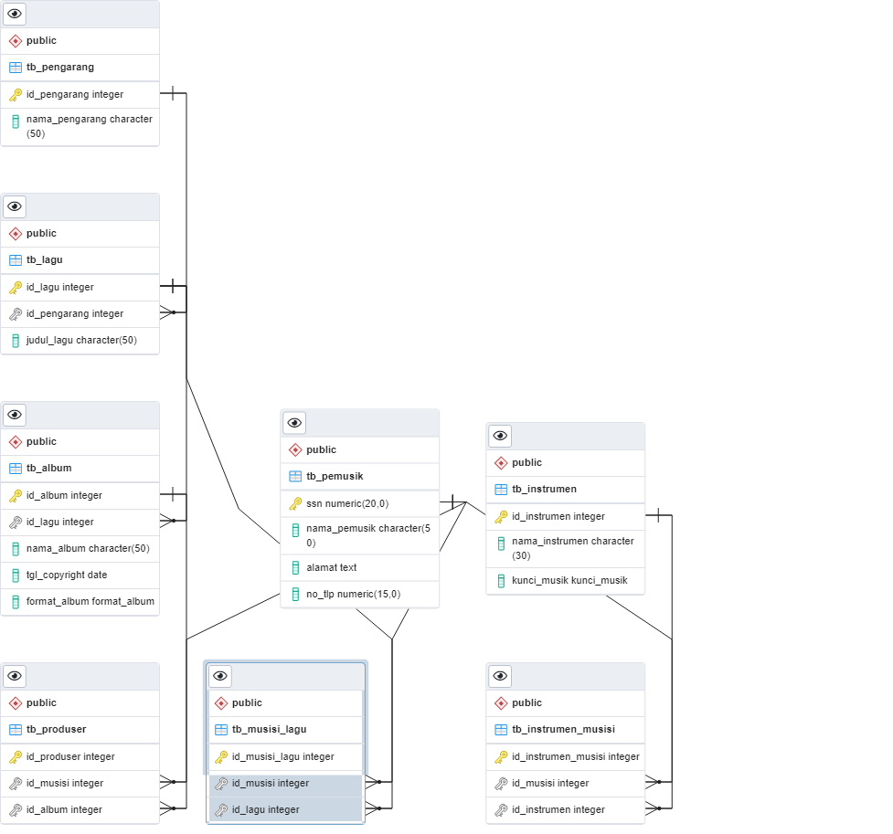

Gambar 2. DB_MELODI_INDAH (ERD)

**1. CREATE SCRIPT**

**1.1 public.tb_pemusik**

-- DROP TABLE IF EXISTS public.tb_pemusik;

CREATE TABLE IF NOT EXISTS public.tb_pemusik

(

ssn numeric(20,0) NOT NULL,

nama_pemusik character(50) COLLATE pg_catalog."default" NOT NULL,

alamat text COLLATE pg_catalog."default",

no_tlp numeric(15,0) NOT NULL,

CONSTRAINT tb_pemusik_pkey PRIMARY KEY (ssn)

)

TABLESPACE pg_default;

ALTER TABLE IF EXISTS public.tb_pemusik

OWNER to postgres;

**1.2 public.tb_instrumen**

-- DROP TABLE IF EXISTS public.tb_instrumen;

CREATE TABLE IF NOT EXISTS public.tb_instrumen

(

id_instrumen integer NOT NULL DEFAULT nextval('tb_instrumen_id_instrumen_seq'::regclass),

nama_instrumen character(30) COLLATE pg_catalog."default",

kunci_musik kunci_musik,

CONSTRAINT tb_instrumen_pkey PRIMARY KEY (id_instrumen)

)

TABLESPACE pg_default;

ALTER TABLE IF EXISTS public.tb_instrumen

OWNER to postgres;

**1.3 public.tb_pengarang**

-- DROP TABLE IF EXISTS public.tb_pengarang;

CREATE TABLE IF NOT EXISTS public.tb_pengarang

(

id_pengarang integer NOT NULL DEFAULT nextval('tb_pengarang_id_pengarang_seq'::regclass),

nama_pengarang character(50) COLLATE pg_catalog."default",

CONSTRAINT tb_pengarang_pkey PRIMARY KEY (id_pengarang)

)

TABLESPACE pg_default;

ALTER TABLE IF EXISTS public.tb_pengarang

OWNER to postgres;

**1.4 public.tb_lagu**

-- DROP TABLE IF EXISTS public.tb_lagu;

CREATE TABLE IF NOT EXISTS public.tb_lagu

(

id_lagu integer NOT NULL DEFAULT nextval('tb_lagu_id_lagu_seq'::regclass),

id_pengarang integer,

judul_lagu character(50) COLLATE pg_catalog."default",

CONSTRAINT tb_lagu_pkey PRIMARY KEY (id_lagu),

CONSTRAINT fk_pengarang FOREIGN KEY (id_pengarang)

REFERENCES public.tb_pengarang (id_pengarang) MATCH SIMPLE

ON UPDATE NO ACTION

ON DELETE NO ACTION

)

TABLESPACE pg_default;

ALTER TABLE IF EXISTS public.tb_lagu

OWNER to postgres;

**1.5 public.tb_album**

-- DROP TABLE IF EXISTS public.tb_album;

CREATE TABLE IF NOT EXISTS public.tb_album

(

id_album integer NOT NULL DEFAULT nextval('tb_album_id_album_seq'::regclass),

id_lagu integer NOT NULL,

nama_album character(50) COLLATE pg_catalog."default" NOT NULL,

tgl_copyright date NOT NULL,

format_album format_album NOT NULL,

CONSTRAINT tb_album_pkey PRIMARY KEY (id_album),

CONSTRAINT fk_lagu FOREIGN KEY (id_lagu)

REFERENCES public.tb_lagu (id_lagu) MATCH SIMPLE

ON UPDATE NO ACTION

ON DELETE NO ACTION

)

TABLESPACE pg_default;

ALTER TABLE IF EXISTS public.tb_album

OWNER to postgres;

**1.6 public.tb_instrumen_musisi**

-- DROP TABLE IF EXISTS public.tb_instrumen_musisi;

CREATE TABLE IF NOT EXISTS public.tb_instrumen_musisi

(

id_instrumen_musisi integer NOT NULL DEFAULT nextval('tb_instrumen_musisi_id_instrumen_musisi_seq'::regclass),

id_musisi integer,

id_instrumen integer,

CONSTRAINT tb_instrumen_musisi_pkey PRIMARY KEY (id_instrumen_musisi),

CONSTRAINT fk_instrumen FOREIGN KEY (id_instrumen)

REFERENCES public.tb_instrumen (id_instrumen) MATCH SIMPLE

ON UPDATE NO ACTION

ON DELETE NO ACTION,

CONSTRAINT fk_musisi FOREIGN KEY (id_musisi)

REFERENCES public.tb_pemusik (ssn) MATCH SIMPLE

ON UPDATE NO ACTION

ON DELETE NO ACTION

)

TABLESPACE pg_default;

ALTER TABLE IF EXISTS public.tb_instrumen_musisi

OWNER to postgres;

**1.7 public.tb_musisi_lagu**

-- DROP TABLE IF EXISTS public.tb_musisi_lagu;

CREATE TABLE IF NOT EXISTS public.tb_musisi_lagu

(

id_musisi_lagu integer NOT NULL DEFAULT nextval('tb_musisi_lagu_id_musisi_lagu_seq'::regclass),

id_musisi integer NOT NULL,

id_lagu integer NOT NULL,

CONSTRAINT tb_musisi_lagu_pkey PRIMARY KEY (id_musisi_lagu),

CONSTRAINT fk_lagu FOREIGN KEY (id_lagu)

REFERENCES public.tb_lagu (id_lagu) MATCH SIMPLE

ON UPDATE NO ACTION

ON DELETE NO ACTION,

CONSTRAINT fk_musisi FOREIGN KEY (id_musisi)

REFERENCES public.tb_pemusik (ssn) MATCH SIMPLE

ON UPDATE NO ACTION

ON DELETE NO ACTION

)

TABLESPACE pg_default;

ALTER TABLE IF EXISTS public.tb_musisi_lagu

OWNER to postgres;

**1.8 public.tb_produser**

-- DROP TABLE IF EXISTS public.tb_produser;

CREATE TABLE IF NOT EXISTS public.tb_produser

(

id_produser integer NOT NULL DEFAULT nextval('tb_produser_id_produser_seq'::regclass),

id_musisi integer NOT NULL,

id_album integer NOT NULL,

CONSTRAINT tb_produser_pkey PRIMARY KEY (id_produser),

CONSTRAINT fk_album FOREIGN KEY (id_album)

REFERENCES public.tb_album (id_album) MATCH SIMPLE

ON UPDATE NO ACTION

ON DELETE NO ACTION,

CONSTRAINT fk_musisi FOREIGN KEY (id_musisi)

REFERENCES public.tb_pemusik (ssn) MATCH SIMPLE

ON UPDATE NO ACTION

ON DELETE NO ACTION

)

TABLESPACE pg_default;

ALTER TABLE IF EXISTS public.tb_produser

OWNER to postgres;

**2. INSERT DATA**

insert into tb_pemusik values

(134658123, 'chandra', 'jln. ansi no 8', 23425643),

(234658167, 'nami', 'jln. sinsa no 9', 23455643),

(334652343, 'brook', 'jln. orange no 7', 8924643),

(434567663, 'usop', 'jln. malky no 7', 27825643),

(534634553, 'sanji', 'jln. ways no 6', 45725643)

insert into tb_instrumen values

(1, 'gitar', 'C'),

(2, 'flute', 'A'),

(3, 'piano', 'B#')

insert into tb_pengarang values

(1, 'jacob'),

(2, 'arial'),

(3, 'violet')

insert into tb_lagu values

(1, 3, 'dark'),

(2, 1, 'versace on the floor'),

(3, 2, 'treasure')

insert into tb_album values

(1, 1, 'album a', '2022-01-01', 'CD'),

(2, 1, 'album b', '2022-02-01', 'CD'),

(3, 2, 'album b', '2022-03-01', 'MC')

insert into tb_instrumen_musisi values

(1, 134658123, 2),

(2, 234658167, 1),

(3, 334652343, 3),

(4, 334652343, 1),

(5, 334652343, 2),

(6, 434567663, 1)

insert into tb_musisi_lagu values

(1, 234658167, 3),

(2, 234658167, 2),

(3, 234658167, 2),

(4, 234658167, 2)

insert into tb_produser values

(234658167, 2),

(234658167, 2),

(334652343, 1),

(334652343, 3)

**3. QUERY**

**3.1 Judul lagu & Nama album**

select l.judul_lagu, a.nama_album, a.tgl_copyright, a.format_album

from tb_album as a

left join tb_lagu as l on a.id_lagu = l.id_lagu

**3.2. nama-nama instrumen**

select * from tb_instrumen

**3.3. nama-nama musisi**

select * from tb_pemusik

**3.4. nama-nama pengarang**

select * from tb_pengarang

**3.5. instrumen yang dipakai musisi**

select p.nama_pemusik, i.nama_instrumen from tb_instrumen_musisi as im

left join tb_pemusik as p on im.id_musisi = p.ssn

left join tb_instrumen as i on im.id_instrumen = i.id_instrumen

**3.6. nama lagu dan pengarang**

select p.nama_pengarang, l.judul_lagu from tb_lagu as l

left join tb_pengarang as p on l.id_pengarang = p.id_pengarang

**3.7. nama musisi dan lagu**

select p.nama_pemusik, l.judul_lagu from tb_musisi_lagu as ml

left join tb_pemusik as p on ml.id_musisi = p.ssn

left join tb_lagu as l on ml.id_lagu = l.id_lagu

**1.8. produser musik**

select p.id_produser, z.nama_pemusik, a.nama_album from tb_produser as p

left join tb_pemusik as z on p.id_musisi = z.ssn

left join tb_album as a on p.id_album = a.id_album