1.REACTJS -HOL

App.js

import React from 'react';

function App() {

  return (

    <div className="App">

      <h1>Welcome the first session of React</h1>

    </div>

  );

}

export default App;

OUTPUT:

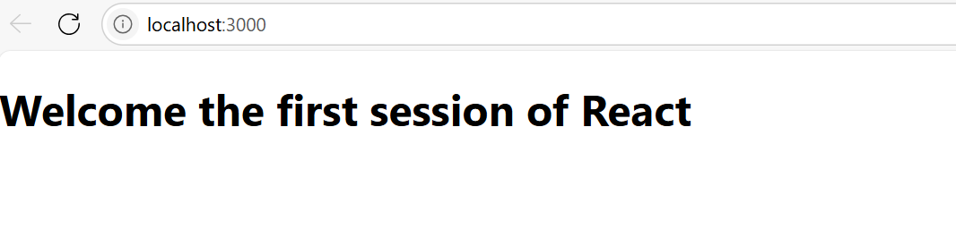

2.

Home.js

import React, { Component } from 'react';

class Home extends Component {

  render() {

    return (

      <h2>Welcome to the Home Page of Student Management Portal</h2>

    );

  }

}

export default Home;

About.js

import React, { Component } from 'react';

class About extends Component {

  render() {

    return (

      <h2>Welcome to the About Page of Student Management Portal</h2>

    );

  }

}

export default About;

Contact.js

import React, { Component } from 'react';

class Contact extends Component {

  render() {

    return (

      <h2>Welcome to the Contact Page of Student Management Portal</h2>

    );

  }

}

export default Contact;

OUTPUT:

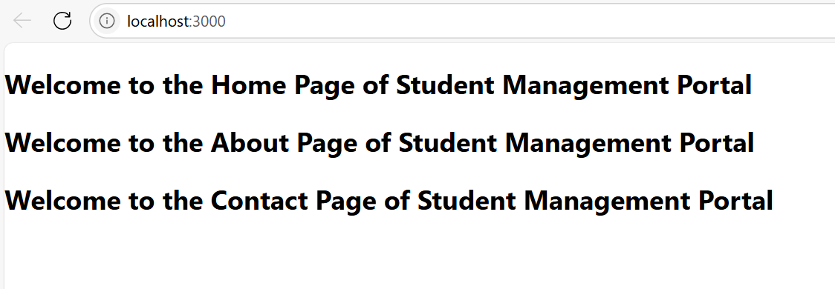

3.

CalculatorScore.js

import React from 'react';

import '../Style/style.css';

function CalculatorScore(props) {

  const { Name, School, total, goal } = props;

  return (

    <div className="container">

      <h2>Student Details:</h2>

      <div className="Name">Name: {Name}</div>

      <div className="School">School: {School}</div>

      <div className="Total">Total: {total}</div>

      <div className="formdesign">Goal: {goal}</div>

    </div>

  );

}

export default CalculatorScore;

Style.css

.container {

    display: flex;

    flex-direction: column;

    align-items: center;

    justify-content: center;

    height: 100vh;

    text-align: center;

  }

  .Name {

    font-weight: 900;

    color: blue;

  }

  .School {

    color: crimson;

  }

  .Total {

    color: darkmagenta;

  }

  .formdesign {

    font-size: large;

  }

  h2 {

    color: forestgreen;

  }

  OUTPUT:



4.

Post.js

import React from 'react';

class Post extends React.Component {

  render() {

    const { title, body } = this.props;

    return (

      <div style={{ border: '1px solid gray', margin: '10px', padding: '10px' }}>

        <h2>{title}</h2>

        <p>{body}</p>

      </div>

    );

  }

}

export default Post;

Posts.js

import React from 'react';

import Post from './Post';

class Posts extends React.Component {

  constructor(props) {

    super(props);

    this.state = {

      posts: [],

    };

  }

  componentDidMount() {

    this.loadPosts();

  }

  loadPosts = () => {

    const data = [

      { id: 1, title: "How to Learn React", body: "Start with the official docs and build small projects." },

      { id: 2, title: "Why JavaScript is Popular", body: "It runs everywhere and has a huge ecosystem." },

      { id: 3, title: "Benefits of Functional Components", body: "They are simpler and use hooks for side effects." }

    ];

    this.setState({ posts: data });

  };

  componentDidCatch(error, info) {

    console.error("Error caught in component:", error);

  }

  render() {

    return (

      <div>

        <h1>Posts</h1>

        {this.state.posts.map(post => (

          <Post key={post.id} title={post.title} body={post.body} />

        ))}

      </div>

    );

  }

}

export default Posts;

App.js

import React from 'react';

import './App.css';

import Posts from './components/Posts';

function App() {

  return (

    <div className="App">

      <Posts />

    </div>

  );

}

export default App;

OUTPUT:

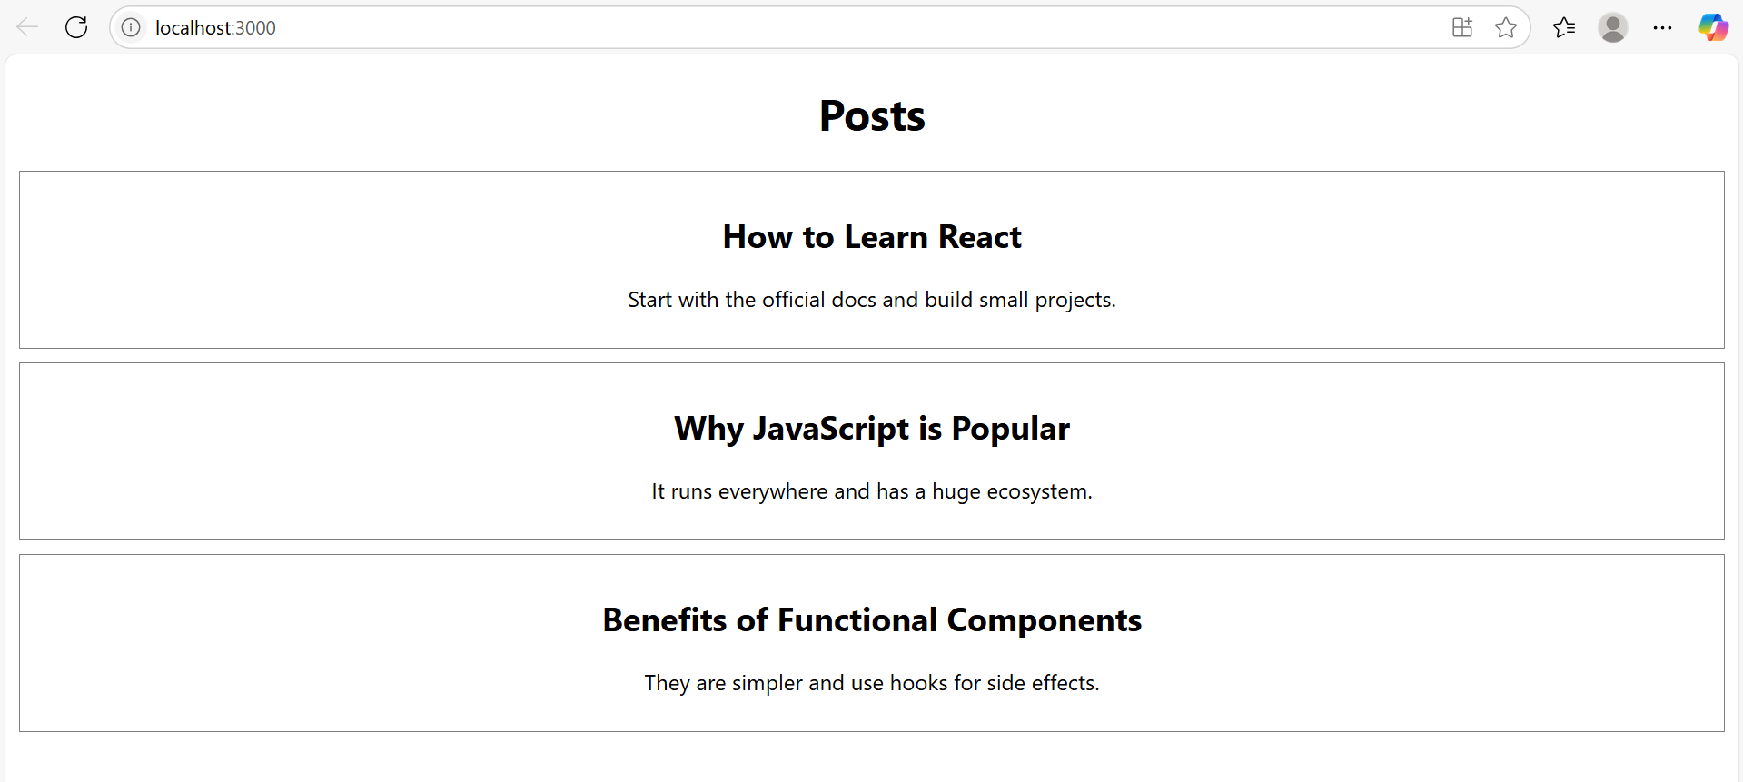

5.

CohortDetails.module.css

.box {

  width: 300px;

  display: inline-block;

  margin: 10px;

  padding: 10px 20px;

  border: 1px solid black;

  border-radius: 10px;

}

dt {

  font-weight: 500;

}

CohortDetails.js

import styles from './CohortDetails.module.css';

function CohortDetails(props) {

    const status = props.cohort.currentStatus?.toLowerCase();

    const headingStyle = {

        color: status === 'ongoing' ? 'green' : 'blue'

    };

    return (

        <div className={styles.box}>

            <h3 style={headingStyle}>

                {props.cohort.cohortCode} -

                <span>{props.cohort.technology}</span>

            </h3>

            <dl>

                <dt>Started On</dt>

                <dd>{props.cohort.startDate}</dd>

                <dt>Current Status</dt>

                <dd>{props.cohort.currentStatus}</dd>

                <dt>Coach</dt>

                <dd>{props.cohort.coachName}</dd>

                <dt>Trainer</dt>

                <dd>{props.cohort.trainerName}</dd>

            </dl>

        </div>

    );

}

export default CohortDetails;

OUTPUT:

