Creating local git repo

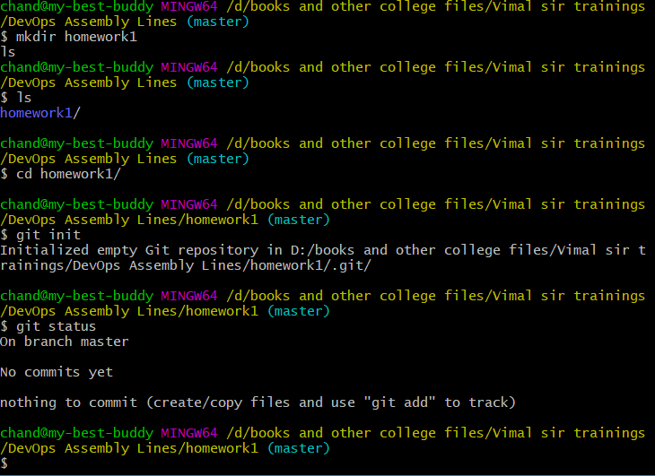

Added a index.html file and then added and committed the file

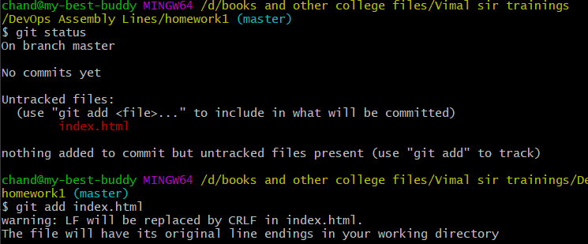

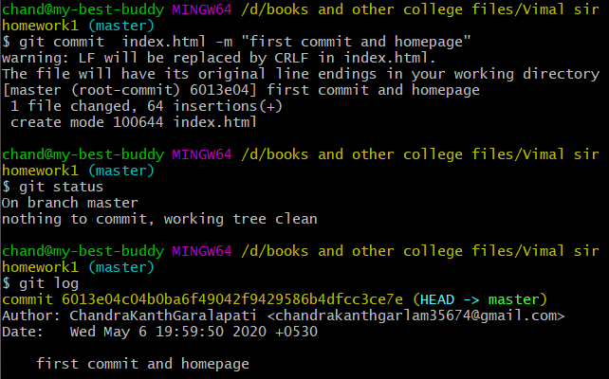

Create a developer branch which works on the styling of the homepage

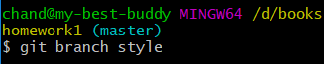

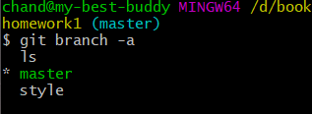

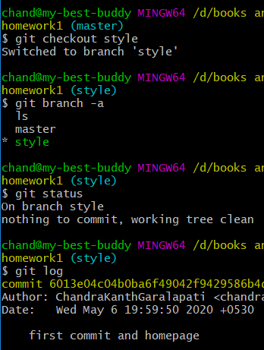

Creating a folder in git hub and connecting it to the local repo we have created

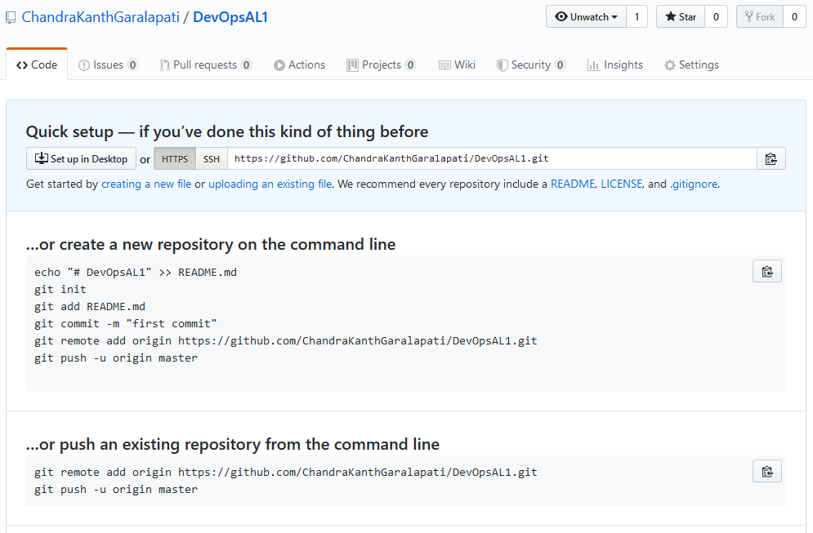

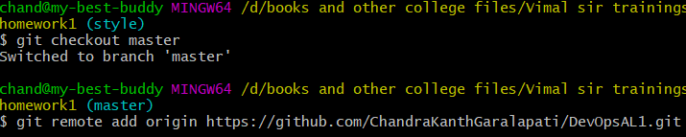

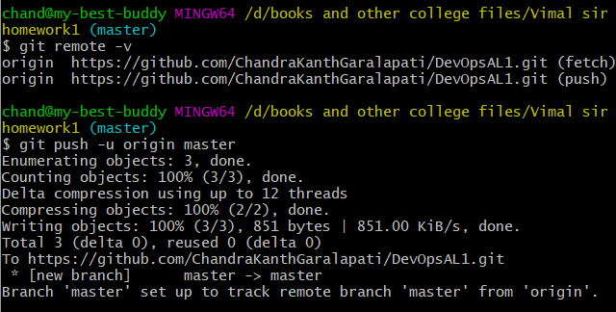

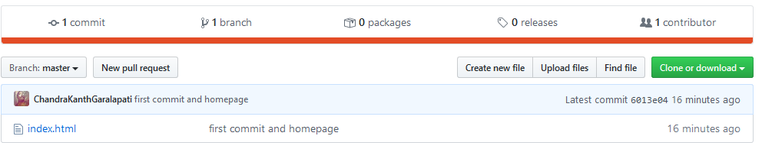

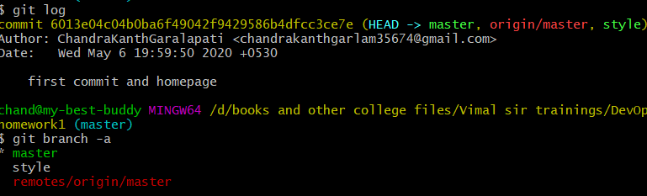

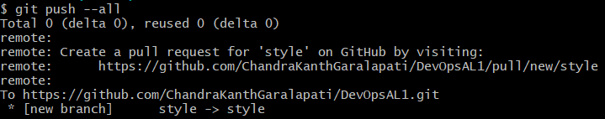

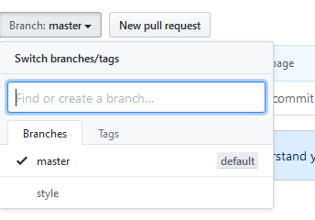

Now creating jobs in Jenkins for both the branches

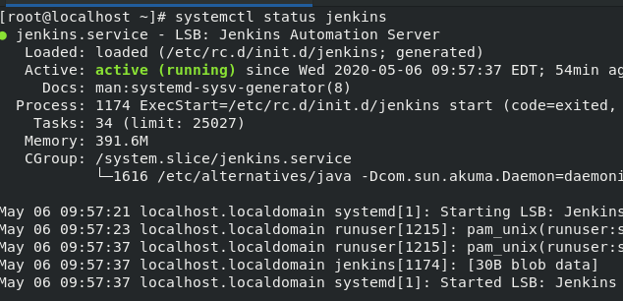



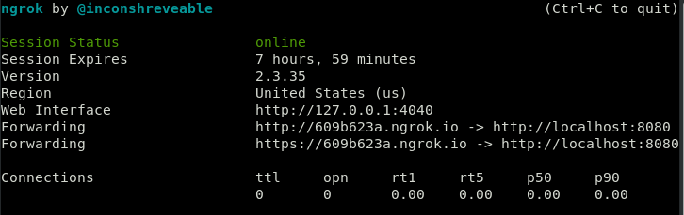

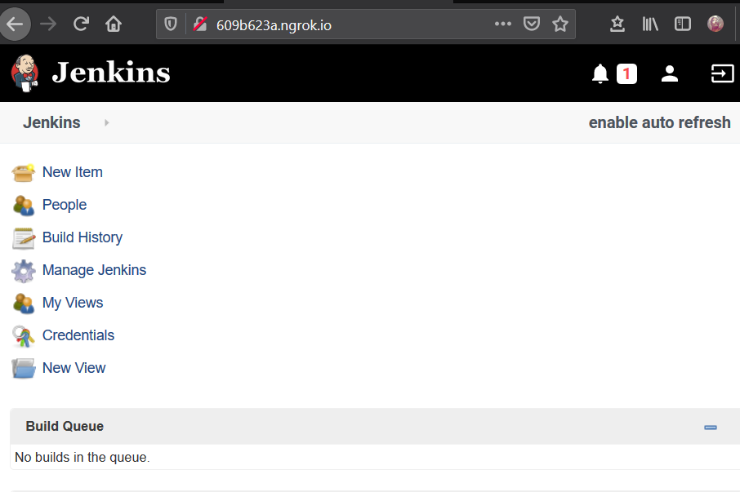



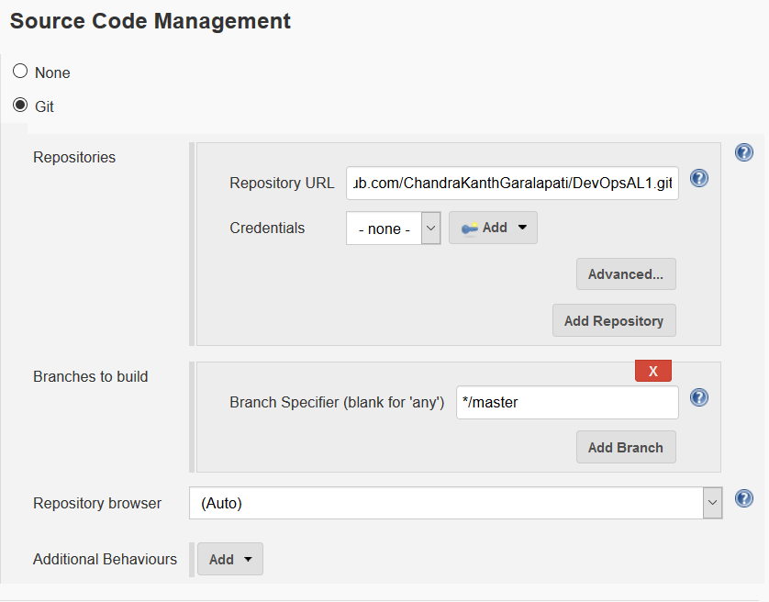

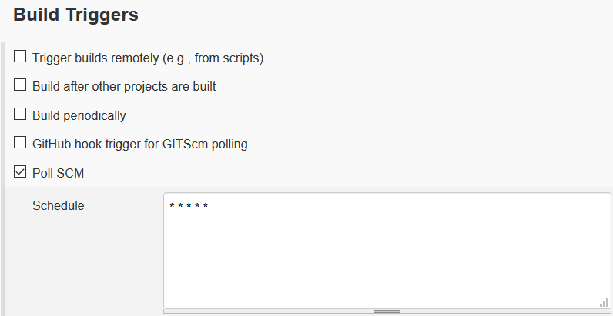

Giving Jenkins unlimited power





Downloading the image and creating volume for the practical

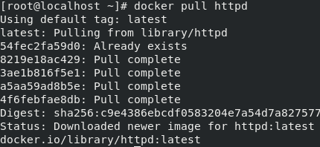

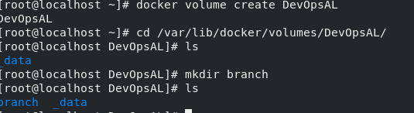

Testing whether image works fine and removing the container

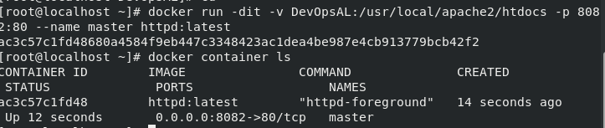



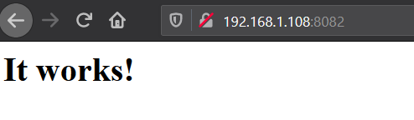

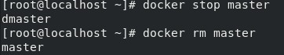

Continuing the job of master branch to download if any changes observed and copy the files to the volumes path

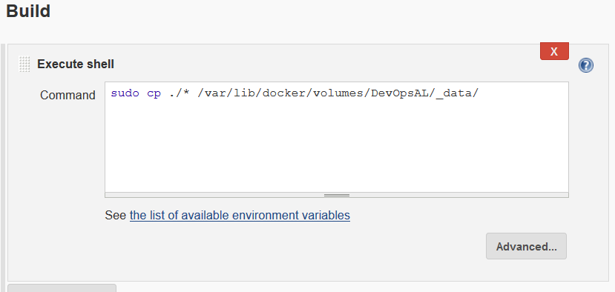

Similarly creating the job for the style branch



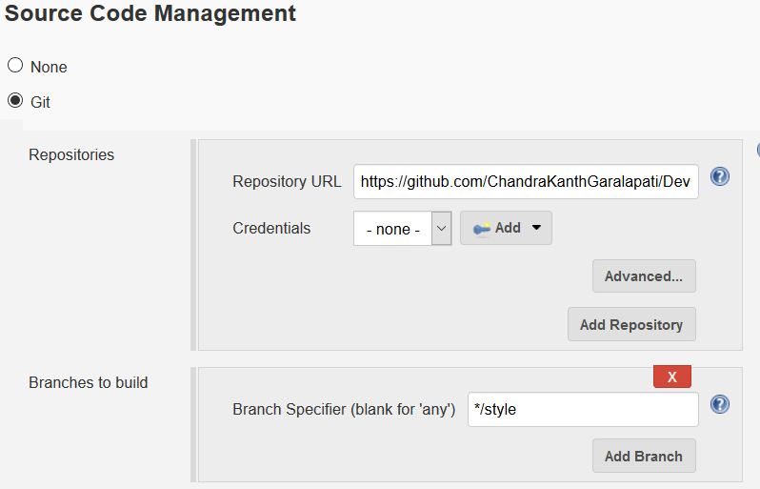



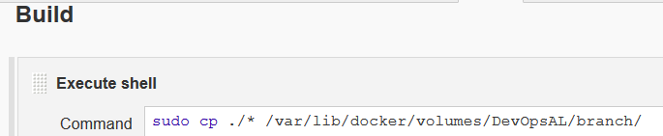

And thus the jobs run for the 1st time successfully

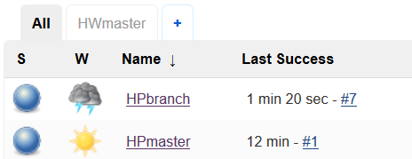

Creating hooks to make the push automatic after commit

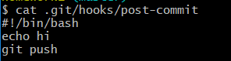

Testing the hook working fine

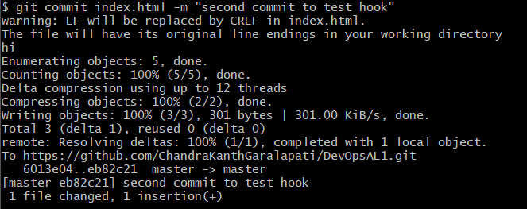

Testing the hook for the branch and understood that it is working fine

But has to set upstream to work the push properly

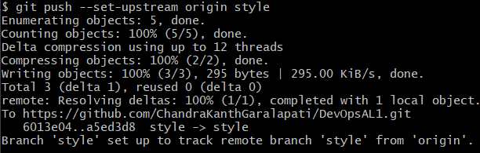

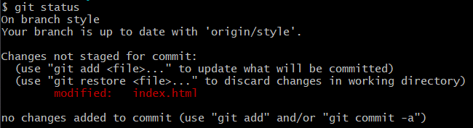

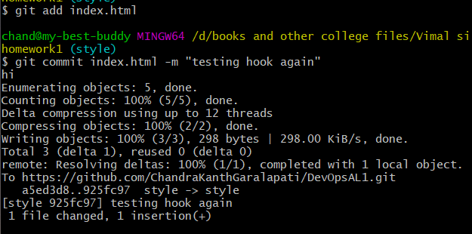

Create a chain job for the master branch to deploy the container in production environment

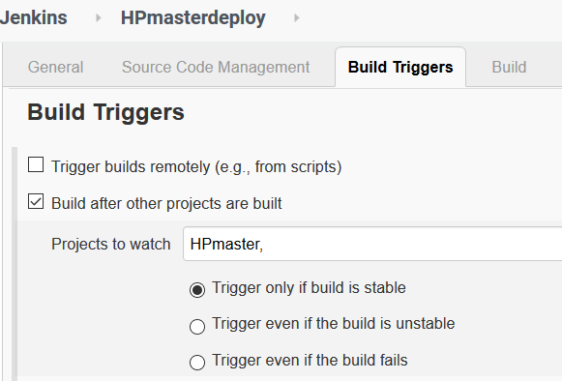

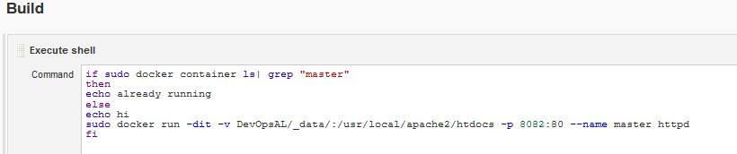

Create a chain job for the style branch to deploy the container in the testing environment similar to master branch

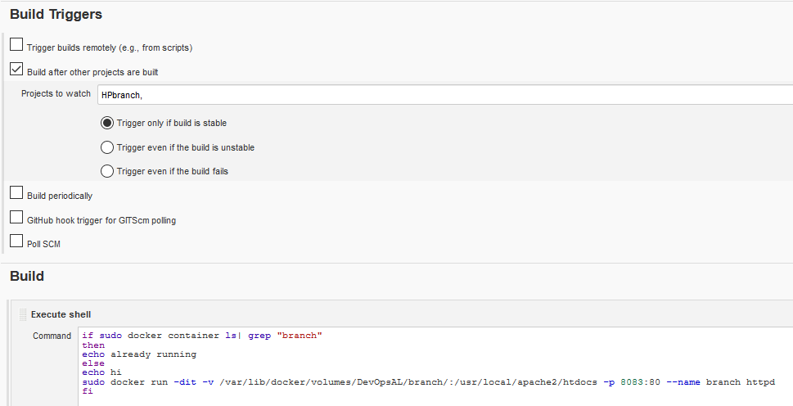

Now creating a job HPQAT for the QAT to trigger the merge of the branches and also remove the testing system using the remote URL

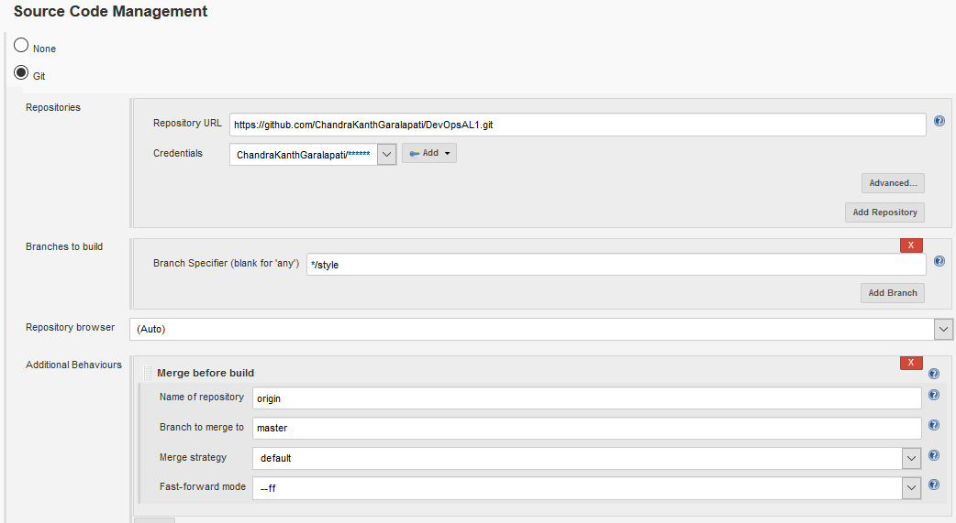

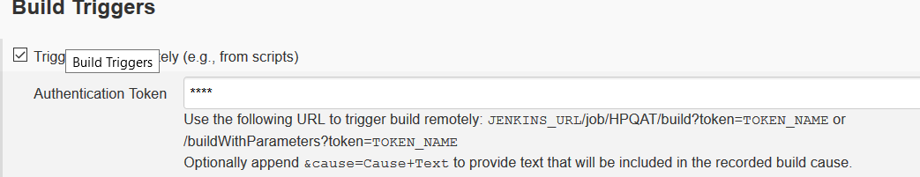

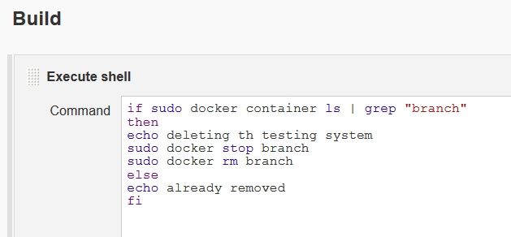

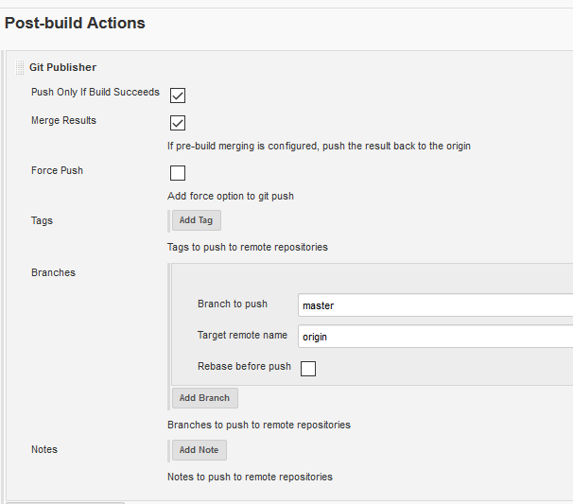

This complete the stuff we have to do to automate the process

And after the quality assurance team finds the changes are fine then they run the URL of the HPQAT job and

Then it triggers the merge of the branches

And since there were changes made in the master branch it will trigger the HPmaster

And on successful complete it triggers the downstream job HPmasterdeploy which deploys the stuff in the production environment

And this completes a demo or test project the depicts the work flow ( typical and basic ) of a website management from end-end ( only minimum features are used as it is built form the technologies I knew )

The entire event testing

1: changes made to style branch

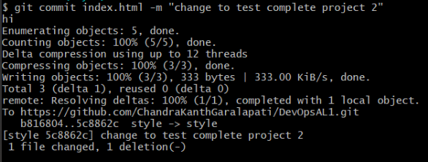

2: the branch job runs

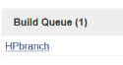

Which initiates the branch deploy



3: testing the website by QAT 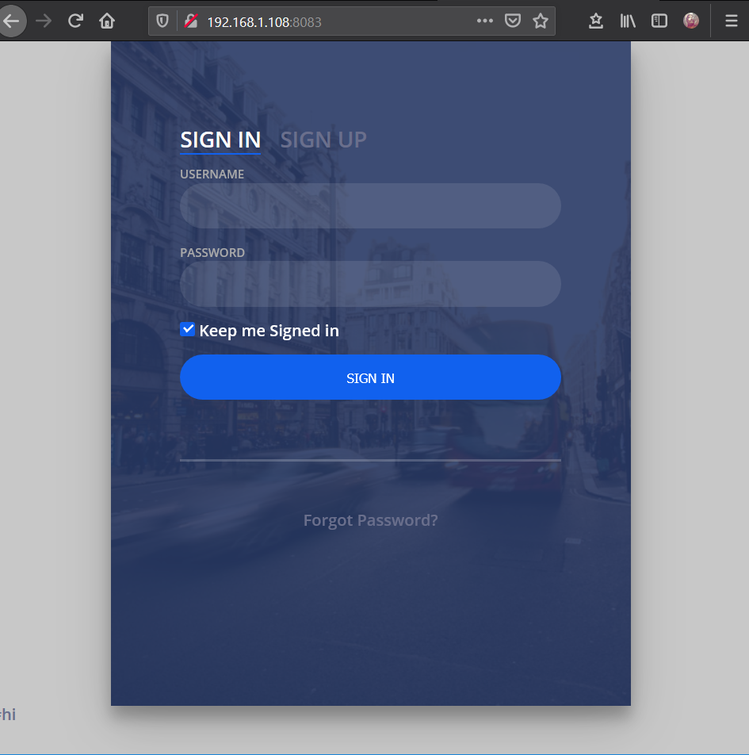

4: run the QAT job on approval

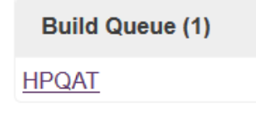

5: as the merge happens the changes are made in master branch triggers the master job

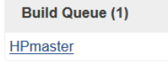

Which triggers the master deploy on the production environment

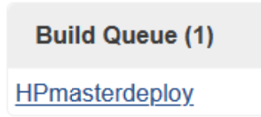

6: At last the website hosting on the production environment

