- Monthly View
- Consolidated View
- Patient Details
- Key Takeaways
DASHBOARDS - 4

BUSINESS REQUIREMENTS

- after loading the data in to power bi - derive the date and hour from the admission date column in the power Query
- create a age group based on the age
Patient Age>=90,"90 - 100",
Patient Age>=80,"80 - 89",
Patient Age>=70,"70 - 79",
Patient Age>=60,"60 - 69",
Patient Age >=50,"50 - 59",
Patient Age>=40,"40 - 49",
Patient Age>=30,"30 -39",
Patient Age>=20,"20 -29","10-19")

- derive the column admisioin status column based on the admisiion flag

- derive the hour range column in the
[Hours] <2, "00 - 02",
[Hours] <4, "03 - 04",
[Hours] <6, "05 - 06",
[Hours] <8, "07 - 08",
[Hours] <10,"09 - 10",
[Hours] <12,"11 -12",
[Hours] <14,"13 - 14",
[Hours] <16,"15 - 16",
[Hours] <18,"17 - 18",
[Hours] <20,"19 - 20","24")
KPI’s Requirements

- Number of Patients:
Measure the total number of patients visiting the ER daily.
Display a daily trend using an area sparkline to understand patterns over time, such as peak days or seasonal trends.
- Average Wait Time:
Calculate the average time patients wait before being attended to by a medical professional.
Use an area sparkline to show daily fluctuations and identify days with higher wait times that may require operational adjustments.
- Patient Satisfaction Score:
Analyze the average satisfaction score of patients on a daily basis to evaluate the quality of service provided.
Present a daily trend using an area sparkline to identify dips in satisfaction and correlate them with operational challenges or peak times.
- Number of Patients Referred:
Count the number of patients referred to specific departments from the ER each day.
Use an area sparkline to track daily trends and identify departments with high referral rates, which may require additional resources.

BUSINESS REQUIREMENTS
Dashboard 1: Monthly View
Objective: Monitor key metrics and trends on a month-by-month basis to identify patterns and areas for improvement.
Charts to Develop:
  - Patient Admission Status: Track admitted vs. non-admitted patients.
  - Patient Age Distribution: Group patients by 10-year age intervals.
  - Department Referrals: Analyze referral trends across different departments.
  - Timeliness: Measure the percentage of patients seen within 30 minutes.
  - Gender Analysis: Visualize patient distribution by gender.
  - Racial Demographics: Analyze patient data by race.
  - Time Analysis: Assess patient volume by day and hour.
Dashboard 2: Consolidated View
Objective: Provide a holistic summary of hospital performance for a selected date range.
Charts to Develop:
  - Similar metrics as the Monthly View, but aggregated over a customizable date range for broader insights and trend analysis
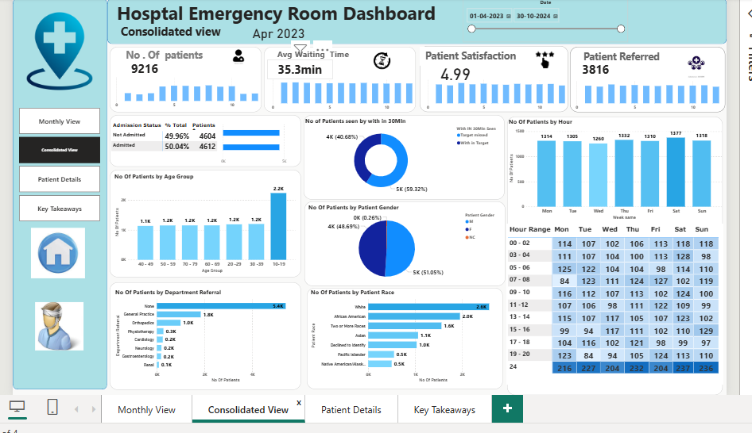
Dashboard 3: Patient Details
Objective: Offer granular insights into patient-level data to enable detailed analysis and troubleshooting.
Charts to Develop: A grid displaying essential fields:
- Patient ID
- Patient Full Name
- Gender
- Age
- Admission Date
- Patient Race
- Wait Time
- Department Referral
- Admission Status
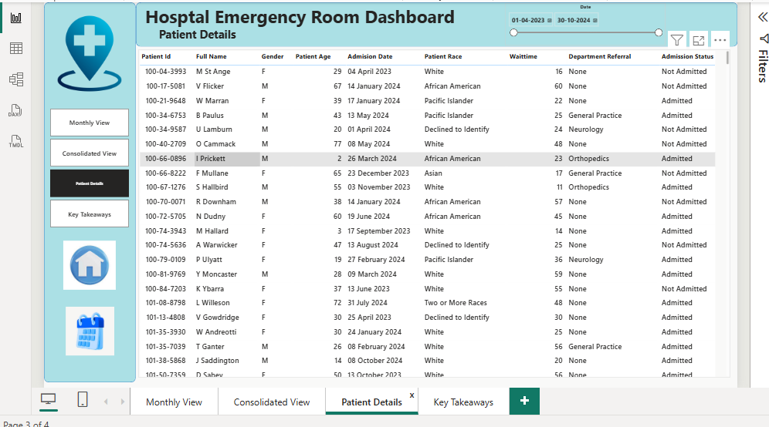

Dashboard 4: Key Takeaways
Objective: Summarize the findings from all dashboards to provide clear and actionable insights for stakeholders.
Charts to Develop:
  - Descriptive analysis of each metric and visualization, including patterns, anomalies, and actionable recommendations to optimize emergency room operations and patient care.
