**Prerequisites:**

* **Version Control:** Your project should be in VCS(Git)
* **Jenkins Installation:** Install the jenkins and ensure all the plugins are installed.
* **Maven Installation:** Install the Maven on your jenkins server and configure the jenkins.
* **Tomcat Server:** Ensure to install the Tomcat server.

**Jenkins Job Setup:**

* **Freestyle-job:** Use build steps for maven commands and then “Deploy the war/ear to the container” post build step
* **Pipeline job:** Use a scripted or declarative pipeline. A pipeline is recommended for flexibility and versioning your build process along with your code.

**Explanation of Jenkinsfile:**

* **Checkout Stage:** Uses the Git plugin to pull the latest code from remote repository.
* **Build Stage:** Invokes maven to clean any previous artifacts and packages your new code into war/jar/ear files.
* **Test stage:** Ensure all the tests to ensure the code quality.
* **Deploy Stage:** By using containerisation tools to deploy the tools

**Configuring Tomcat for deployment:**

* **Adding the User:** Add the username and the password along with the role.
* **Access the Rights:** Verify you can access the Tomcat Manager URL. This URL should return a plain text interface once you’re authenticated.

**Work flow:**

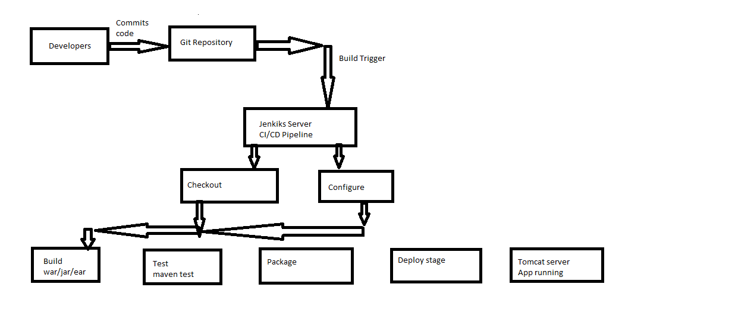**Explanation:**

* **Developer:** Developer builds the code and commits the changes into the Git Repository.
* **Git Repo:** After committing the code into the git the action triggers the Jenkins action pipeline by using Webhook action and Periodic polling.
* **Build:** Jenkins executes the Maven commands to compile the code and package it into WAR file.
* **Test:** Automated tests are run to verify that the code adheres to the code quality standards.
* **Package and Deploy:** With a successful build and test cycle, the WAR file is deployed. Jenkins uses either a pipeline to deploy step or “Deploy to the Container” plugin to push the artifact to a Tomcat Server configured with the proper manager credentials.
* **Tomcat Server:** once the application is deployed, then the Tomcat Server hosts the application and makes it available for Servers.