# Task 1: Total Number of Combinations

total_combinations = 6 * 6

total_combinations = 6 * 6: Calculates the total number of combinations when rolling two six-sided dice.

# Task 2: Distribution of Combinations

from collections import Counter  
# Generate all possible pairs of dice rolls and count occurrences

distribution = Counter([(a, b) for a in range(1, 7) for b in range(1, 7)])

distribution = Counter([(a, b) for a in range(1, 7) for b in range(1, 7)]): Generates all possible pairs of dice rolls and uses Counter to count the occurrences of each pair.

# Task 3: Probability of Sums

# Calculate the probability of each sum

sum_probabilities = Counter([sum(pair) for pair in distribution])

for sum_val in sum_probabilities:

sum_probabilities[sum_val] /= total_combinations

sum_probabilities = Counter([sum(pair) for pair in distribution]): Calculates the sum for each pair in the distribution and uses Counter to count the occurrences of each sum.

for sum_val in sum_probabilities: sum_probabilities[sum_val] /= total_combinations: Converts the counts to probabilities by dividing each count by the total number of combinations.

# Displaying results for Part A

total_combinations, distribution, sum_probabilities

This line displays the total number of combinations, the distribution of combinations, and the probabilities of sums.

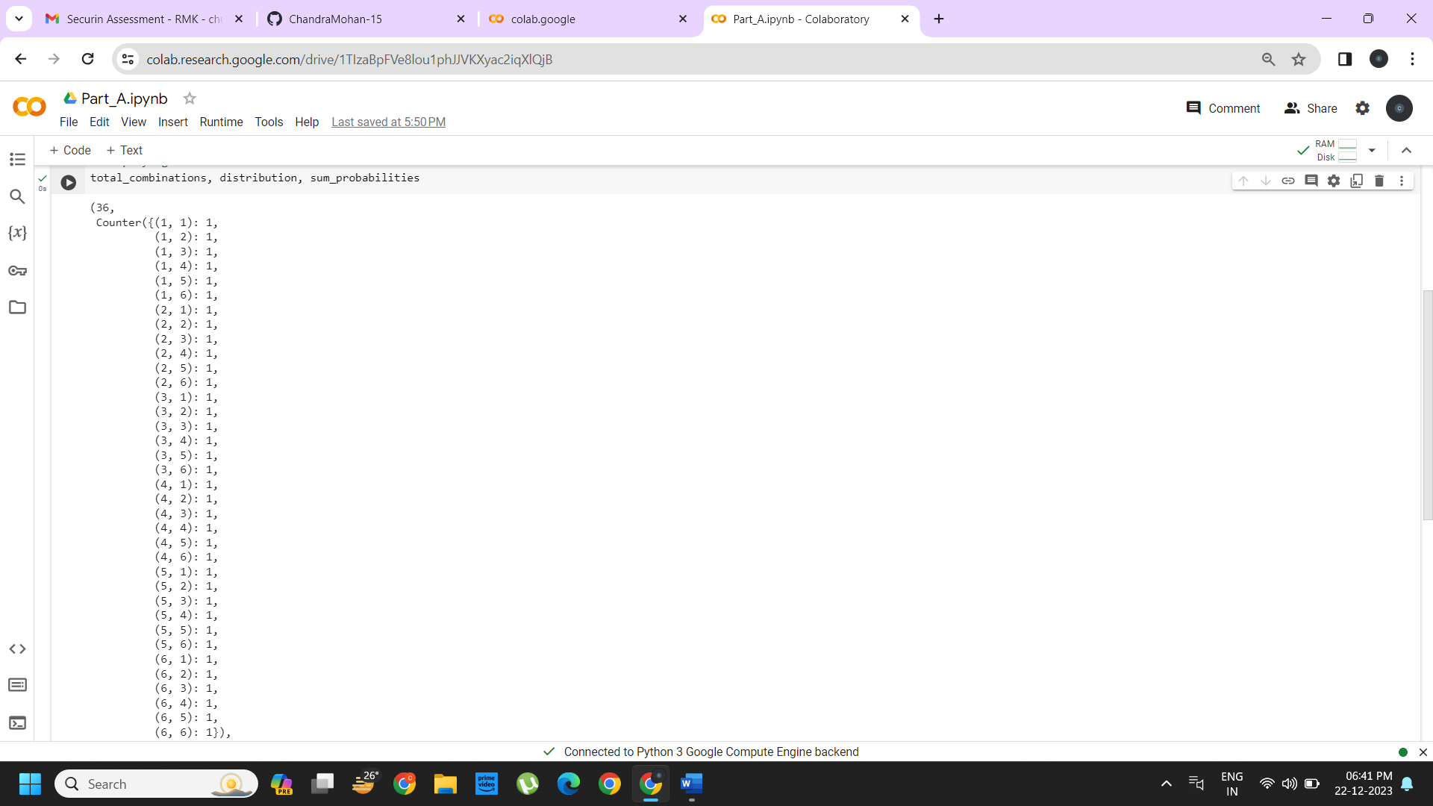

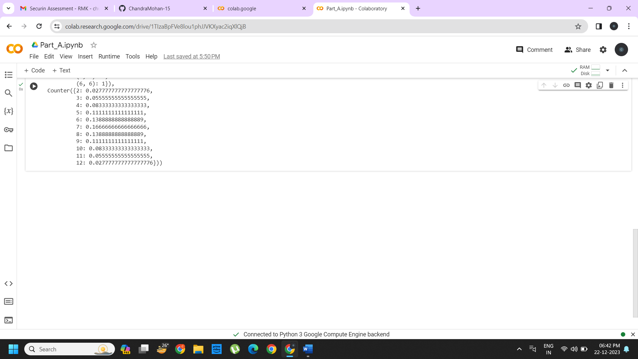

from collections import Counter

def undoom_dice():

# Original Dice Configurations

die_a_original = list(range(1, 7))

die_b_original = list(range(1, 7))

die_a_original: Represents the original configuration for Die A with spots ranging from 1 to 6.

die_b_original: Represents the original configuration for Die B with spots ranging from 1 to 6.

# New Dice Configurations

die_a_new = [1, 2, 3, 4, 3, 2] # Restrict Die A to no more than 4 spots

die_b_new = [1, 2, 3, 4, 5, 8] # Adjust Die B accordingly

die_a_new = [1, 2, 3, 4, 3, 2]: New configuration for Die A, limiting it to no more than 4 spots on any face.

die_b_new = [1, 2, 3, 4, 5, 8]: New configuration for Die B, adjusting it accordingly.

# Validate that the sum probabilities are maintained

original_sums = Counter(a + b for a in die_a_original for b in die_b_original)

new_sums = Counter(a + b for a in die_a_new for b in die_b_new)

original_sums: Counter for the sum probabilities using the original configurations.

new_sums: Counter for the sum probabilities using the new configurations.

# Check if the distributions are the same

if original_sums == new_sums:

return die_a_new, die_b_new

else:

return None, None # In case the distributions do not match

Compares the original and new sum probability distributions.

If they match, the function returns the new configurations; otherwise, it returns None

undoomed_die_a, undoomed_die_b = undoom_dice()

undoomed_die_a, undoomed_die_b

Calls the undoom_dice function and prints the undoomed configurations for Die A and Die B.

# The result (None, None) indicates that the function undoom_dice was unable to find new configurations for Die A and Die B that maintain the same sum probabilities as the original dice within the specified constraints and search range.

