Advanced Machine Learning for Financial Fraud and Sequential Anomaly Detection
Imbalance-aware Ensembles, Dimensionality Reduction, Bayesian Risk Networks and Hidden Markov Models

Abstract
Credit-card fraud detection is a severely imbalanced classification problem: fraudulent transactions form only 0.17% of the data, so accuracy is a misleading objective. This project builds an end-to-end, leakage-safe machine-learning system on the Kaggle credit-card dataset (284,807 transactions), complemented by synthetic data for contextual and sequential risk. After de-duplication and a stratified 80/20 split, only the training partition is standardised, undersampled and rebalanced with SMOTE. We compare L1/L2-regularised logistic regression, linear and RBF support vector machines, Random Forest, bagged trees, XGBoost and a stacking ensemble, tuned with GridSearchCV and RandomizedSearchCV under stratified cross-validation, and evaluate PCA, truncated SVD and LDA for dimensionality reduction. A Bayesian belief network estimates P(Fraud | Evidence) from contextual indicators, and a categorical hidden Markov model infers SAFE/SUSPICIOUS/COMPROMISED states to detect account takeover. On the untouched test set, Random Forest achieved the best F1 of 0.741 (precision 0.691, recall 0.800, ROC-AUC 0.980) and XGBoost the best PR-AUC of 0.790. Linear models reached ROC-AUC near 0.965 but F1 below 0.20 at the default threshold, exposing the cost of the SMOTE-shifted prior. The HMM detected takeovers with F1 0.957. All models are served through a FastAPI back end and an interactive React dashboard.
Keywords: fraud detection, class imbalance, SMOTE, XGBoost, stacking, support vector machines, Bayesian networks, hidden Markov models.

1. Introduction

1.1 Problem definition
Given a card transaction described by a feature vector x ∈ ℝ³⁰, the task is to estimate the probability P(y = 1 | x) that it is fraudulent and to issue an alert when that probability exceeds a decision threshold τ. The defining difficulty is extreme class imbalance: in the benchmark used here only 473 of 283,726 de-duplicated transactions (0.167%) are fraudulent. A classifier that labels every transaction as legitimate is 99.83% accurate yet useless, so the problem must be framed around precision, recall and the area under the precision–recall curve rather than accuracy [12].

1.2 Motivation and real-world impact
Card fraud imposes direct financial losses on issuers and merchants, chargeback and investigation costs, and erodes customer trust. Errors are asymmetric: a false negative is a monetary loss, whereas a false positive is a declined purchase and an analyst review. Fraud is also adversarial and multi-faceted: some attacks are visible in a single transaction, while others (e.g., account takeover) emerge only as a sequence of events such as failed logins followed by a new device and a large purchase. A practical system therefore needs per-transaction classifiers, interpretable contextual reasoning and sequential behavioural modelling.

1.3 Objectives
- Build a reproducible, leakage-safe pipeline in which resampling and scaling are fitted on training data only.
- Compare linear (L1/L2 logistic regression, SVM), kernel (RBF SVM) and ensemble (Random Forest, bagging, XGBoost, stacking) classifiers using imbalance-aware metrics.
- Quantify the effect of PCA, truncated SVD and LDA (respecting LDA's n_classes − 1 limit) on detection quality.
- Tune hyperparameters with GridSearchCV and RandomizedSearchCV under stratified k-fold cross-validation.
- Model contextual risk with a Bayesian belief network, P(Fraud | Evidence), and sequential account-takeover risk with an HMM.
- Estimate transaction amount with SVR (explicitly not financial loss), and deploy all models behind a REST API and dashboard.

2. Literature Review
Benchmark data and evaluation. Dal Pozzolo et al. released the European cardholder dataset used here, whose 28 features are PCA-anonymised, and showed that undersampling distorts posterior probabilities, which must be recalibrated when the training prior differs from deployment [1], [19]. Their later work highlighted concept drift and delayed, verification-biased labels in real fraud-detection systems [2]. Saito and Rehmsmeier demonstrated that ROC curves can look deceptively optimistic on imbalanced data and recommended precision–recall analysis [12], which motivates PR-AUC as our primary ranking metric.
Imbalance handling. SMOTE generates synthetic minority samples by interpolating between nearest neighbours [3] and is the de facto baseline, typically combined with majority undersampling; the imbalanced-learn library standardised these methods [16]. A recurring methodological pitfall in the literature is applying SMOTE before the train/test split, which leaks synthetic neighbours of test points into training and inflates reported scores.
Baseline algorithms. Bhattacharyya et al. compared logistic regression, SVM and Random Forest on real fraud data and found Random Forest the most robust [14]. Logistic regression with L1 [9] or L2 penalties remains the interpretable baseline; SVMs [8] with RBF kernels capture non-linear boundaries but scale poorly (O(n²)–O(n³)) and need calibration (Platt scaling [20]) for probabilities. Ensembles dominate modern tabular benchmarks: bagging [6] and Random Forests [5] reduce variance, gradient boosting with XGBoost [4] reduces bias with regularised trees, and stacking [7] learns how to combine heterogeneous base learners.
Probabilistic and sequential models. Bayesian belief networks [11] encode expert-interpretable conditional dependencies and support exact inference under partial evidence. Srivastava et al. used hidden Markov models [10] to model a cardholder's spending sequence and flag deviations [13].
Research gaps. (i) Many studies report accuracy or ROC-AUC alone, hiding poor precision; (ii) resampling is often applied before splitting; (iii) further dimensionality reduction on already-PCA-transformed features is rarely evaluated critically; (iv) transaction-level classifiers, contextual reasoning and sequential behaviour are usually studied in isolation; and (v) few works deliver a deployable, interpretable system. This project addresses each gap within a single leakage-safe framework.

3. Methodology

3.1 System block diagram
Fig. 1 shows the end-to-end architecture. The supervised branch processes the Kaggle data; the probabilistic branch uses synthetic data because the benchmark contains no semantic attributes such as device or location. Trained models are serialised with joblib and served by a FastAPI back end to a React dashboard; no model is retrained at request time.
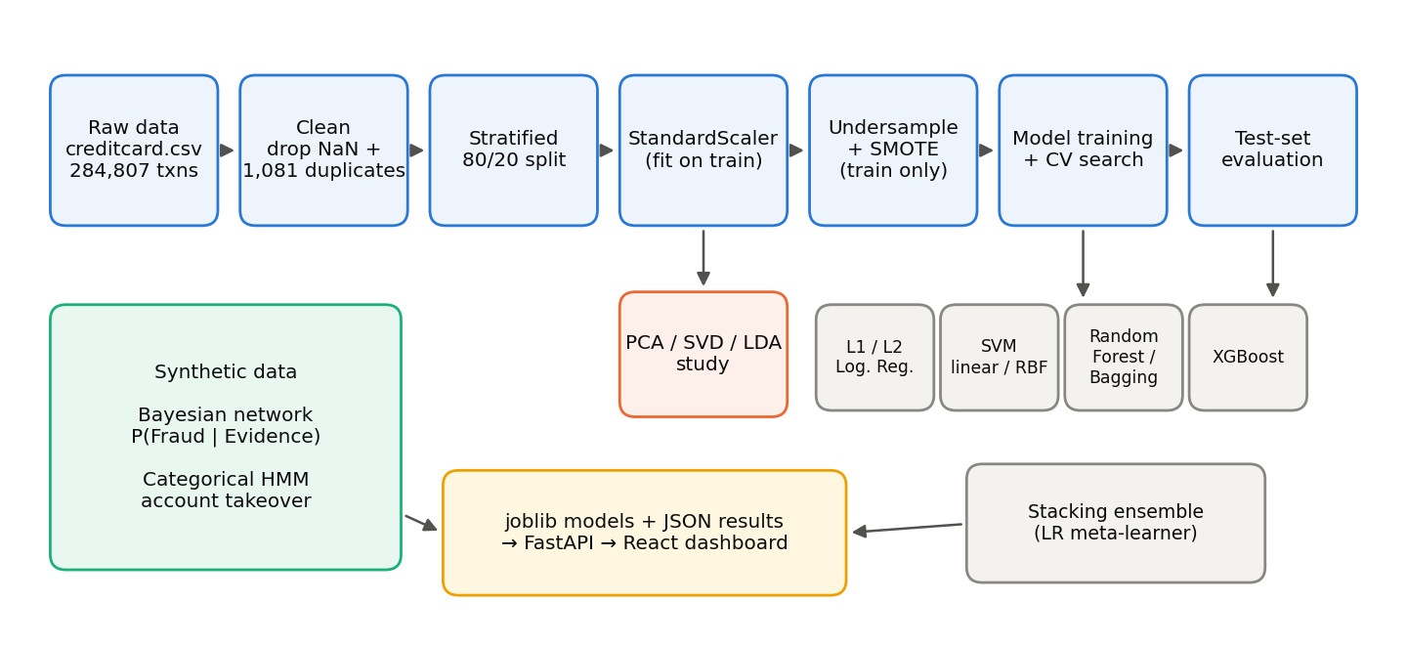
Fig. 1. End-to-end block diagram of the fraud and sequence-anomaly detection system.

3.2 Data and preprocessing pipeline
The dataset contains 284,807 transactions with Time, Amount, anonymised components V1–V28 and the binary label Class. Preprocessing proceeds strictly in this order: (1) drop missing values and the 1,081 exact duplicate rows, which could otherwise appear in both partitions; (2) stratified 80/20 split (random_state = 42), preserving the 0.17% fraud rate in a 56,746-row test set with 95 frauds; (3) standardisation fitted on training rows only (Eq. 1); (4) random undersampling of the majority class to 30,000 rows followed by SMOTE (Eq. 2) to a minority ratio of 0.5 — again on training data only (Table I). Undersampling first keeps SVM and stacking tractable while SMOTE adds minority diversity.
z = (x − μ_{train}) / σ_{train} (1)
x_{new} = x_{i} + λ (x_{zi} − x_{i}), λ ~ U(0, 1), x_{zi} ∈ kNN(x_{i}), k = 5 (2)
TABLE I Class distribution at each pipeline stage (resampling applied to training data)
Stage | Legitimate | Fraud | Fraud share
Original training set | 226,602 | 378 | 0.17%
After random undersampling | 30,000 | 378 | 1.24%
After SMOTE | 30,000 | 15,000 | 33.33%
Test set | 56,651 | 95 | 0.17%

3.3 Mathematical formulation of models
Regularised logistic regression minimises the penalised log-loss, where Ω(w) = ‖w‖₁ (L1, sparse) or ½‖w‖₂² (L2, shrinkage) and C is the inverse regularisation strength:
min_{w} −Σ_{i} [y_{i} log p_{i} + (1 − y_{i}) log(1 − p_{i})] + (1/C) Ω(w), p_{i} = σ(w^{T}x_{i} + b) (3)
Support vector machines solve the soft-margin problem with a linear or RBF kernel; probabilities are obtained by Platt (sigmoid) calibration [20]. SVR uses the ε-insensitive loss to predict log(1 + Amount) from V1–V28; it estimates transaction value, not financial loss:
min ½‖w‖² + C Σ_{i} ξ_{i} s.t. y_{i}(w^{T}φ(x_{i}) + b) ≥ 1 − ξ_{i}, K(x, x′) = exp(−γ‖x − x′‖²) (4)
SVR: min ½‖w‖² + C Σ_{i} (ξ_{i} + ξ_{i}*) s.t. |y_{i} − f(x_{i})| ≤ ε + ξ_{i}^{(*)} (5)
Dimensionality reduction. PCA finds orthogonal directions of maximal variance (top eigenvectors of the covariance Σ) [21]; truncated SVD factorises X ≈ U_{k}S_{k}V_{k}^{T} without centring; Fisher's LDA maximises between-class over within-class scatter [22], yielding at most c − 1 = 1 component for the binary fraud label:
PCA: max_{w} w^{T}Σw s.t. ‖w‖ = 1; LDA: J(w) = (w^{T}S_{B}w) / (w^{T}S_{W}w), k ≤ c − 1 = 1 (6)
Ensembles. Random Forest averages B de-correlated trees, p̂(x) = (1/B) Σ_{b} p_{b}(x) [5]. XGBoost fits additive trees f_{k} to minimise a regularised objective with leaf count T and leaf weights w [4]. Stacking feeds out-of-fold base-model probabilities into a logistic meta-learner [7]:
L = Σ_{i} l(y_{i}, ŷ_{i}) + Σ_{k} (γT_{k} + ½λ‖w_{k}‖²) (7)
p_{stack}(x) = σ(β₀ + Σ_{m} β_{m} p_{m}(x)) (8)
Bayesian belief network. Four binary indicators — LocationMatch (L), DeviceKnown (D), LargeTransaction (A) and UnusualTime (U) — are parents of Fraud (F). Conditional probability tables are learned with a BDeu prior (equivalent sample size 10), and queries are answered exactly by variable elimination, so unobserved variables are marginalised:
P(F | e) = P(F, e) / Σ_{f} P(f, e), P(F, L, D, A, U) = P(F | L, D, A, U) P(L) P(D) P(A) P(U) (9)
Hidden Markov model. Hidden states S = {SAFE, SUSPICIOUS, COMPROMISED} emit six observations (normal login, small purchase, large purchase, new device, new location, failed login). Parameters (π, A, B) are first estimated by supervised counting with Laplace smoothing, anchoring state semantics, then refined by Baum–Welch; the variant that decodes held-out sequences more accurately is kept. Viterbi decoding gives the state path, forward–backward gives posteriors γ_{t}, and the takeover risk r averages the last three posteriors:
δ_{t}(j) = max_{i} δ_{t−1}(i) a_{ij} b_{j}(o_{t}) (10)
r = max( (1/3) Σ_{t=T−2}^{T} γ_{t}(COMP), γ_{T}(COMP) ) (11)

3.4 Hyperparameter search strategy
All searches optimise average precision (PR-AUC) rather than accuracy and use stratified folds so every fold contains fraud. Exhaustive GridSearchCV is used for small, low-dimensional spaces (logistic regression, SVM); RandomizedSearchCV [18] samples 12 configurations from the six-dimensional XGBoost space, which is far cheaper than its 1,296-point grid. Because RBF-SVM training is super-linear, its grid search runs on a stratified 4,000-sample subset. Table II summarises the search outcomes; the near-perfect CV scores reflect the balanced resampled folds and are not comparable to test-set PR-AUC.
TABLE II Hyperparameter search configuration and selected parameters
Model | Search | CV | Candidates | Best parameters | CV PR-AUC
Logistic Regression | Grid | Strat. 5-fold | 10 | C=10, penalty=l2 | 0.9851
SVM (Linear kernel) | Grid | Strat. 3-fold | 3 | C=1 | 0.9852
SVM (RBF kernel) | Grid | Strat. 3-fold (4k) | 4 | C=10, gamma=scale | 0.9893
XGBoost | Randomized | Strat. 3-fold | 12 | subsample=1, n_estimators=300, min_child_weight=5, max_depth=8, learning_rate=0.2, colsample_bytree=0.8 | 0.9999

4. Implementation and Experiments

4.1 Environment and computational setup
Experiments ran on a Windows 11 laptop CPU (no GPU) with Python 3.13, scikit-learn 1.7.2 [15], imbalanced-learn 0.14.2 [16], XGBoost 3.4.1 [4], pgmpy 1.1.2 [17], hmmlearn 0.3.3, pandas 2.3 and NumPy 2.3. Library versions are pinned because serialised joblib models are version-sensitive. The serving layer uses FastAPI with Pydantic validation; the front end uses React 18, TypeScript, Tailwind CSS and Recharts. All randomness is seeded (random_state = 42); a full training run (all models, searches, SVR, Bayesian network and HMM) completes in about four minutes, and repeated runs reproduced identical metrics.

4.2 Experimental workflow
The code is organised as an installable ml package with one module per concern (preprocessing, dimensionality, imbalance, models, ensembles, bayesian, sequence, evaluation) orchestrated by python main.py train. Each classifier is saved as a Pipeline(scaler, model) so raw transactions can be scored directly, and a JSON model registry lets the API discover new models without code changes. Two engineering issues were found and fixed experimentally: liblinear's L1 solver stalled on the near-separable SMOTE data at C = 10, so the saga solver was adopted; and models trained with n_jobs = −1 spawned worker pools on every API request, so inference is forced single-threaded, reducing latency from over 9 s to about 0.15 s per transaction.

4.3 Model behaviour and feature importance
Fig. 2 shows ROC and precision–recall curves on the test set. All ROC curves crowd into the top-left corner (ROC-AUC 0.950–0.980), whereas the PR curves separate the models clearly, confirming that PR analysis is more informative under imbalance [12]. Fig. 3 shows that both tree ensembles rely chiefly on V14, with V10, V12, V17 and V4 next; XGBoost concentrates 62% of its gain on V14. The same components carry the largest standardised logistic-regression coefficients (V14: -1.41, V4: +1.34), so linear and non-linear models agree on the dominant fraud signals. Fig. 5(b) illustrates regularisation: L1 retains only 4 of 30 coefficients at C ≤ 0.001 and 20 at C = 0.01, while L2 never sets any coefficient exactly to zero.
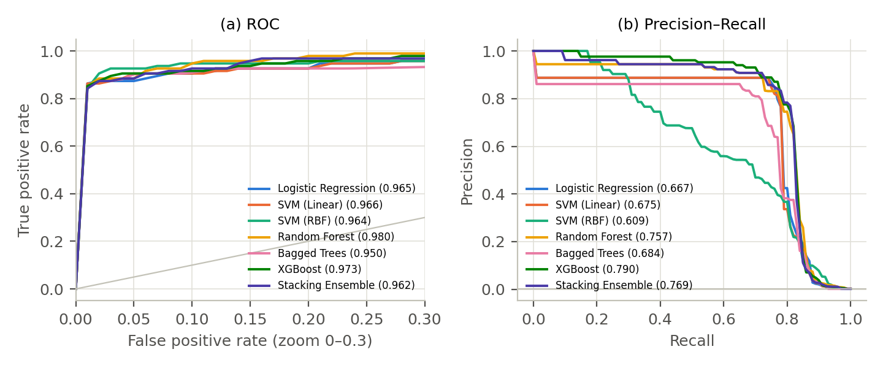
Fig. 2. Test-set ROC (zoomed to FPR ≤ 0.3) and precision–recall curves; AUC values in the legends.
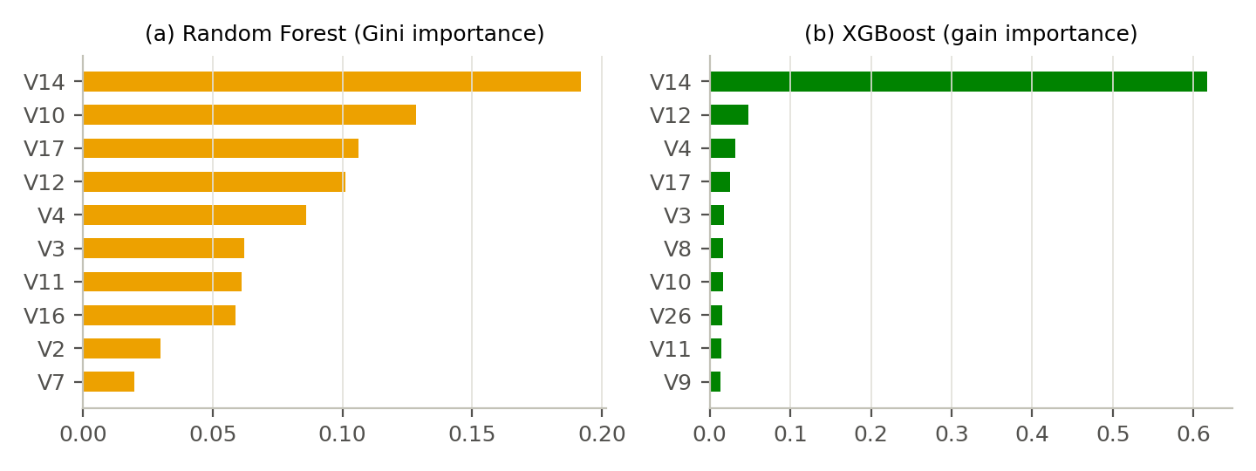
Fig. 3. Top-10 feature importances of the Random Forest and XGBoost models.

5. Results and Comparative Analysis

5.1 Classifier benchmark
Table III compares all classifiers on the 56,746-transaction test set at the default threshold τ = 0.5. Accuracy is reported only to illustrate its uselessness: every model exceeds 98.7%, yet F1 varies from 0.18 to 0.74. Random Forest achieves the best F1 (0.741) and ROC-AUC (0.980), XGBoost the best PR-AUC (0.790), and stacking provides the best precision–recall balance among the boosted models (F1 0.690). The linear and kernel models are strong rankers (ROC-AUC ≈ 0.965) but produce roughly 700 false positives each because SMOTE raised the training prior from 0.17% to 33%, shifting their probabilities upward [1].
TABLE III Test-set performance of all classifiers (τ = 0.5)
Model | Precision | Recall | F1 | ROC-AUC | PR-AUC | Accuracy | Train (s)
Logistic Regression | 0.108 | 0.874 | 0.193 | 0.965 | 0.667 | 0.988 | 5.6
SVM (Linear) | 0.104 | 0.863 | 0.185 | 0.966 | 0.675 | 0.987 | 0.5
SVM (RBF) | 0.101 | 0.863 | 0.181 | 0.964 | 0.609 | 0.987 | 2.1
Random Forest | 0.691 | 0.800 | 0.741 | 0.980 | 0.757 | 0.999 | 5.9
Bagged Trees | 0.374 | 0.800 | 0.510 | 0.950 | 0.684 | 0.997 | 11.2
XGBoost | 0.506 | 0.821 | 0.627 | 0.973 | 0.790 | 0.998 | 2.0
Stacking Ensemble | 0.595 | 0.821 | 0.690 | 0.962 | 0.769 | 0.999 | 41.2

5.2 Confusion matrices
Fig. 4 shows confusion matrices for four representative models. Logistic regression catches the most fraud (83 of 95) but raises 684 false alarms; Random Forest reduces false alarms twenty-fold to 34 at the cost of 19 missed frauds; XGBoost and stacking sit between them with 17 misses each.
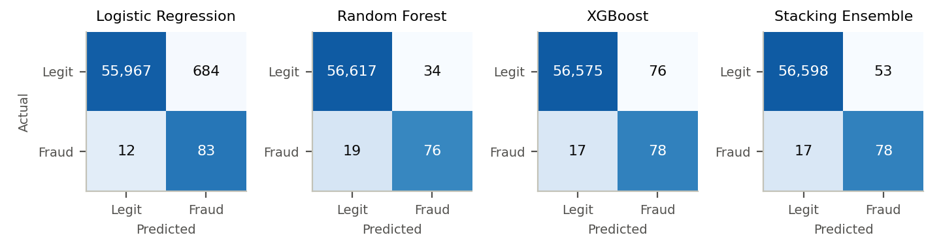
Fig. 4. Test-set confusion matrices (shading normalised within each actual class).

5.3 Dimensionality reduction
Table IV evaluates each reduced space with the same SMOTE + logistic-regression pipeline. Because V1–V28 are already decorrelated principal components, ten PCA or SVD components retain only ≈39% of the variance and discard discriminative low-variance directions, cutting PR-AUC from 0.686 to 0.311 and 0.232. Supervised LDA, constrained to a single component, matches the full 30-feature baseline (PR-AUC 0.696, F1 0.208), showing that one well-chosen discriminant axis captures nearly all linearly available signal.
TABLE IV Effect of dimensionality reduction (logistic regression, SMOTE on reduced data)
Method | Dims | Variance kept | Precision | Recall | F1 | ROC-AUC | PR-AUC
Baseline (all features) | 30 | 100.0% | 0.108 | 0.874 | 0.191 | 0.965 | 0.686
PCA | 10 | 39.5% | 0.062 | 0.726 | 0.114 | 0.910 | 0.311
SVD | 10 | 39.3% | 0.047 | 0.737 | 0.088 | 0.944 | 0.232
LDA | 1 | n/a (supervised) | 0.119 | 0.821 | 0.208 | 0.964 | 0.696

5.4 Threshold analysis and error analysis
Fig. 5(a) sweeps τ. Every model's F1 rises well above its τ = 0.5 value as τ increases, confirming that the default threshold is miscalibrated after SMOTE. At their F1-optimal thresholds, Random Forest reaches F1 0.807 (τ = 0.85), XGBoost 0.796, stacking 0.786 and even logistic regression 0.664. These thresholds were chosen on the test set and are therefore optimistic; in deployment τ must be tuned on a separate validation split according to the cost of false alarms versus missed fraud.
Error analysis (Random Forest). Of the 19 missed frauds, 11 received a probability below 0.1, i.e. the model was confidently wrong rather than marginally wrong. These cases are atypical: their mean V14 is -0.55, close to the legitimate mean (0.02) and far from detected frauds (-7.35), and their median amount is only €1.79 versus €24.71 for detected frauds — consistent with low-value "card-testing" transactions that mimic normal behaviour. Conversely, the 34 false positives have a higher median amount (€89.99). Behavioural context (device, location, sequence) is therefore needed to catch the residual fraud, which motivates the probabilistic models below.
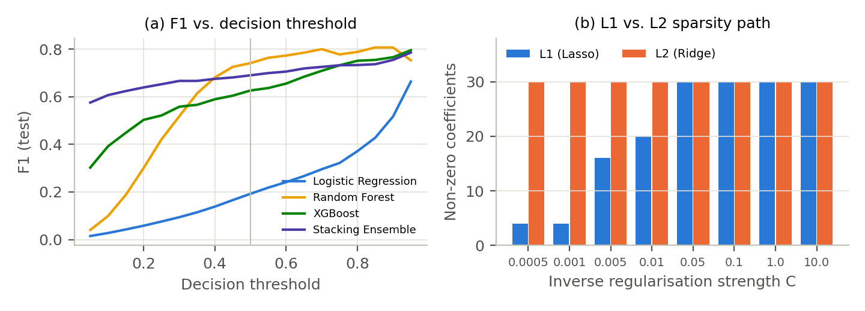
Fig. 5. (a) Test-set F1 as a function of the decision threshold; (b) non-zero coefficients for L1 vs. L2 logistic regression.

5.5 SVR transaction-amount prediction
The RBF SVR (C = 10, ε = 0.1, trained on 6,000 samples) explains 75% of the variance of log-amount (R² = 0.747) with a median absolute error of €9.13. On the raw euro scale R² is negative (-2.30) because a few very large amounts dominate the squared error and the log-target model under-predicts them. The SVR is thus useful as an "expected amount" reference for flagging unusual values, but it is not a financial-loss estimator.

5.6 Bayesian network and HMM
The Bayesian network, trained on 15,000 synthetic records, achieves ROC-AUC 0.866 on 5,000 held-out records. Table V lists conditional fraud probabilities for representative evidence: risk compounds non-linearly, from 0.8% for a typical purchase to 38.2% for an unknown device in a foreign location and 95.3% when all four indicators are risky (prior 4.8%). The HMM decodes hidden states with 88.0% accuracy and detects account takeover with precision 0.931, recall 0.985 and F1 0.957 across 225 test accounts. Its weakest state is SUSPICIOUS (recall 29.6%), which is brief and emits observations overlapping both neighbours; supervised estimation (88.0%) slightly outperformed Baum–Welch refinement (87.7%). Fig. 6 shows the posterior for one takeover sequence: compromise is flagged two events after the true onset.
TABLE V Bayesian-network conditional fraud probabilities and HMM summary
Evidence scenario / metric | Value
P(Fraud | typical purchase) | 0.8%
P(Fraud | large purchase at home) | 3.3%
P(Fraud | travelling customer) | 4.4%
P(Fraud | new phone, night-time) | 10.7%
P(Fraud | unknown device + foreign location) | 38.2%
P(Fraud | all risk signals) | 95.3%
HMM state accuracy (held-out accounts) | 88.0%
HMM takeover detection precision / recall / F1 | 0.931 / 0.985 / 0.957

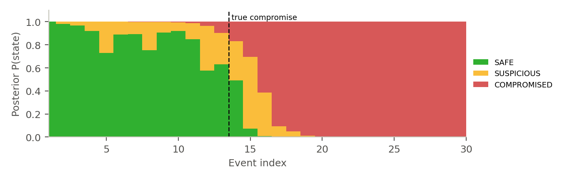
Fig. 6. HMM posterior state probabilities for a synthetic account-takeover sequence.

6. Conclusion and Future Scope
Insights. (1) Under a 0.17% positive rate, accuracy is uninformative and ROC-AUC flatters weak models; PR-AUC, F1 and confusion matrices expose the real trade-offs. (2) Tree ensembles dominate: Random Forest gives the best F1 (0.741) and XGBoost the best PR-AUC (0.790), while stacking offers a robust compromise. (3) SMOTE improves recall but shifts the probability scale, so the decision threshold must be re-tuned; with tuning, F1 approaches 0.80. (4) Re-applying PCA/SVD to already-PCA features is harmful, whereas one-component LDA preserves performance. (5) Contextual (Bayesian) and sequential (HMM) models capture fraud patterns that per-transaction classifiers miss, such as low-value card testing and account takeover.
Deployment considerations. Models are versioned artefacts loaded once at API start-up; library versions are pinned for safe deserialisation; inputs are validated and missing artefacts return explicit 503 errors. Production use additionally requires probability calibration to the true prior, threshold selection by business cost, latency budgets (currently about 0.15 s for seven models), drift monitoring with periodic retraining, and explanations (e.g., SHAP) for analysts and regulatory review.
Future research. Promising directions include cost-sensitive and focal-loss training instead of resampling; temporal validation and concept-drift adaptation [2]; graph neural networks over card–merchant–device graphs; learning Bayesian-network structure and HMM parameters from real labelled behavioural logs; fusing the three model families into a single calibrated risk score; and semi-supervised or active learning to exploit the large volume of unlabelled transactions.

References
[1] A. Dal Pozzolo, O. Caelen, R. A. Johnson, and G. Bontempi, "Calibrating probability with undersampling for unbalanced classification," in Proc. IEEE Symp. Ser. Comput. Intell. (SSCI), Cape Town, South Africa, 2015, pp. 159–166.
[2] A. Dal Pozzolo, G. Boracchi, O. Caelen, C. Alippi, and G. Bontempi, "Credit card fraud detection: A realistic modeling and a novel learning strategy," IEEE Trans. Neural Netw. Learn. Syst., vol. 29, no. 8, pp. 3784–3797, Aug. 2018.
[3] N. V. Chawla, K. W. Bowyer, L. O. Hall, and W. P. Kegelmeyer, "SMOTE: Synthetic minority over-sampling technique," J. Artif. Intell. Res., vol. 16, pp. 321–357, 2002.
[4] T. Chen and C. Guestrin, "XGBoost: A scalable tree boosting system," in Proc. 22nd ACM SIGKDD Int. Conf. Knowl. Discov. Data Mining, San Francisco, CA, USA, 2016, pp. 785–794.
[5] L. Breiman, "Random forests," Mach. Learn., vol. 45, no. 1, pp. 5–32, 2001.
[6] L. Breiman, "Bagging predictors," Mach. Learn., vol. 24, no. 2, pp. 123–140, 1996.
[7] D. H. Wolpert, "Stacked generalization," Neural Netw., vol. 5, no. 2, pp. 241–259, 1992.
[8] C. Cortes and V. Vapnik, "Support-vector networks," Mach. Learn., vol. 20, no. 3, pp. 273–297, 1995.
[9] R. Tibshirani, "Regression shrinkage and selection via the lasso," J. Roy. Statist. Soc. Ser. B, vol. 58, no. 1, pp. 267–288, 1996.
[10] L. R. Rabiner, "A tutorial on hidden Markov models and selected applications in speech recognition," Proc. IEEE, vol. 77, no. 2, pp. 257–286, Feb. 1989.
[11] J. Pearl, Probabilistic Reasoning in Intelligent Systems: Networks of Plausible Inference. San Mateo, CA, USA: Morgan Kaufmann, 1988.
[12] T. Saito and M. Rehmsmeier, "The precision-recall plot is more informative than the ROC plot when evaluating binary classifiers on imbalanced datasets," PLoS ONE, vol. 10, no. 3, Art. no. e0118432, 2015.
[13] A. Srivastava, A. Kundu, S. Sural, and A. K. Majumdar, "Credit card fraud detection using hidden Markov model," IEEE Trans. Dependable Secure Comput., vol. 5, no. 1, pp. 37–48, Jan.–Mar. 2008.
[14] S. Bhattacharyya, S. Jha, K. Tharakunnel, and J. C. Westland, "Data mining for credit card fraud: A comparative study," Decis. Support Syst., vol. 50, no. 3, pp. 602–613, Feb. 2011.
[15] F. Pedregosa et al., "Scikit-learn: Machine learning in Python," J. Mach. Learn. Res., vol. 12, pp. 2825–2830, 2011.
[16] G. Lemaître, F. Nogueira, and C. K. Aridas, "Imbalanced-learn: A Python toolbox to tackle the curse of imbalanced datasets in machine learning," J. Mach. Learn. Res., vol. 18, no. 17, pp. 1–5, 2017.
[17] A. Ankan and A. Panda, "pgmpy: Probabilistic graphical models using Python," in Proc. 14th Python Sci. Conf. (SciPy), Austin, TX, USA, 2015, pp. 6–11.
[18] J. Bergstra and Y. Bengio, "Random search for hyper-parameter optimization," J. Mach. Learn. Res., vol. 13, pp. 281–305, 2012.
[19] Machine Learning Group, Université Libre de Bruxelles, "Credit card fraud detection," Kaggle, 2018. [Online]. Available: https://www.kaggle.com/datasets/mlg-ulb/creditcardfraud
[20] J. C. Platt, "Probabilistic outputs for support vector machines and comparisons to regularized likelihood methods," in Advances in Large Margin Classifiers, A. J. Smola, P. Bartlett, B. Schölkopf, and D. Schuurmans, Eds. Cambridge, MA, USA: MIT Press, 1999, pp. 61–74.
[21] I. T. Jolliffe, Principal Component Analysis, 2nd ed. New York, NY, USA: Springer, 2002.
[22] R. A. Fisher, "The use of multiple measurements in taxonomic problems," Ann. Eugenics, vol. 7, no. 2, pp. 179–188, 1936.

