**Customer Segmentation using K-Means Clustering**

# Goal/Objective:

To cluster customers into the groups based on Age, Annual Income (k$) and Spending Score (1-100) using the K-Means Clustering.

**Process/task completion steps:**

## step-1. Problem Definition

Segment customers into groups for the targeted marketing strategies.

## step-2. Data Collection

Synthetic customer dataset with features Age, Annual Income and Spending Score.

## step-3. Data Preprocessing

I have Cleaned and encoded Gender and selected numerical features.

## step-4. Feature Selection

I have used: Age, Annual Income (k$), and Spending Score (1-100).

## step-5. Model Training (K-Means)

I applied the Elbow method to determine the optimal clusters and I then trained KMeans with k=5.

## step-6. Cluster Visualization

Generated 2D scatter plot and 3D PCA plot to visualize customer segments.

## step-7. Cluster Analysis

Interpreted each cluster based on spending and income patterns.

**Tools/Resources used:**

Jupyter notebook, python libraries,pandas, matplotlib, seaborn, scikit-learn, plotly.

**Value Proposition:**

This project demonstrates the power of unsupervised learning in marketing strategy. Businesses can use these segments for personalized promotions and efficient resource allocation.

Elbow Method

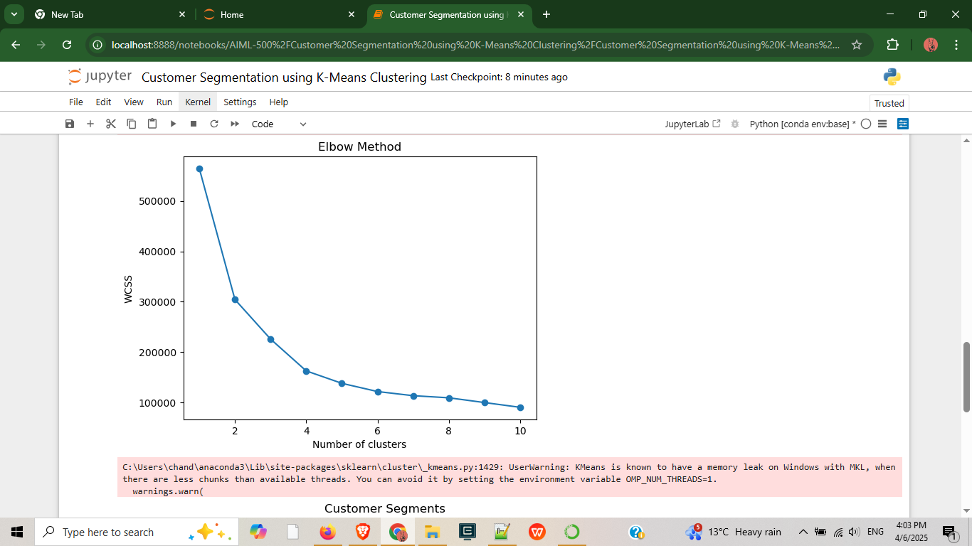

Customer Segments

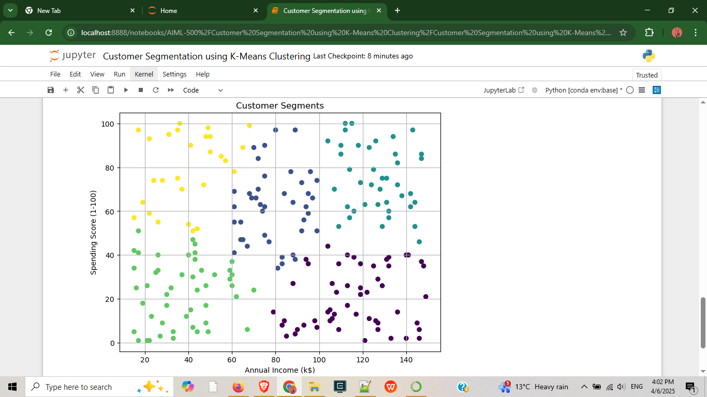

Cluster Centers and Cluster [i] sample customers

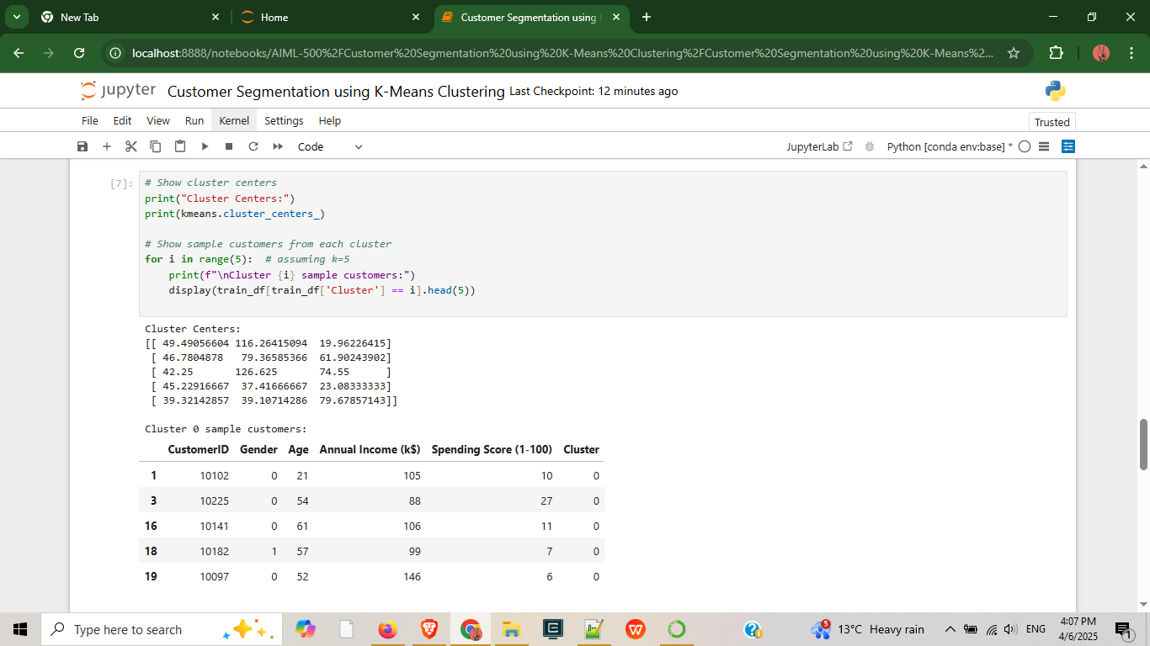

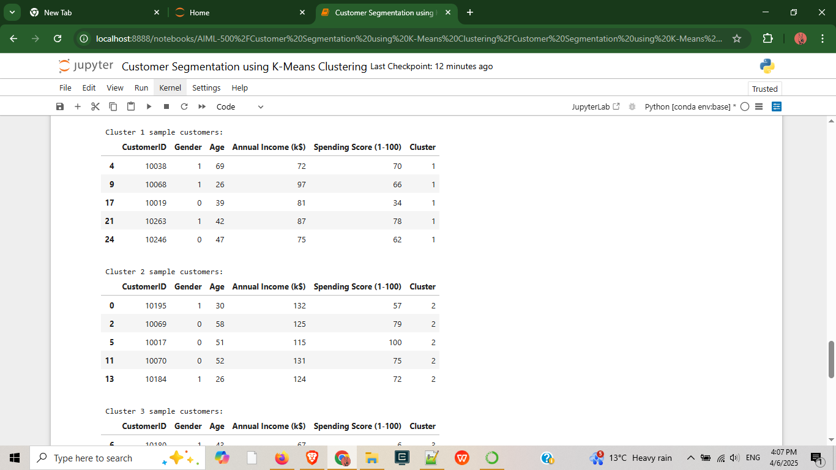

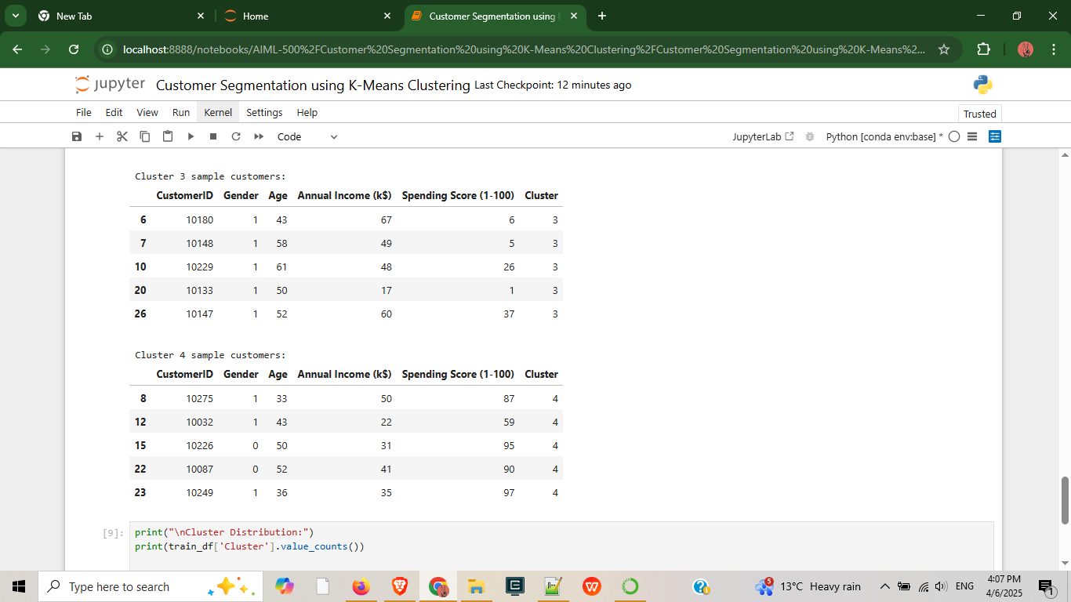

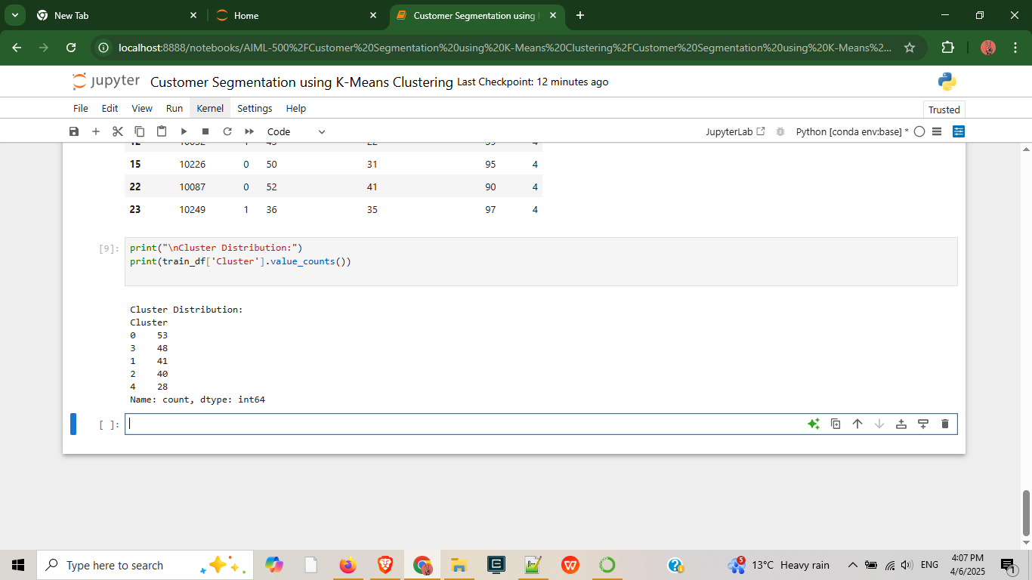

Customer Segments in 3D(PCA)

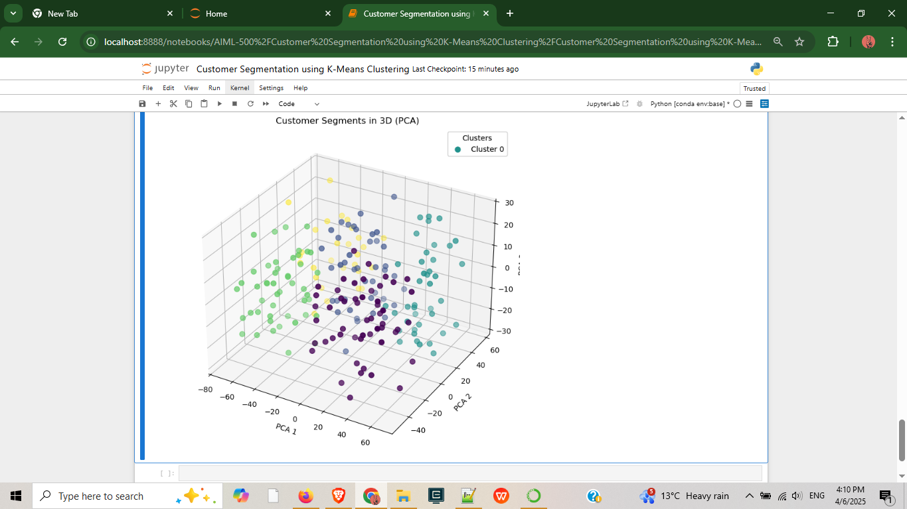

Customer Segments in 3D(PCA Interactive)

