|  |  |
| --- | --- |
| **Offer Fives Pillard n° undefined Quote 1** | |
| **Date** | |
|  | |
|  |  |
| **Project engineer**  Shreyash | |
| Vyas  854695512  undefined  shreyash.vyas@wahinnovations.com | |
| **Your ref. / Date** | |
| Your email dated | |
|  | |
| **N° VAT** | |
| FR 54 055 809 255 – 2821Z | |
| **Client** : undefined | |
|  | |

**Burlington Textiles Corp of America**

525 S. Lexington Ave

27215

Burlington

USA

Phone: (336) 222-7000

For the attention of:

Mr.

Dannie J.

Cooney

Phone:556481368

danniejcooney@armyspy.com

Quote 1

**OFFER FOR A BURNER TIPS IMPROVEMENT**

Further to your request, Fives Pillard is pleased to send you the present offer n° undefined to upgrade your firing equipment Fives Pillard n°10.44.1711.00.

Our After-Sales Service Department remains at your disposal to attend you to your operations and maintenance activities, to design and supply the best solution to meet your expectations.

Fives Pillard is a part of the Energy division of Fives Group.

**SUMMARY**

Chapter I. Technical proposal 3

1. Inlet data 3

1.1. Utilities 3

1.2. Plant conditions 3

2. Scope of supply 4

1.3. ONE (1) SET NOVAFLAM BURNER TIPS FOR SECIL MACEIRA’S NOVAFLAM BURNER INCLUDING: 4

1.4. ONE (1) SET OF STUDIES FOR BURNER TIPS UPGRADE TO INCREASE ASF SUBSTITUTION RATE 4

Chapter II. Commercial Proposal 5

1. Price 5

2. Terms of payment 5

3. Terms of delivery 5

4. Freight Prices 5

5. Validity of the proposal 5

6. COVID-19 and Ukraine crisis 6

7. Specific conditions applicable 6

8. Mechanical guarantee 6

9. Sanctions 6

10. Business ethics 6

11. Origin of Goods and Custom Rates 7

# Technical proposal

## Inlet data

### Utilities

#### Power supply

* For instruments 220V, 1 ph
* For motors 380V 3 ph
* Frequency 50 Hz
* For flame scanners and solenoid valves 24 VDC
* For analog signals 4-20 mA / 24 VDC
* Electrical component protection:
* Instruments IP 65
* Junction box IP 65
* Local box IP 65
* Control panel IP 55

#### Instrument air

* Stable pressure barg 5 to 9
* Temperature °C ambient
* Quality Dry, clean, oil free

#### Ignitor’s fuel

* Type Natural Gas
* Required pressure < 1.5 bar eff
* Required air flow (from cooling air fan) 50 nm3/h

### Plant conditions

* Atmosphere: Non aggressive
* Temperature °C 20 – 40 (to be confirmed)
* Humidity % 50 – 90 (to be confirmed)
* Type Outdoors
* Altitude masl 100 m

## Scope of supply

### ONE (1) SET NOVAFLAM BURNER TIPS FOR SECIL MACEIRA’S NOVAFLAM BURNER INCLUDING:

* + Axial air tip with ferrule, deflector and ring 02+14+21+26 (new design)
  + Air swirler with pipe end 22+12
  + Coal tip 08
  + Stabilizer 09
  + Blowing tip for ASF 09A

### ONE (1) SET OF STUDIES FOR BURNER TIPS UPGRADE TO INCREASE ASF SUBSTITUTION RATE

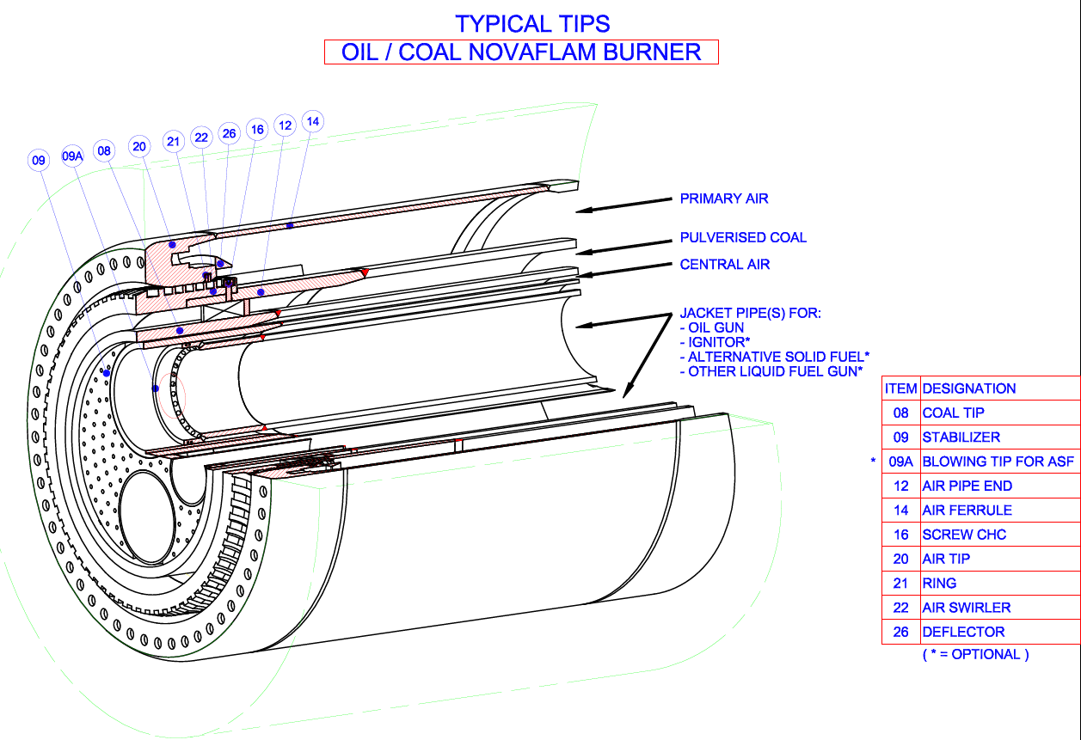

Note: As a rule, our supply does not include any works or spare parts not mentioned in the hereby proposal

# Commercial Proposal

## Price

|  |  |  |  |  |
| --- | --- | --- | --- | --- |
| **Item** | **Works designation** | **Price per unit**  **€ ex V.A.T.** | **Quantity** | **Total price**  **€ ex V.A.T.** |
| 1 | Axial air tip 02+14+21+26 | 11 470 | 1 | 11 470 |
| 2 | Air swirler 22+12 | 3 514.66 | 1 | 3 515 |
| 3 | Coal tip 08 | 4 985.33 | 1 | 4 985 |
| 4 | Stabilizer 09 | 1 495.33 | 1 | 1 495 |
| 5 | Blowing tip for ASF 09A | 1 495.33 | 1 | 1 495 |
| 6 | Studies for burner upgrade | 3 900 | 1 | 3 900 |
| 7 | Export packing | 170 | 1 | 170 |
|  |  |  |  |  |
|  | **Total price** | |  | **27 030 €** |

The prices quoted are fixed, based upon the full scope of supply in the proposal, for the duration of the contract, provided that we are in possession of an effective contract within the validity period stated in the price schedule. We reserve the right to review our price and deliveries in the event that the contract is not effective within this period.

## Terms of payment

100% of total price at 45 days date of invoice, by bank transfer

Currency is EURO

## Terms of delivery

Incoterms is Ex Works our workshop in Marseille.

The delivery time is 14 weeks from effective date of contract.

## Freight Prices

The price of the freight, if included in this offer, is based on the price estimated on the date of the of the offer plus 15% of administrative costs. Due to the current strong volatility in the international freight prices, the price cannot be guaranteed. In case of order confirmation, Fives Pillard reserves the right to modify the price of the transport before and during the execution of the purchase order.

## Validity of the proposal

This quotation, its conditions and prices, remain valid for two (2) calendar weeks from the offer date. Options remain valid for two (2) calendar weeks after date of Contract effectiveness. Any revision of this quotation cancels and replaces the former one.

Prices are valid for the duration of the contract execution at the condition that the Effectiveness (refer to paragraph 5.5) occurs within six (6) weeks from receipt by Client of the necessary invoice and related documents. Should the Effectiveness date of the Contract be delayed for reasons not attributable to Fives Pillard, Fives Pillard shall be entitled to revise, in good faith, the Contract Price and delivery time.

## COVID-19 and Ukraine crisis

The performance of the Supplier’s obligations under this Contract may be adversely impacted by circumstances related to (i) the coronavirus Covid-19 and/or (ii) the Ukrainian crisis and the related international situation, such as shortage of electrical components and raw materials and/or prices volatility of electrical components and raw materials and/or transportation issues and/or sanctions, restrictions or lockdowns issued by any national/international public authorities. In such circumstances, the Parties already agree that (i) the Supplier shall not be in default of performing its obligations under this Contract and (ii) the time schedule and the Contract Price shall be updated by the Supplier in order to take into account all the consequences of the abovementioned adverse impact.

## Specific conditions applicable

Orgalime S-2012 in annex

## Mechanical guarantee

Such a guarantee is limited to the sending of replacement parts to the Client, further to the receipt by FIVES PILLARD of the defective parts returned by the Client which have a defect making them improper for the use to which they were intended, as defined by the part manufacturer, and which must be respected by the Client.

Such a guarantee does not apply in the case of a defect which is the result of abnormal use, or mishandling, or not following maintenance or running instructions, with regards to professional codes of practice.

Such a guarantee expressly excludes:

* Any site services for dismantling or fitting of parts or costs concerning any necessary shutdowns which are and remain at the Client’s expense.
* Any guarantee concerning the sub-assembly or set or complete plant to which the spare parts are fitted, excluding in particular any guarantee of result.

Such a guarantee applies for one calendar year from the date of ex-works availability at the FIVES PILLARD warehouse (or FIVES PILLARD’s subcontractor) for the parts sold.

## Sanctions

In the event that any law or regulation (i) becomes effective, enacted or otherwise applicable and (ii) restricts the ability of Fives Pillard or any of its affiliated companies to do business in the Buyer’s country and/or exposes the Buyer, the End-user and any of its shareholders, directors, and/or officers or any of its affiliated companies to sanctions, prohibitions, restrictions or other adverse measures in any countries (“Sanctions”), Fives Pillard reserves the right to suspend the execution of the contract until the Sanctions are lifted or cancelled or allow the execution of the contract to resume. This condition is at the discretion of Fives Pillard. All the Goods will remain the property of Fives Pillard during the suspension. Fives Pillard shall store the Goods at the Buyer's expense and risk.

Upon the resumption of the Contract (this condition remains at the discretion of Fives Pillard), the Buyer and Fives Pillard shall discuss the possible costs and the resulting new delivery schedule.

## Business ethics

The Buyer undertakes to perform its activities under all circumstances by strictly complying with the laws, rules and regulations of all natures that are applicable in the country of the Seller or in the country of domicile of the Buyer.

The Buyer expressly undertakes to abide by and adhere without reservations to the legal provisions against corruption in accordance with the OECD Anti-Bribery Convention of 1997 against Corruption (UNCAC) of 2003, the French law on transparency, the fight against corruption and the modernization of economic life.

Furthermore, the Buyer certifies that no direct or indirect payment has been promised, done or shall be done, either directly by the Customer or indirectly through a third party, on its own behalf, on behalf of its seller or of the Seller, to any person of public authority, in charge of a public service or invested with an elected public office, to any political party or candidate to an elected office, or to any seller or person, including all employees, officers, directors or representatives of the Buyer or the Seller, if such payments serve to obtain from these persons that they accomplish or refrain from accomplishing an act, in violation of the laws applicable in the country of domicile of the Buyer or of the Seller, or in violation of any other applicable law or regulation.

It is understood that no payment shall be made with the intention or the effect of public or private corruption.

The Buyer shall report to the Seller without delay any requests for bribes from any officials or individuals in the any territory or otherwise regarding or related to the Products.

The breach of any of the provisions of this Article or of any applicable anti-bribery law is a material breach under the agreement between the Buyer and the Seller and, is without prejudice to any other right, relief or remedy, entitles the Seller to terminate this agreement immediately.

## Origin of Goods and Custom Rates

Origin: Europe

Custom rates: 84.16.9000

**Shreyash Vyas T. AUTRAN**

Sales Rep Head of Service Sales department

Appendix: Orgalime S 2012