

W Booth School of Engineering Practice and Technology - McMaster University

Senior Engineer Project - SFWRTECH 4FD3

**Design Document**



**Flashminder**

*(An Assistive Learning tool for building long term memory)*

Supervised by

**Dr. Seshasai Srinivasan**

Submitted by

**Chandra Rai (400351588)**

**Emily Goodwin (400352097)**

**Stefan Slehta (400291135)**

**Violet Huang (400348357)**

Winter 2022

**TABLE OF CONTENTS**

**1.** **Executive Summary** 2

**2.** **Business Objectives** 2

2.1 BUSINESS OPPORTUNITY 2

2.2 PRODUCT SOLUTION 2

2.3 DELIVERABLES 3

**3.** **Project Description** 3

3.1 SCOPE 3

3.2 SYSTEM OUTLINE 4

3.3 USERS 4

3.5 USE CASES 4

3.6 USE CASE DIAGRAMS 5

3.7 SAMPLE OF BRIEF USE CASE DESCRIPTION 7

3.8 DATABSE SCHEMA DESIGN 8

3.9 HIGH LEVEL ARCHITECTURAL OVERVIEW 9

**4.** **Completion Criteria** 9

**5.** **Validation Strategy** 10

**6.** **Ethics and sustainability considerations** 11

**7.** **Proposed Timeline** 11

## **Executive Summary**

*Flashminder* is a unique end-to-end solution to a problem of retaining information in the long term. With its web solution accessible from anywhere, and cross platform mobile solution for Android and iOS devices, *Flashminder* will provide a highly customizable online and offline solution using proven methodologies and algorithms based on research around memory retention to cater to everyone’s learning needs.

## **Business Objectives**

### BUSINESS OPPORTUNITY

With ever-growing student population at an estimated 739 million pupils in primary[1] , over 601 million in secondary[2] schools, as well as over 220 million[3] students in higher education, the TAM (Total addressable market) for an application to assist people in learning is extremely large. While students might be the primary target audience, this application is suitable for anyone who wants to improve their information retention and recall.

### 2.2 PRODUCT SOLUTION

*Flashminder* will allow users to utilize the spaced repetition SM-2 Algorithm which quizzes users on their knowledge at timed intervals. Users will be able to enter their own questions and answers that the application will later quiz them on. The product will then notify the user at various times to answer questions chosen based on the SM-2 Algorithm. The principle is simple, if the user remembers the information correctly, then it is shown to the user over a longer interval, and if the user cannot remember the information, then they are reminded of it again, in a shorter interval.

The software has several features, including a backend with user profiles, information that the user can add, remove, edit, and categorize their settings on the spaced repetition, and an effective UI (User Interface) for editing the collected information. It will maintain correct status of user learning experience such as study area of interests, level of difficulty, priority etc. thereby improving learning pace and making quality experience. A part of the software is also a cross-platform (Android / iOS) mobile application that synchronizes the database of information and allows users to practice both online and offline, even when they are not near a computer.

### 2.3 DELIVERABLES

* Web application
* Android application
* iOS application

## **Project Description**

### 3.1 SCOPE

The scope of this project *includes*:

* Development, testing and deployment of the web application product
* Development, testing and deployment of the Android application compatible with android 5 (KitKat) (97% market share) and up, to the Google Play store
* Development, testing and deployment of the iOS application compatible with iOS 14+ (98% market share) to the Apple App Store

However, due to the constraints of various factors, the scope of the product *does not include:*

* The functionalities such as Print, Share quizzes in social media
* The implementation of Multiple languages and Language Translation features
* Covering hosting or deployment of app in public domain at this moment
* Ongoing technical support

### 3.2 SYSTEM OUTLINE

The system shall cover user verification and authentication, and processes described in product solution section.

### 3.3 USERS

The following are the end-users of the systems:

* Student
* Business Analyst
* System Administrator

### 3.5 USE CASES

|  |  |  |
| --- | --- | --- |
| No. | Goal Use Case | User’s role/ Actor |
| 1. | Sign up account | Student, Administrator |
| 2. | Sign in account | Student, Administrator |
| 3. | Set privileges | Administrator |
| 4. | View account | Student, Administrator |
| 5. | Update account | Student, Administrator |
| 6. | Delete account | Student, Administrator |
| 7. | Create flashcard | Student, Administrator |
| 8. | View flashcard | Student, Administrator |
| 9. | Update flashcard | Student, Administrator |
| 10. | Delete flashcard | Student, Administrator |
| 11. | View quiz | Student, Administrator |
| 12. | Rate quiz | Student, Administrator |

*(Table 1)*

### USE CASE DIAGRAMS

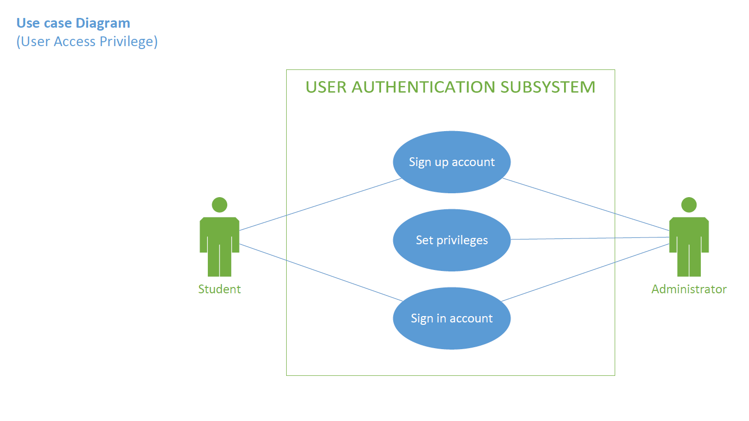

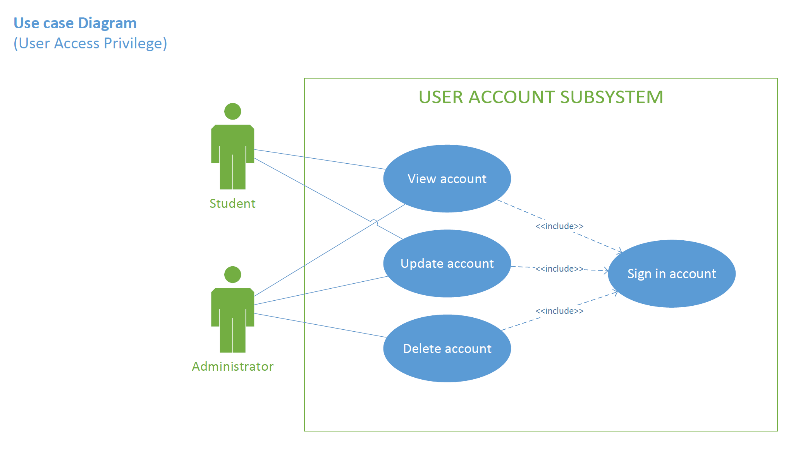

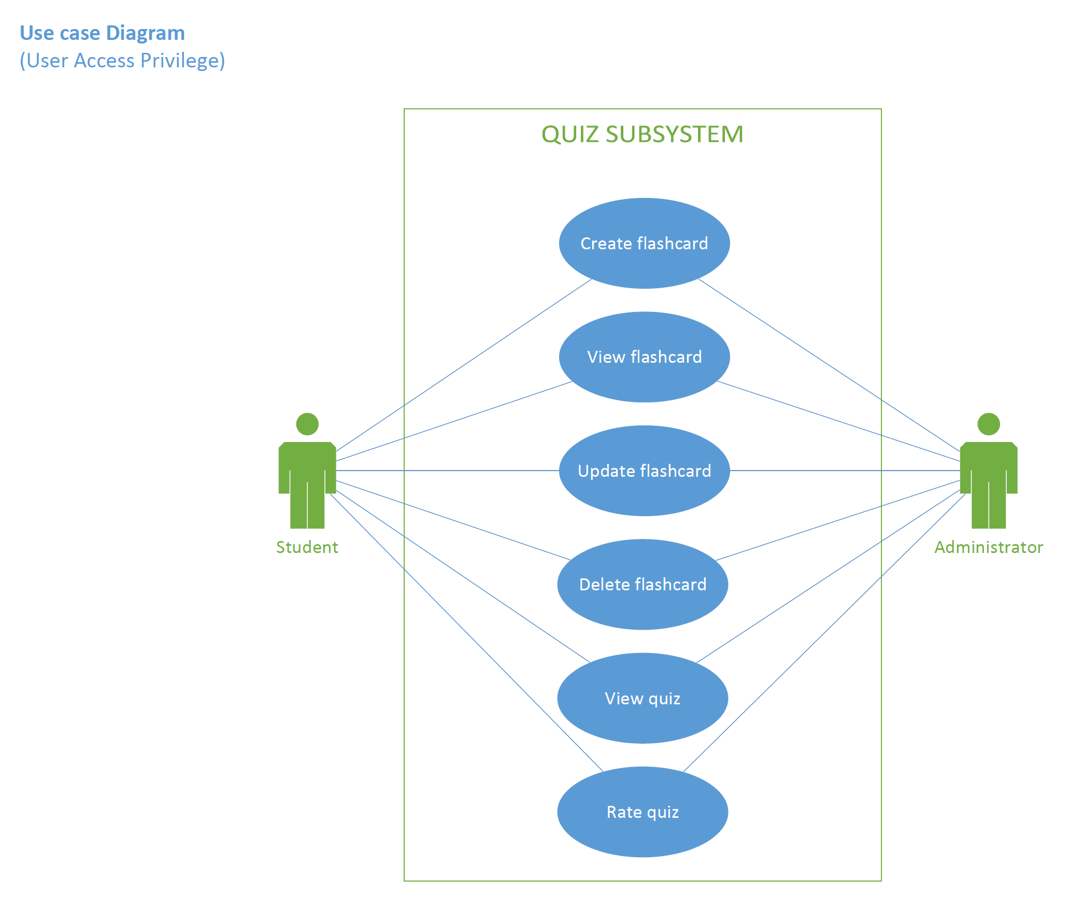

### SAMPLE OF BRIEF USE CASE DESCRIPTION

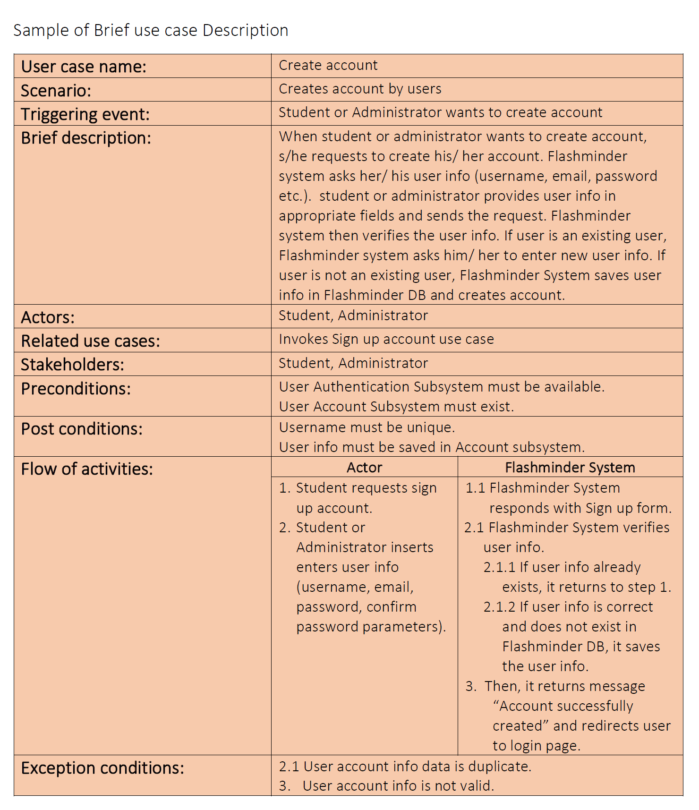

### DATABSE SCHEMA DESIGN

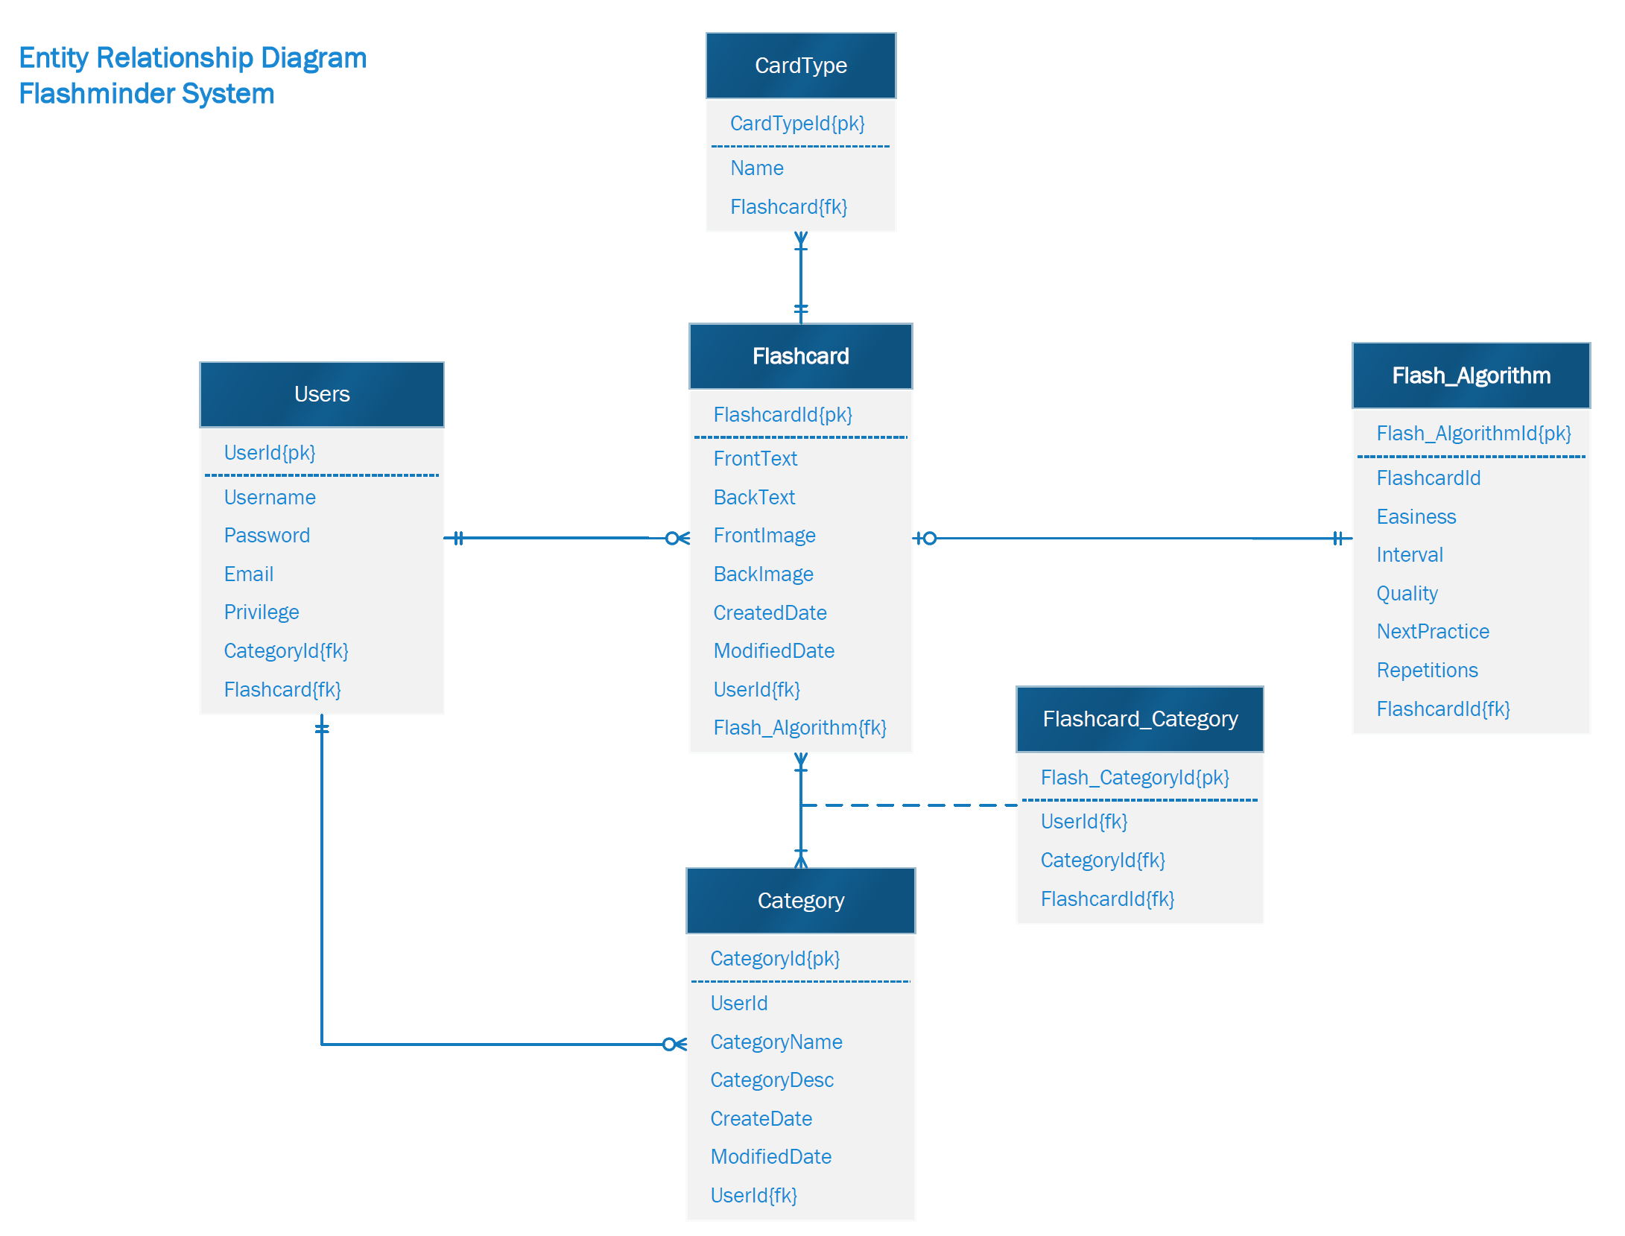

### HIGH LEVEL ARCHITECTURAL OVERVIEW

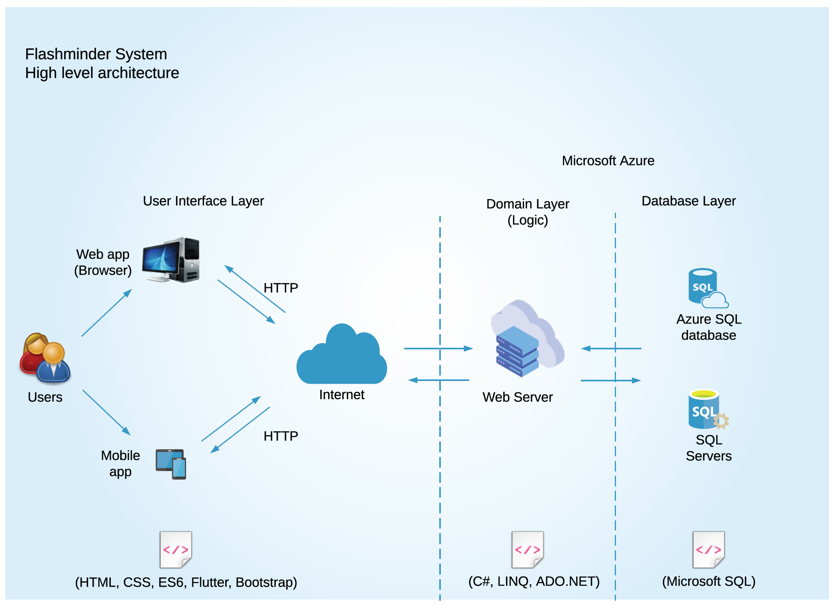

## **Completion Criteria**

The following are the task specific completion criteria.

|  |  |  |  |
| --- | --- | --- | --- |
| Activity List | | | |
| Task No. | Task Name | Dependency | Completion Criteria |
| 101 | User Stories/ requirements gathering | - | User requirements document is complete, reviewed and signed off by each team member, and is ready for Project Specification |
| 102 | Prepare Project Specification Document | 101 | Project specification document is complete, reviewed and signed off by each team member, and is ready for designing System architecture |
| 103 | Design System Overview | 102 | System architecture is complete, reviewed and signed off by each team member and ready for building prototypes |
| 104 | Prepare Test Plan | 103 | Test Plan document with detailed strategy is complete, reviewed and signed off by each team member |
| 105 | Build Prototypes – Web/Android/iOS | 101, 102, 103 | All products are ready for testing |
| 106 | Validation | 104, 105 | 100% Test coverage is achieved, Not known serious defect |

*(Table 2)*

The project is considered done upon successful delivery of the products - Web, Android, and iOS applications.

## **Validation Strategy**

The project will be done in Agile management model. There will be enough communication and individual interactions to understand user requirements and meet their needs. The project tasks will be divided into reasonable sprints and completed iteratively. The project team will perform unit tests, integration tests, and system tests at various points of development. Documentation will be looked over by each member of the group and signed off by each member over communication channel. The Beta version will be tested by peers and other individuals in our targeted demographic collaboratively to validate it to meet user requirements, standards, and needs. The project team will gather user feedback timely and will improve the user experience based on those relevant feedbacks.

### 

## **Ethics and sustainability considerations**

The project is oriented around everyone's user’s learning pathway, focusing on information they do not readily remember or understand. The project will:

* not exclude any user group of age, gender, race, and community.
* not require and be storing any private and critical information of its users (i.e., date of birth, license no. etc.) in order to avoid invasion of privacy.
* not allow any unauthorized access to the system for security.
* provide software accuracy developing appropriate test conditions, performing thorough system validation and verification, and documenting assumptions (if team is aware of them).
* follow best engineering and technological practices to minimize carbon footprints and support for ethical and environmental sustainability.

### 

## **Proposed Timeline**

The following is the project execution plan including validation strategies and the allotment of time.

|  |  |  |
| --- | --- | --- |
| No. | Activity | Week |
| 1. | User Stories/ requirements gathering | 2 |
| 2. | Project Specification Document | 3 |
| 3. | System Overview and Design | 4 |
| 4. | Test Plan | 5 |
| 5. | Build Prototypes – Web/Android/iOS | 6, 7, 8, 9 |
| 6. | Product Testing | 10, 11 |
| 7. | Final Product | 12 |

*(Table 3)*

*Project Approval*

____________________ ____________________

Signature Date

1. https://www.statista.com/statistics/1227106/number-of-pupils-in-primary-education-worldwide/
2. https://www.statista.com/statistics/1227098/number-of-pupils-in-secondary-education-worldwide/
3. https://www.worldbank.org/en/topic/tertiaryeducation#1