**BovControl Utility Report**

This report is the short description of the milk price prediction utility.

**Input**:

Simulated Farmers data, Nestle Stock Data, Danone Stock Data, Class III milk futures data.

**Output**:

Class III milk price prediction

**Problem Design:**

I have made a utility that can help farmers manage and mitigate their risk and maximize their profits when selling their milk.

If (predicted class III milk price for next month) > (class III milk future quote)

1. Famers can take advantage of this higher price and sell their milk at the higher price by not going short on class III milk futures. **OR**
2. Farmers can still play safe and purchase PUT options for that month.

Else (predicted class III milk price for next month) < (class III milk future quote)

1. Farmers should sell next month class III milk futures (i.e. go short on class III milk futures) **OR**
2. Farmers can purchase PUT options.

**Architecture:**

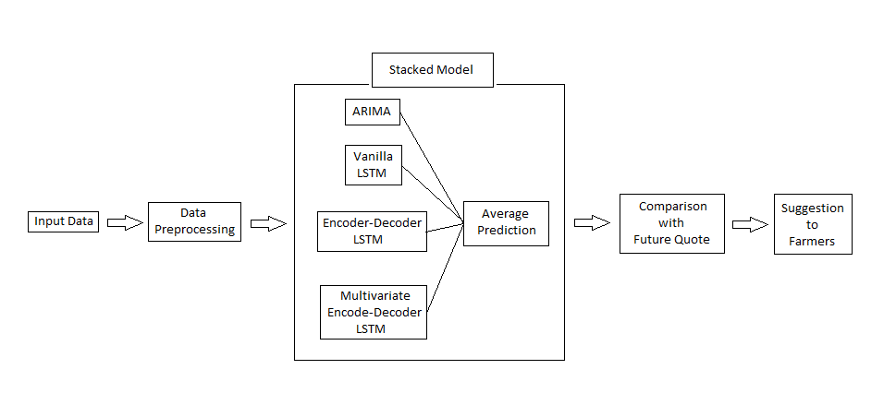

Figure 1

As depicted in Figure 1, the utility preprocesses the data and sends it to multiple models. Then each model predicts the price for the milk and final prediction is calculated by averaging these individual predictions. Later the utility compares it with Future Quote price and consults farmers in how they can manage the risk and take maximize their profits.

**Future scope:**

There are a lot of ways that will improve this utility further.

1. Make it more presentable.
2. Make it more accurate. (model tuning)
3. Make it more generalize. (for other products apart from class III milk.)
4. Include more facilities e.g. Include premium and comment on whether Options contract is beneficial, or Futures contract is beneficial based on the prediction.