IoT PROJECT REPORT

SUBJECT TITLE : INTERNET OF THINGS
SUBJECT CODE: 15IT422E
SUBMITTED TO: Dr. Kayalvizhi Jayavel

COLLISION DETECTION SYSTEM by DISTANCE CALCULATION

- CHANDRAHAS REDDY
RA1611008010265

LINKS TO GITHUB AND YOUTUBE:

YouTube:
https://youtu.be/IkOK3-FL3IA
Github:
https://github.com/Chandrahas03/Distance-calculation-with-HR-SC-04

ACKNOWLEDGEMENT

I would like to express my sincere gratitude to our IoT Faculty Dr. Kayalvizhi Jayavel for being out there at every step of my course and guiding us all along the way to be capable of moldings our ideas into smart projects and helping us enhance our skills.
I would also like to thank my parents, without whom I wouldn’t be able to anything in any regard.

ABSTRACT

HARDWARE REQUIRED:
- Nodemcu ESP8266 module.
- Arduino Uno
- Ultrasonic sensor HR-SC-04
- Jumper Wires
- Breadboard
- A Smartphone
- A Computer.
- Micro USB cable

SOFTWARE REQUIRED :
- Arduino IDE.
- ESP8266 library.
- Google Firebase connectivity
MISCELLANEOUS:
- WiFi Internet Connection

TOTAL COST OF COMPONENTS :- Rs.900 - Rs.1000.
Node MCU ESP8266- Rs.380
HR-SC-04 = 220
Arduino UNO = 450
Jumper wires- Rs.20

SYSTEM OVERVIEW

Ultrasonic Sensor detect the obstacle and calculate the distance between them. For that we used HR-SC-04 the range for this sensor is 2cm to 80cm with an accuracy of 3mm and measuring angle covered is less than 15 degrees having the Operating Frequency of 40HZ.
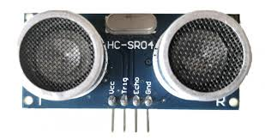

NodeMCU ESP8266 is a Micro Controller unit that have an inbuilt WIFI module. In this model we used this micro controller so that to make a connectivity of WIFI to transfer and retrieve the data from the cloud. Here we use the google firebase cloud services to store the real-time data i.e., it shows the distance that calculated by the Ultrasonic Sensor.
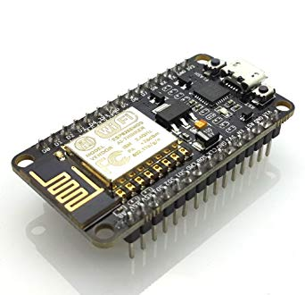

Circuit diagrams:
Circuit for NodeMCU and HC-SR04

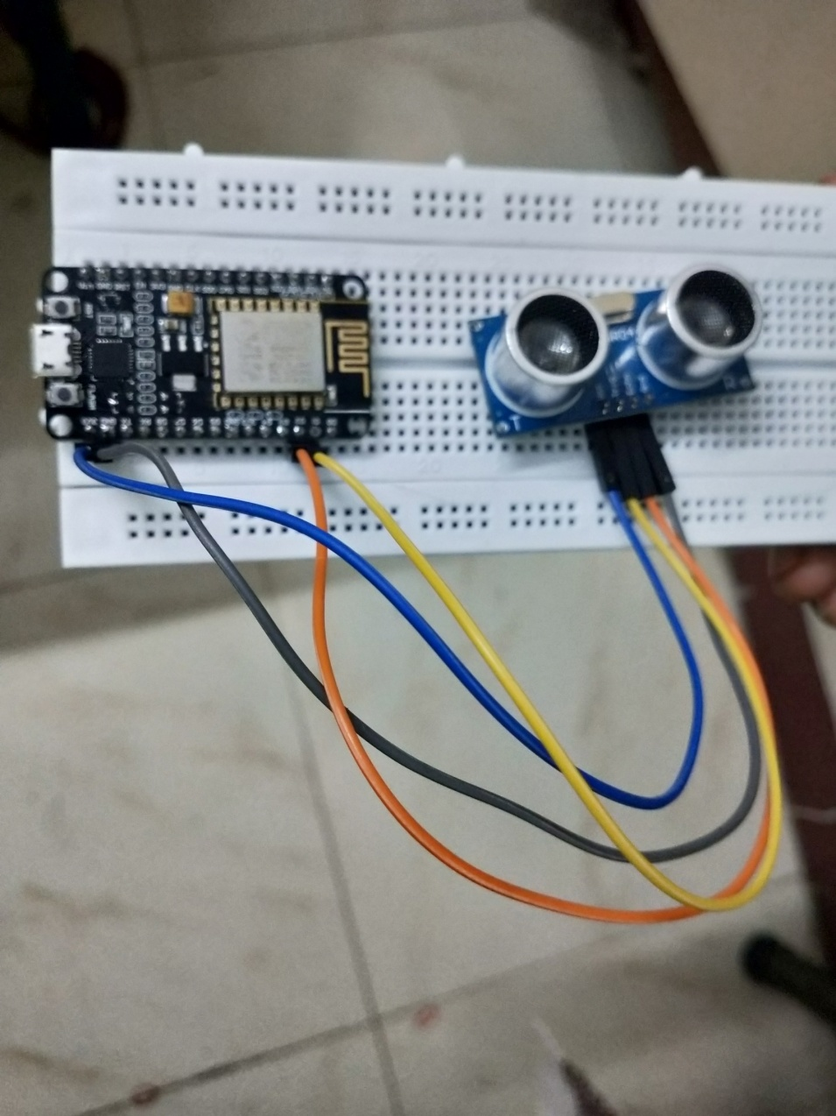

Programming NodeMCU and setting up ThingSpeak Dashboard :

- Make all the necessary circuit connections.
- Import ESP8266WiFi.h Library to the Arduino IDE
- Create an account in google firebase and start a project set the details and save the firebase authentication and firebase host.
- Upload the HC-SR04 code into your NodeMCU.
- Setup your firebase console realtime database.
- Run your code in aurdino ide.
- Once the code is running open COM3 port where all your readings are shown.
- These readings are reflected on firebase database and the same results are in the serial monitor.

CODE
Ultrasonic Sensor
#define TRIGGER 5
#define ECHO 4
#include <ESP8266WiFi.h>
#include <FirebaseArduino.h>
// Set these to run example.
#define FIREBASE_HOST "speedy-nodemcu.firebaseio.com"
#define FIREBASE_AUTH "A1Az2TkGnSyTjHxK7EPTEYZRNi4nPE3L1yCtnamA"
#define WIFI_SSID "chandrahass"
#define WIFI_PASSWORD "micromax"

void setup() {
Serial.begin(9600);

// connect to wifi.
WiFi.begin(WIFI_SSID, WIFI_PASSWORD);
Serial.print("connecting");
while (WiFi.status() != WL_CONNECTED) {
Serial.print(".");
delay(500);
}
Serial.println();
Serial.print("connected: ");
Serial.println(WiFi.localIP());
Firebase.begin(FIREBASE_HOST, FIREBASE_AUTH);
pinMode(TRIGGER, OUTPUT);
pinMode(ECHO, INPUT);
pinMode(BUILTIN_LED, OUTPUT);
}
void loop() {
long duration, distance;
digitalWrite(TRIGGER, LOW);
delayMicroseconds(2);
digitalWrite(TRIGGER, HIGH);
delayMicroseconds(10);
digitalWrite(TRIGGER, LOW);
duration = pulseIn(ECHO, HIGH);
distance = (duration/2) / 29.1;
Serial.print(distance);
Serial.println("Centimeter:");
Firebase.setInt("Distance",distance);
delay(1000);
}

Connection for NodeMCU and HC-SR04
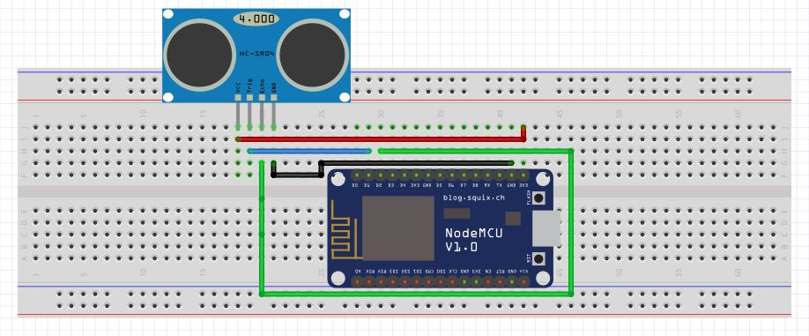
Connecton for NodeMCU and HC-SR04 with Arduino UNO
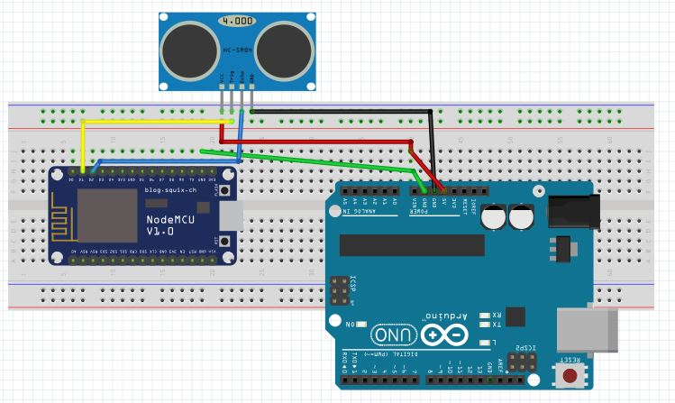

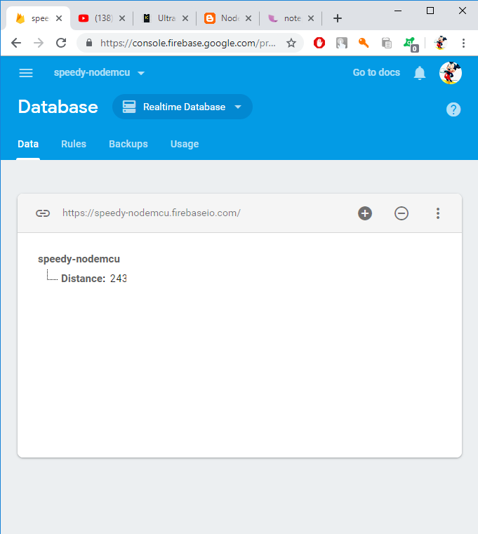

Result :
Collision detection by calculating the distance using the NodeMCU and with the help of Arduin UNO is successfully implemented. The connectivity to google firebase is been set to take the result from the mcu into the cloud database.

