Solution Design Document

**PruCabs Rental Services**

Version: 1.00

Updated: 30/11/2022

Author: Chandrajeet Yadav

# Introduction

* PruCabs Rental Services is a new venture that is going to start offering affordable car rental services in Bangalore city.
* The company will be offering luxury and premium luxury cars to the customers with a seamless experience at the beginning.

# Requirement Details

* Implement APIs to avail car booking service.
* Implement appropriate guard rails wherever necessary.
* Car inventory consists of 4 (2 x 2) cars.

# Assumptions and Prerequisites

* User registration is not required to book a car.
* User can book a car for one day or multiple days.
* The rental prices will be charged per hour basis.
* User has to pay for the fuel charges i.e. fuel charges is not included in the rental price.
* Caching is not considered as we are dealing with a very small set of data.
* Advance Booking can be made within 30 days from current date.
* Booking can be made for at max 30 days.

# [High-Level Design](https://softwaredominos.com/home/software-design-development-articles/high-level-solution-design-documents-what-is-it-and-when-do-you-need-one/)

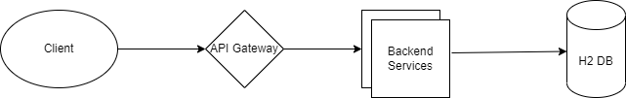

# Impact Analysis

* The user will not be able to avail the car services if all the cars are booked and they will be notified the same.
* Users will be impacted if the APIs are down or experiencing infrastructure issue.

# Out-of-scope

* User registration service
* Real time payment services
* Inventory management