Creating the Container by using Service

* First launch the instance
* Install the docker in the instance and start the docker service.
* Now create the index file
* Now we create the images we should have a Docker file using vi Docker file. “D must be in capital letter”.

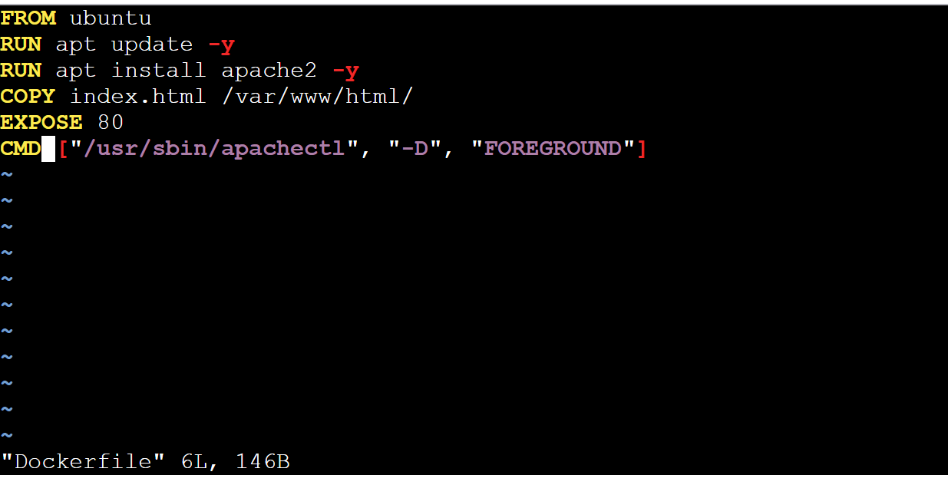

Now Create the Image using docker build -t image name .

Tag the Image:

* Before creating the tag first, we have to create the repository in Docker Hub.
* To create the tag we must use command called {docker tag image1 username/repository name}.

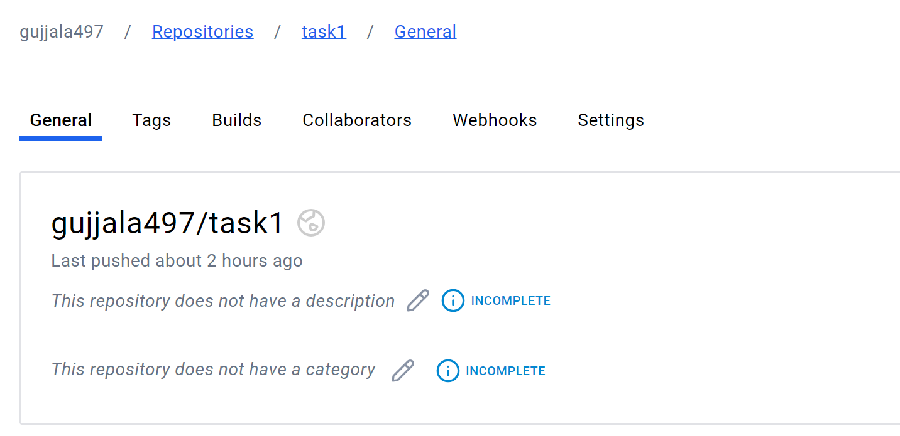

* Here you will get the tag of the image in the form of username/repository name.
* Before pushing you must log the docker hub using docker login.
* Username: your docker username
* Password: your docker password

Push the image to docker hub:

By using the tag we are pushing the image to Docker hub.

Docker push username/repository name {docker push username/repository name}



Create the Node:

To create Node we have the use the command called {docker swarm init}.

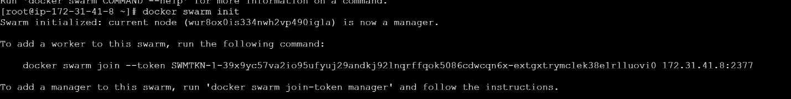

Now the Node is created.



Create the service:

By using the Node the Service will be created.To create the service {docker service create –-name (container name) -- publish 80:80 httpd}

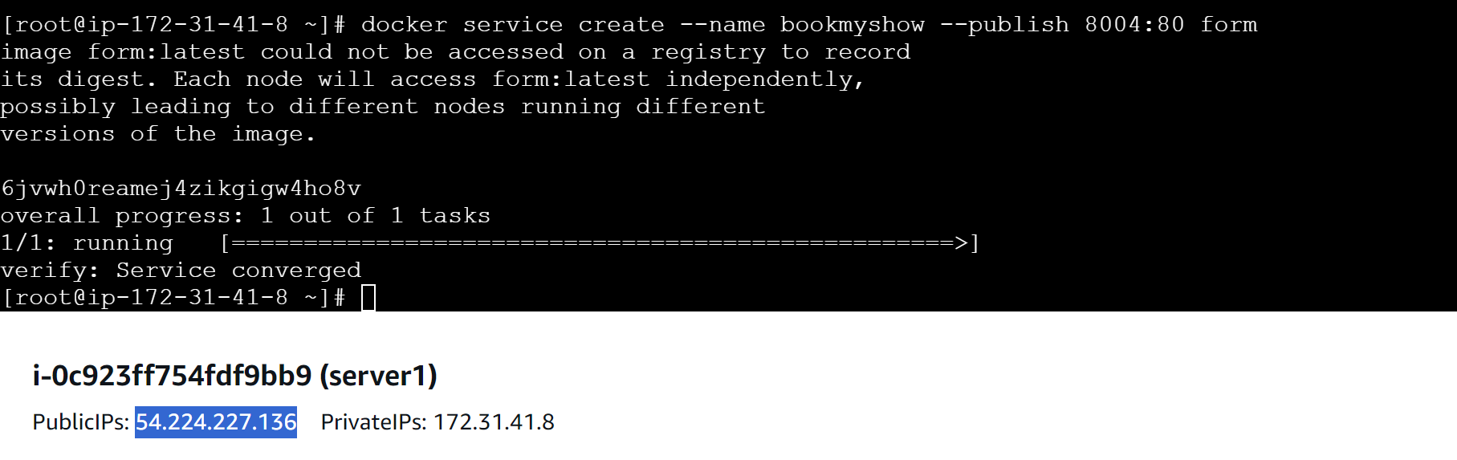

Along with the service Container also creates as shown below.

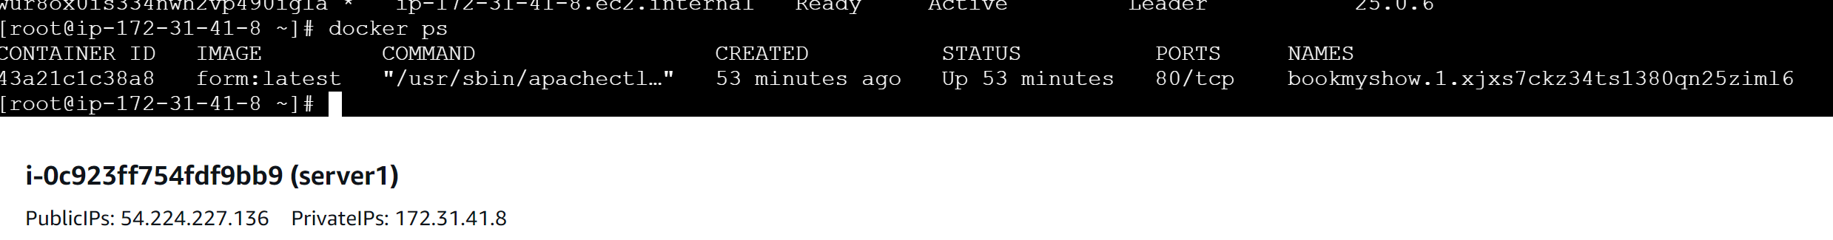

Output:

