Application Home page

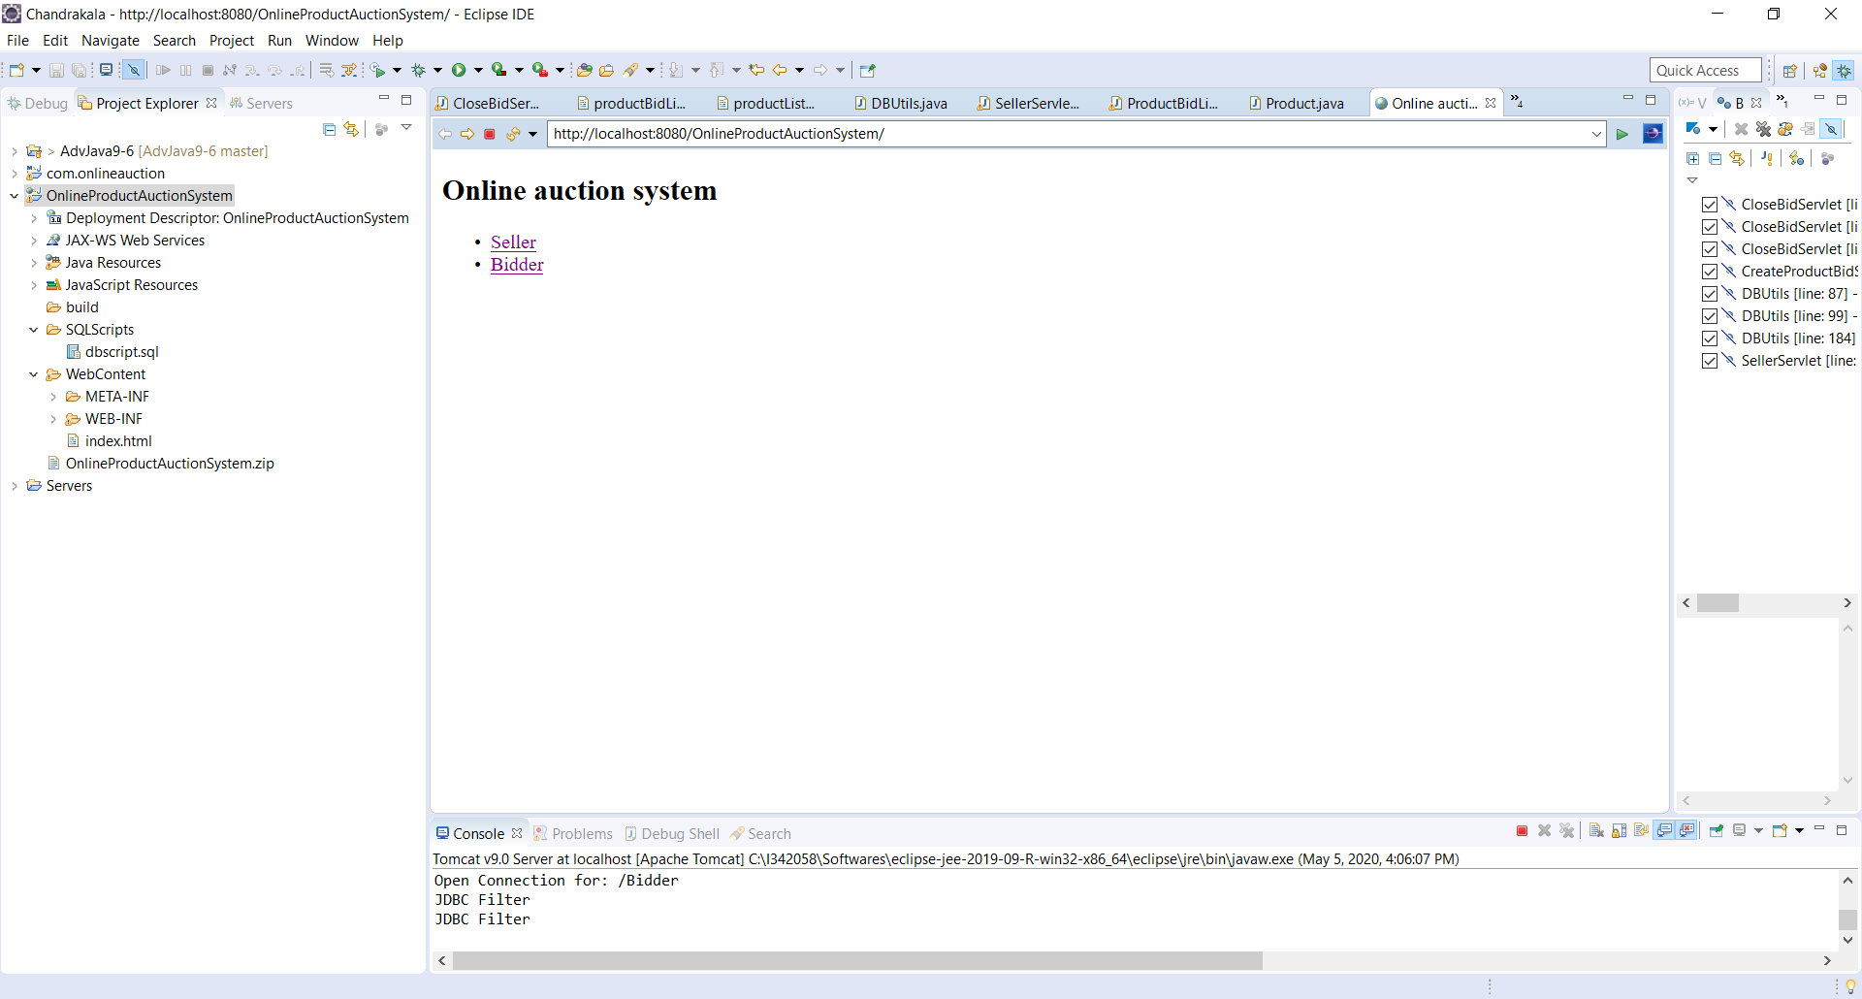

Seller login page: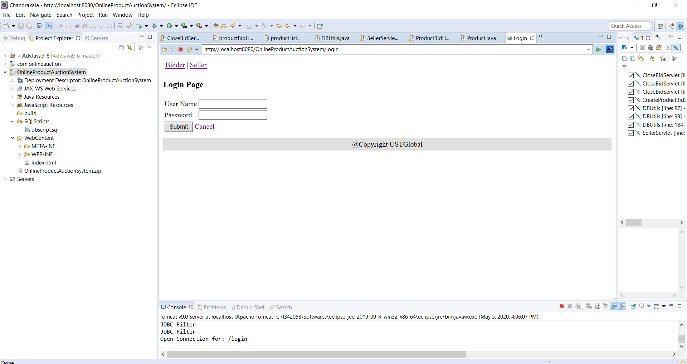

Seller login page – credentials:

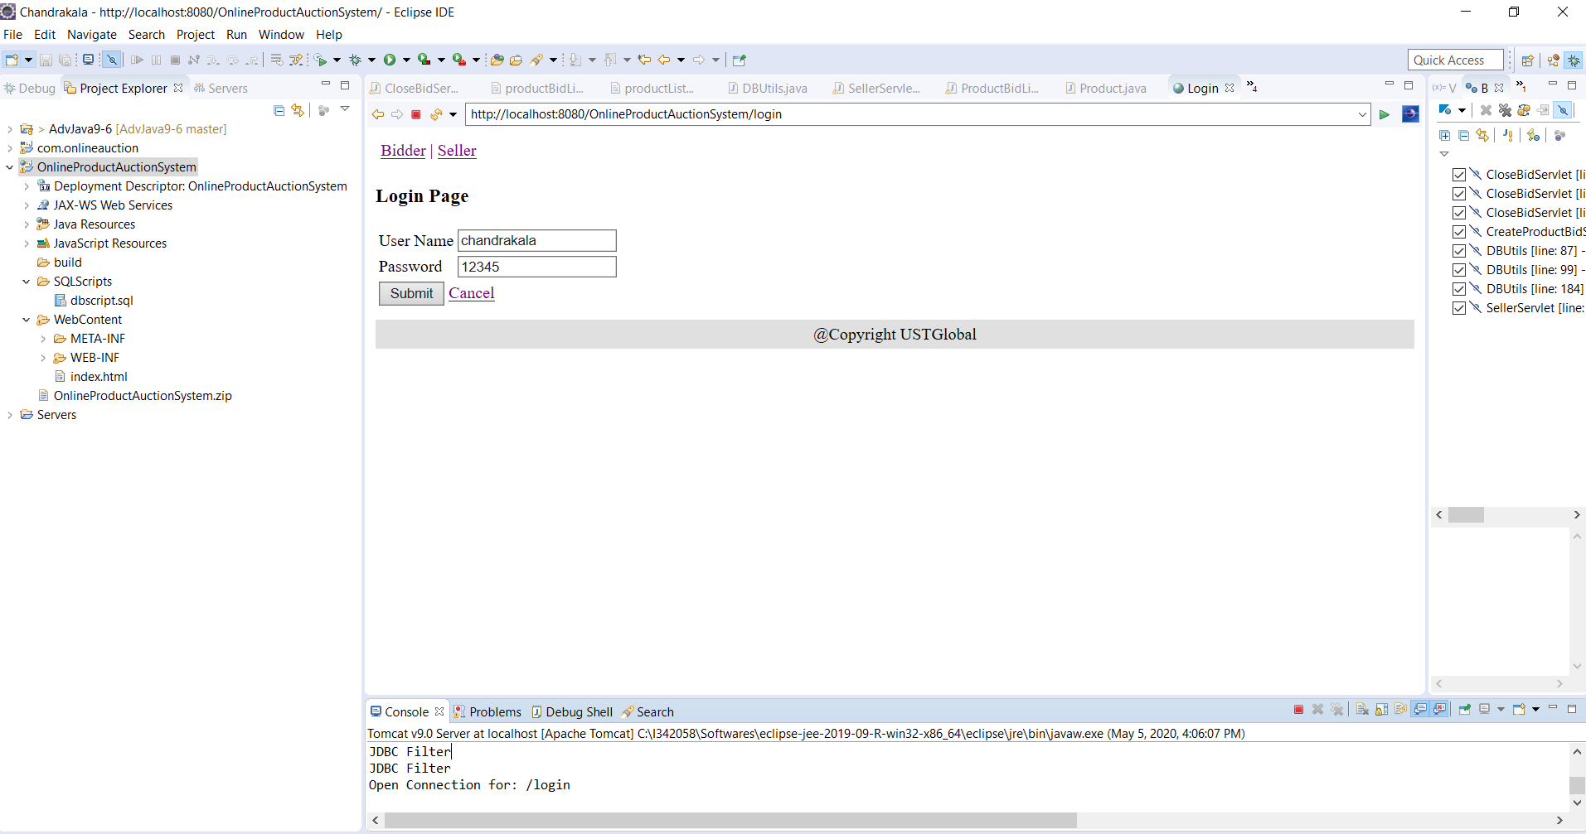

Seller default page: Without any product or bids

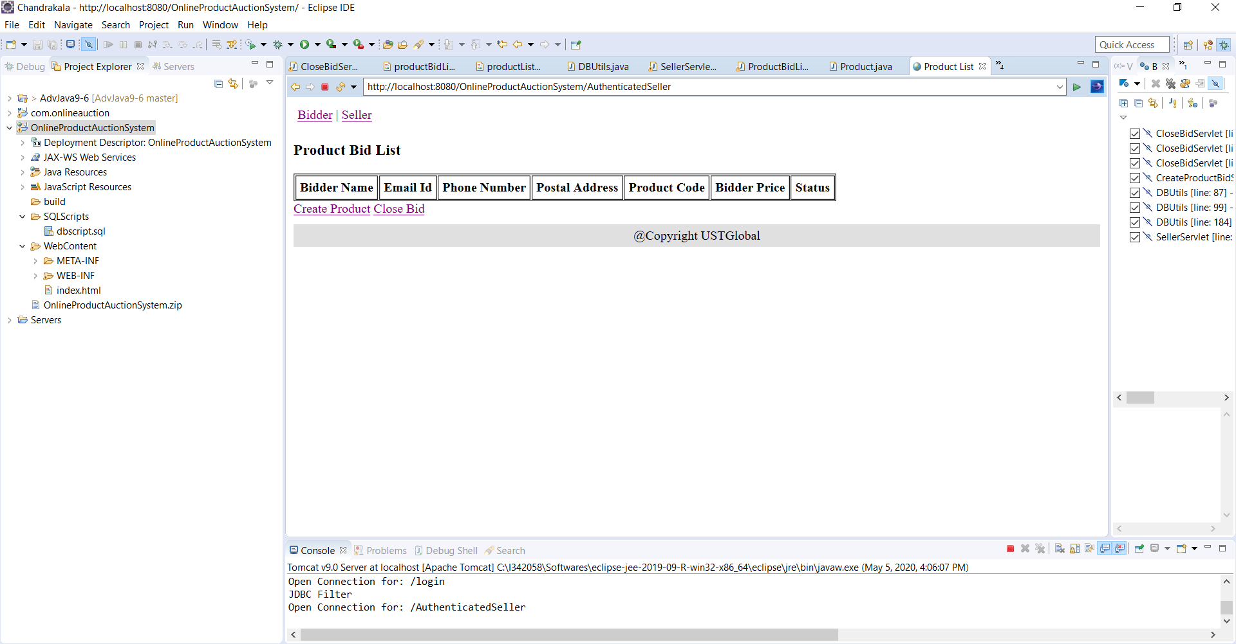

Seller – Creates product and save for bids.

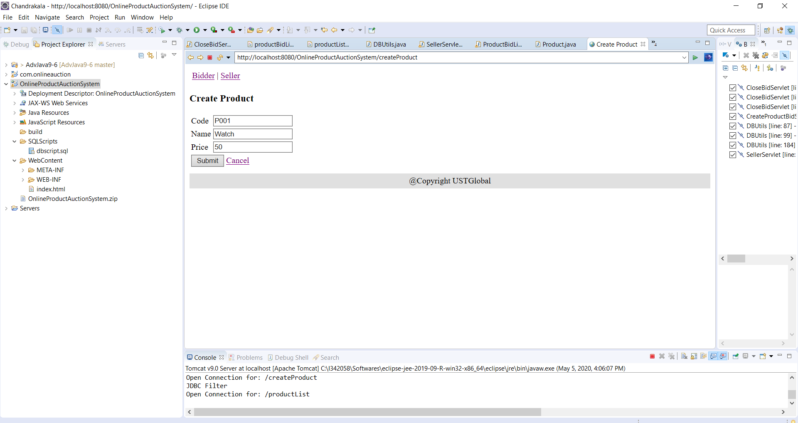

Bidder can see product P001 in bidder product list page:

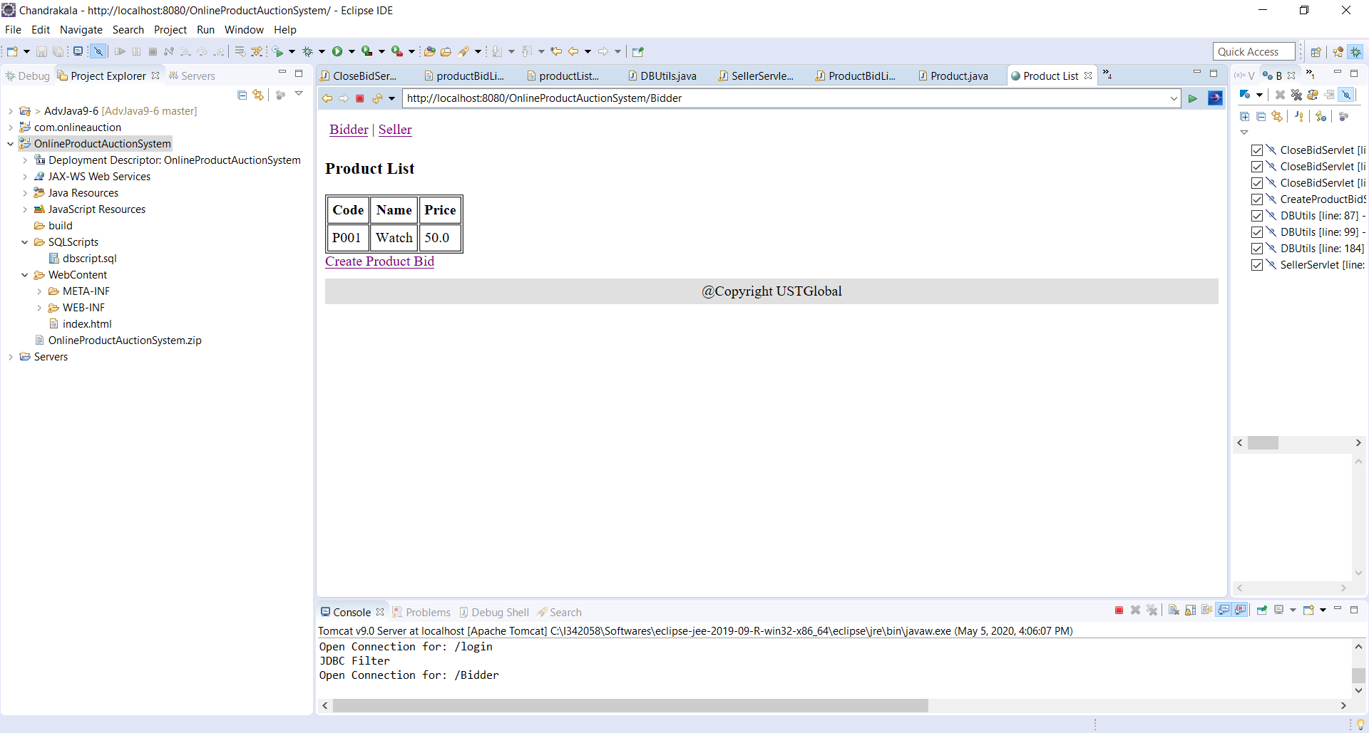

Bidder – Chandrakala creating bid .

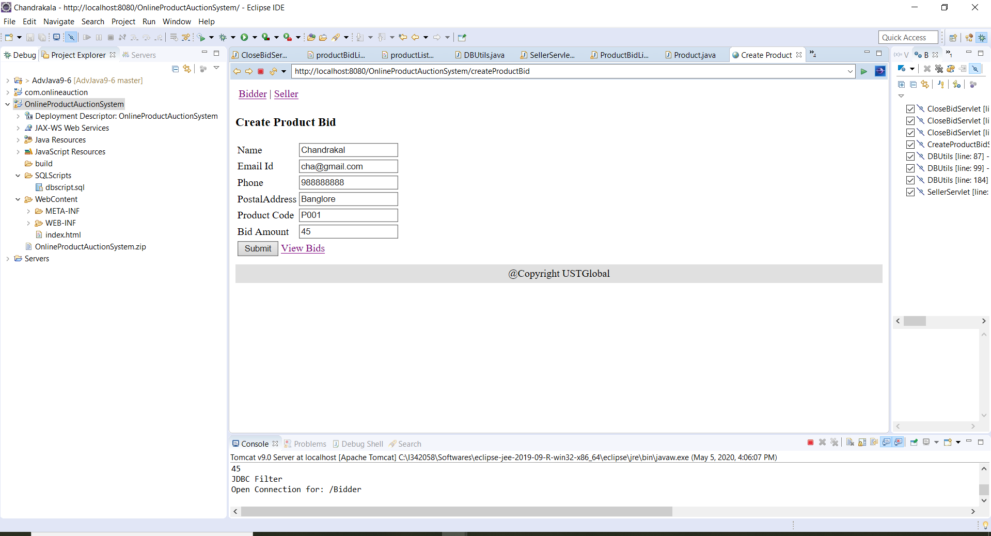

Bidder – Suresh creating bid.

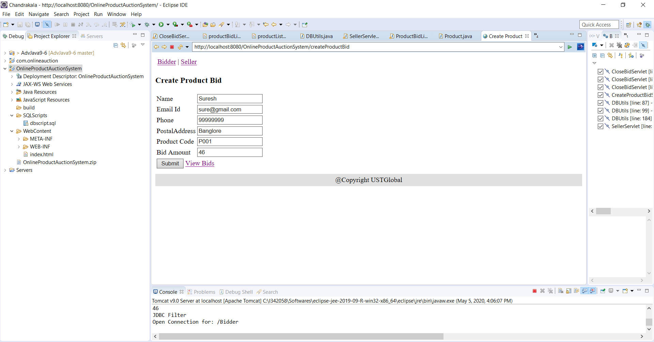

Now seller can bid list in his home page.

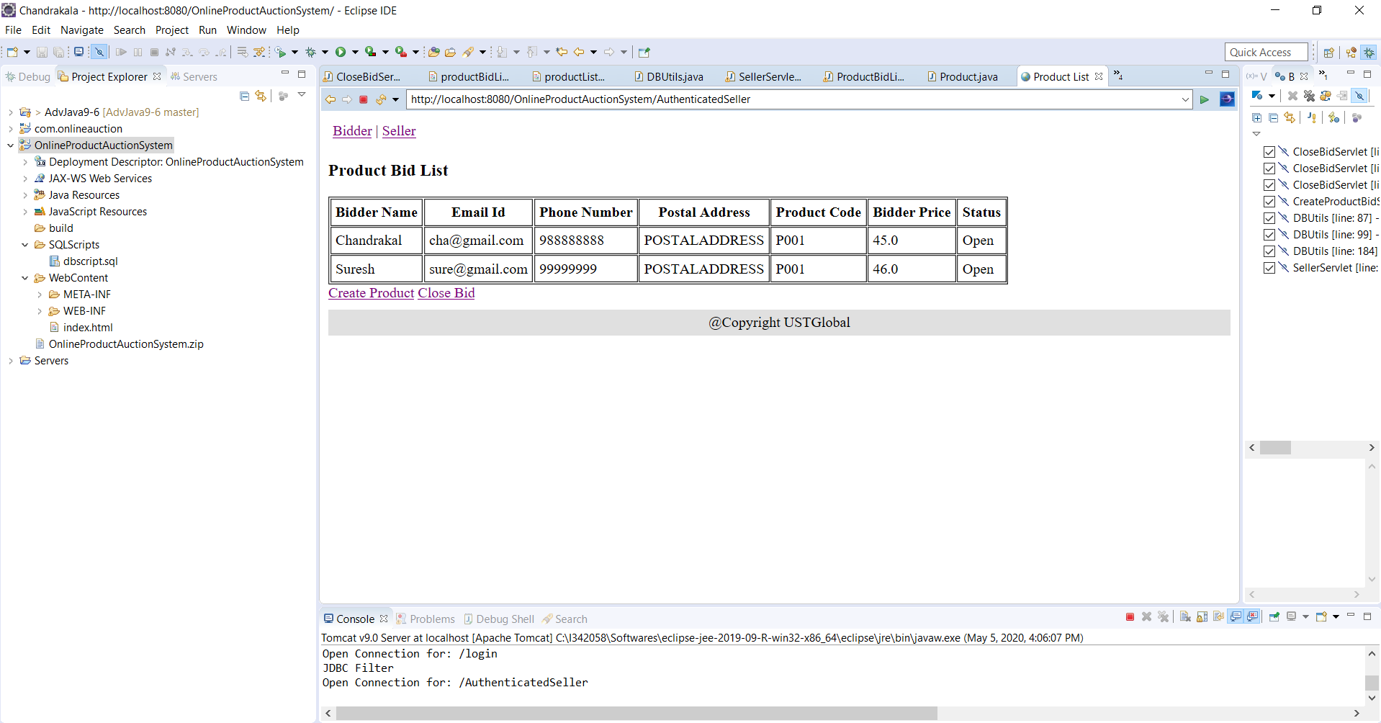

Seller – closing bids for the product P001

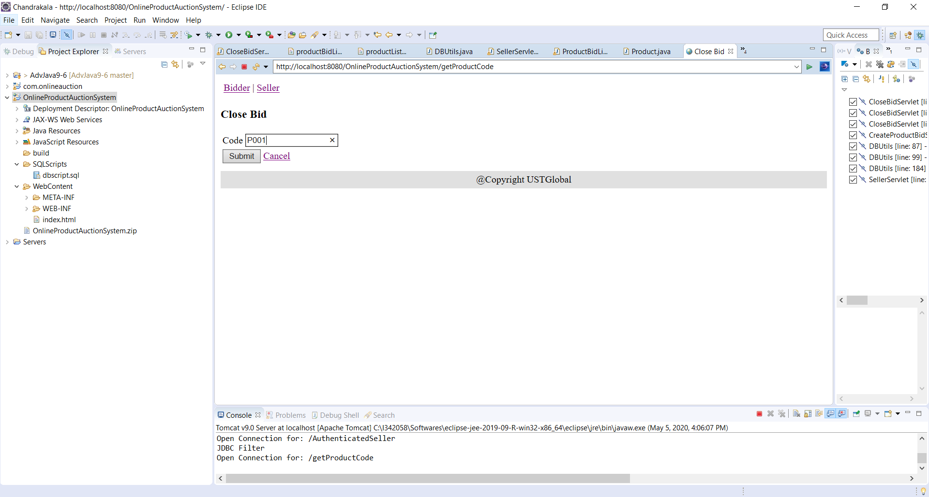

Seller – Bid list with status either “Accepted” or “Rejected”

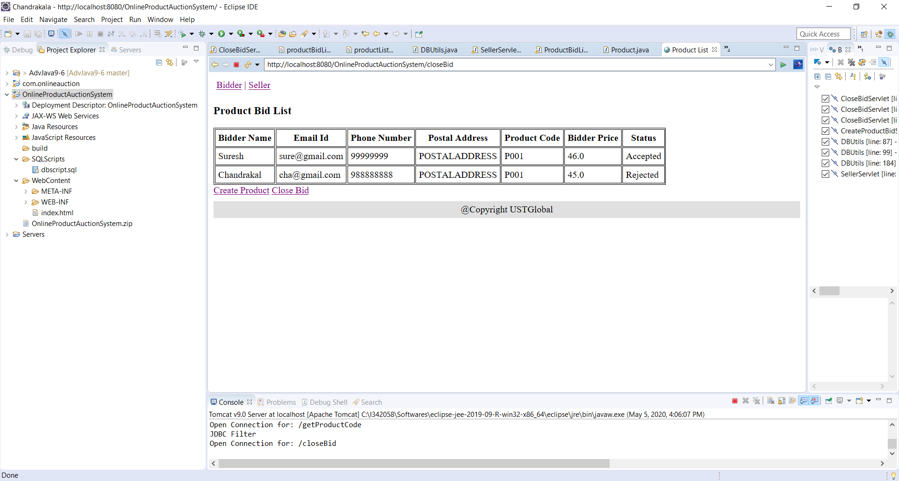

Bidder – Bidding is closed for the Product P001, So bidder can’t see anymore product in the list.

