1. Publish **Common.Core** project and generate the **nuget** package. Make sure to update the nuget version every time a change is made

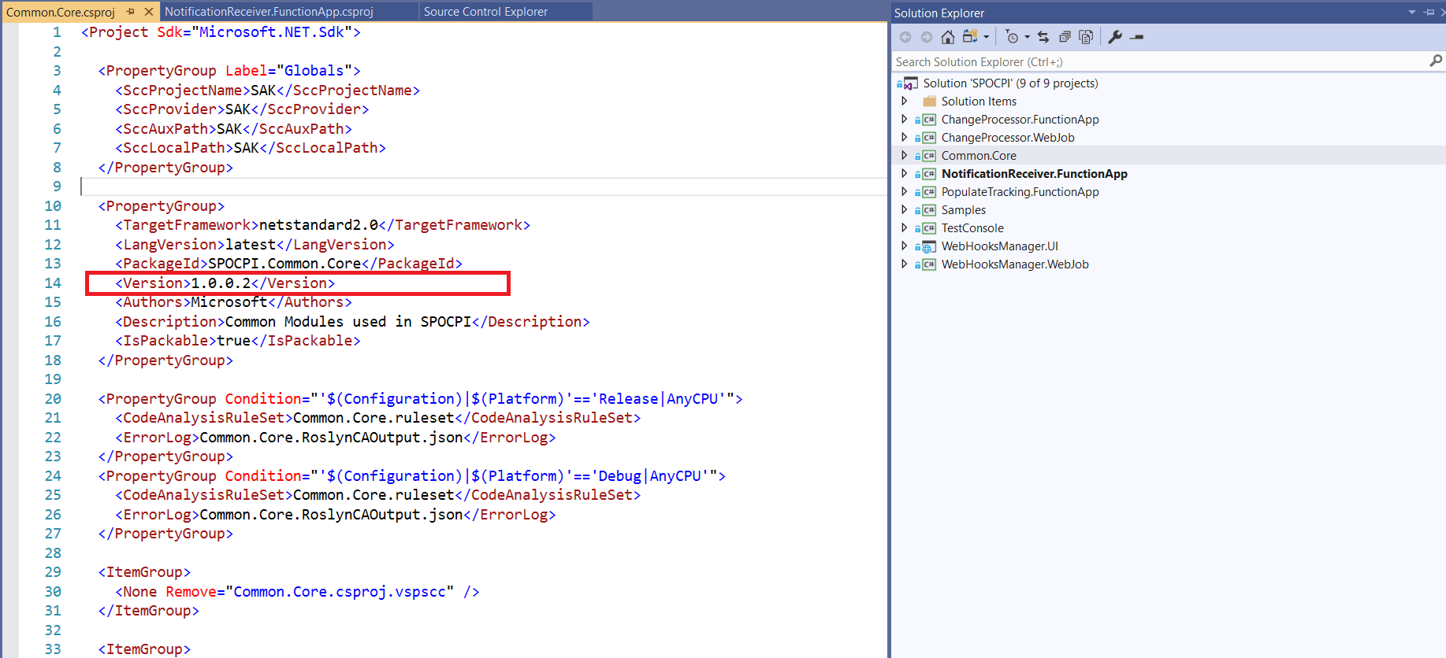

1. Make sure a Personal access token is generated - <https://shellsearch.visualstudio.com/_usersSettings/tokens>. For SPOCPI, the access token name is – SPOCPIAdmin

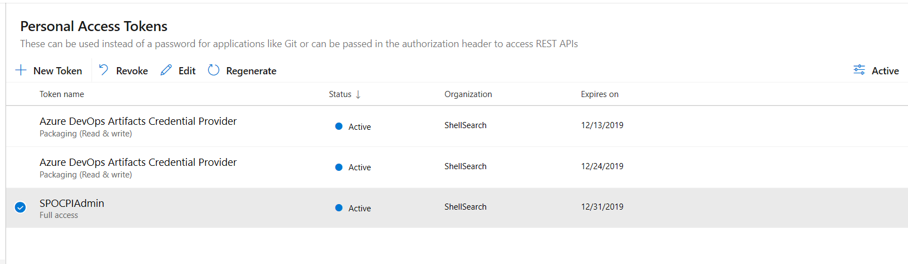

1. Get all **nuget** sources

nuget.exe sources

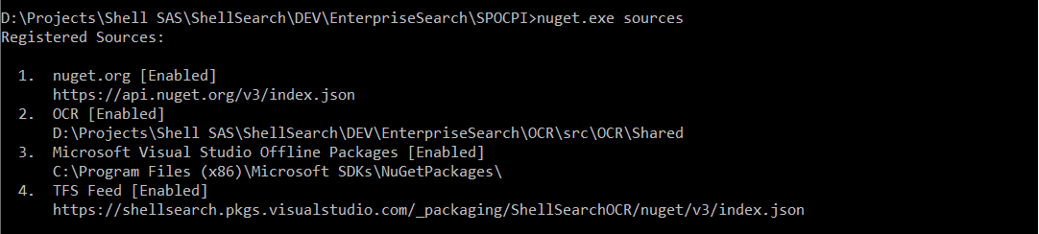

1. Push the latest nuget package to the TFS feed

nuget.exe push -Source "TFS Feed" -ApiKey SPOCPIAdmin "D:\Projects\Shell SAS\ShellSearch\DEV\EnterpriseSearch\SPOCPI\Shared\SPOCPI.Common.Core.1.0.0.2.nupkg"

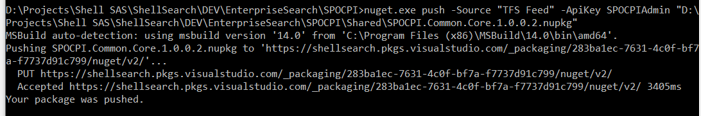

1. Verify that version number for SPOCPI.Common.Core feed is updated

