* **Step 1**
* Create an Azure Data Lake Gen 2 (Storage Account) with folders and uploaded .csv files into folders

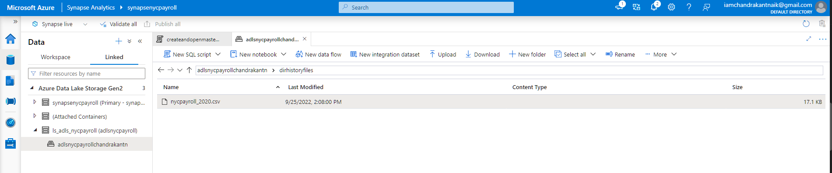

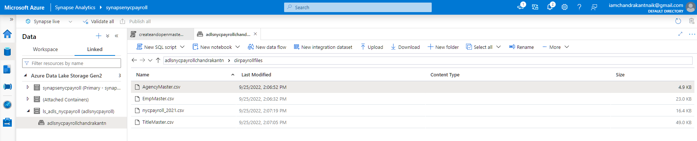

* Create Azure Data Factory Resource
* Create Azure SQL DB Resource

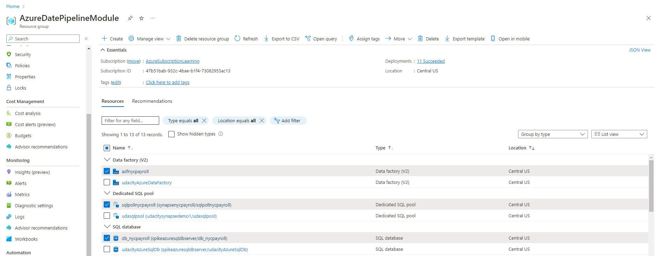

* Create Synapse Analytics workspace with SQL pool with tables
  + 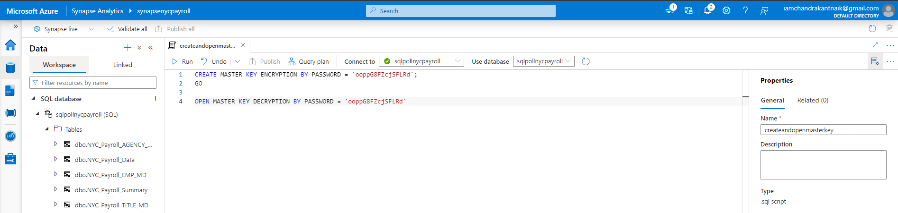
* **Step 2**
* Create linked services to Azure Data Lake (**ls_adls_nycpayroll**)
* Create linked services to Azure SQL DB (**ls_sqldb_nycpayroll**)
* Create linked services to SQL Pool in Synapse Analytics **(ls_synapsesqlpool_nycpayroll**)
  + 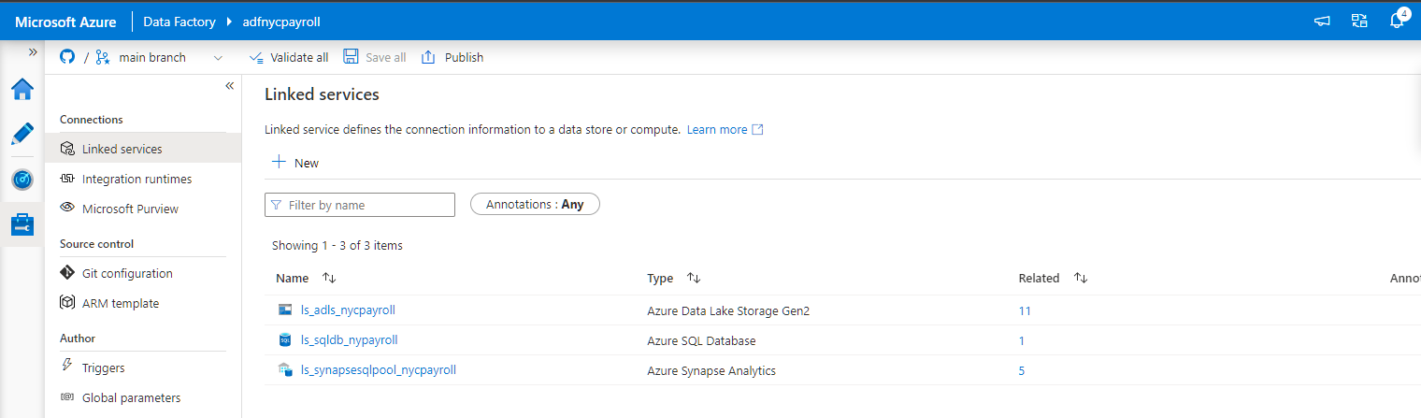
* **Step 3**
* Create datasets for files in Data Lake Gen2
* Create datasets for SQL DB (Refer to **nycpayrolldatatransaction** dataset)
  + 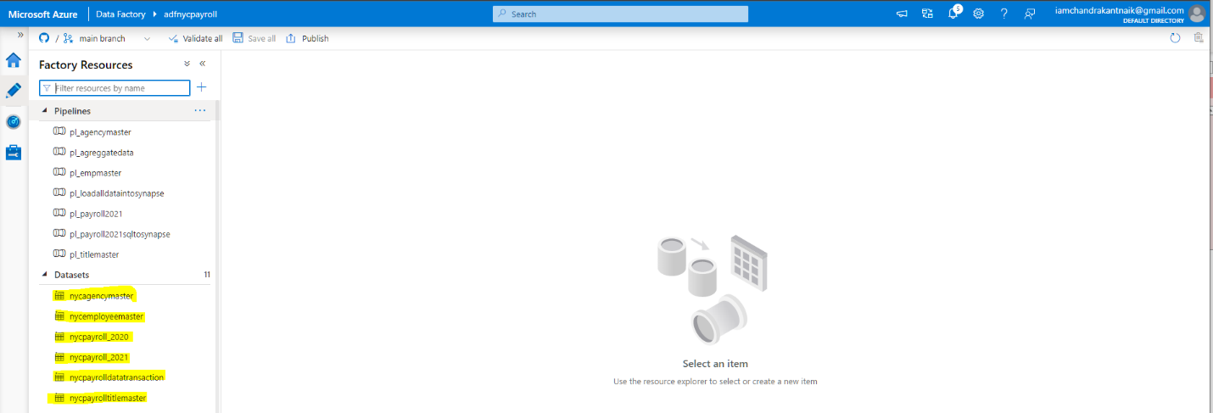
* Create datasets for synapse analytics workspace and SQL Pool with data tables. (**Refer to the highlighted ones**)
  + 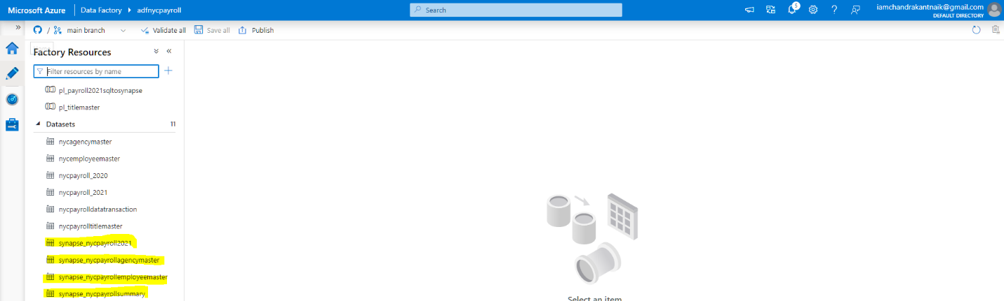
* **Step 4**
* Create dataflows
  + 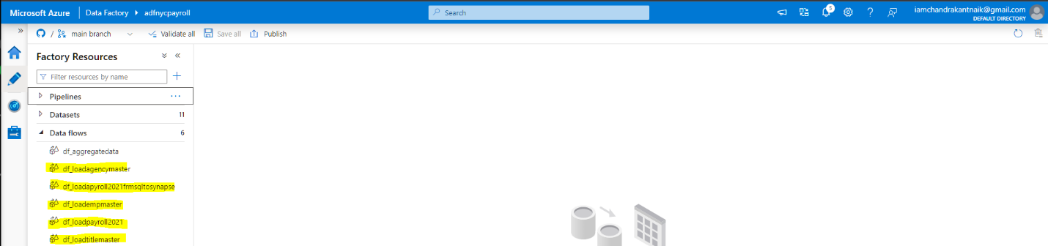
* Create pipelines containing the mapping dataflows and their status post triggering them
  + 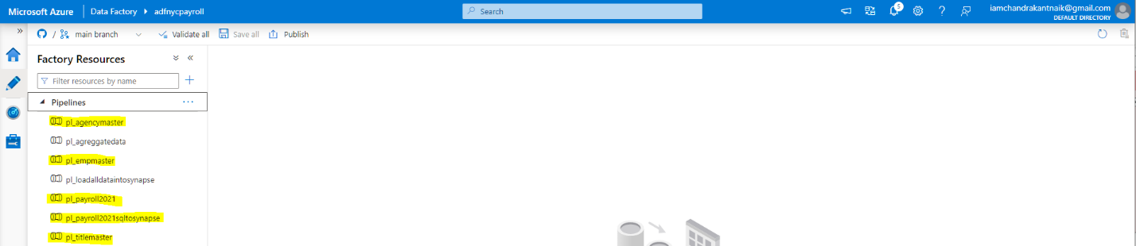

* 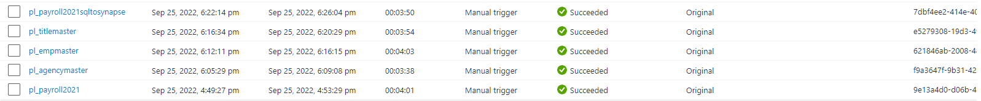

* The highlighted pipeline is a master pipeline to invoke all the Data Flows and its status post triggering
* 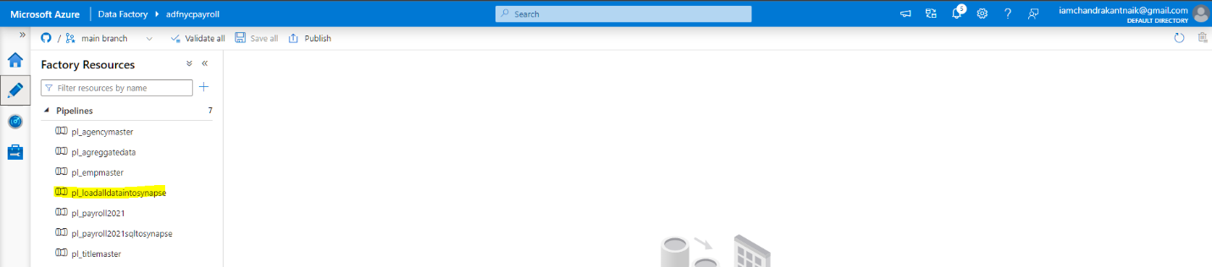

* 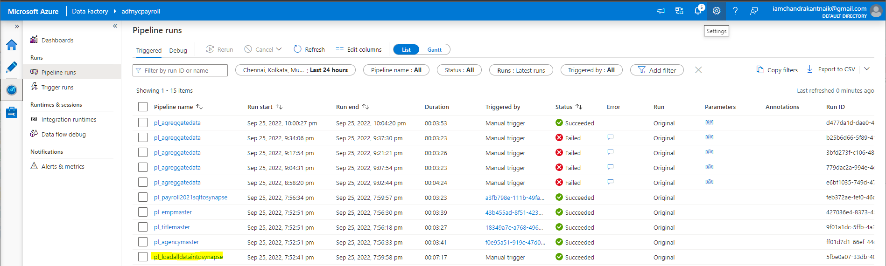

* **Step 5**
* Create table_synapse_nycpayroll_summary in synapse analytics (Refer to table **[dbo].[NYC_Payroll_Summary]**)
  + 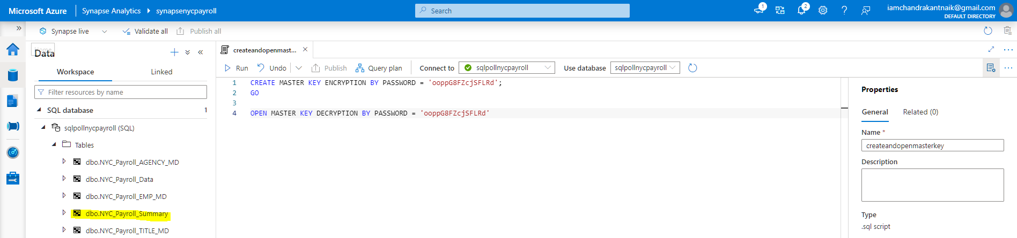
* Created a dataset for historical tables
  + 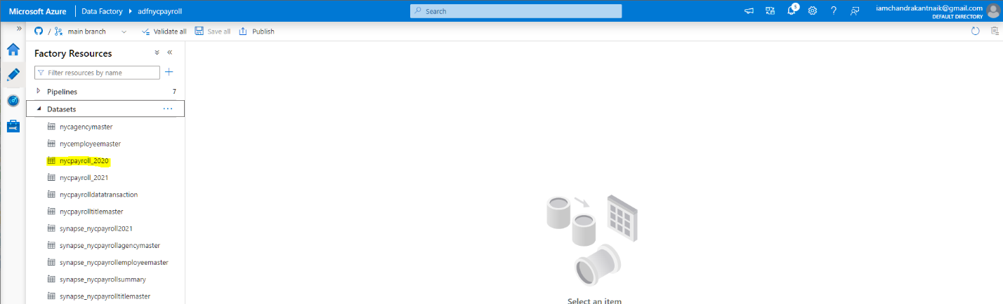
* Created an Aggregate dataflow
  + 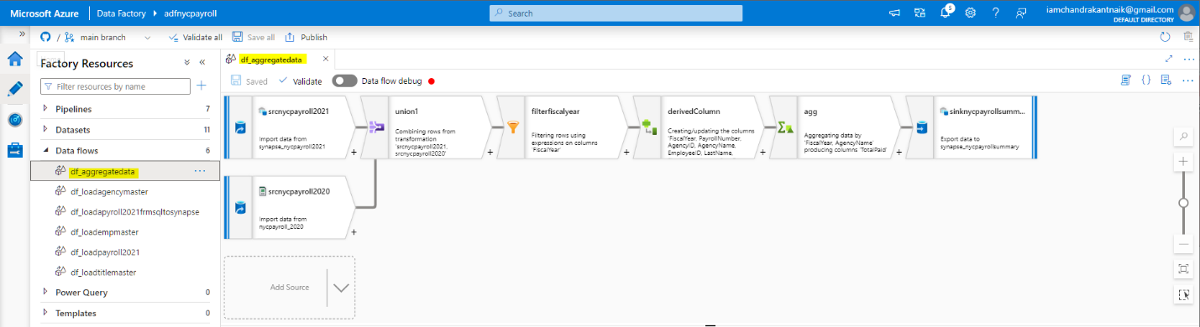
* Screenshot of monitored run
  + 