***Workflow of digital marketing project management:***

* ***Understanding digital marketing –***
  + What is digital marketing?
  + How digital marketing is different from traditional marketing?
  + Why digital marketing must be combined with traditional marketing?
  + How Digital Marketing is affecting business?
* ***Website planning and architecture –***
  + Understanding nature of business for website
  + Understanding customer requirements and your suggestions
  + Choosing right domain name
  + Understanding target audience
  + Getting the website ready which is mobile friendly
  + How to get developed User-friendly and SEO friendly website
  + Why UX/UI of website is crucial for better marketing
* ***Search Engine Optimization (SEO)/ Search Engine Marketing (SEM) –***
  + Keyword research and competitors analyses
  + Using different tools for finding best keyword
  + Using Google’s Keyword Planner for finding best keywords
  + Finding target audience
  + Applying the collected the keywords in the website
  + On-Page SEO
  + Off-Page SEO
  + Local SEO
  + Web audits and analysis
* ***Social Media Marketing (SMM) –*** 
  + Understanding Importance of Social Media
  + What is social Media Marketing and why it’s important for online presence and branding
  + Detailed coverage on Facebook/Twitter/Google Plus/LinkedIn/Instagram
  + Detailed working on Whatsapp (Group/Broadcast – remarketing with existing data)
* ***Lead Generation for Business –*** 
  + Understanding how to use digital marketing for Business lead generation
  + Creating lead nurturing strategy
  + Steps in lead nurturing
  + Converting leads to sales
* ***Digital display marketing –*** 
  + What is banner advertising?
  + How to advertise your banner on Youtube
  + How to advertise your banner on Facebook
  + How to advertise your banner through Adwords
  + Identifying websites where we can advertise our banners
  + Text Links vs. Graphic Links
* ***Adwords (PPC) Campaign –***
  + What is PPC
  + How it’s different from Organic SEO
  + How to create Adwords account and manage
  + How to create successful campaign
  + How to create better ads
  + Understanding bidding in Adwords
  + Understanding conversion in PPC
* ***Blog –***
  + How to create free blogs
  + How to write effective blogs
  + How to optimize blogs
  + Engaging your visitors in your blog
* ***Affiliate Marketing –***
  + Understanding Affiliate Marketing
  + How to find best paying affiliates sites
  + How to optimize your blog and website for affiliate marketing
* ***Web Analytics –***
  + How to track your visitors
  + How to optimize your blog/website as per users visits
  + Changing your business strategy as per your visitors behavior
* ***Content Marketing –***
  + Why quality content is essential for website
  + How to write unique content
  + How to engage your visitors with useful content
  + How to submit your content in the web for link generation
* ***Youtube Advertising –***
  + How to post your video on Youtube
  + How to optimize video for better search presence
  + How to advertise on Youtube
  + How to earn money on Youtube
* ***Online Reviews & Brand Reputation –***
  + What are online reviews?
  + How this affects your business
  + How to get reviews from your customers
  + How to give polite reply for bad reviews
* ***Email Marketing and SMS Marketing***
  + Select an ESP (Email Service Provider)
  + Plan your campaign by setting realistic goals
  + Design the layout of your email newsletter, match it to the design of your website and social presence if at all possible
  + Write engaging copy that is of interest to your audience
  + Create an attention grabbing headline for your newsletter
  + Test and tweak your emails to increase opening rates for your campaigns
  + Schedule your email messages, remember to use different frequencies for different lists
  + Track and analyze performance to optimize results
* ***ONLINE PR MARKETING***
  + Conduct a thorough audit of your current media coverage
  + Set realistic goals for your online PR campaign
  + Determine the online audience you intend or need to reach
  + Identify interested and influential reporters to amplify your message
  + Define the key aspects of your message
  + Develop your pitch based on your brand strategy and voice
  + Follow up with your intended targets as appropriate
  + Assess the results of your online campaign and set new campaign goals

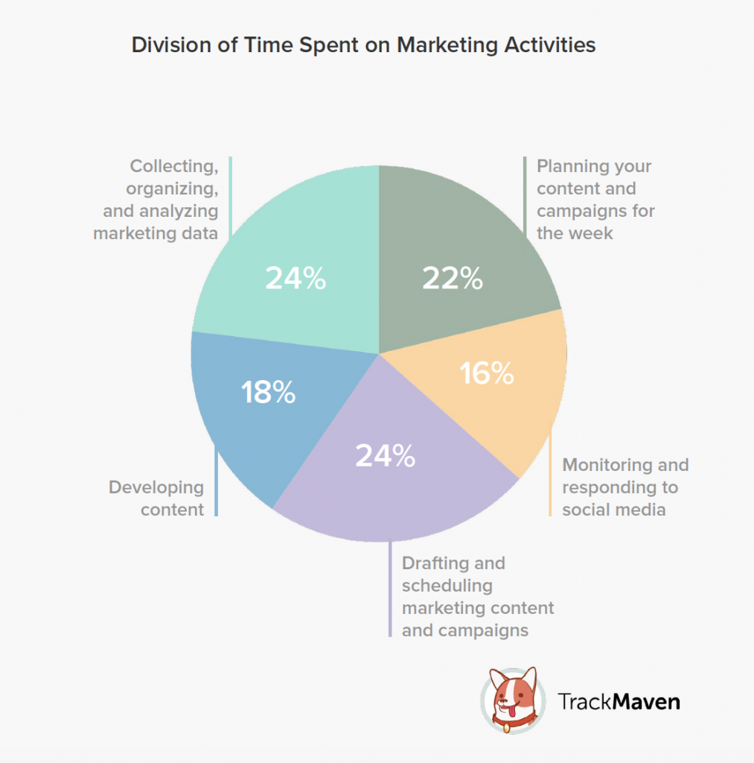

***Area of Contradiction –***

* If both agency work on same segment, then the entire work will be overloaded.
* If both work on same segment & also same time, it will very hard to segregate their specific work.
* If both work on same segment, it is very hard to measure the output results each of them.
* If both work on same segment, same credentials are visible to both of them.
* If both work on same time, any of them can start negative campaign against the organization, which is very hard to find out.
* If both work for an organization, one can show false report for their work; it is very hard to prove their offence.
* As digital marketing is a long term process, if both agency work at the same time, proper result may not come at the short period of time.
* If both agencies get access of social media at the same time, one can easily destroy another work; as a result organization will be lost their reputation.
* For paid campaign, as organization’s credit card will be attached for the particular campaign, one can easily twist another work as all campaigns are visible to all – there is no such procedure for separation of login credentials.

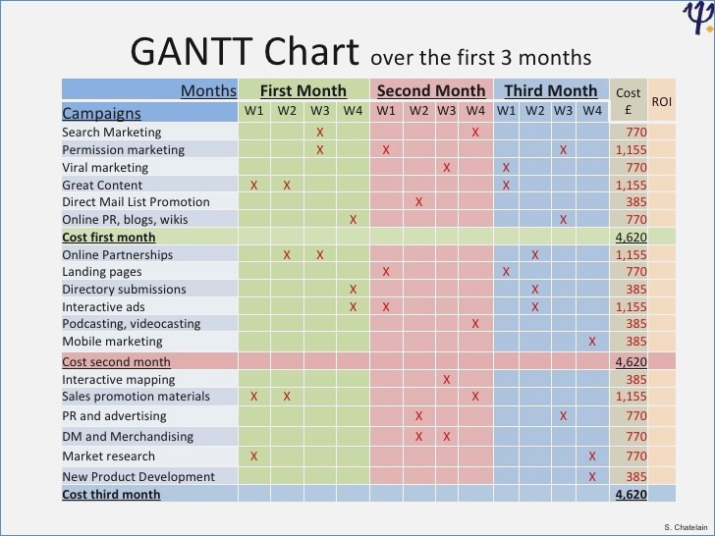

***How to solve contradiction –***

* If one agency works on single domain then it will help