**(Management Information System)**

* **MIS-**MIS is a **Management Information System.** MIS is a collection of systems, hardware, procedures and people that all work together to process, store, and produce information that is useful to the organization. Example- **Sales management systems & Budgeting Systems.**
* **Need of MIS-**The following are some of the justifications for having an MIS system as:-

**a.** **Decision makers need information to make effective decisions.** Management Information Systems (MIS) make this possible.

**b**. **MIS systems facilitate communication within and outside the organization** – Employees within the organization are able to easily access the required information for the day to day operations. Facilitates such as Short Message Service (SMS) & Email make it possible to communicate with customers and suppliers from within the MIS system that an organization .

**c**. **Record keeping**– Management information systems record all business transactions of an organization and provide a reference point for the transactions.

* **Components of MIS-**The major components of a typical management information system are;

**a. People** – These are the users who use the information system to record the day to day business transactions. The users are usually qualified professionals such as accountants, human resource managers, etc.

**b. Data** – The recorded day to day business transactions. For a bank, data is collected from activities such as deposits, withdrawals, etc.

**c. Business Procedures** –These are agreed upon best practices that guide the users and all other components on how to work efficiently. Business procedures are developed by the people.

**d.Hardware** –.Hardware is made up of the computers, printers, networking devices, etc. The hardware provides the computing power for processing data. It also provides networking and printing capabilities. The hardware speeds up the processing of data into information.

**e. Software** – These are programs used to handle the data. These include programs such as spreadsheet programs, database software etc.

* **Characteristic of MIS**:- The characteristic of MIS is given below:-

### a. Management oriented- This means that the system is designed around the need felt by the management at different levels for information. The focus of the system is to satisfy the information needs of management.

### b. Management directed- Management is involved in the designing process of MIS and also in its continuous review and up gradation to develop a good qualitative system. The system is structured as per directions factored by management.

### c. Integrated- It is integrated with all operational and functional activities of management. The reason for having an integrated system is that information in the managerial context for decision-making may be required from different areas from within the organization.

### d. Common data flows- MIS the data being stored into the system, retrieved from the system, disseminated within the system or processed by the system can be handled in an integrated manner.

### e. Strategic planning- The reason for this kind of planning is to ensure that the MIS being built not only satisfies the information need of the managers today but can also serve the organization for the next five to ten years with modifications.

* **Functions of MIS:-**The functions of MIS are as given below as:-

**a. To improve decision-making-** MIS helps management by providing background information on a variety of issues and helps to improve the decision-making quality of management. The fast and accurate information supplied by MIS is leveraged by the managers to take quicker and better decisions.

**b.** **To improve efficiency-** MIS helps managers to conduct their tasks with greater ease and with better efficiency. This reflects in better productivity for the company.

**c.** **To provide connectivity:**MIS provides managers with better connectivity with the rest of the organization.

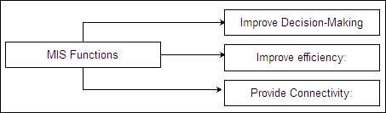

* **Manual Information System**- A manual information system does not use any computerized devices. The recording, storing and retrieving of data is done manually by the people who are responsible for the information system.
* **Components of Manual Information System**- The following are the major components of a manual information system as-

**a. People –**People are the recipients of information system.

**b.** **Business Procedures –**These are measures put in place that define the rules for processing data, storing it, analyzing it and producing information.

**c.** **Data –**These are the recorded day to day transactions.

**d.** **Filing system –**This is an organized way of storing information.

**e.** **Reports –**The reports are generated after manually analyzing the data from the filing system and compiling it.

* **Structure of Manual Information System**-The structure of Manual Information System is given below as-

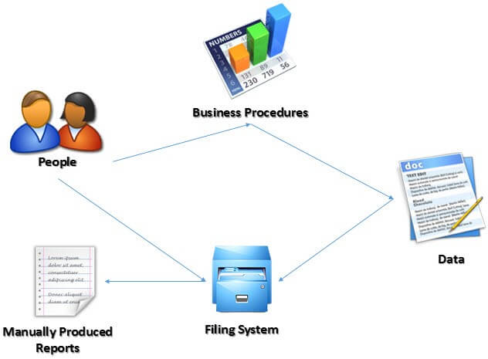

**Fig1: Structure of Manual Information System**

* **Advantage of Manual Information System-**The following are the advantages of manual information systems as:-

**a. Cost effective –**It is cheaper compared to a computerized system because there is no need to purchase expensive equipment such as servers, workstations, printers, etc.

**b. Flexible –**Evolving business requirements can easily be implemented into the business procedures and implemented immediately

* **Disadvantage of Manual Information System:-** The following are some of the disadvantages of a manual information system as-

**a.** **Time consuming –**All data entries need to be verified before filing, this is a time consuming task when done by humans.

**b. Lack of security –**The security of manual systems is implemented by restricting access to the file room. Experience shows unauthorized people can easily gain access to the filing room.

**c**. **Duplication of data –**Most departments in an organization need to have access to the same data. In a manual system, it is common to duplicate this data to make it easy to accessible to all authorized users.

**d. Data inconsistency –**Due to the duplication of data, it is very common to update data in one file and not update the other files. This leads to data inconsistency.

**e.** **Lack of backups –**If the file get lost or mishandled, the chances of recovering the data are almost zero.

* **Computer Based Information System** :- A computer-based information system is an information system  that collects, proccesses, stores and analyzes information for specific purpose.
* **Advantage of Computer Based Management Information System**:-

The following are the advantages of computerized information systems as:-

a. **Fast data processing and information retrieval –**This is one of the biggest advantages of a computerized information system. It processes data and retrieves information at a faster rate. This leads to improved client/customer service.

**b.** **Improved data accuracy –**Easy to implement data validation and verification checks in a computerized system compared to a manual system.

**c.** **Reduced data duplication –**Database systems are designed in such a way that minimized duplication of data. This means updating data in one department automatically makes it available to the other departments.

**d.** **Improved security –**In addition to restricting access to the database server, the computerized information system can implement other security controls such as user’s authentication, biometric authentication systems.

**e. Easy access to information –**Most business executives need to travel and still be able to make a decision based on the information. The web and[Mobile](https://www.guru99.com/mobile-testing.html)technologies make accessing data from anywhere possible.

* **Disadvantage of Computer Based Management Information System:**

The following are the disadvantages of computerized information systems as :-

**a.** **It is expensive to set up and configure –**The organization has to buy hardware and the required software to run the information system. The staff will need to be trained on how to use the computerized information system.

**b. Heavy reliance on technology –**If something happens to the hardware or software that makes it stop functioning, then the information cannot be accessed until the required hardware or software has been replaced.

**c.** **Risk of fraud –**If proper controls and checks are not in place, an intruder can post unauthorized transactions such as an invoice for goods that were never delivered etc.