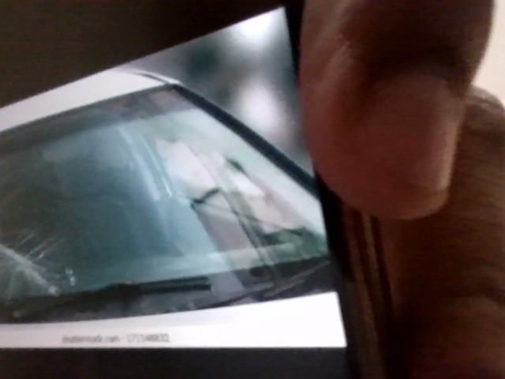

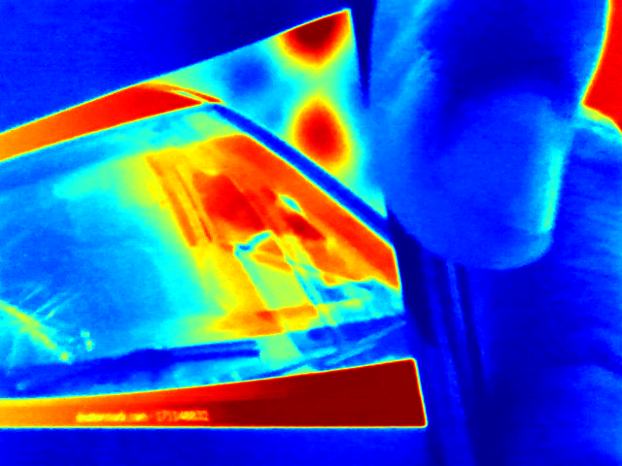

The image shows significant damage to the windshield. The damage appears to be on the driver's side and extends across a large portion of the glass. Due to the extent and location of the damage, a complete windshield replacement is recommended to ensure proper visibility and structural integrity. Consult a qualified auto glass technician for replacement.