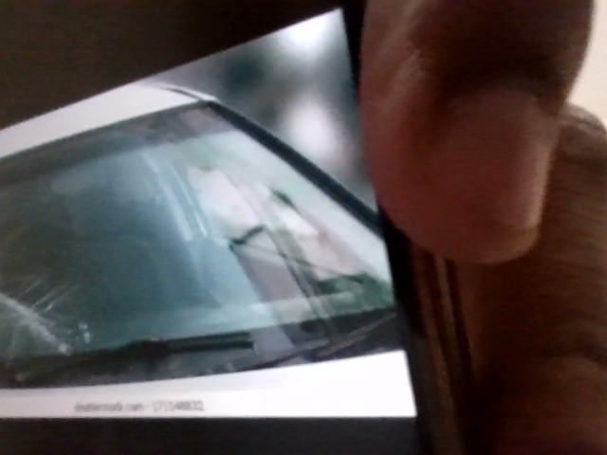

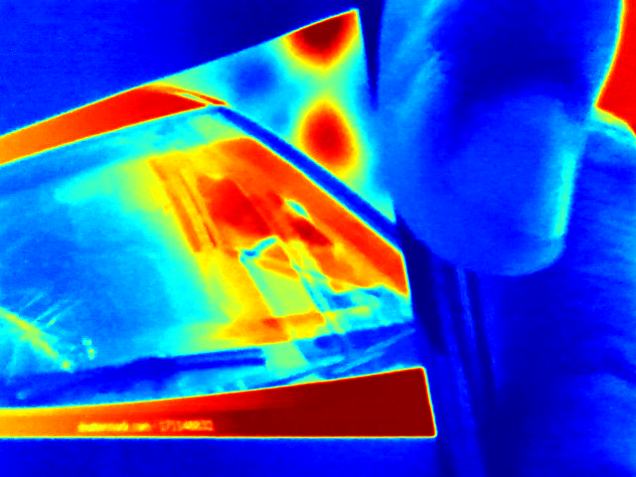

The image shows significant damage to the windshield. The damage appears to be on the driver's side and extends across a large portion of the glass. Due to the extent and location of the damage, a complete windshield replacement is recommended to ensure proper visibility and structural integrity. Consult a qualified auto glass technician for replacement.

The provided vehicle data shows that the tyre pressure levels are not within the ideal range. The left front and left rear tyres are significantly underinflated, while the right rear tyre is overinflated. The right front tyre pressure is slightly below the ideal range.  
  
To ensure optimal vehicle performance and safety, it is crucial to adjust the tyre pressure levels. The left front and left rear tyres should be inflated to 90 psi, while the right front tyre should be inflated to 95 psi. The right rear tyre should be deflated to 90 psi.  
  
Incorrect tyre pressure levels can lead to several hazards, including:  
  
- Reduced traction and handling, increasing the risk of accidents  
- Uneven tyre wear, resulting in premature tyre failure  
- Increased fuel consumption due to higher rolling resistance  
- Damage to the vehicle's suspension system  
  
By following these instructions, the tyre pressure levels will be corrected, ensuring a safe and efficient vehicle operation.

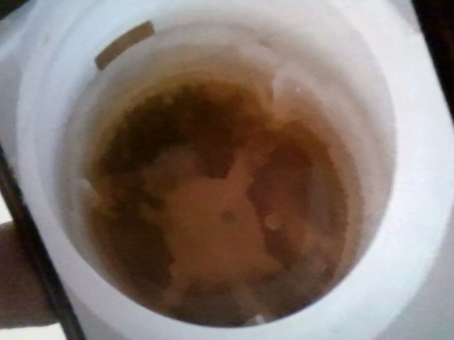

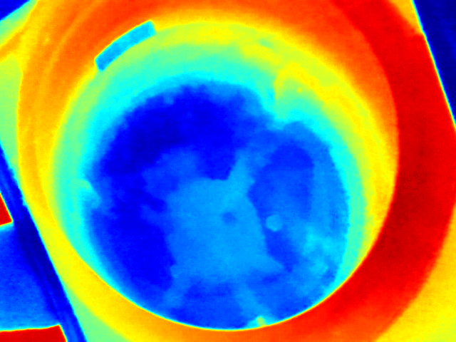

The engine oil appears very dark and dirty. This suggests it is well overdue for a change. The dark color indicates significant contamination from combustion byproducts. I recommend an immediate oil and filter change to prevent accelerated engine wear.

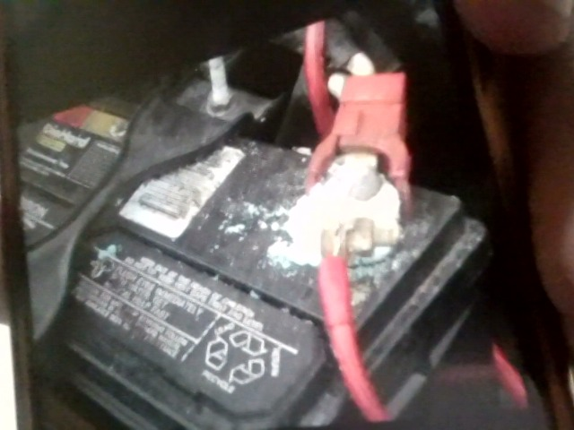

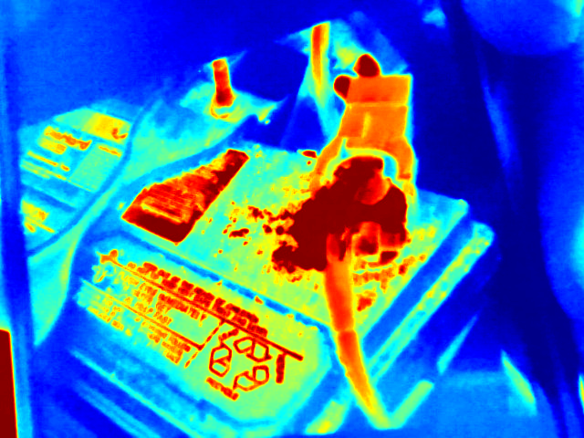

the battery shows significant corrosion on the positive terminal and around the surrounding area. this indicates leakage and potential damage. the corrosion needs to be carefully cleaned using a baking soda and water solution. after cleaning, inspect the terminal for damage. if the terminal is damaged, the battery likely needs replacement. for future maintenance, ensure terminals are tightly fastened and consider applying a battery terminal protector spray to prevent corrosion.

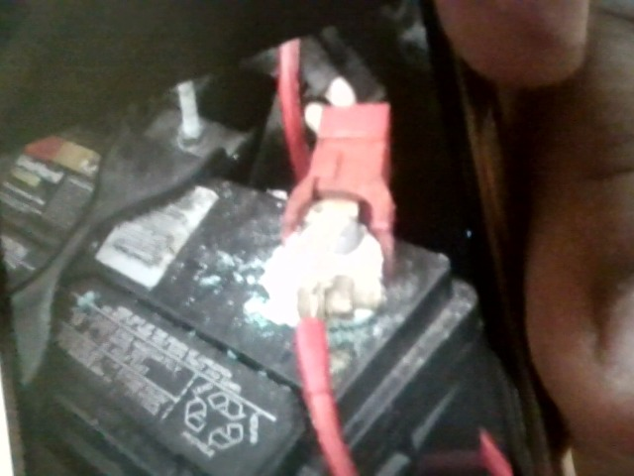

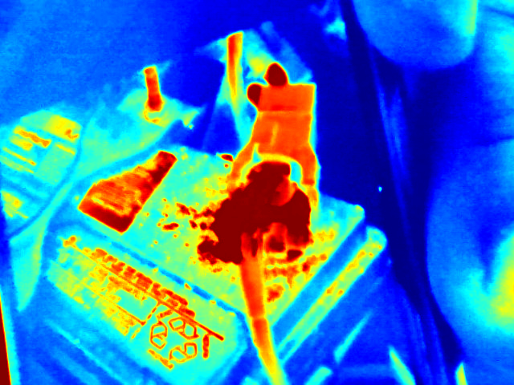

The battery terminals show significant corrosion, particularly around the positive (red) terminal. This white, powdery buildup is a common issue caused by battery acid leaks.   
  
To address this, disconnect the battery terminals (negative first), and clean the terminals and battery posts with a baking soda and water solution. Wear gloves and eye protection. After cleaning, apply dielectric grease to the terminals before reconnecting them. Consider replacing the battery if the corrosion is severe or the battery is old.

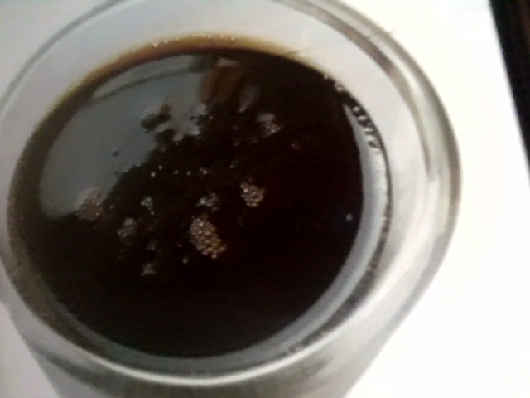

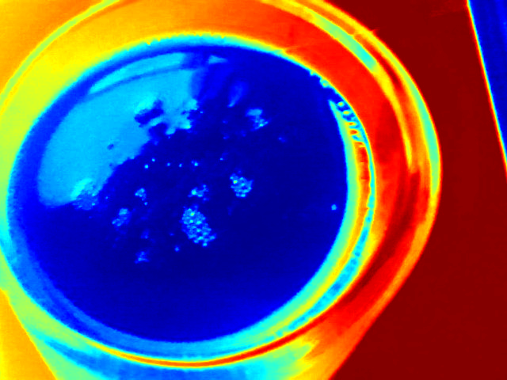

The brake fluid appears very dark and contaminated. This suggests it's old and likely absorbed moisture. It needs to be flushed and completely replaced with fresh fluid. This is crucial for safe braking.