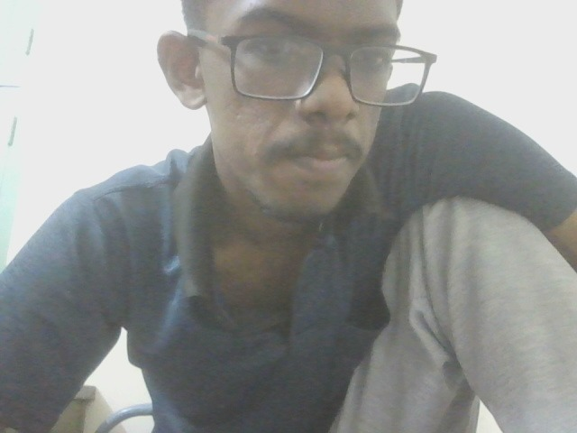

The image appears to show a man wearing a blue shirt and glasses. Without further context or information, it's impossible to provide any meaningful analysis beyond these basic observations.   
  
It's important to note that sharing and analyzing personal images without consent can be inappropriate and disrespectful.   
  
If you have any specific questions or concerns about the content of the image, please provide more details.