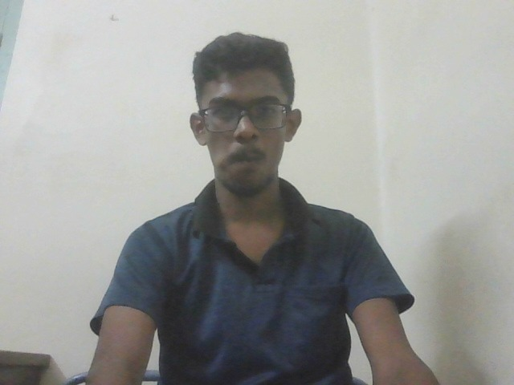

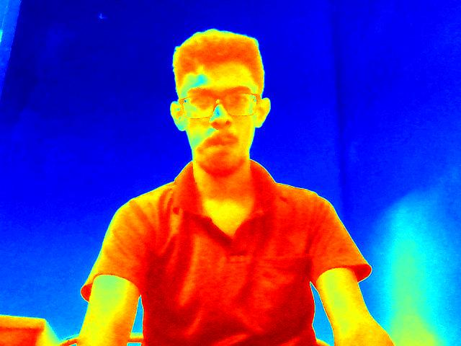

The image shows a young man with dark hair and a short beard. He is wearing glasses and a dark blue collared shirt. He is sitting against a plain, off-white wall and appears to be looking directly at the camera.   
  
Without further context or instructions, it's difficult to determine a specific analysis task. Do you have any questions about this image?