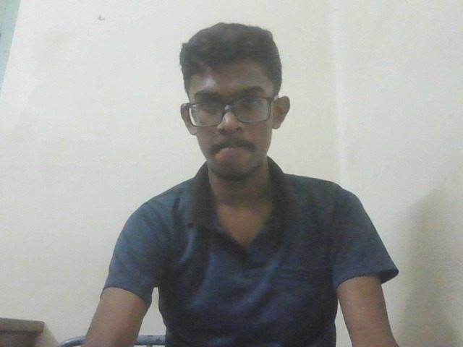

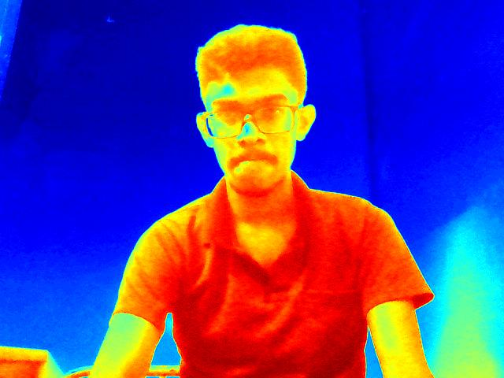

The image shows a young man with dark hair, wearing a blue polo shirt, and glasses. He is facing the camera with a neutral expression.   
  
There is no specific analysis task requested for this image.   
  
Please provide a specific question or task related to the image, such as:  
  
\* "What is the approximate age of the person in the image?"  
\* "Describe the emotion displayed by the person in the image."  
\* "What objects are visible in the background?"   
  
Once you provide a clear question or task, I can help analyze the image further.