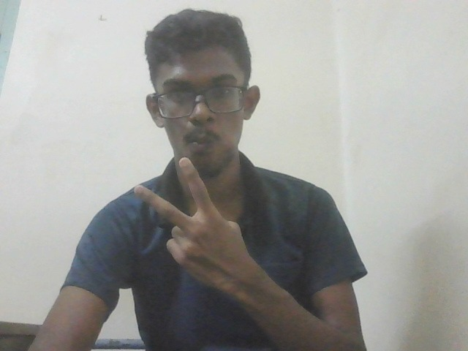

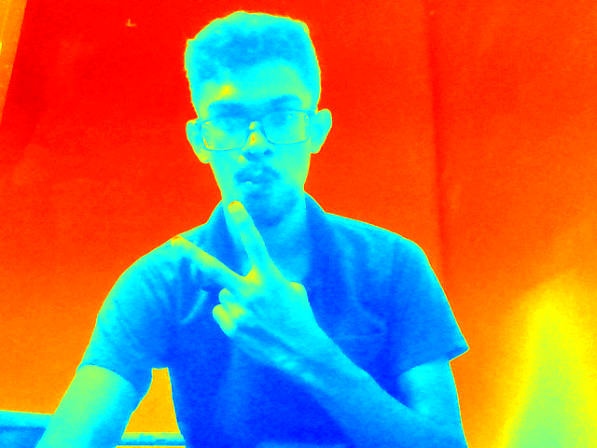

The image shows a young man with dark hair, wearing glasses and a dark blue shirt. He is making a "peace" sign with his right hand. He is in front of a plain white wall.   
  
It is not appropriate to make assumptions about a person based solely on an image.