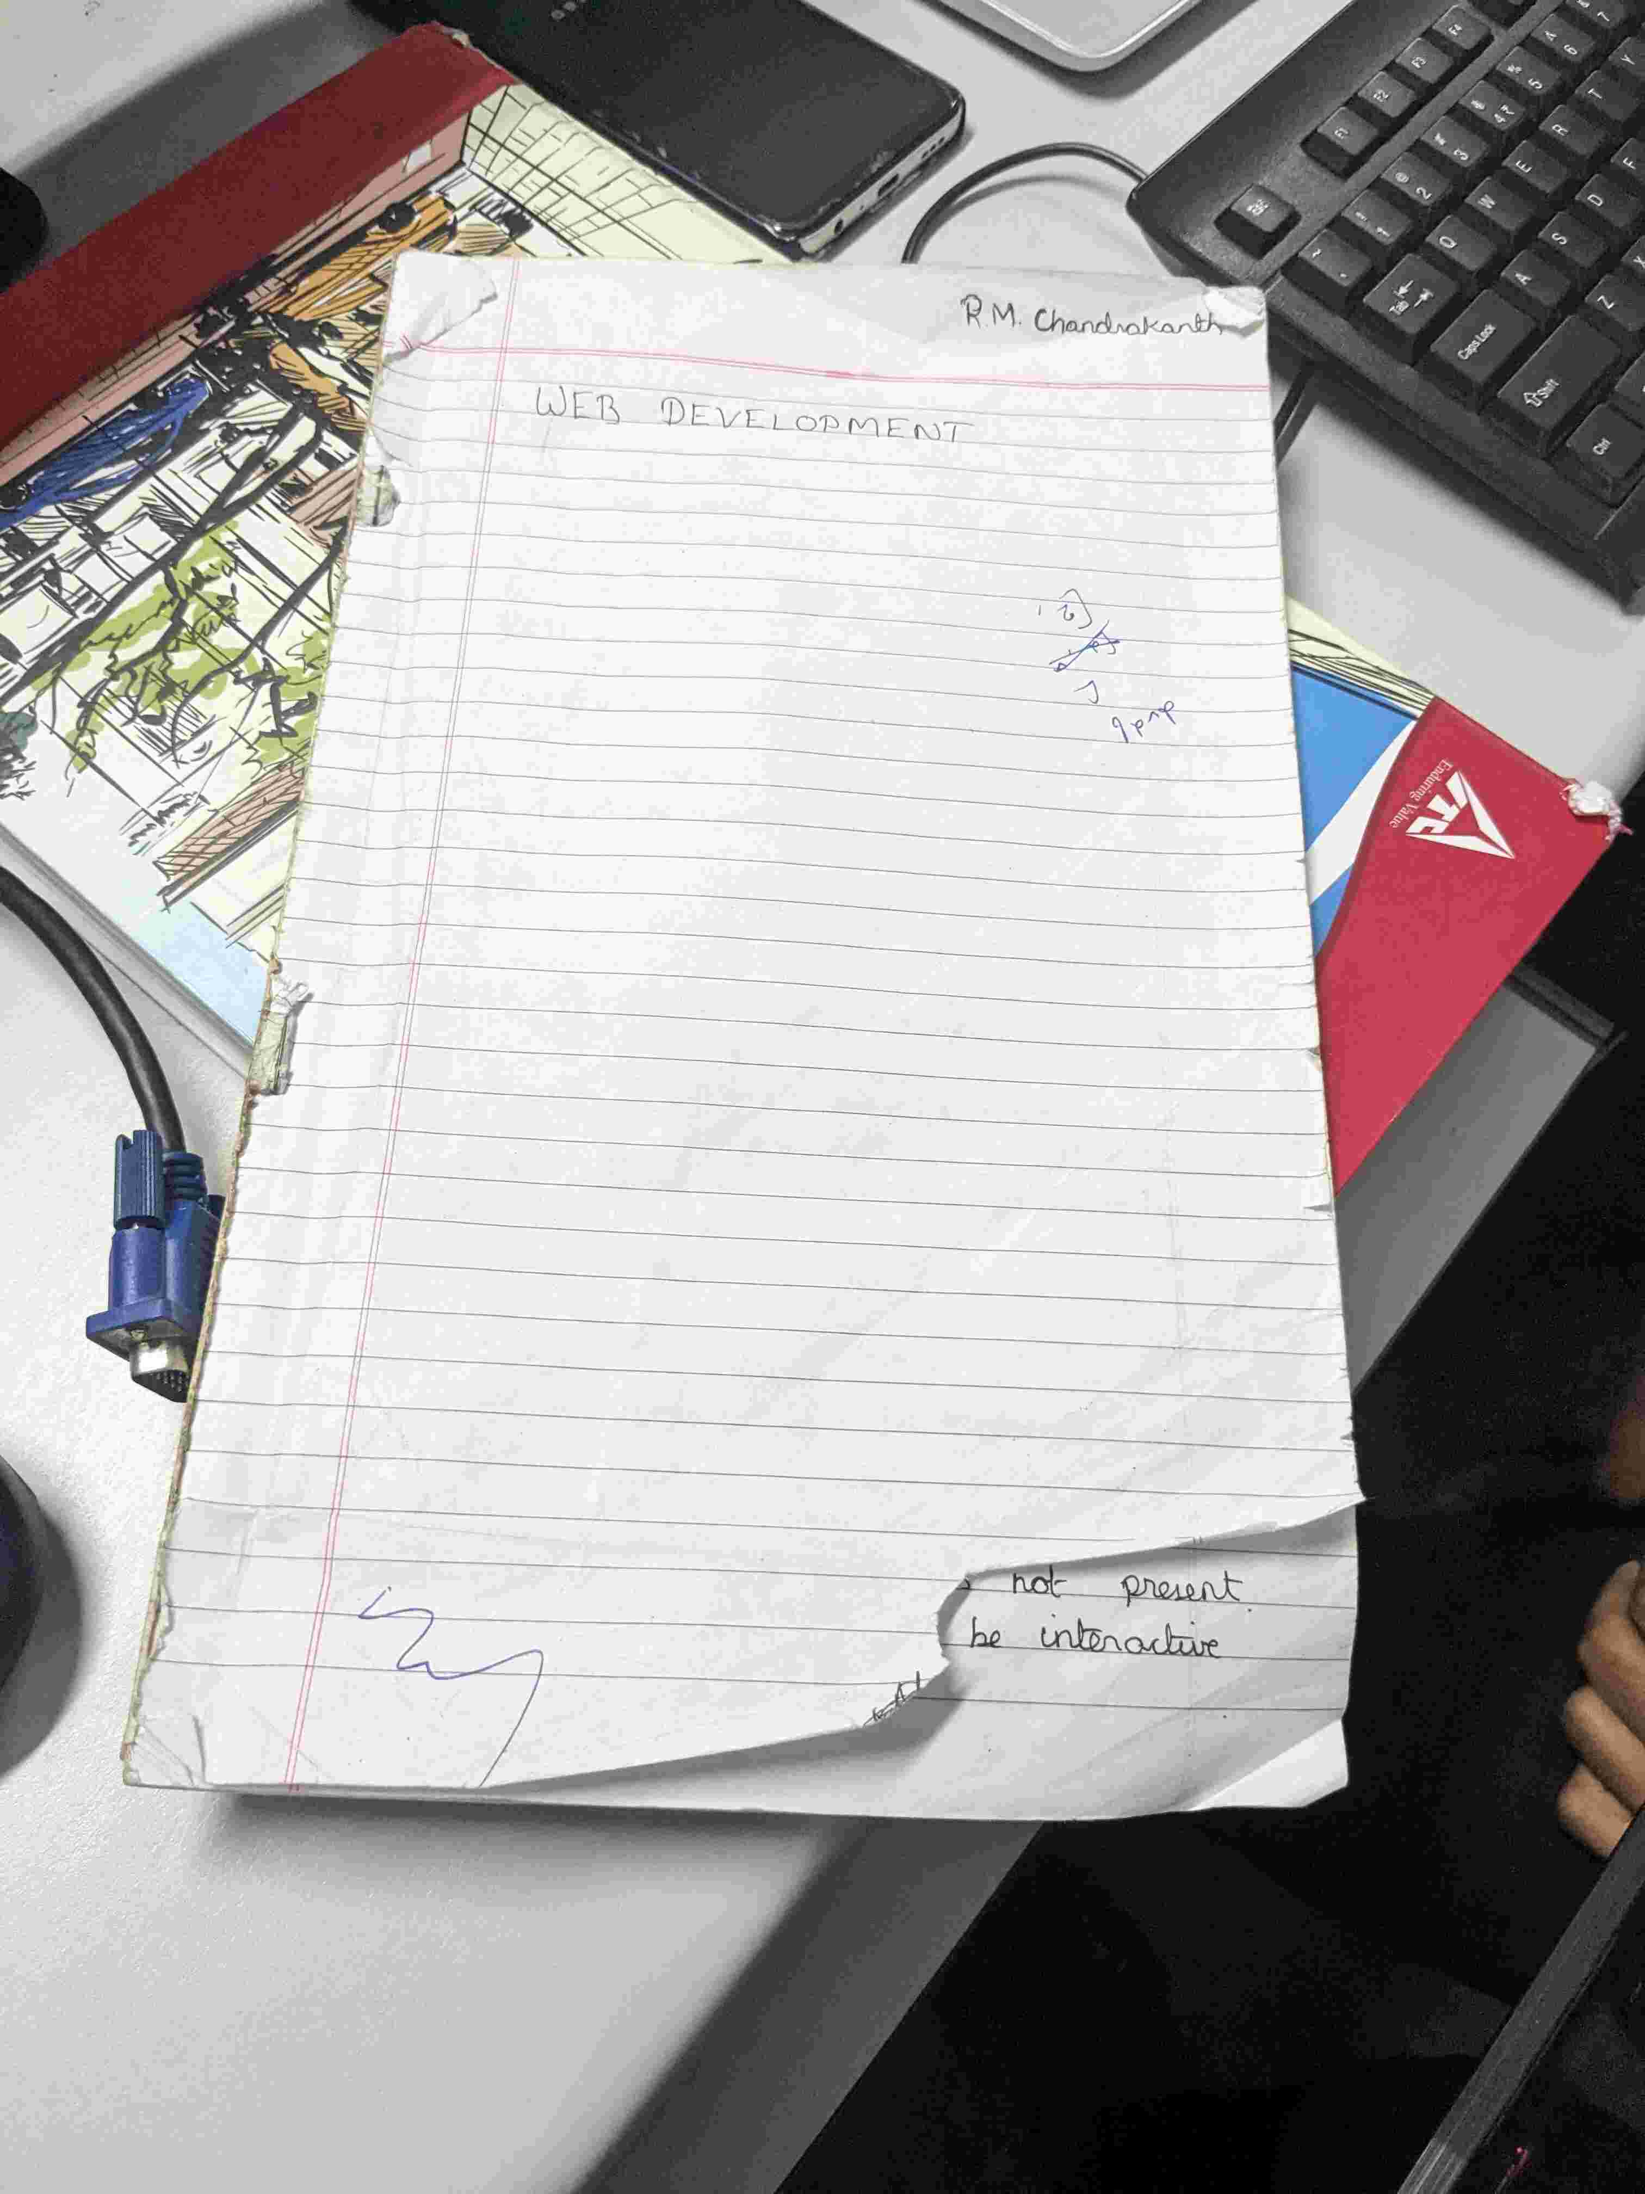

Uploaded at: 2024-07-05 09:32:52.307524+00:00

response:  
GenerateContentResponse(  
 done=True,  
 iterator=None,  
 result=glm.GenerateContentResponse({'candidates': [{'content': {'parts': [{'text': 'The bottom right corner of the notebook paper is torn, where the writing "not present\\nbe interactive" is. \n'}], 'role': 'model'}, 'finish_reason': 1, 'index': 0, 'safety_ratings': [{'category': 9, 'probability': 1, 'blocked': False}, {'category': 8, 'probability': 1, 'blocked': False}, {'category': 7, 'probability': 1, 'blocked': False}, {'category': 10, 'probability': 1, 'blocked': False}], 'token_count': 0, 'grounding_attributions': []}]}),  
)