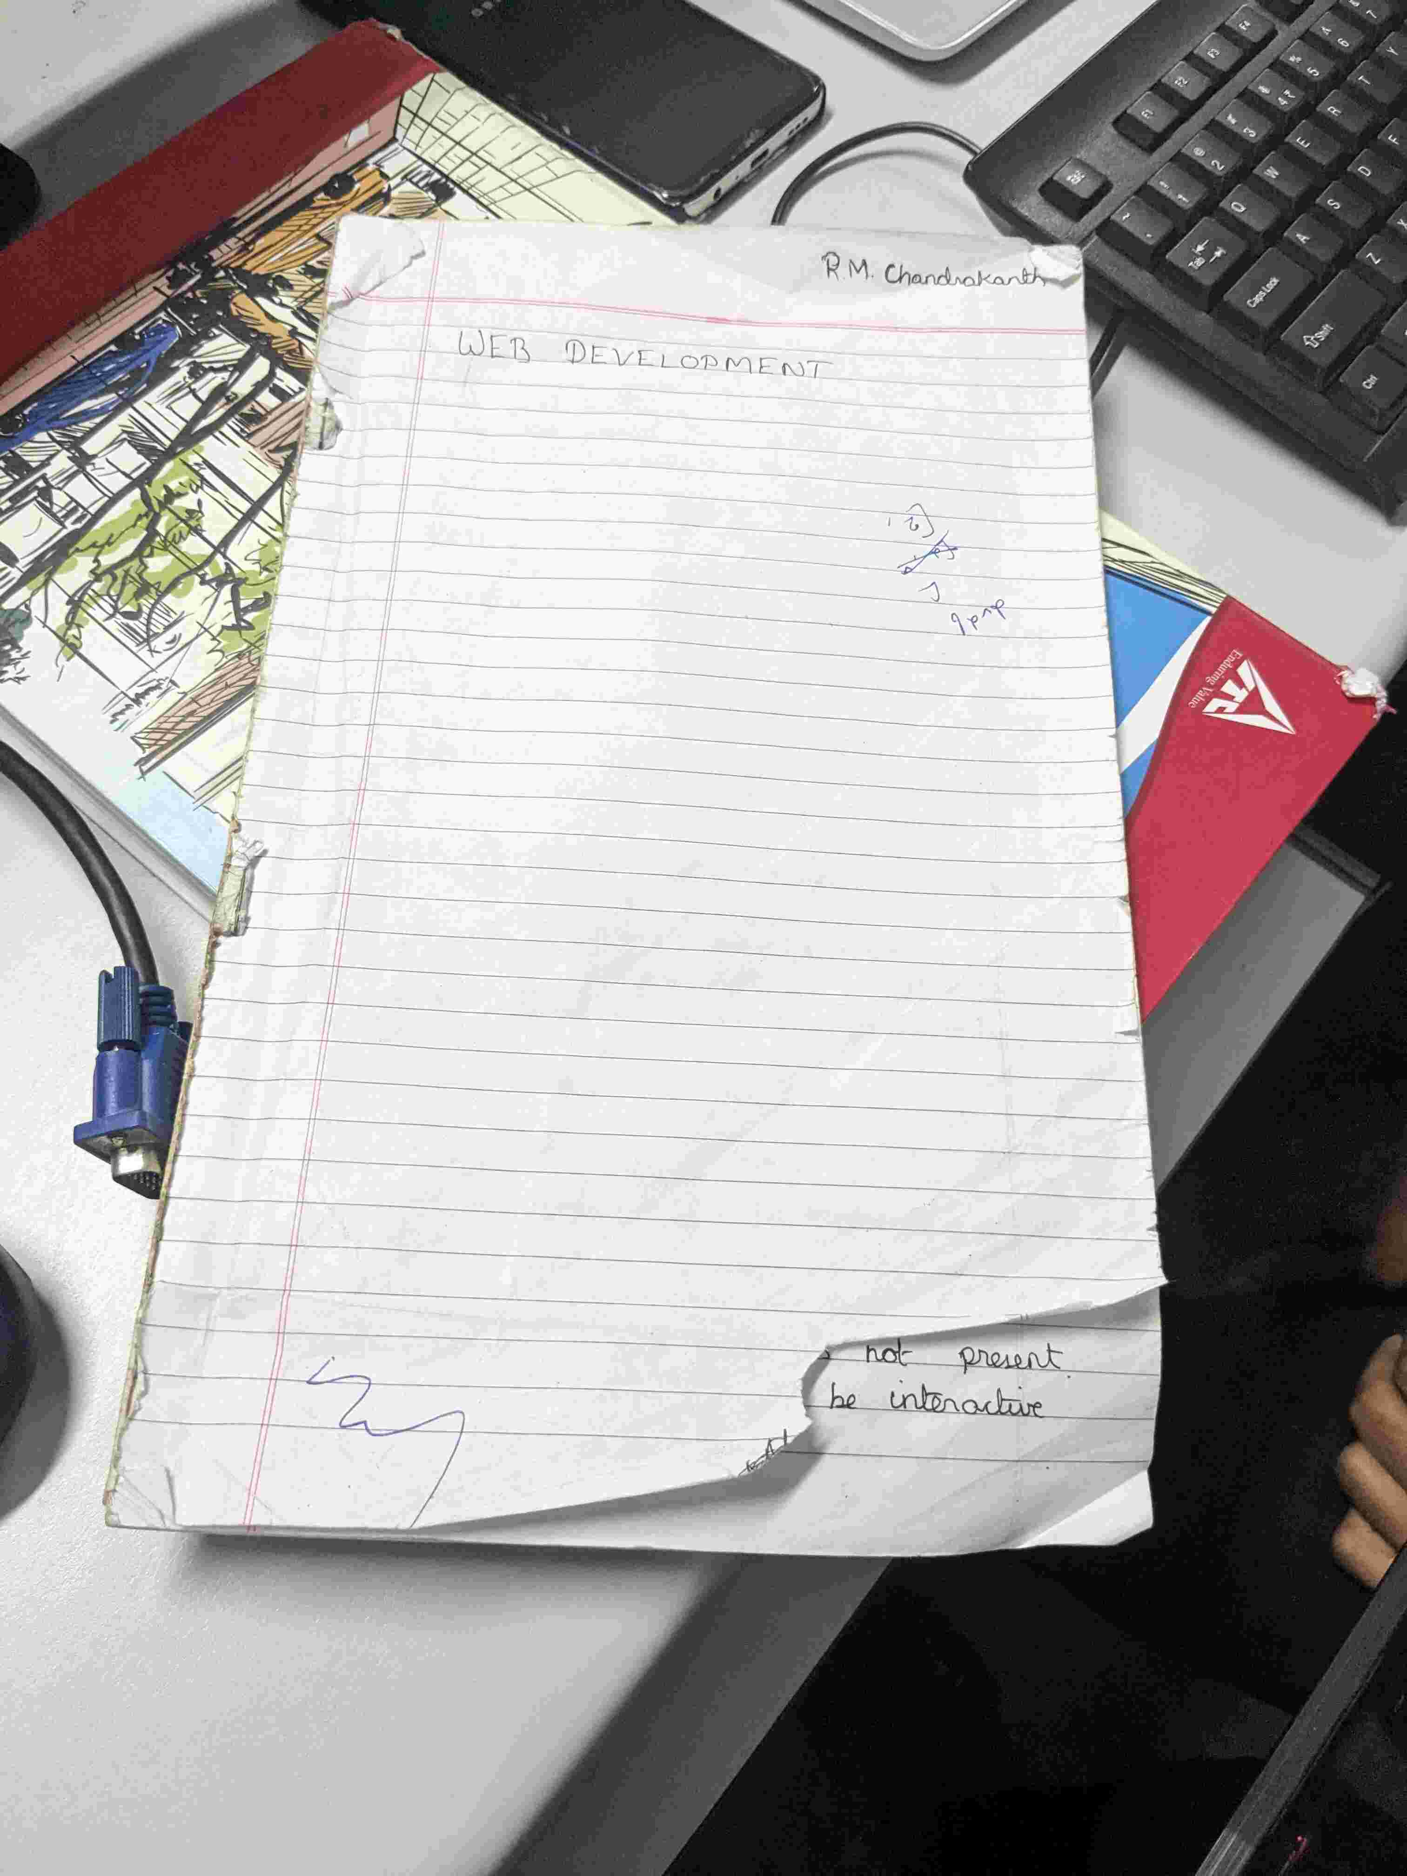

Uploaded at: 2024-07-05 09:40:03.157555+00:00

The paper is torn on the bottom right corner.