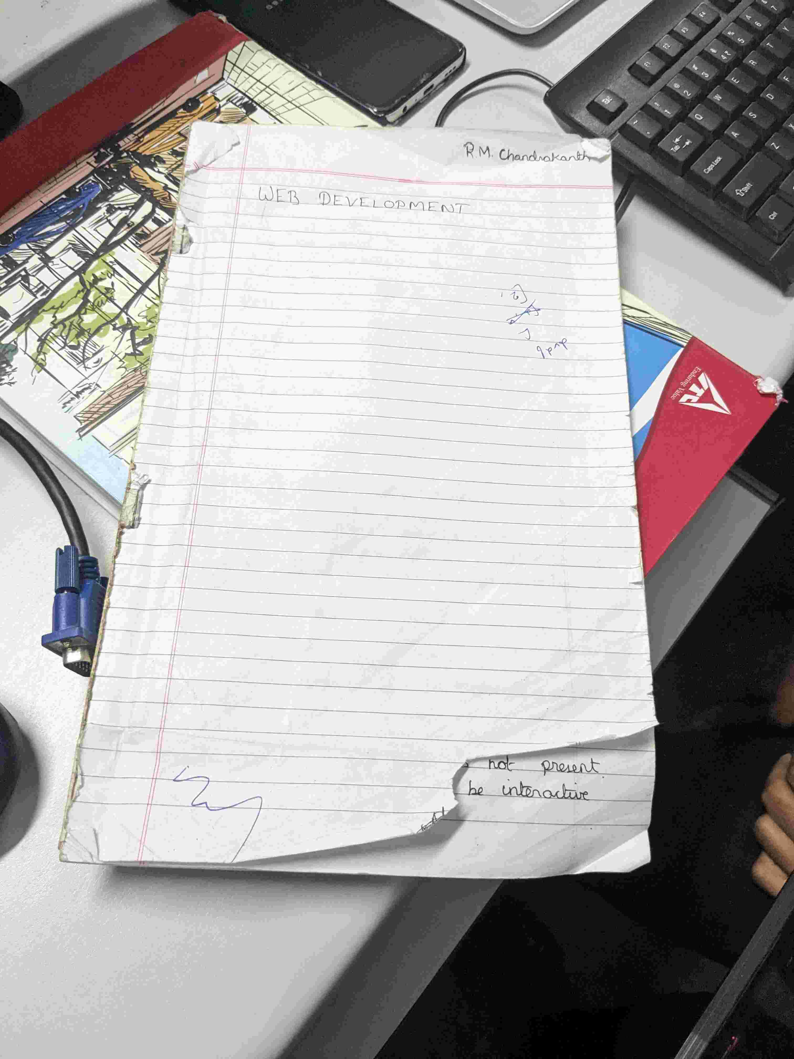

Uploaded at: 2024-07-05 09:48:51.182616+00:00

Gemini Response Summary:

The paper is torn on the bottom right corner.

