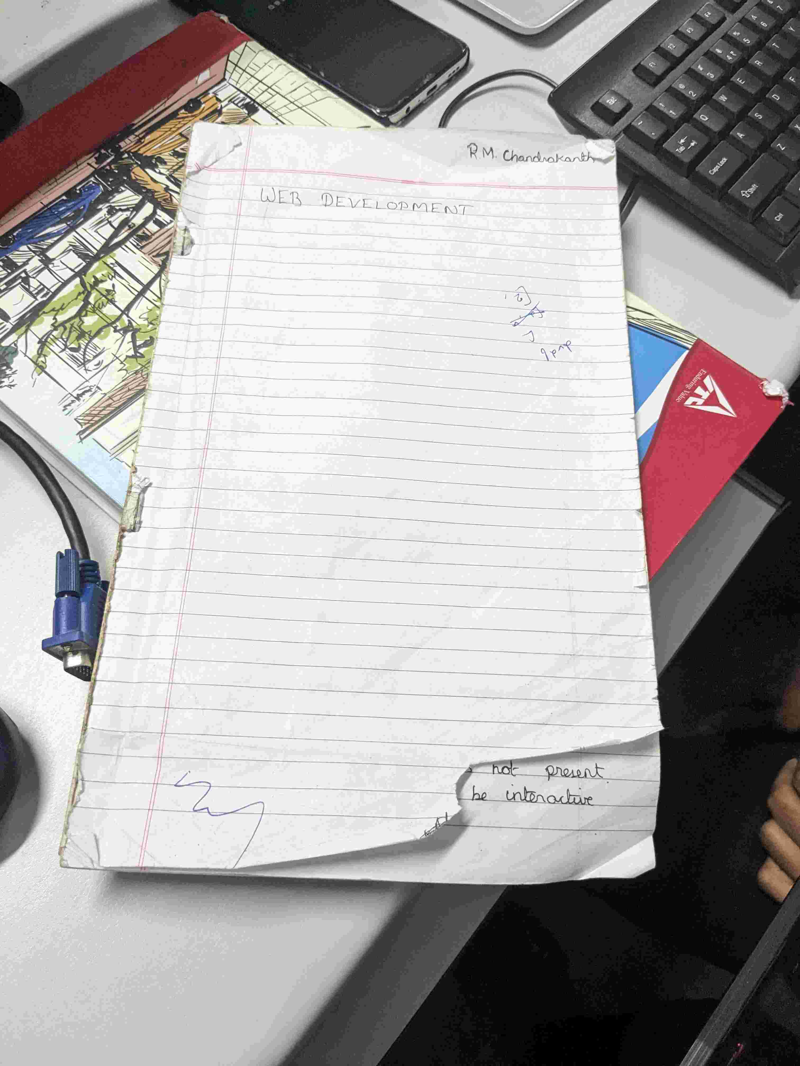

Uploaded at: 2024-07-05 09:57:49.542217+00:00

Gemini Response Summary:

Yes, the bottom right corner of the paper is torn.

