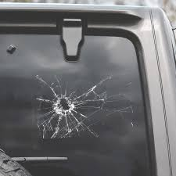

Uploaded at: 2024-07-05 10:02:44.934047+00:00

Gemini Response Summary:

The vehicle window glass is damaged. There is a large, spiderweb-like crack located in the center-left of the image.

