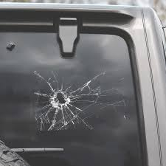

Uploaded at: 2024-07-05 10:05:17.703284+00:00

Gemini Response Summary:

The vehicle window has significant damage - there's a large, spiderweb-like crack in the glass a little to the left of center.

