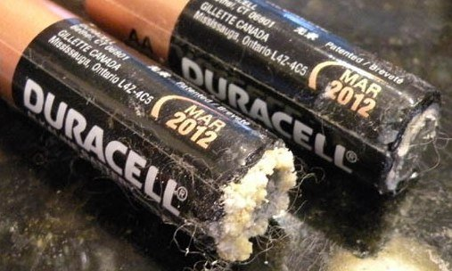

Uploaded at: 2024-07-05 09:18:18.354577+00:00