**LINUX COMMANDS:**

## Command 1: pwd

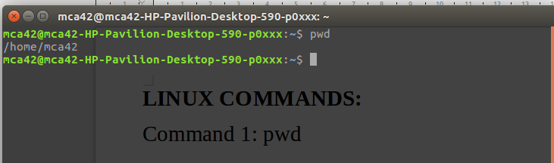

## Command 2: dir

## 

## Command 3: a.ls

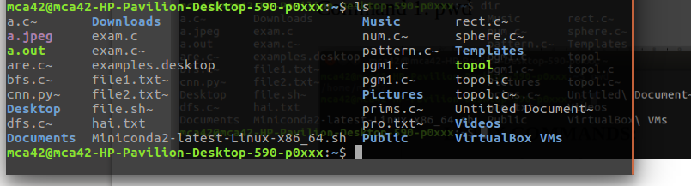

b.ls -al

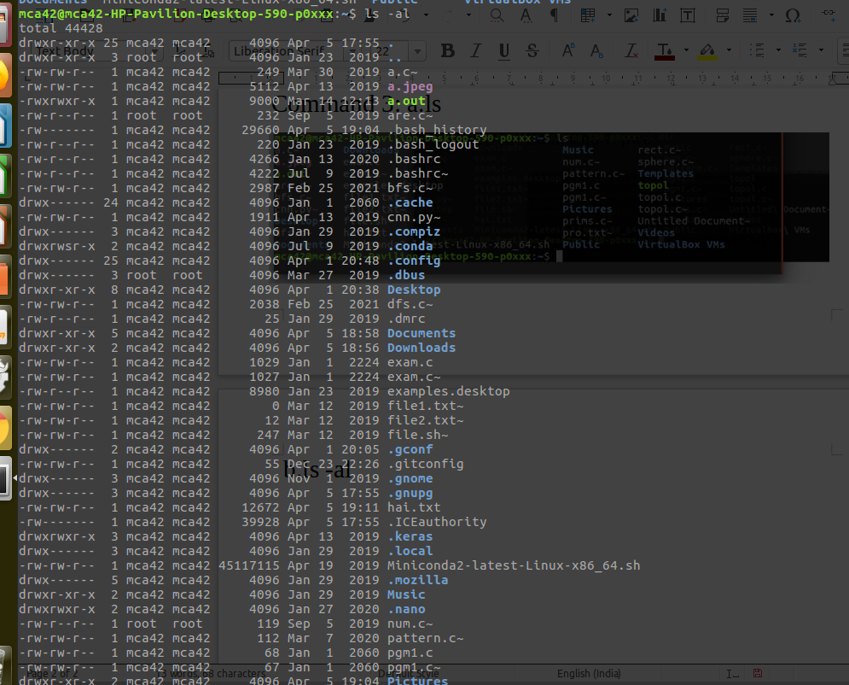c.ls -R

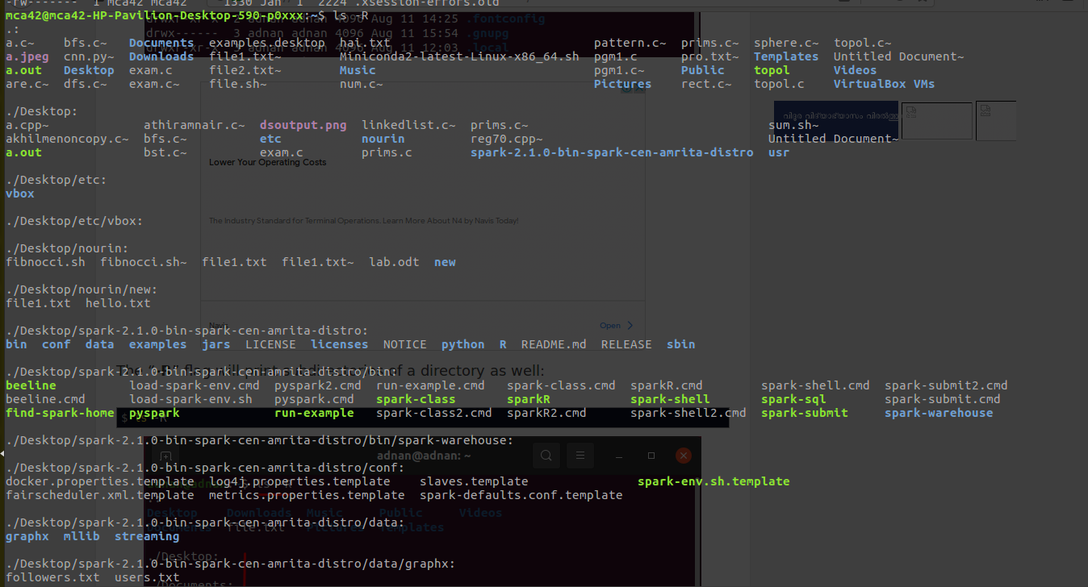d.ls -a

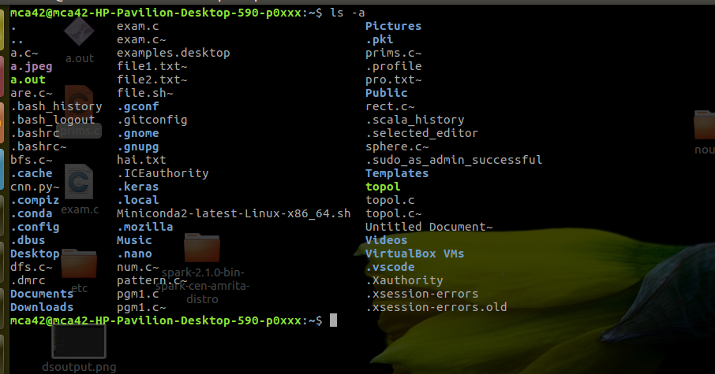

## **Command 4: cd**

## 

## **Command 5: touch**

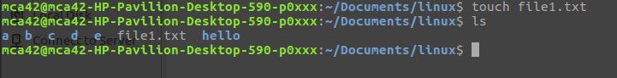

## **Command 6: cat – show’s the content inside the file.**

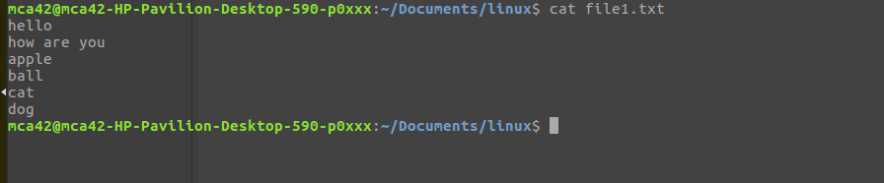

## **Command 7: mkdir**

## 

## **Command 8: rm**

## 

## **Command 9: cp**