Date - 07-04-22

**the remaining linux commands:**

1.ping command (to check the connectivity to your server)

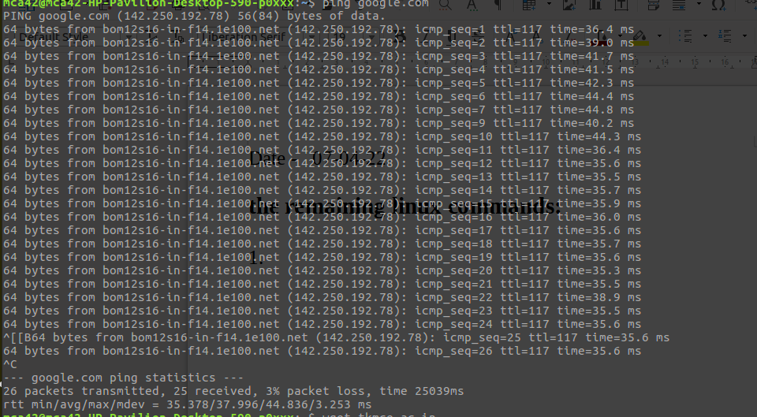

2.wget command(to download the content from the internet)

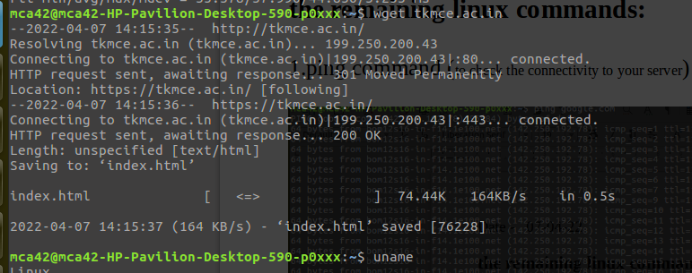

3.uname command



a.uname -s



b.uname -o

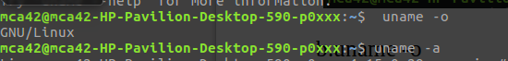

c.uname -a



4.top

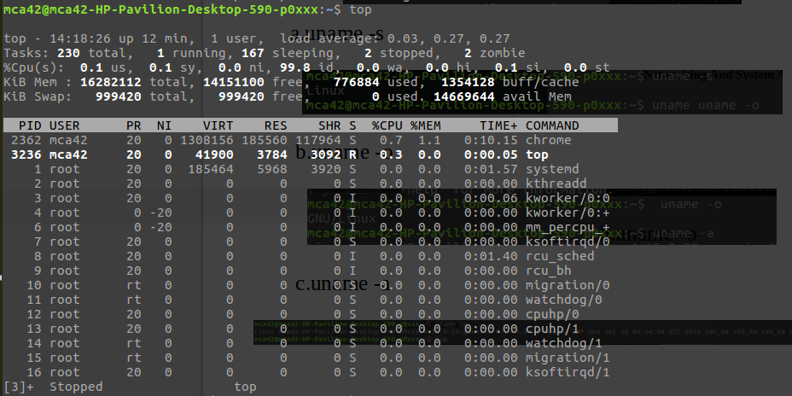

5.history command

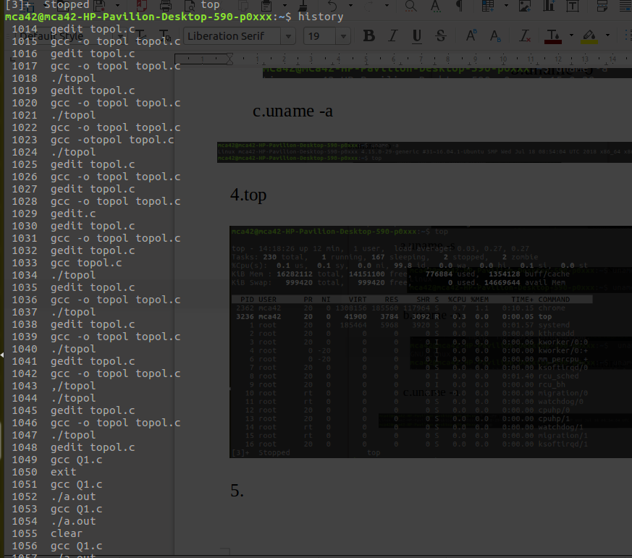

6.man

a.man tail

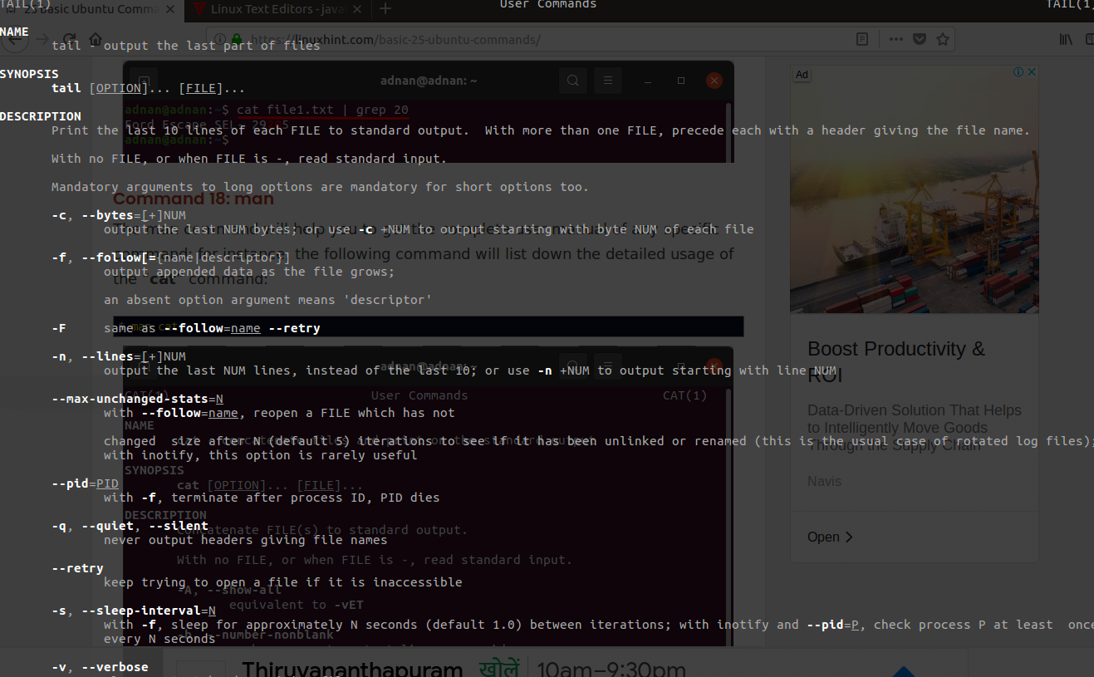

b.

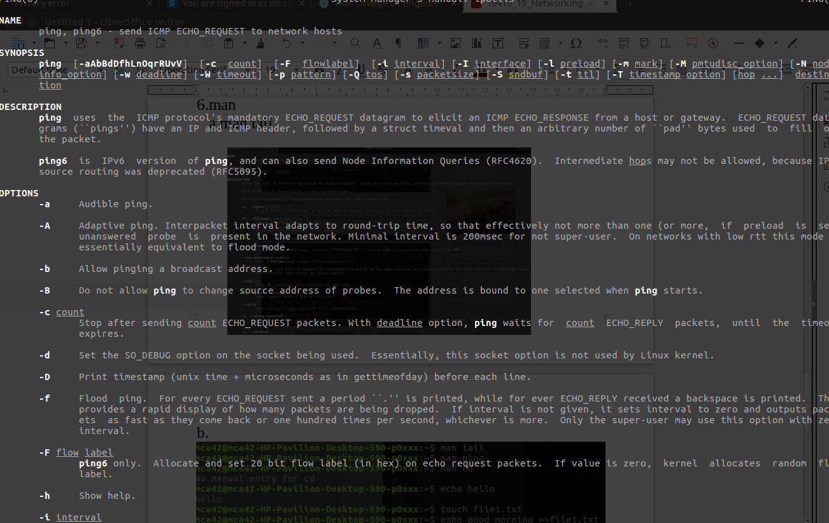

7.echo command



8.echo file(inside we can type contents)



9. hostname

