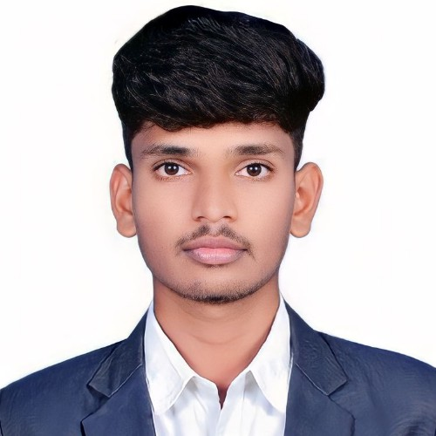[chandrakanthc663@gmail.com](mailto:chandrakanthc663@gmail.com) 9113678870

https://www.linkedin.com/mwlite/in/chandrakanth-k-s-15a362249

As a beginner in the field of Information Technology, I strive to associate myself with an organization where I can utilize my skills in the best possible manner, which further gives me an opportunity to grow in my career journey while contributing to the development of the organization.



Karpagam Academy of Higher Education

8.89 CGPA (Up to 3rd Sem)





Christ PU College 81%

Unique International School 89%



C HTML CSS

Python Android studio

Machine learning Java

App & Web development Programming Languages Machine learning algorithms Cloud Computing

Completed an Internship training on 'Python Programming' for 15 days in Pantech E-Learning Pvt Ltd, Chennai, (July 2022)

Completed an internship training on 'Web Development Full Stack (React js)' for 15 days in Pantech E-Learning Pvt Ltd, Chennai, (January 2023)



In this project, I led the creation of an advanced AI system for detecting phishing using Machine Learning (ML) and Generative Adversarial Network (GAN) technologies. Phishing attacks are a huge danger to cybersecurity, and traditional detection systems frequently fail to detect extensive and developing phishing schemes. The purpose of this study was to improve the accuracy and robustness of phishing detection mechanisms by combining ML algorithms and GANs.

Certified in 'Introduction to Artificial Intelligence' by Infosys Springboard in 2022 Certified in 'Basics of Python' by Infosys Springboard in 2022

Certified in 'Basic C Sharp Programming' by Infosys Springboard in 2022 Certified in 'Building Levels of VR' by Infosys Springboard in 2022

Certified in HACKSPRINT 1.0 from Karpagam Institutions by Dell Technologies held on 5th October, 2023



Photography Painting & Arting Travel

Communication skills Ability to Work in a Team Computer Skills

English Kannada Hindi Telugu



Father's Name: SRINIVAS K N Date of Birth: 27/01/2004

Address: Bingipura, Araleri road, MALUR, KOLAR, KARNATAKA- 563130

I hereby declare that all the details furnished above are true to the best of my knowledge.

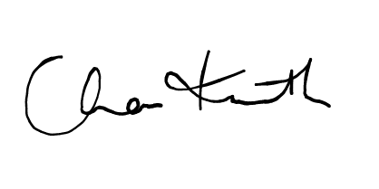

CHANDRAKAKANTH K S