### **Task 1**

* Demonstrate minimum 15 basic Git command with explanation and screenshot.

## **1. git config**

This command is used to configure an author name and email associated with your git activities.

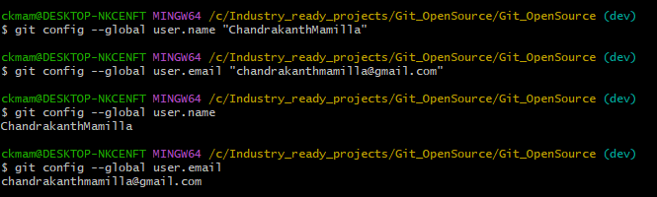

## **2. git init**

This command is used to initialize a new git repository.



## **3. git clone**

This command is used to clone a remote git repository.

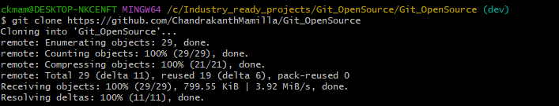

## **4. git add**

This command is used to add files to the staging.



## **5. git commit**

This command is used to record a file permanently in the project version history. It is a standard to add a message associated with the commit.

For committing your staged changes.

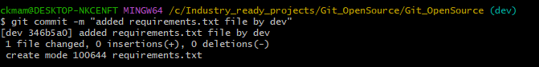

For committing both staged and unstaged files.

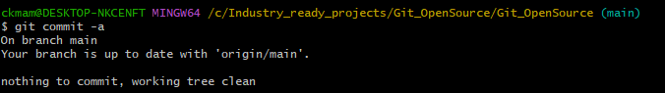

## **6. git status**

This command is used to lists all the committed files.

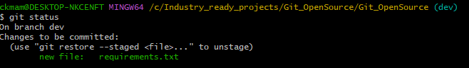

## **7. git rm**

This command is used to delete a specific file from the current working directory and stages the deletion.



## **8. git log**

This command is used for listing the version history of the current git branch.

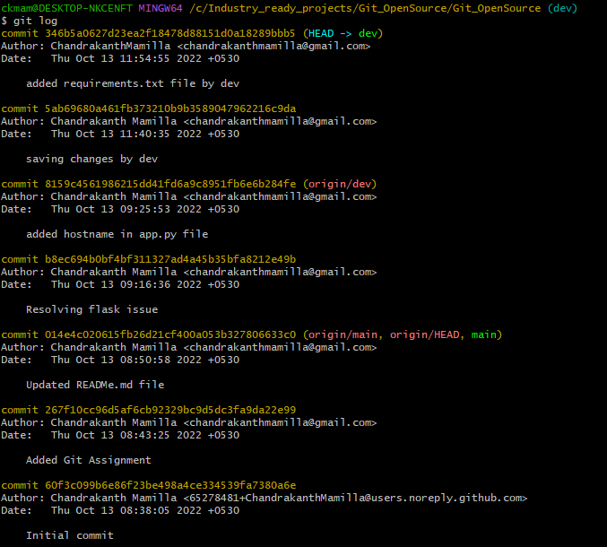

## **9. git branch**

This command is used to create a branch from the current working directory.

Creating a new branch:



Deleting the feature branch:



## **10. git checkout**

This command is used for switching among different git branches.

Checkout a git branch:



Create a new branch and switch into it:

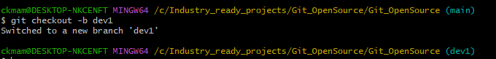

## **11. git merge**

This command is used to merges the specified branch with the current branch.

Merging two branches:

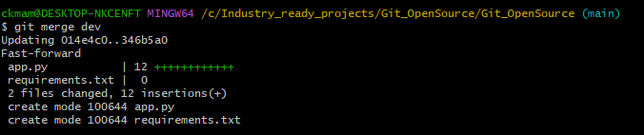

## **12. git push**

This command is used to send your staged changes to the remote repository.

Commit the staged changes to the remote repository.



## **13. git pull**

This command is used to get the changes in the remote repository and merge them to the current working directory.

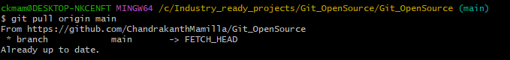

## **14. git remote**

Lists the remote connections you have to other repositories. In other words, the git remote command lets you create, view, and delete connection to other repositories.

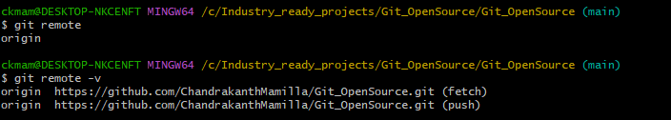

## **15. git fetch**

When we use the command git fetch, git gathers any commits information from the target branch that does not exists in our current branch, and stores it in our local repository. However, it doesn’t merge it with our current branch.

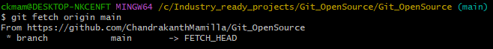

=====================================================================================

### **Task 2**

* Consider that you want to start an open-source project in your organization. Perform all the standard operation to create a repository with minimal permission for all the users. It should contain.

1. Proper open-source structure

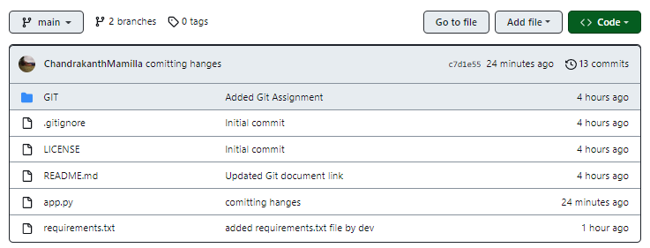

1. Proper Readme

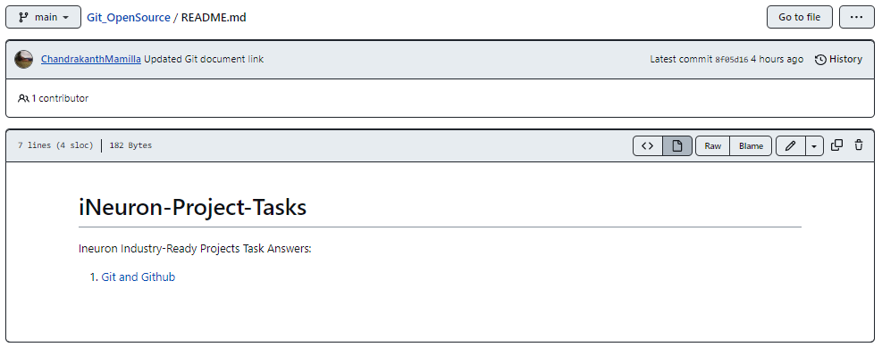

1. Add 2 collaborator

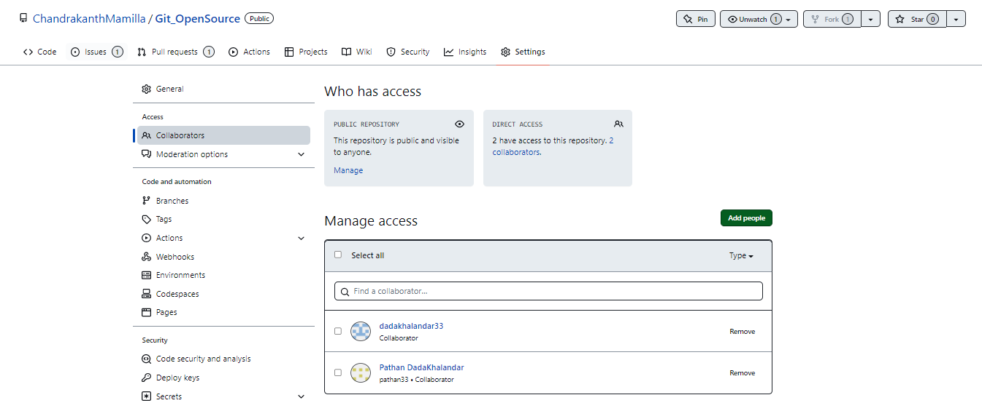

1. Host GitHub Pages using settings (Designed to host your personal, organization, or project pages from a GitHub repository)

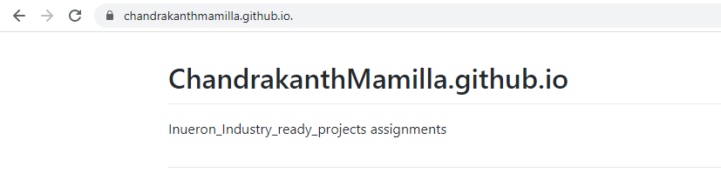

### **Task 3**

1. Create a Issue in your github repository.

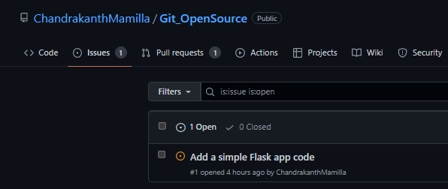

1. Raise a pull request.

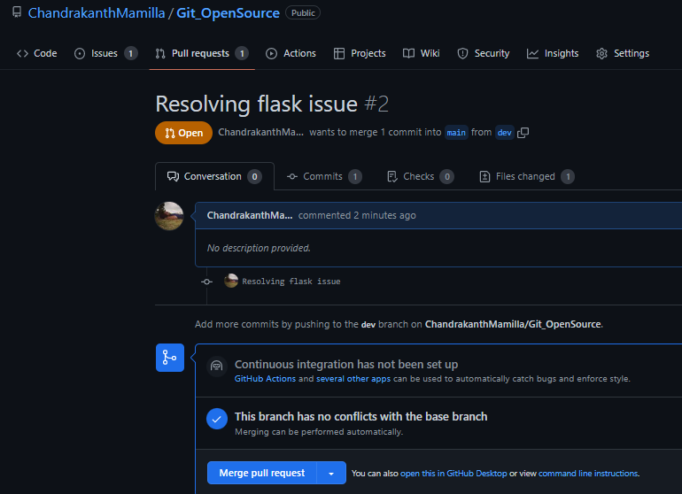

1. Merge A pull request.

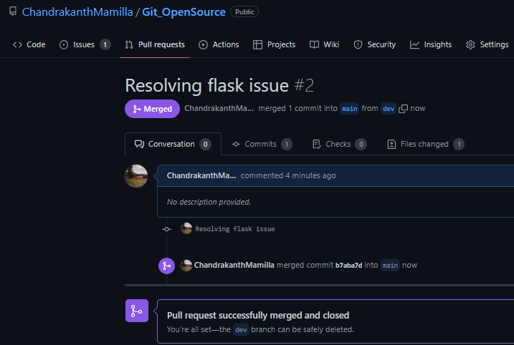

1. Reject a pull request with proper comments.

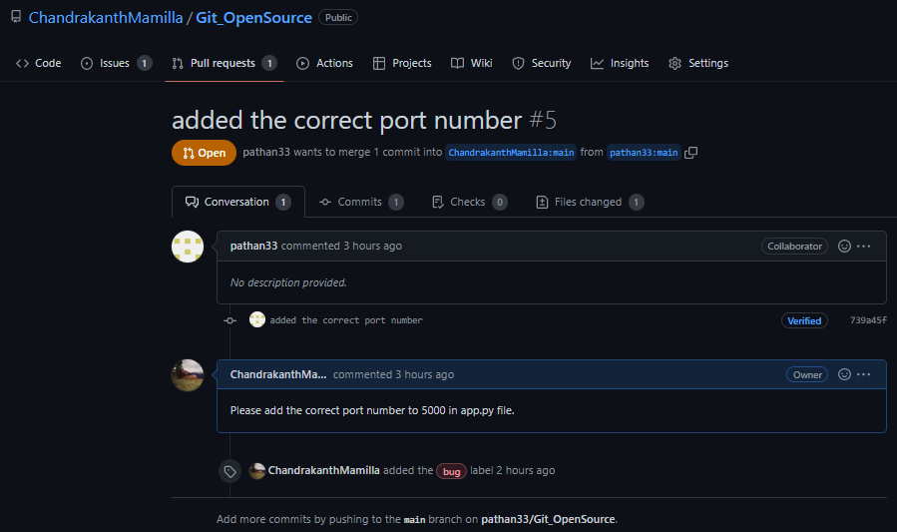

1. Add a Dependabot alerts in your github.(for above cases)



1. Stash changes



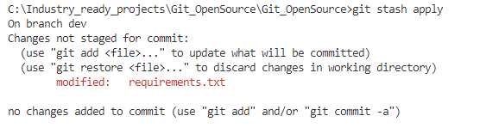

1. Create a release your package

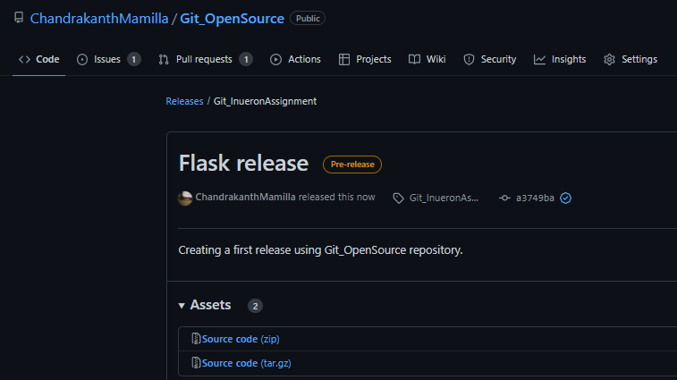

1. Setup a Projects Board for your project.

