Chap 1

Below are the ADAS CAN message receive by camera ECU

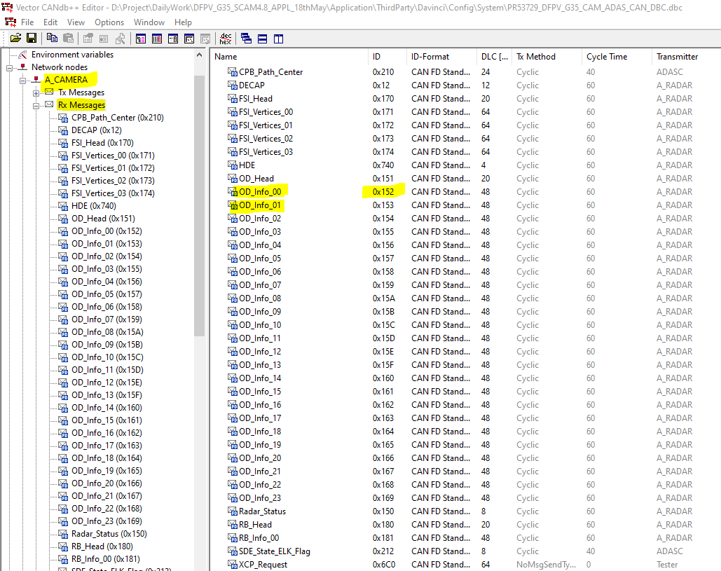

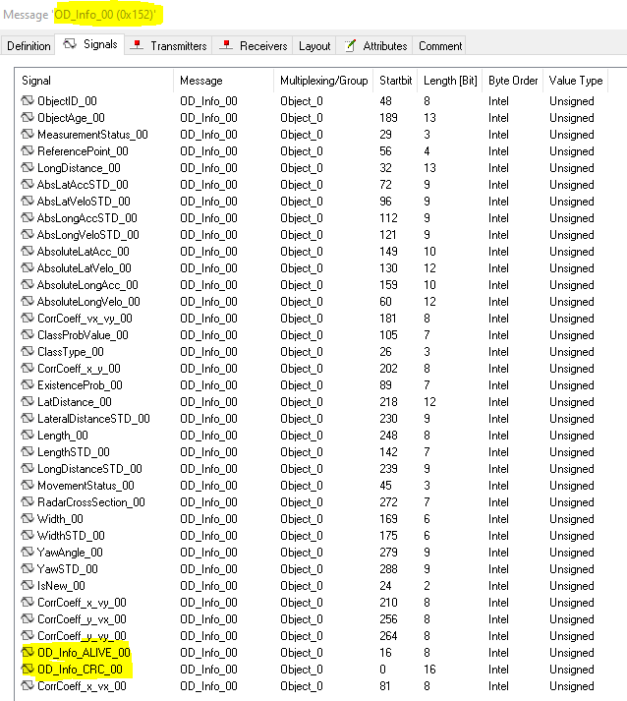

Check below requirement in DOORS for message OD_info_00(0x152) for read

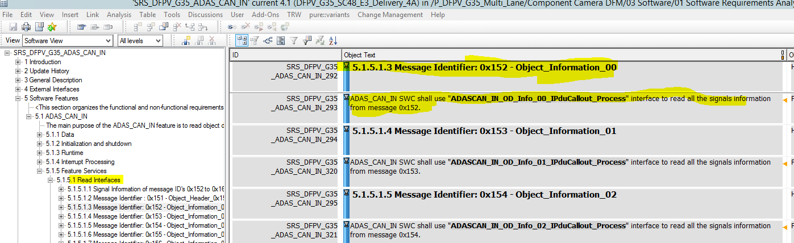

Check below requirement in DOORS for message OD_info_00(0x152) which module interested in this data ,here FRIA

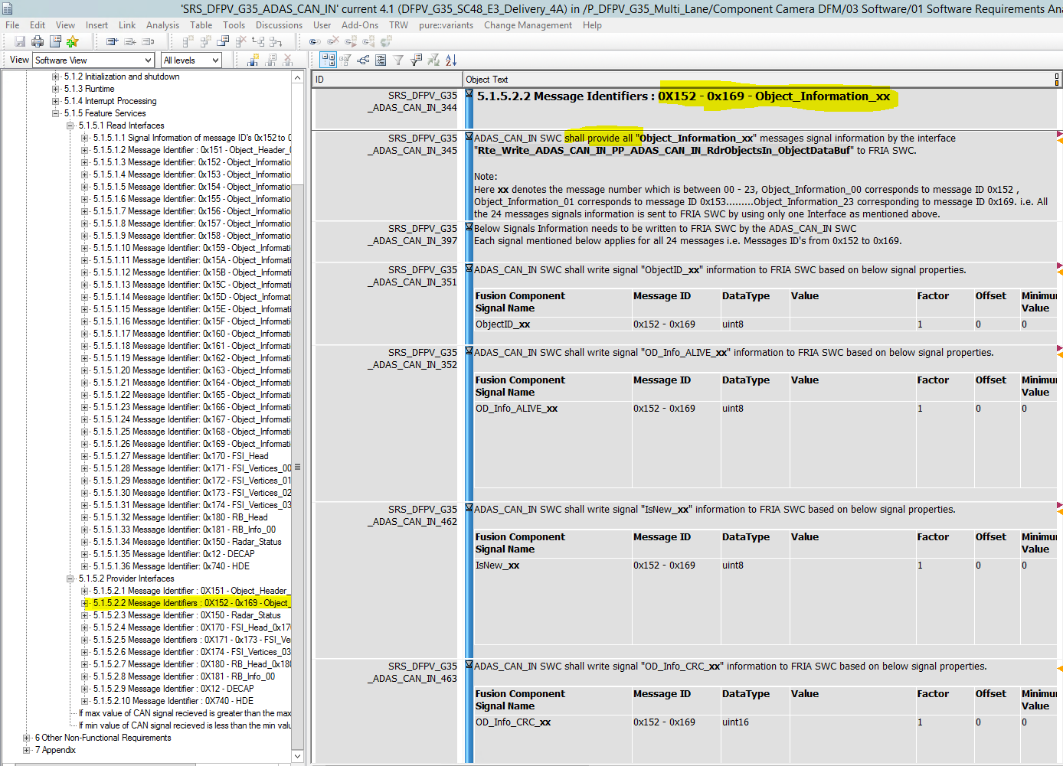

Chap 2

For each message IPdu callout is created in ComIPdus(COM layer).

Check Ipdu callout function for message OD_Info_00 is (ADAS_CAN_IN_OD_Info_00_IPduCallout_Process)

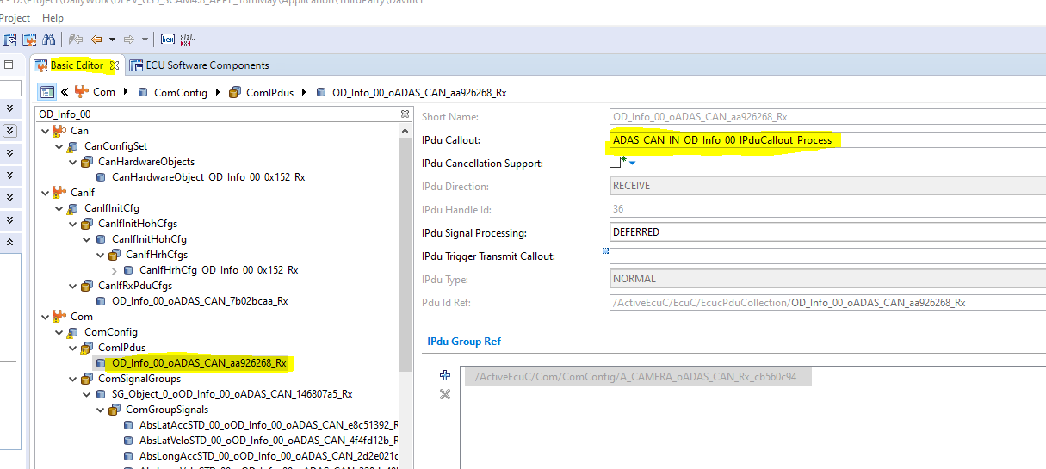

Inside this IPdu callout function whatever we need after message received, we need to implement

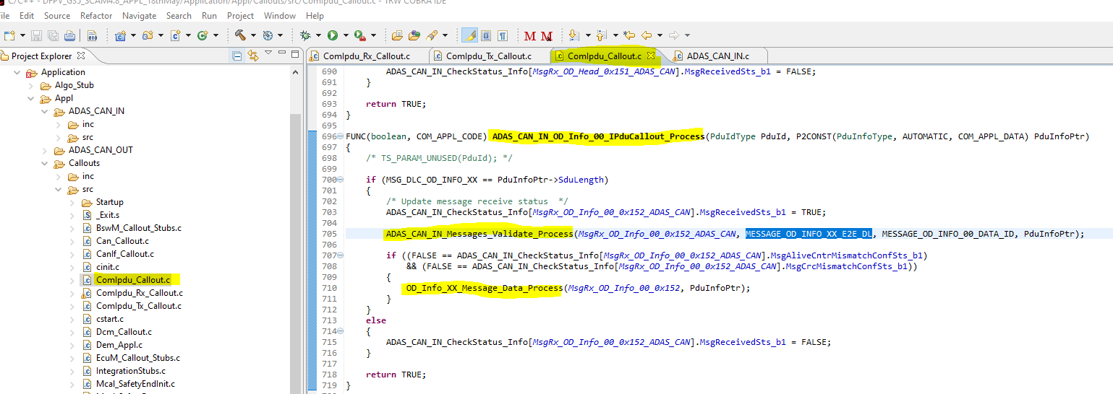

Check above code inside callout function initially Alive counter and CRC will process ( line no 705) inside function



If Alive counter and CRC is ok then we will process further(Line no 710)



Inside this function all signal information extracted from message

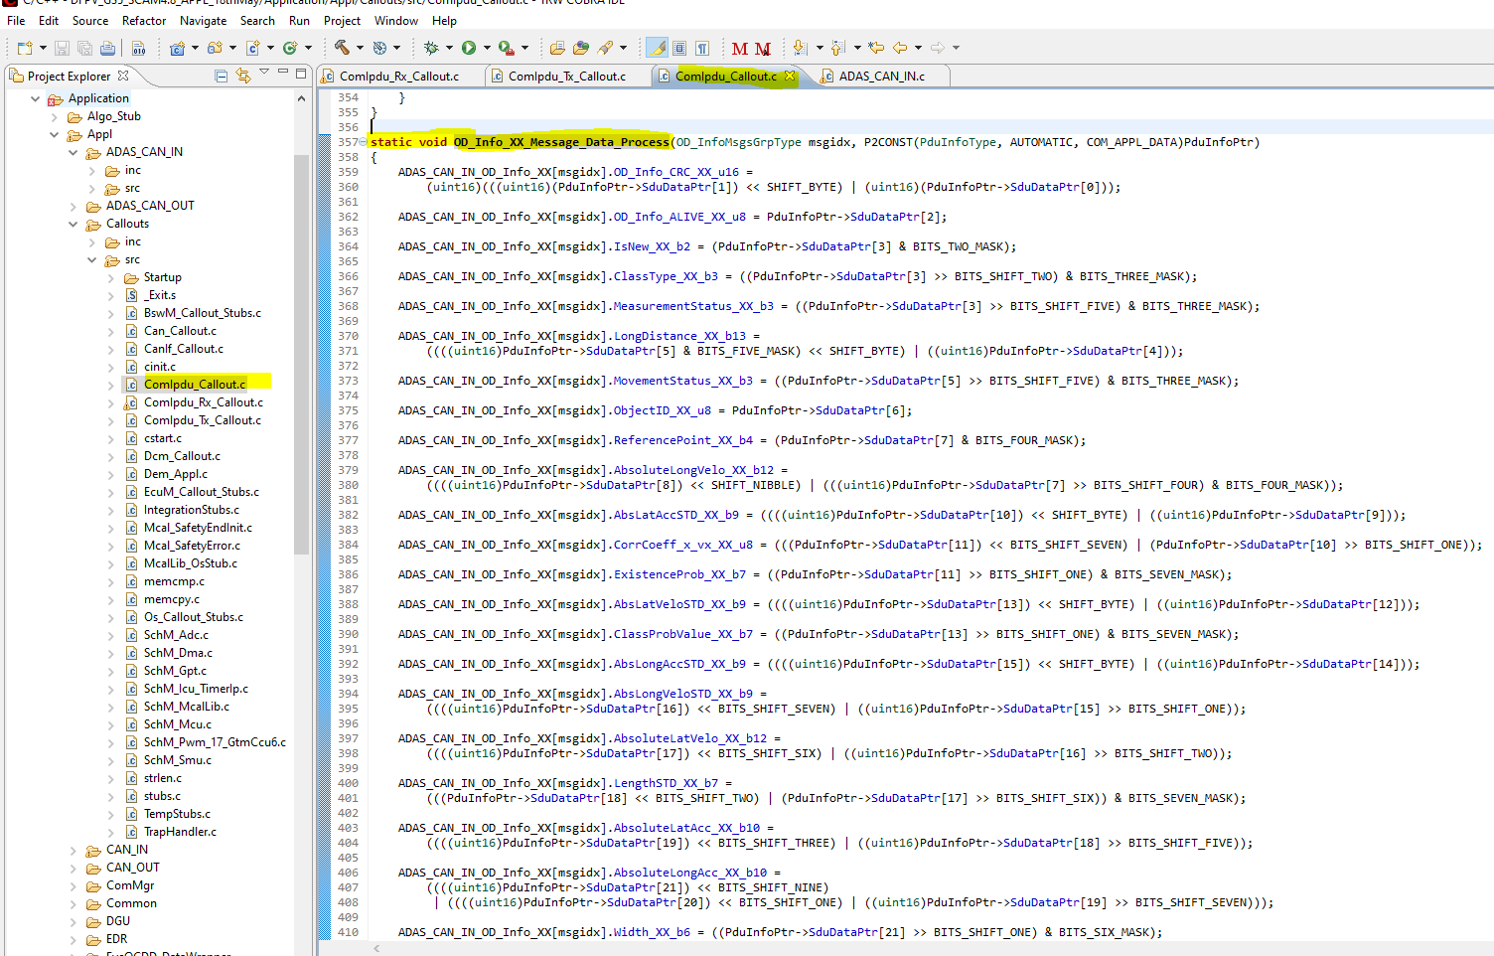

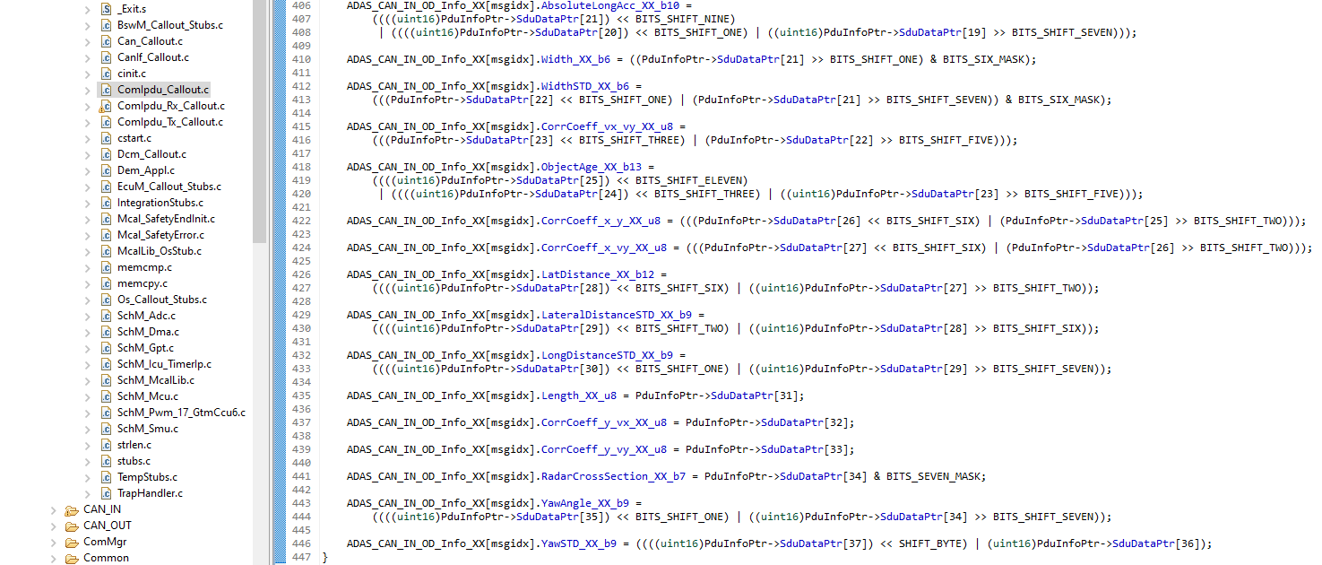

This information filling it into structure ADAS_CAN_IN_OD_Info_XX



This structure has array so all message from OD_Info_00 till OD_Info_23 will fill in this

Chap 3

This structure((ADAS_CAN_IN_OD_Info_XX) will use in ADAS_CAN_IN module to send information to respective interested module (line number 1336)

Check in below image line number 1336 calling function and sending above structure as parameter

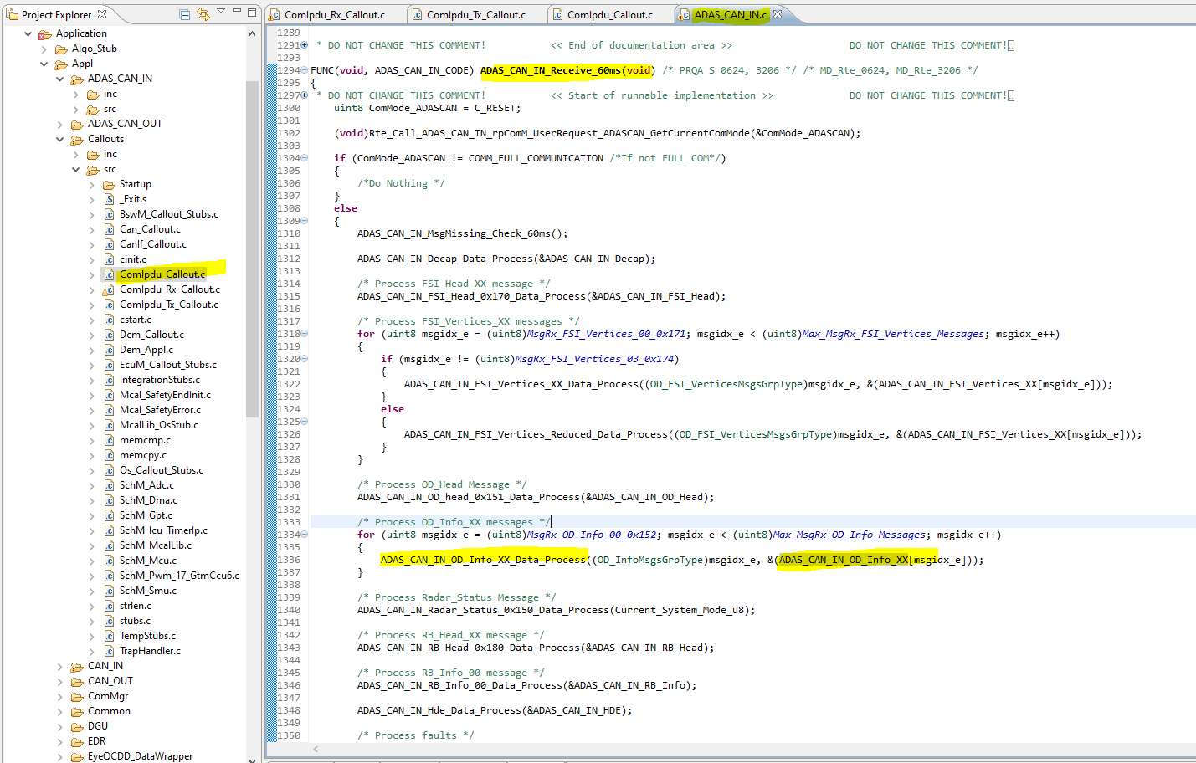

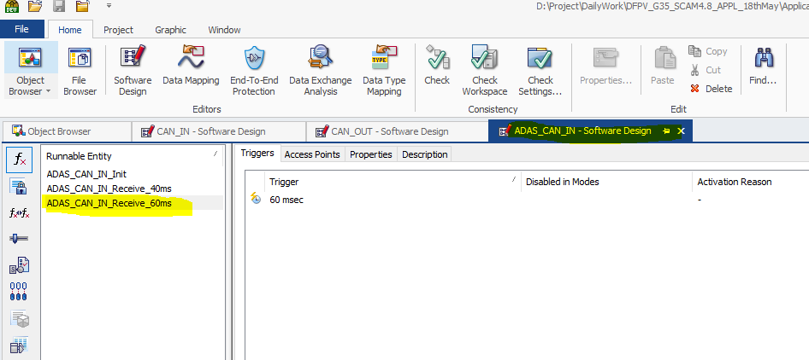

In below image rxData is nothing but that we filled structure

Check line number 1873 ,it is checking value is greater than expected if greater then it will send previous value .

If data is proper then this information will extract from structure and fill it into OdInfoData structure ,check line number 1880 also last valid buffer also filled in use case of error condition (line no-1881)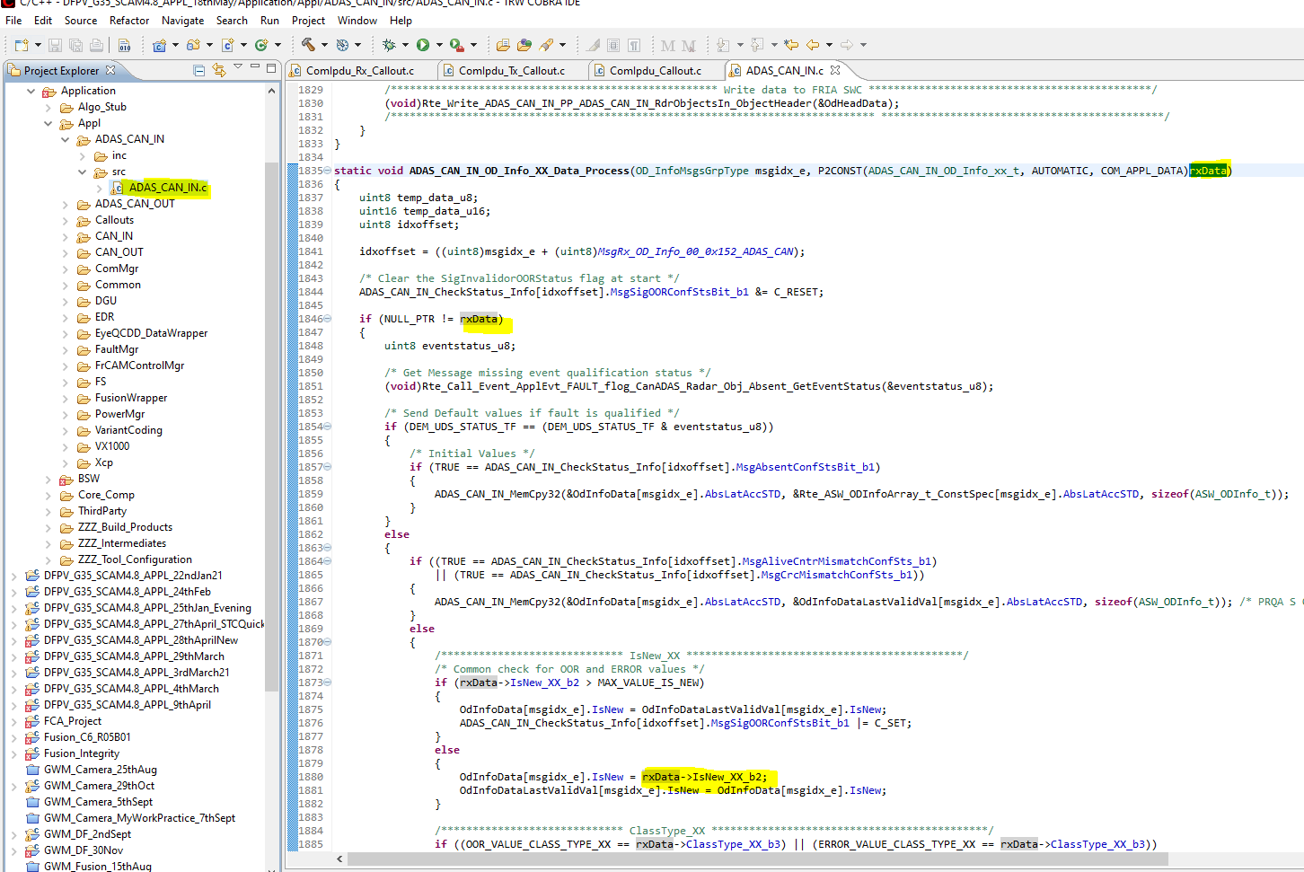

The using OdInfoData structure all information will extract and then it will send to FRIA (line no-2364)

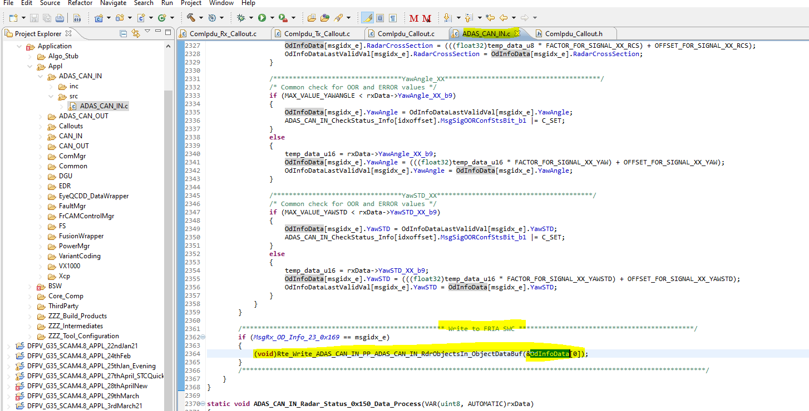

It means we are triggering **ADAS_CAN_IN_Receive_60ms** function every 60ms toprocess and send information to FRIA port  
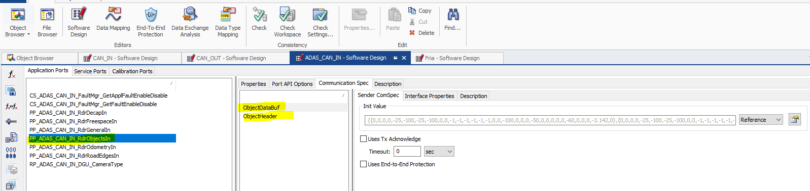

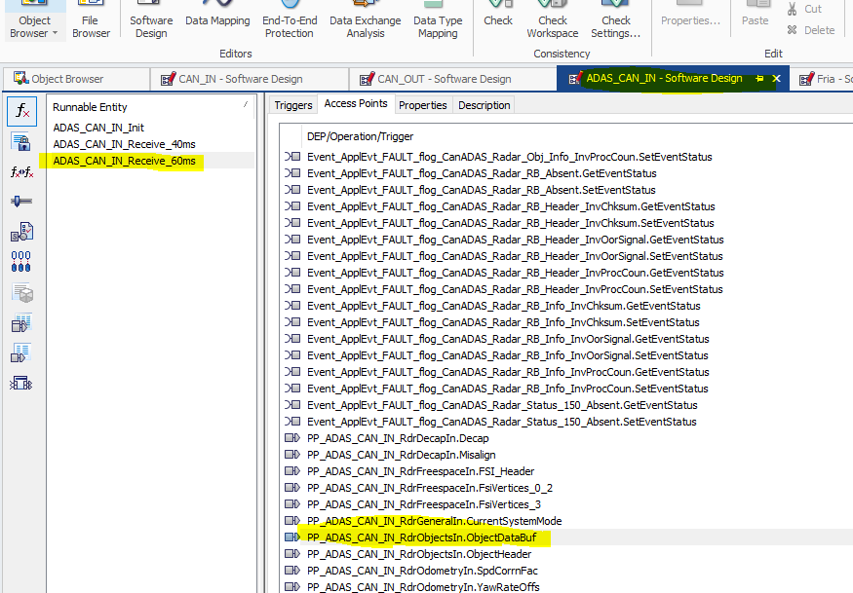

Chap 4

FRIA will read this information on below port in every 50ms.

