Chap 1

Below are the ADAS CAN message transmit by camera ECU

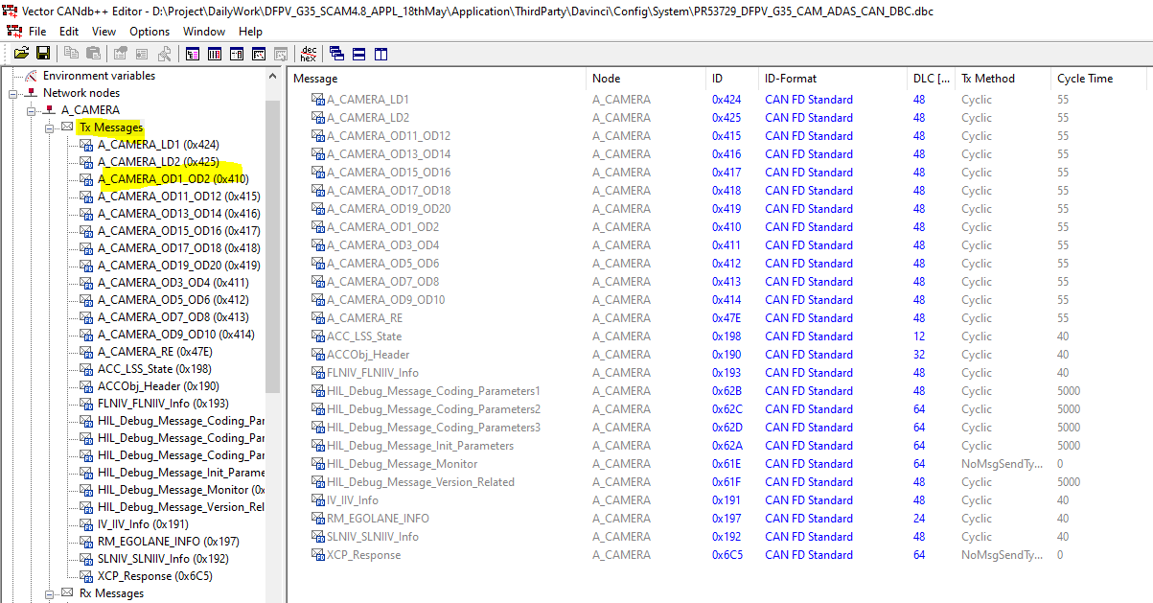

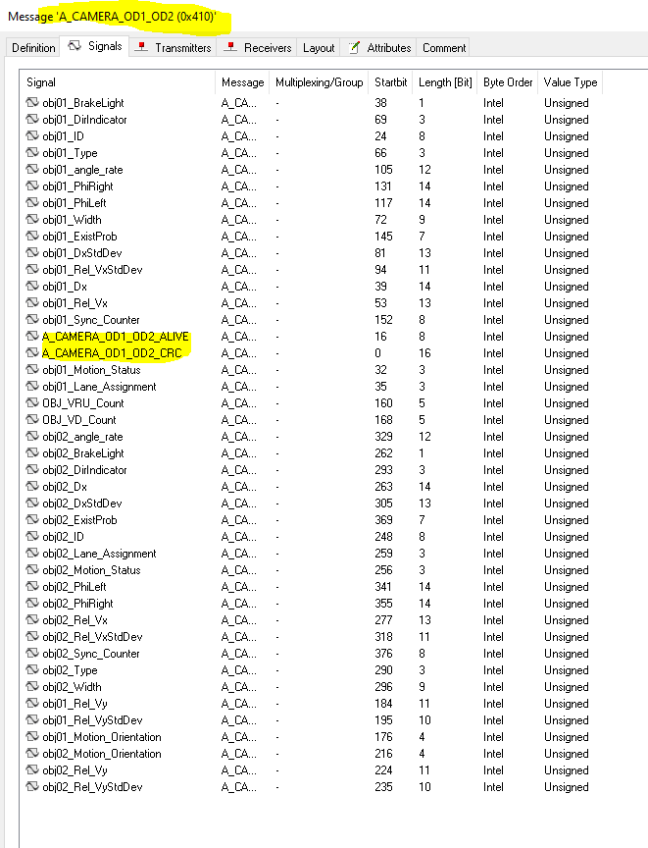

Check below requirement in DOORS for message A_CAMERA_OD1_OD2 (0x410) for read .

This information is nothing but object information which it will read from EyeQCDD

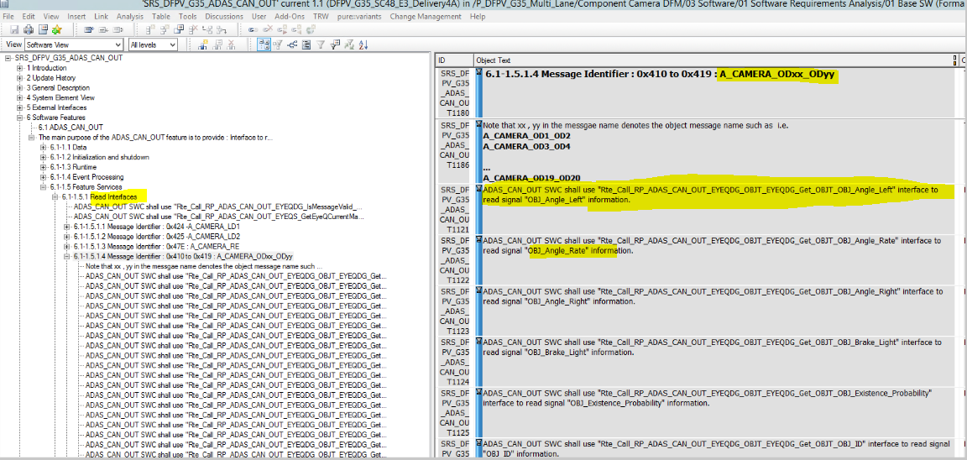

Chap 2

Check below function **ADAS_CAN_OUT_Transmit_55ms**(**void**)( line 3898) which will trigger every 55mses.

Check function ADAS_CAN_OUT_ProcessAndUpdateObjectData()(line 3983) which called inside 55msec.

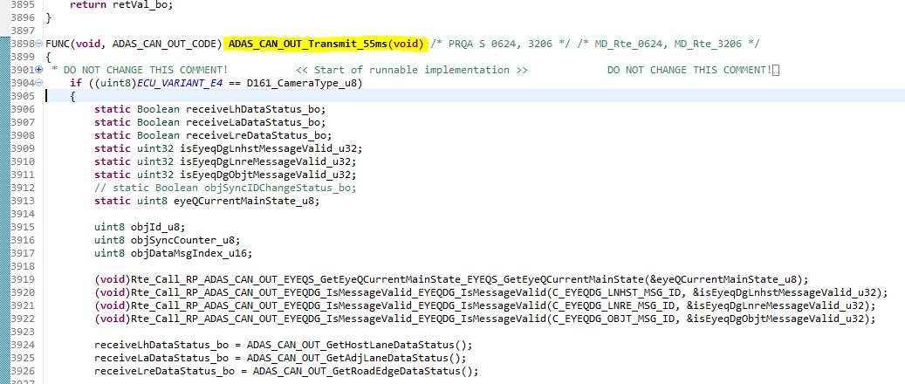

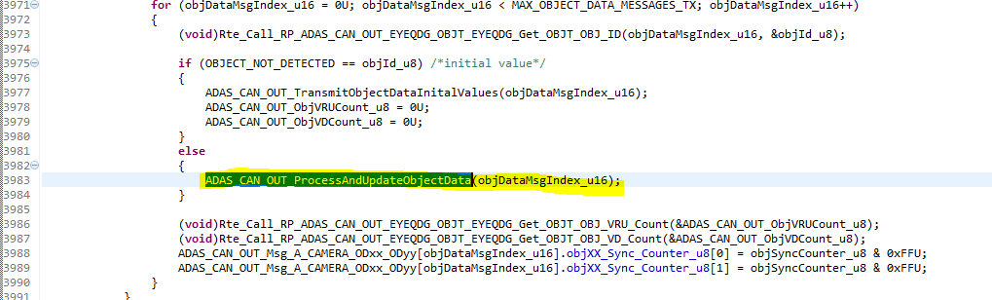

So it is nothing but whatever data requires from EyeQCDD it will read every 55ms

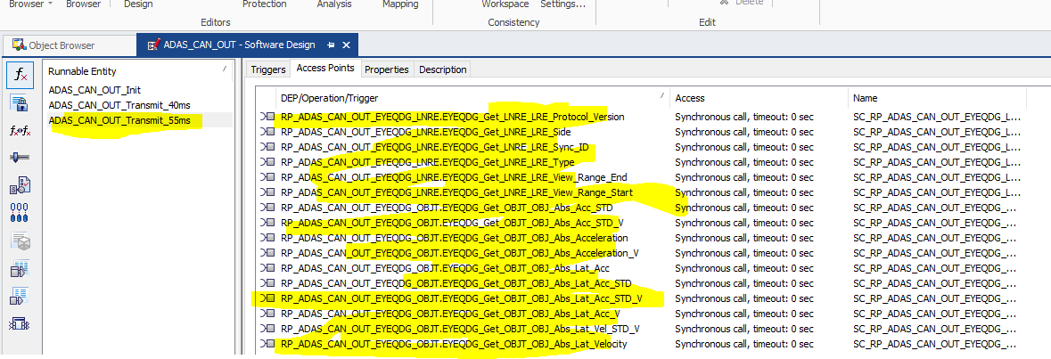

Check function **static** **void** **ADAS_CAN_OUT_ProcessAndUpdateObjectData**(uint16 objDataMsgIndex_u16)

It will read all requires object data information from eyeQCDD and it will fill into array of structure ADAS_CAN_OUT_Msg_A_CAMERA_ODxx_ODyy(line 1635 ,line 1651,…)

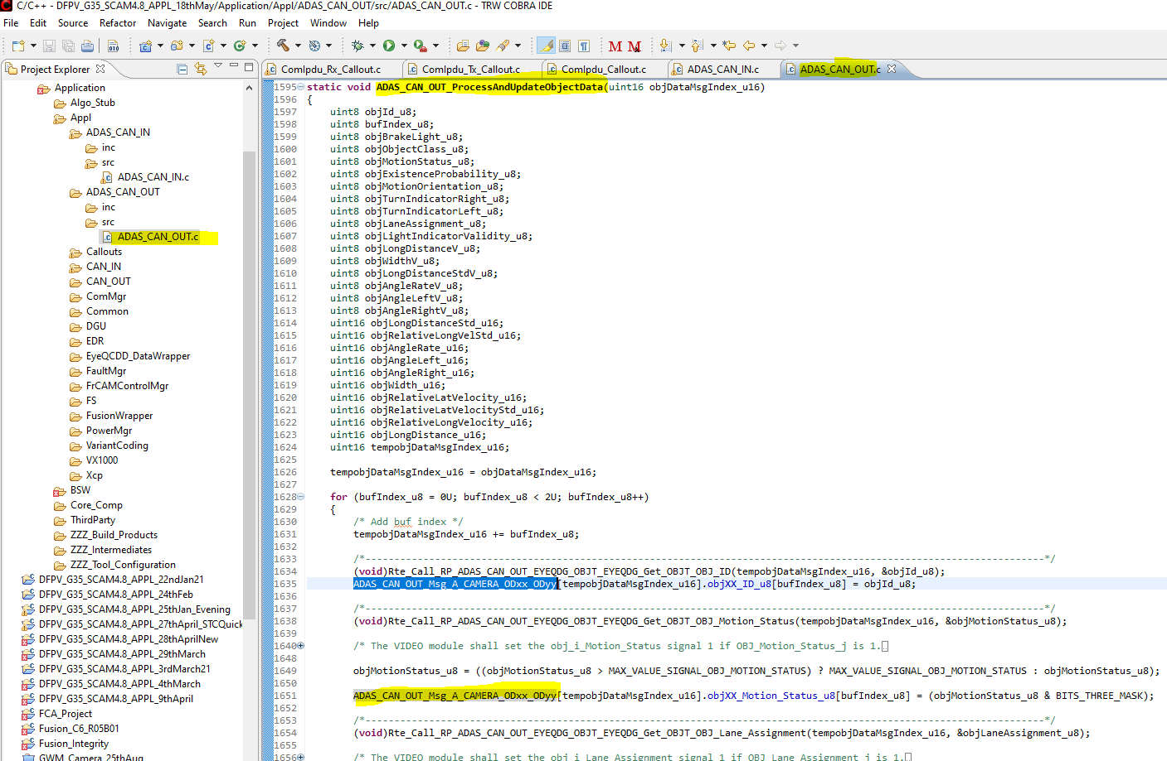

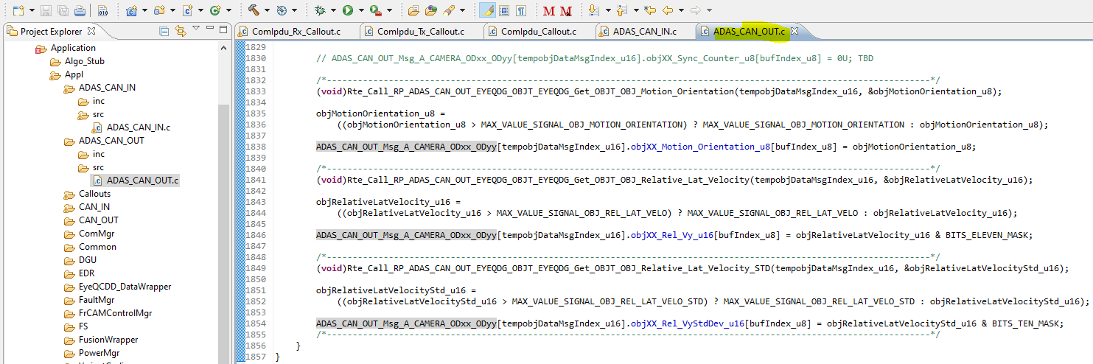

Check structure

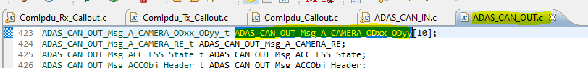

This structure will use to transmit ADAS CAN data using IPdu call out function

Chap 3

For each message IPdu callout is created in ComIPdus(COM layer).

Check Ipdu callout function for message A_CAMERA_OD1_OD2 (0x410) is (ADAS_CAN_OUT_A_CAMERA_OD1_OD2_IPduCallout_Process)

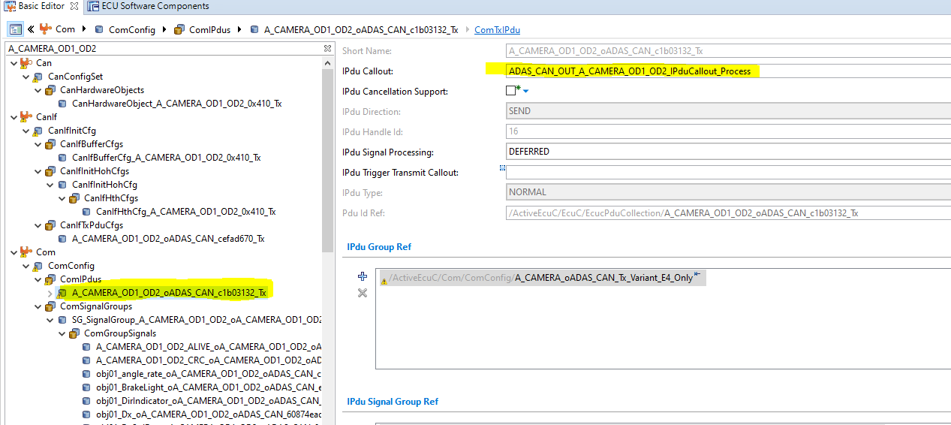

Inside this IPdu callout function whatever we need to transmit inside message, we can implement

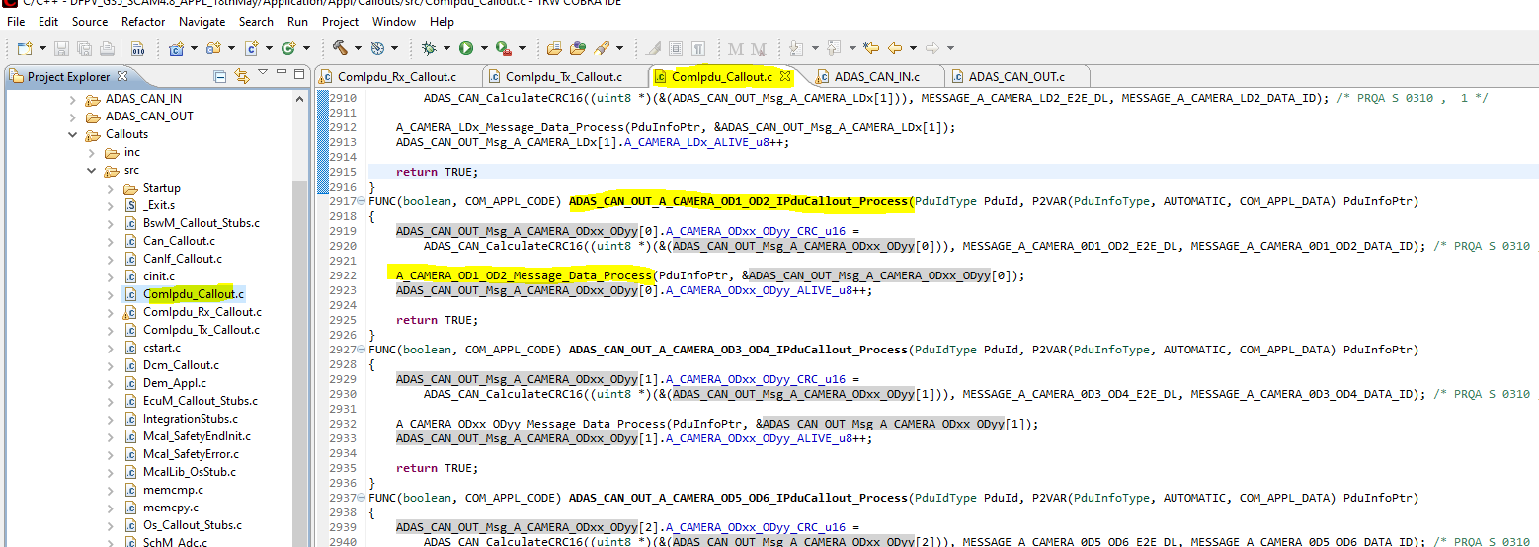

Check above code inside callout function initially CRC will be calculated ( line no 2918) using we filled structure ADAS_CAN_OUT_Msg_A_CAMERA_ODxx_ODyy in ADAS_CAN_OUT module ,which we see in chap2

Check above code inside callout function initially Alive counter will calculated ( line no 2923) using we filled structure ADAS_CAN_OUT_Msg_A_CAMERA_ODxx_ODyy in ADAS_CAN_OUT module ,which we see in chap2

So whatever we need to transmitt inside message A_CAMERA_OD1_OD2(0x410) need to fill in buffer and that buffer filling happens in function A_CAMERA_OD1_OD2_Message_Data_Process( ) ( line no-2922) in above image

Chap 4

Inside this function all information will fill to respective signal which received from ADAS_CAN_OUT module

For this function 1st parameter(PduInfoPtr->) is nothing but buffer location in COM module for that message which we are transmitting periodically.

And second parameter (msgDatabufPtr)is nothing but address of stuct ADAS_CAN_OUT_Msg_A_CAMERA_ODxx_ODyy

So indirectly we are filling buffer with data received from EyeQ_CDD

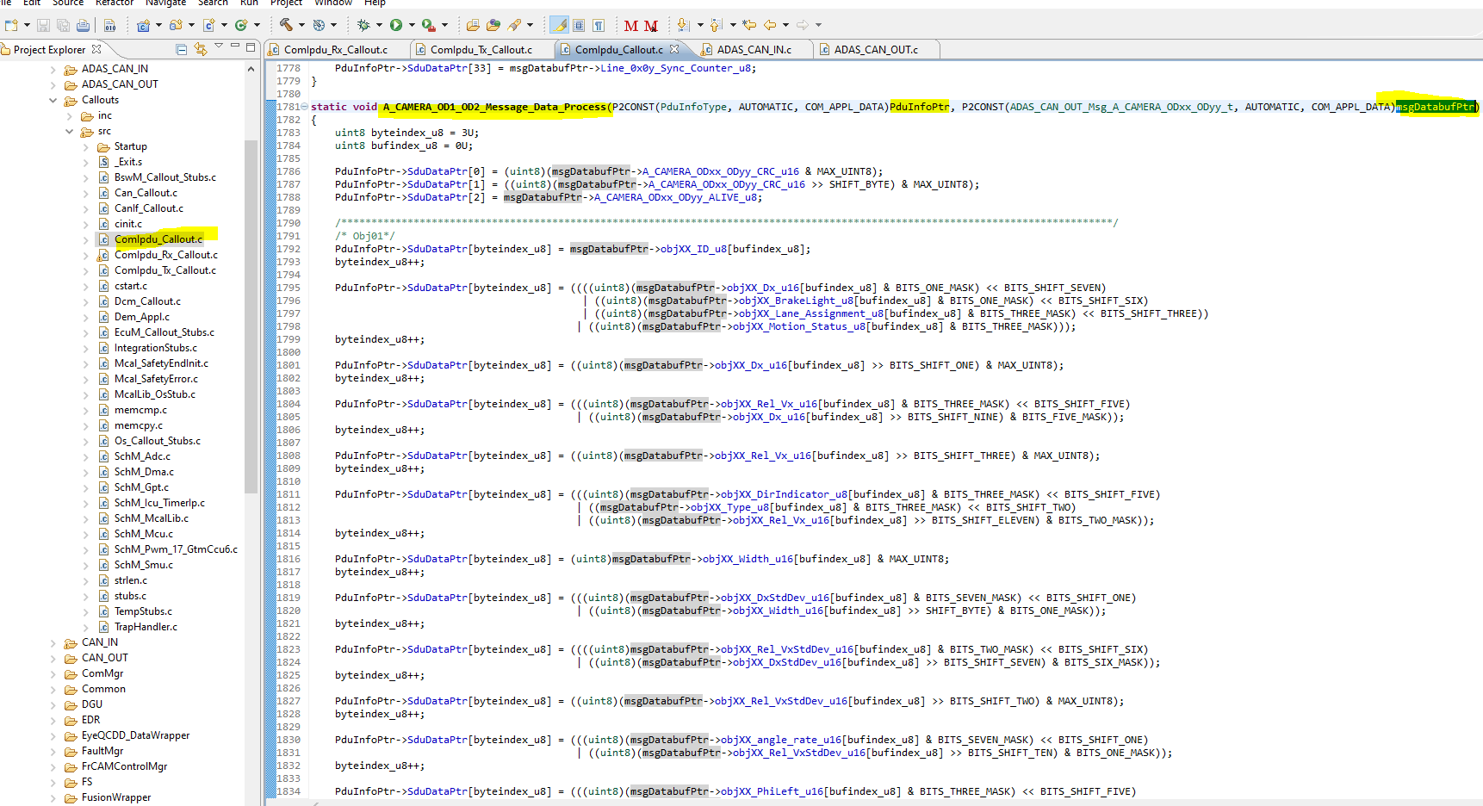

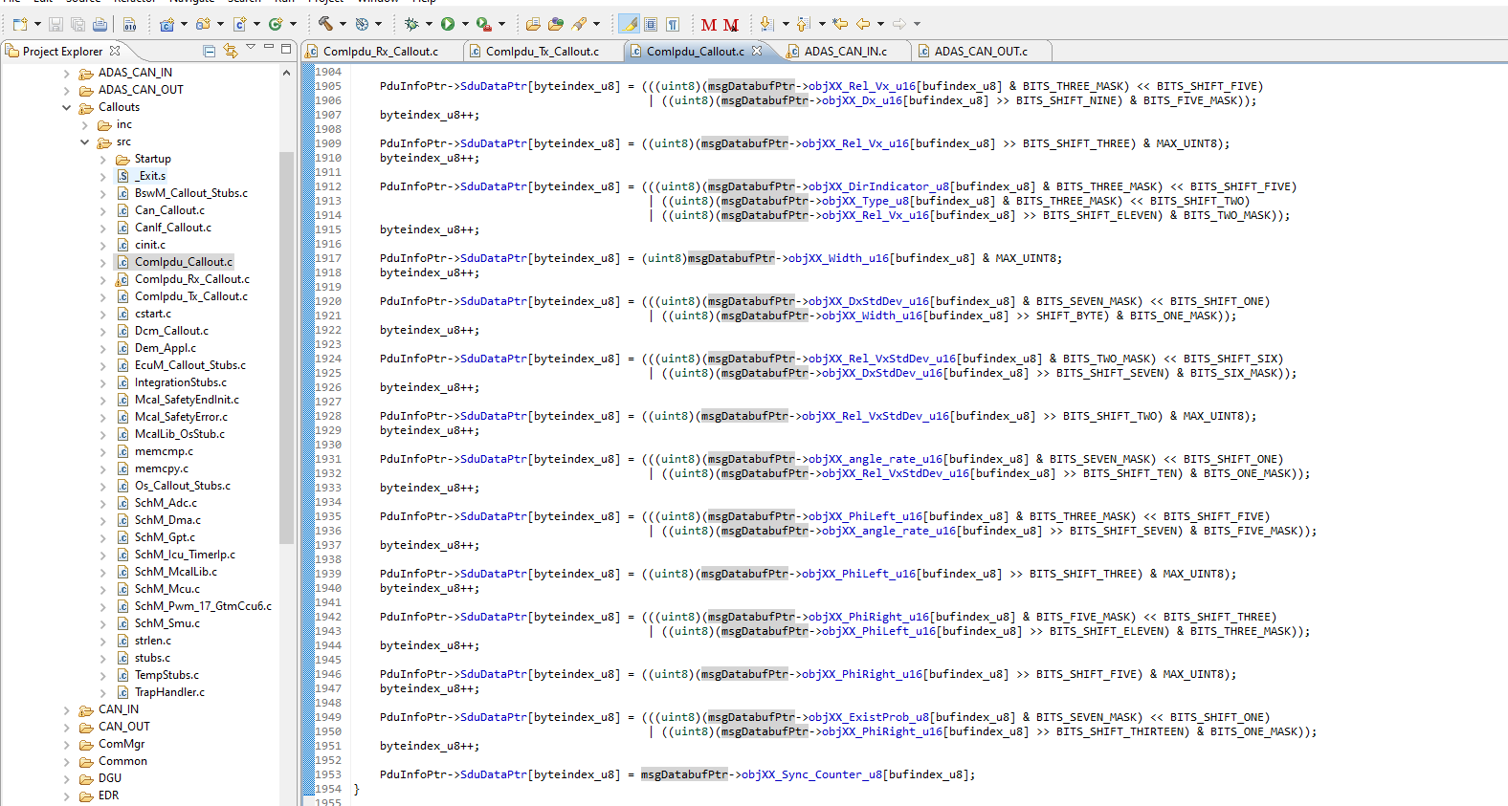`````

Chap 5

Same procedure for all remaining messages