**Overview of CANSM:**

In case bus-off is indicated the CanSM informs the Dem (E_BUSOFF and EVENT_STATUS_PREFAILED), the ComM (SILENT) and BswM (BUSOFF). In the next step the CanSM restarts the controller to STARTED mode. If the according mode indication is received the CanSM sets the Rx Pdu Mode to ONLINE and Tx Pdu Mode to OFFLINE and starts the bus-off timer. If the CanSMBorTimeL1(or CanSMBorTimeL2 if the bus-off count is equal or greater than CanSMBorCounterL1ToL2)elapse CanSM reactivates the Tx path of the channel again, informs the ComM (FULL) and BswM (FULL) and starts the “ensure timer”. If the CanSMBorTimeTxEnsured timer has elapsed without a bus-off indication the CanSM informs the Dem, otherwise the next bus-off recovery sequence is started. The “ensure timer” can also substituted by polling the TxState if CanSMBorTxConfirmationPolling is activated.

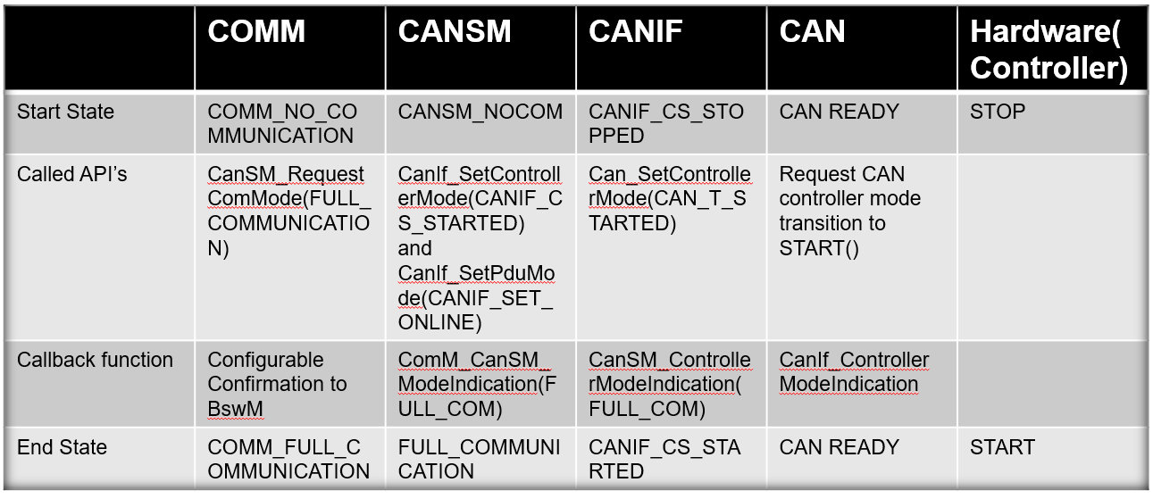

**CanSm:**

The CAN State Manager implements the control flow for CAN networks e.g. bus off.

**CanSMGeneral**

Contains module wide configuration like the CanSMMainFunctionTimePeriod.

**CanSMConfiguration**

The CanSMConfiguration holds two configurable parameters for determining handling of underlaying CanControllers. CanSMModeRequestRepetitionTime determines the time duration the CanSM will repeat CanIf mode change requests i.e. if a mode request is not indicated by the CanIf within CanSMModeRequestRepetitionTime, the mode will be requested again. CanSMModeRequestRepetitionMax determines the maximum number of mode change requests, without a respective mode indication, before the CanSM reports an error to the Det (if Dev Error Detect is enabled in CanSMGeneral) and tries to go back to no communication.

The CanSMConfiguration contains one CanSMManagerNetwork per CAN network. It specifies the different timeout times in the network state machine. It also holds a reference to a network in the ComM module and one or more references to CanControllers. CanSMBorCounterL1ToL2 determines the number of detected bus-offs before the bus-off recover switches short recovery time (CanSMBorTimeL1) to long recovery time (CanSMBorTimeL2). The recovery time is the time after the CanControllers of the network has been restarted, due to a detected bus-off, until transmission is enabled on the network. If a new bus-off occurs within CanSMBorTimeTxEnsured after the transmit path of the network was reenabled, the CanSM assesses this bus-off as sequential bus-off without successful recovery. Since bus-offs can only be detected when PDUs are transmitted, CanSMBorTimeTxEnsured must be great enough to ensure that PDUs have been transmitted again. Typically, CanSMBorTimeTxEnsured is set at least as great as the time period of the fastest periodically transmitted PDU of the network.

Each CanSMController References one of the CAN controllers managed by the CanIf. Network are not allowed to share CAN controllers, i.e. each CanSMController must reference a unique CAN controller.

