* **explain various parameters to be configured in DEM.**

**Configuration of DEM in GWM**

**Importing CDD file :**

* CDD file in GWM is provided by System Teamform STC.
* This file changes whenever there is any addition or deletion of a DTC or DID.
* Generally DID part if is getting changed or updated is being handled by STC team and DTC related configuration are handled by ITC team.
* So if there is any DID and DTC related changes in CDD file only DTC related changes has to be taken care and DID related changes will be taken care by concerned module owner in STC.
* And if there is any DID and DTC related changes in CDD file and STC team has already imported it and checked in we only need to import only DEM changes instead importing whole CDD file.

**DEM Configuration :**

* After importing CDD file and resolving all the Errors successfully.

- Below parameters are to be configured in DEM such as :

* + Latch Type
  + Priority
  + Aging Counter
  + Enable conditions
  + Number of Events referring to the DTC
  + And FiM related configurations for newly added Events.
  + DemFreezeFrameRecNumClassRef.

**Configuration of Latch Type Faults in DEM**

* + As per GWM we have Latch types are defined as :
  + FT1 - The faults that once logged shall be cleared in same operation cycle. Non – ignition latched type of faults.
  + FT2 - The faults that once logged shall not be cleared in same operation cycle rather can be cleared in next operation cycle. This are ignition latched type of faults.

**Configuration of FT1 type of Faults :**

* Requirements in GWM

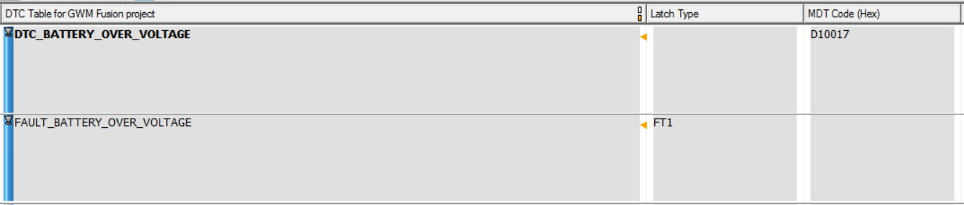

* Corresponding Configurations to fulfill this requirement :

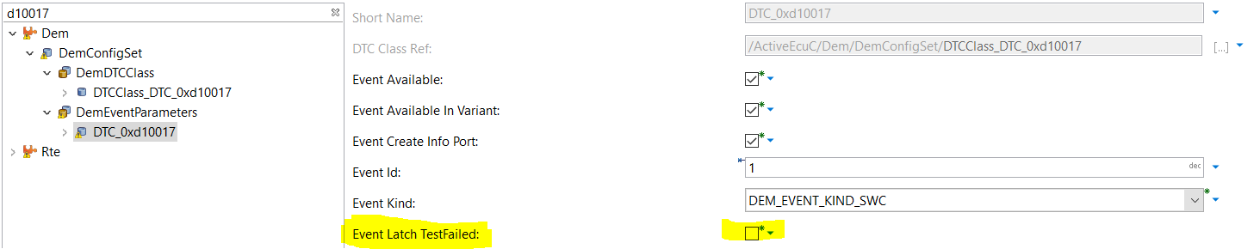

**Configuration of FT2 type of Faults :**

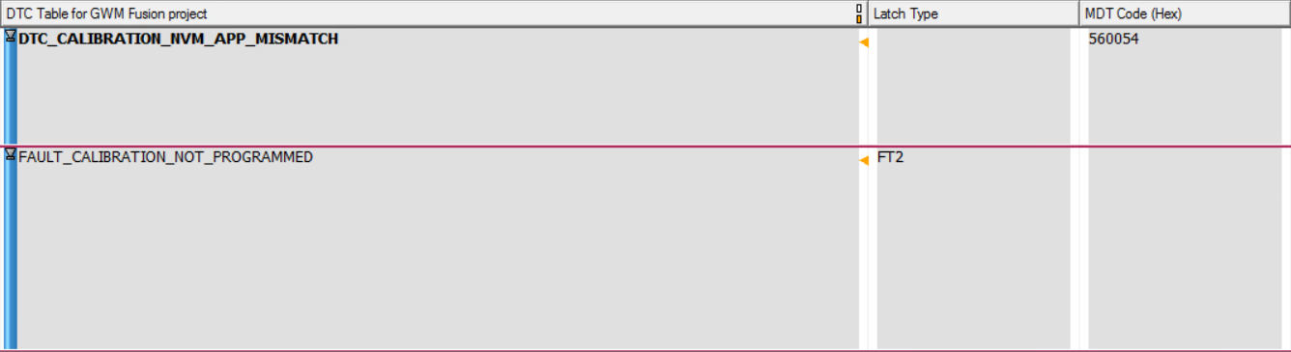

* Corresponding Configurations to fulfill this requirement :

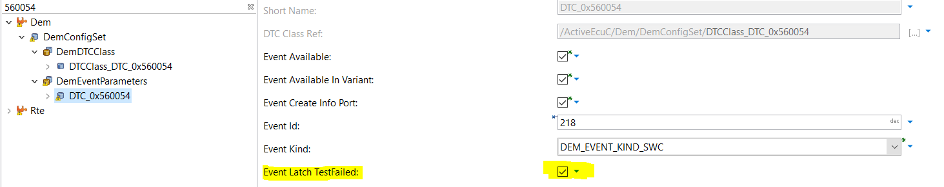

**Configuration of Priority of Faults in DEM**

* In GWM, as per requirements we have mainly four priorities as mentioned below :
* 000b : noSeverityAvailable : There is no severity information available.
* 001b : maintenanceOnly : This value indicates that the failure requires maintenance only.
* 010b : checkAtNextHalt : This value indicates to the failure requires a check of the vehicle at the next halt.
* 100b : checkImmediately : This value indicates to the failure requires an immediate check of the vehicle.
* As per requirement below :



* We can have following table as a reference for configuration of Priority at Event level.

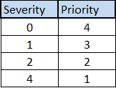

**Configuration of Priority of Faults in DEM (Example)**

In GWM, requirements for Priority of a fault is defined in MDT table in terms of Severity.

* **Configuration of Priority of a Fault :**

Requirement for Priority in GWM :

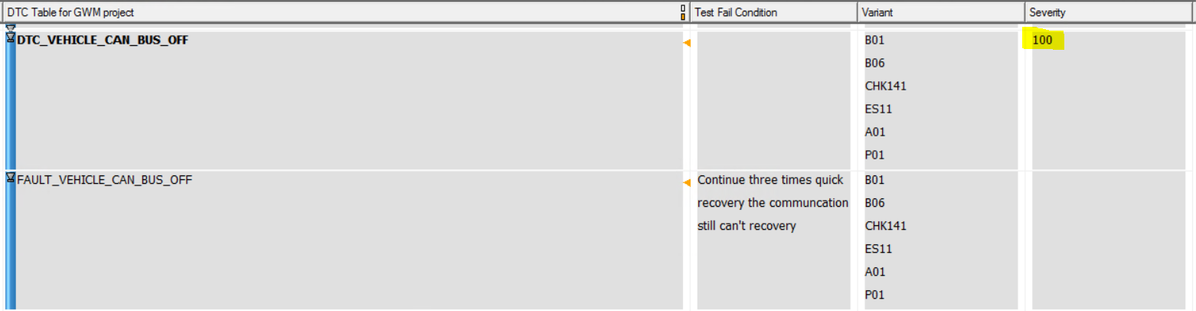

As per table in the previous slide if severity in requirement is defined as “100” i.e. 4.

Corresponding Configuration priority value for this fault shall be “1” as shown below :

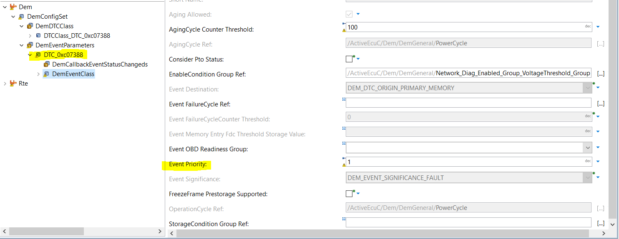

**Configuration of Aging Counter in DEM**

In GWM, as per requirements all faults supports Aging and therefore the Events shall be removed from memory once aging counter reaches it’s Threshold Value :

* As per requirement, GWM supports 100 Aging Cycles before a fault is removed from memory.
* At 100th cycle the fault related Extended Data and Snapshot Data shall be removed along with the fault.

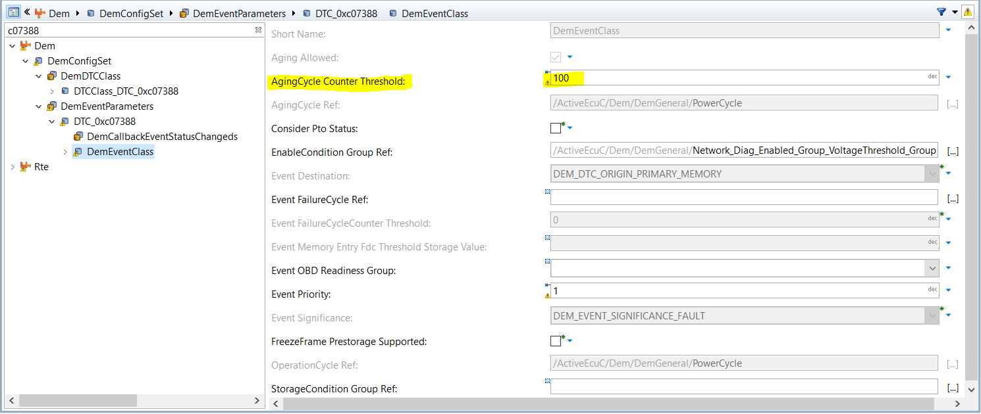

**Configuration of Enable Conditions in DEM**

In order to configure Enable Conditions in DEM, we have an option in DEM General where we have to configure all enable conditions atomically as shown below as per requirements :

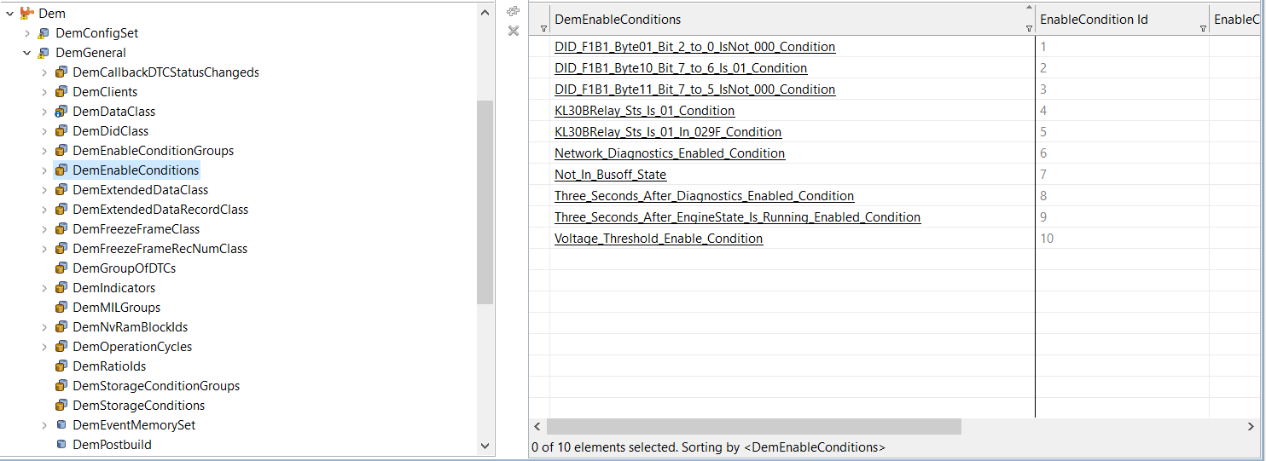

After configuring Enable Conditions in DEM General atomically, we have an option in DEM General where an option is available to create different groups of Enable Condition as shown below :

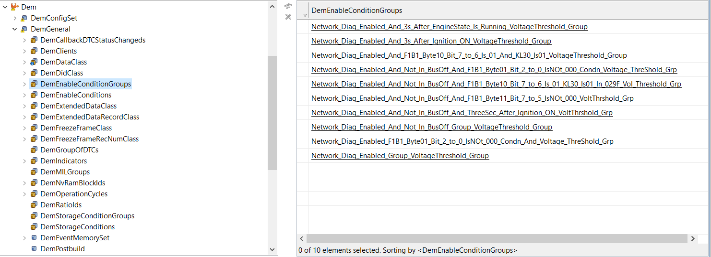

* After grouping Enable Conditions we need to give reference of Grouped Enable Conditions for all Events as per requirement.
* In Developer, the Enable conditions being configured Atomically can be found in DemMater service component.
* This Enable conditions in developer, can be mapped to required Application and connections can be done in configurator.
* **Configuration of Enable Condition of a Fault :**

Requirement for Priority in GWM :

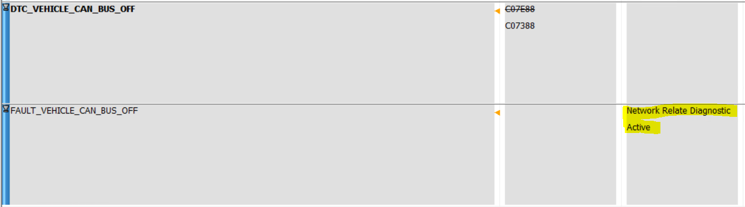

* **Corresponding Configurations to fulfill this requirement :**

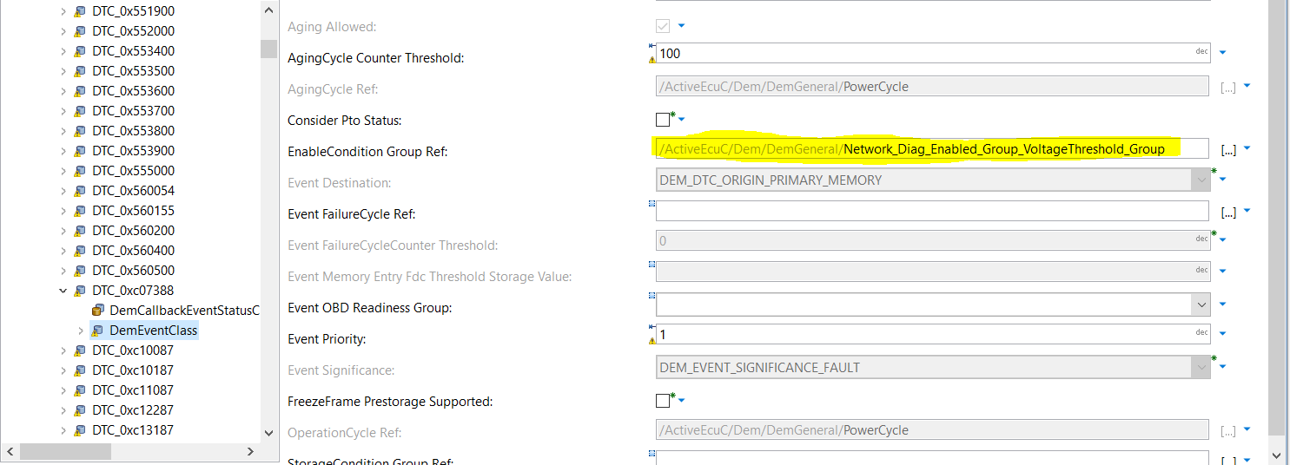

**Configuration of Events in DEM**

* After .cdd file import, in configurator one event gets automatically updated in “DemEventParameters” container with DTC name and other Events has to be configured.

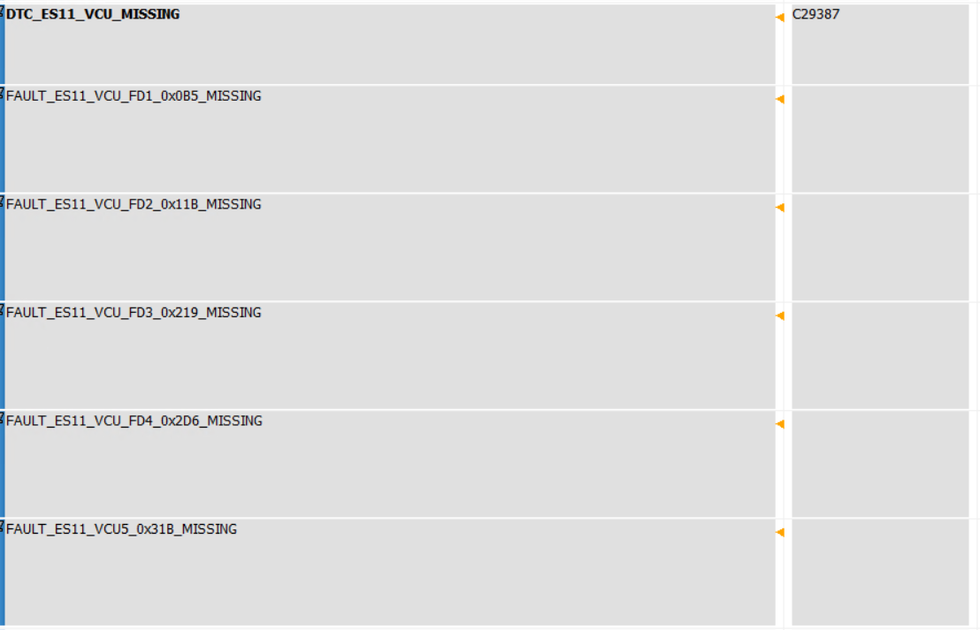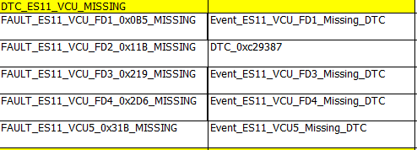

* The above snapshot from the Excel Sheet shows Fault name and is corresponding Event configured in configurator.
* This shall be used by application team to report particular fault through corresponding Rte.

**Configuration of FiM for newly added DEM Events**

After DEM is configured for newly added Events, we shall configure corresponding FiM as per requirement.

* To configure FiM, we shall consider an example as newly added Event and shall configure corresponding FiM.

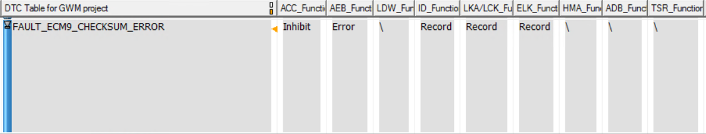

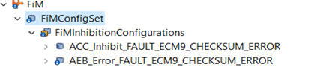

* The Fault “FAULT_ECM9_CHECKSUM_ERROR” shall have 2 FiM configurations as shown in above snapshot.

**Configuration of DemFreezeFrameRecNumClassRef**

* Snapshot data or Freeze Frames are nothing but the data that are captured at the time of Fault logging. This data shall have car’s internal environment data, that shall be useful at the time of debugging and shall help to determine the root cause of occurrence of the fault.
* After importing .cdd file we may get errors in DEM container for newly added DTCs.
* In order to remove this errors there is a need to configure this particular parameter with a reference that is configured in DemGeneral.

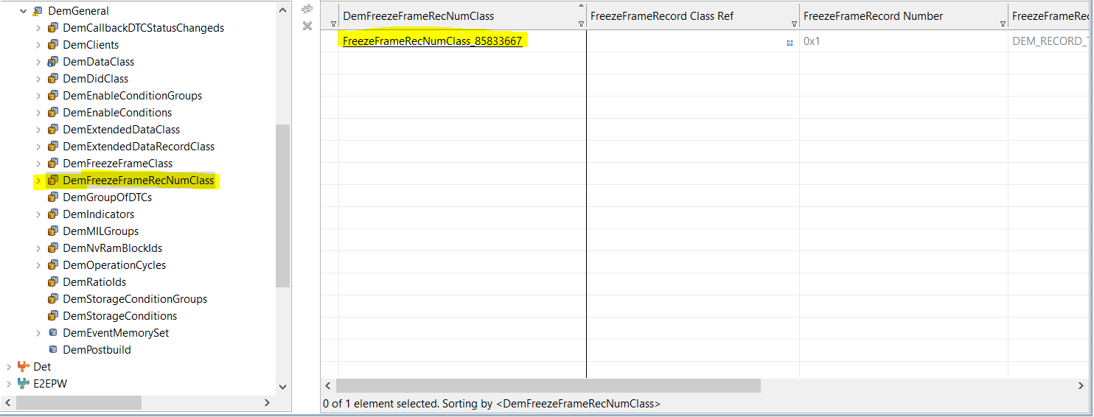

* This parameter shall give freeze frame record class reference as per the requirement.
* In GWM, we have only 1 freeze frame record support that is captured for all the DTCs.
* This data may vary as per variants as mentioned in the requirements.