CHAP : 1

As per shown in DBC below are the Vehicle CAN Messages Output from Camera ECU.

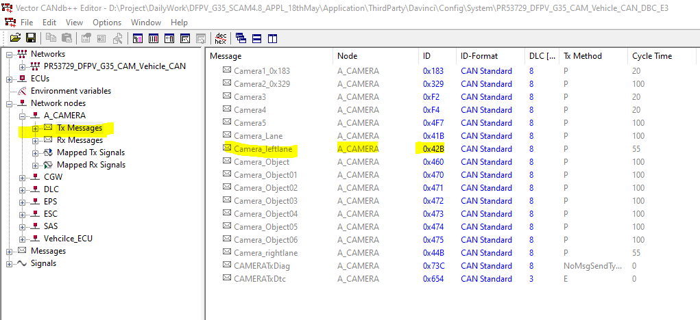

CHAP : 2

Consider message Camera_leftlane(0x42B) and check requirement for the same

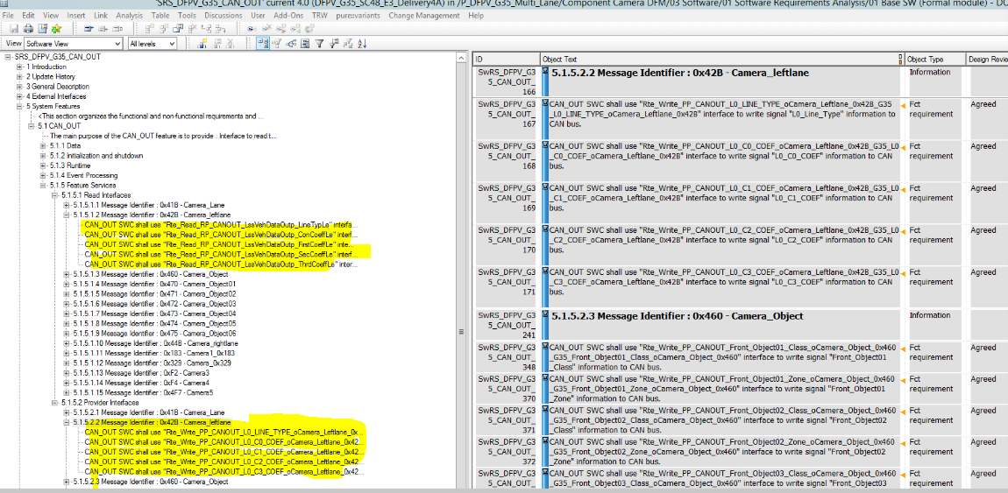

Message Camera_leftlane contains five signal and message count applicable for this Message .

Message count information not given in CAN_OUT requirement but we need to take care of that in Callout function

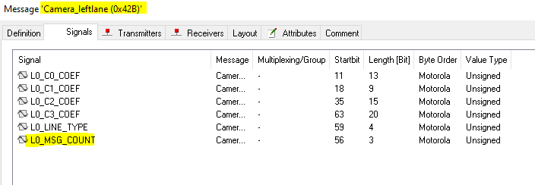

In DOORS which RTE variable signal information will read/write it mentioned. Which we seen above,Here in this example taking signal from LSS module and need to send Vehicle CAN.

So it’s CAN_OUT module responsibility to create Port as mentioned in requirement in SWC of CAN_OUT , For this port , Port Interface information provided by Arxml developer.

In example requirement LSS will provide all information which we can transmit it in to Vehicle CAN. Hence instead of creating many ports one port is create to read LSS data which shown in below image ,

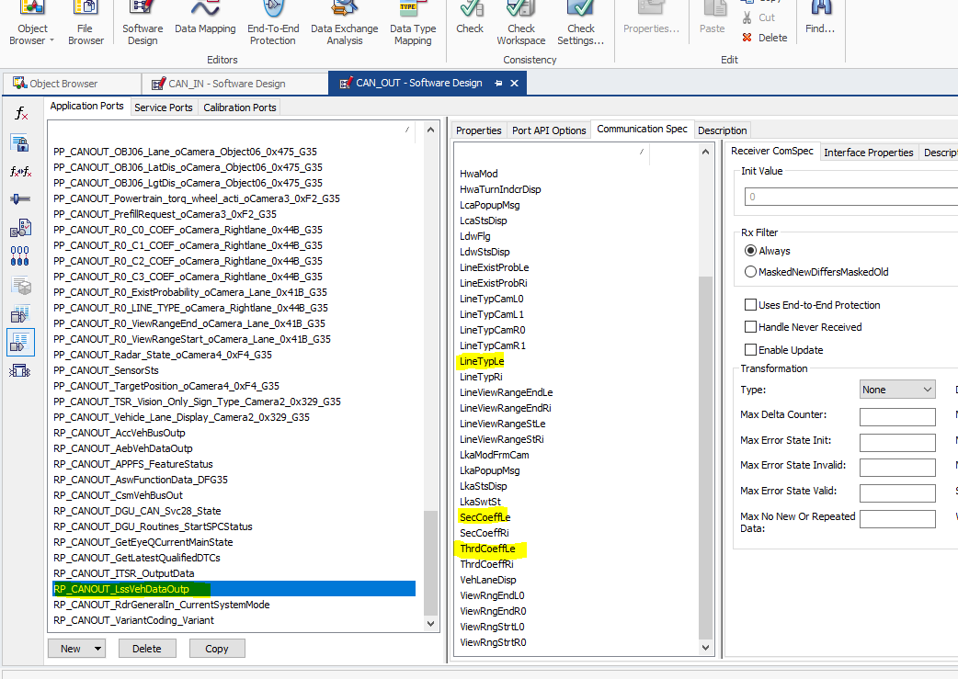

And in this port whatever signals are available only five signal we can transmit in to CAN channel

So for that case also we need to create transmit five port which shown below image five transmit port ,this each port is mapped to one signal of DBC

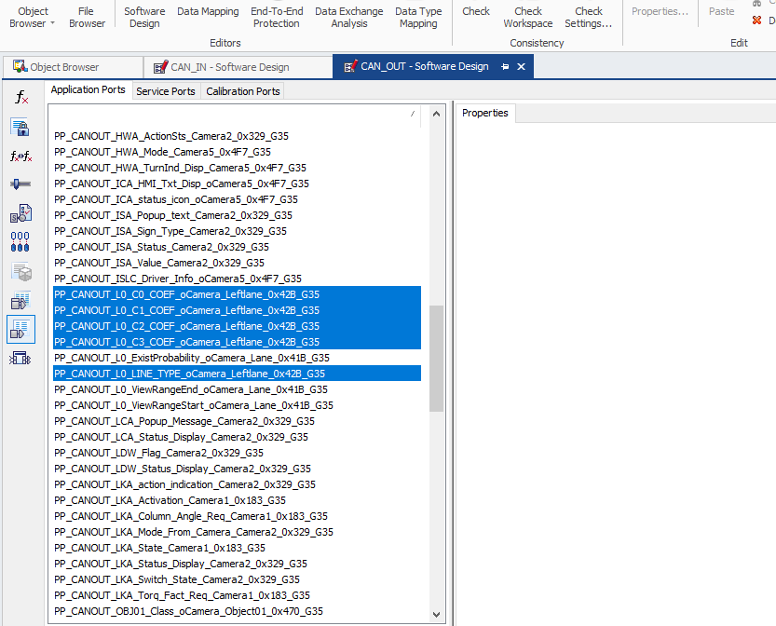

Right now port it is created in SWC ( CAN_OUT) which is above RTE layer so it’s Developer responsibility to provide this signal information ( COM layer) to SWC (below RTE) by connecting it into the Configurator

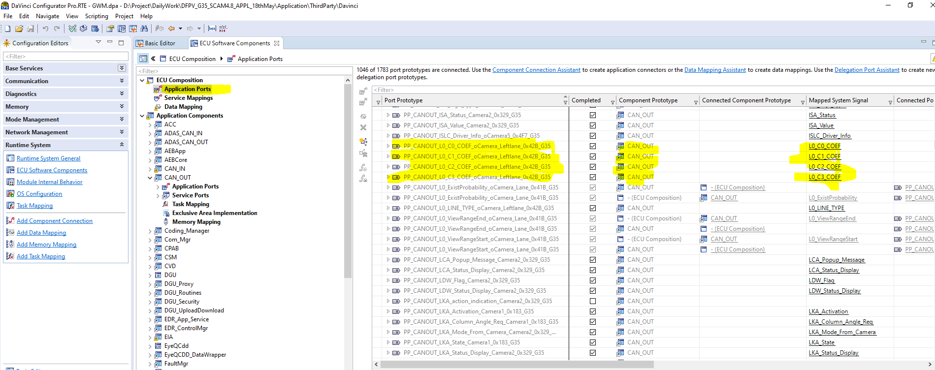

Check Below images for the same by connecting com signal to receive port in CAN_OUT

Check this port is connected in both the level 1) Application Components 2) ECU Composition

Application Component

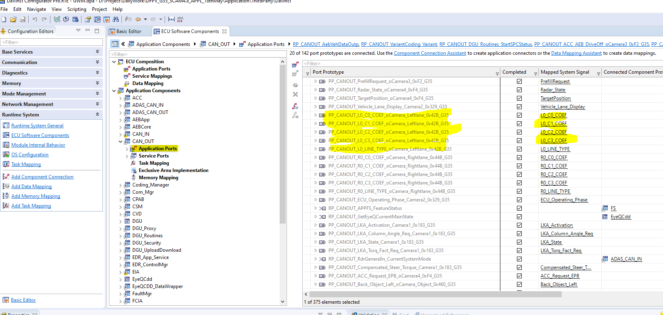

ECU Compostion



Now signal information available at COM ,but how to write this and how to handle Count we will see in next chapter

CHAP : 3

As seen in below image for message Camera_leftlane one IPdu Callout is mentioned : **VEHCAN_Camera_Leftlane_0x42B_TxIPduCallout_Process,** so this callout will implement as per developer needs

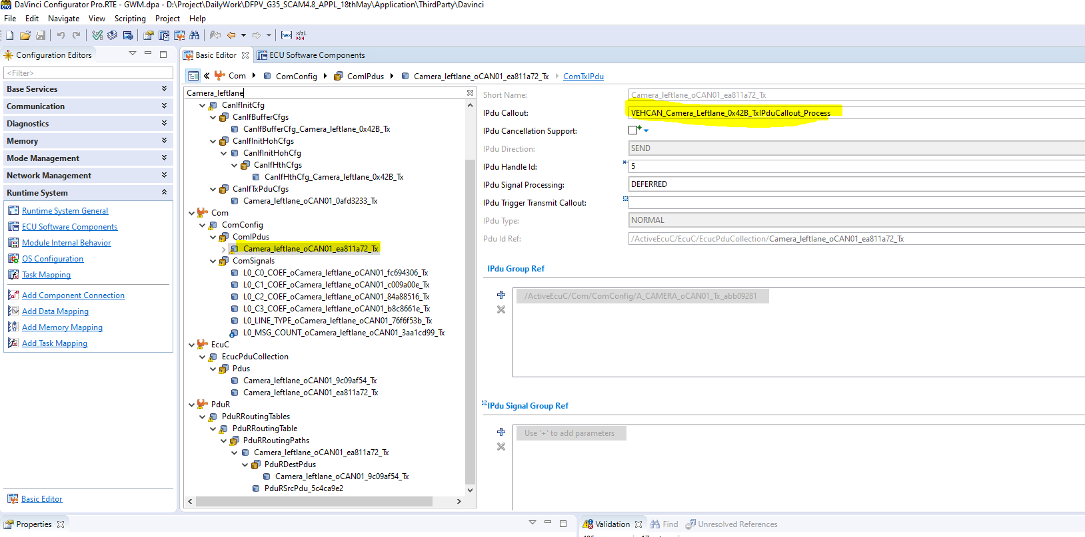

So in DF-G35 project this callout function is using to check CRC and Rolling count of that message(Camera_leftlane)

For all Vehicle CAN Tx message those having Checksum and Rolling counter has taken care inside that mentioned callout function in file ComIpdu_Tx_Callout.C

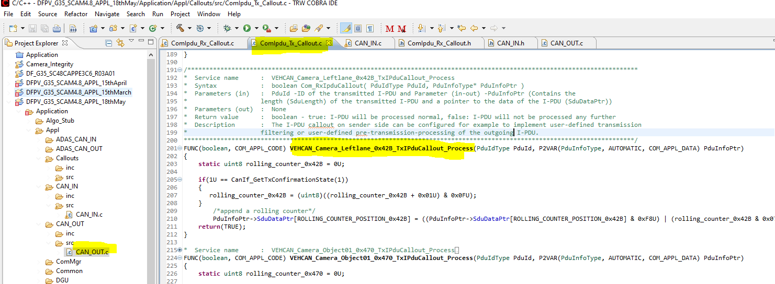

CHAP : 4

Writing of information to COM buffer and sending to Vehicle CAN bus

It’s developer responsibility to provide Vehicle CAN_OUT signal information to interested COM

Check below implementation in CAN_OUT file

1. *WRITE_ISUPDATED:* *2) READ_DATA* 3) *WRITE_SIGNALS*

Check in below how read(line number 501 to 505) and write(line number 517 to 529) will happen shown

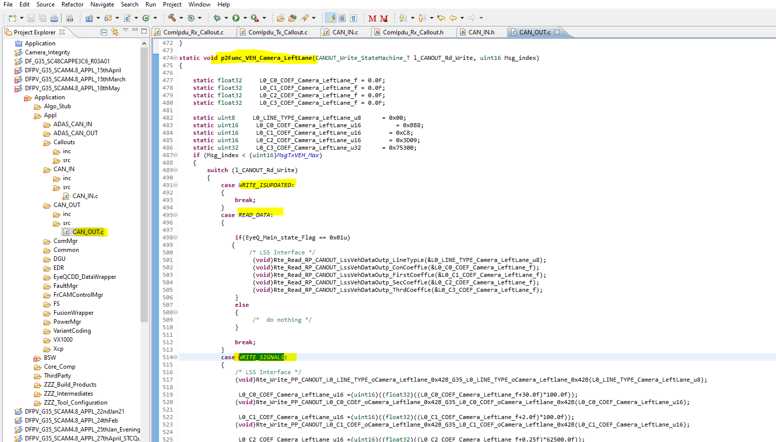

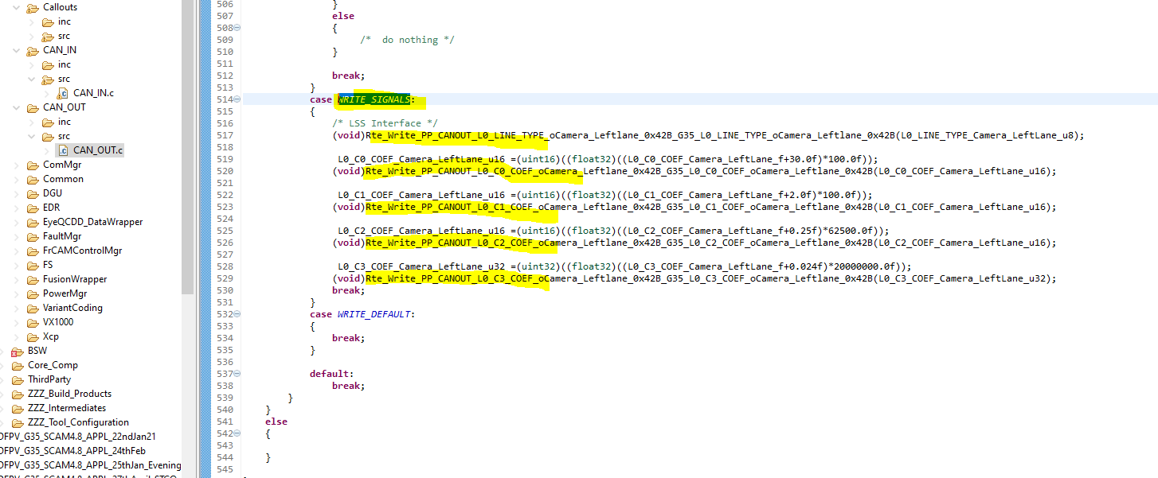

CHAP : 5

# WRITE_ISUPDATED and READ_DATA

As shown below image read of signal happening using this function.

[whatever consider message “Camera_leftlane(0x42B) “this message need to transmit every 55ms]

[ Using this function “**CANOUT_Func_Can_VEH_Read_55ms**(**void**)” we are calling to function

**p2Func_VEH_Camera_LeftLane**(CANOUT_Write_StateMachine_T l_CANOUT_Rd_Write, uint16 Msg_index) every 55msec ,it is nothing but we are reading it in every 55msec,which we shown in previous page ]

check Line number 292 and line number 299 for the same

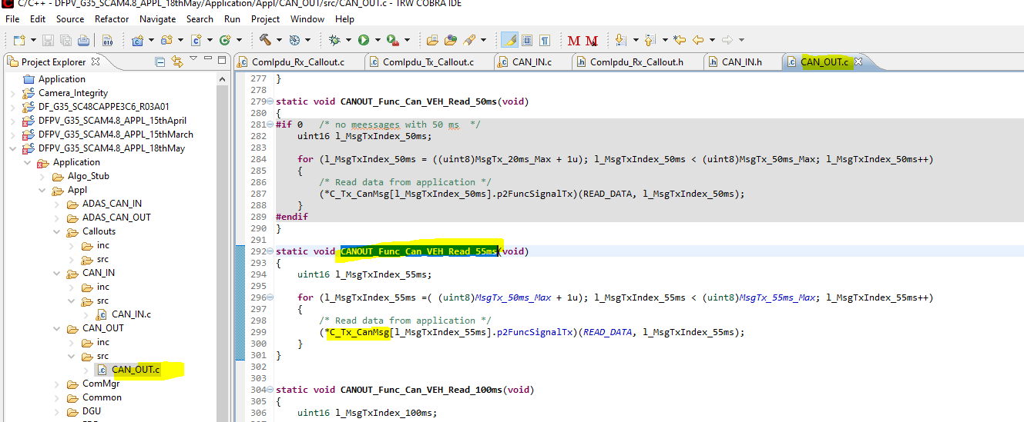

Above function is executing every 55ms . Check below pic for the same

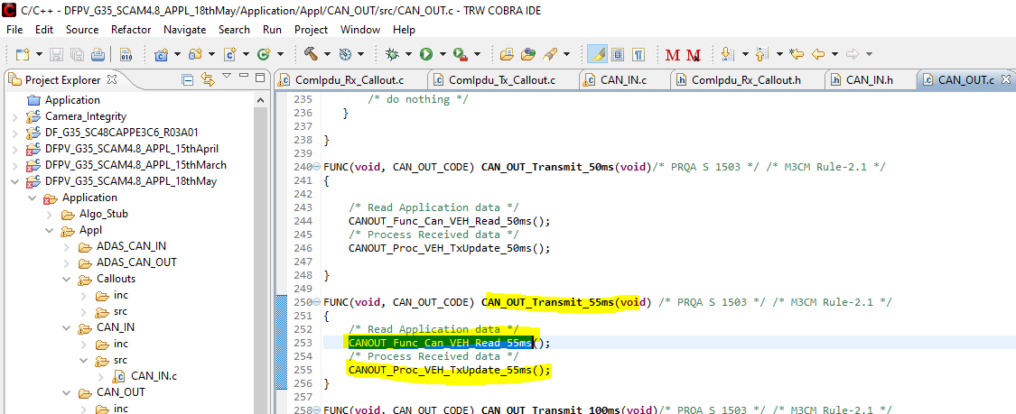

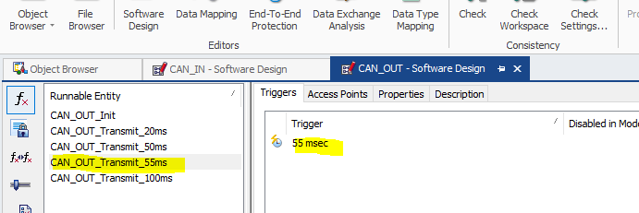

# WRITE_SIGNALS

As shown below image write of signal happening using this function.

