* What is Watchdog alive monitoring?
* WdgM Stack
* Wdg MCAL configuration
* WdgM Alive monitor Parameter
* Setting up WdgIF
* Setting up WdgM General configuration
* Setting up Supervised Entity and Checkpoint
* Reaction after Alive monitoring failure
* Wdg Alive monitoring in Multicore

**What is Watchdog alive monitoring?**

* The WdgM can monitor the following violations:

> timing violation (checked by deadline supervision and alive supervision)

> Aliveness monitors the frequency of hits of checkpoints.

* The WdgM periodically triggers the watchdog device through its interface (WdgIf) and driver layer (Wdg).

When the WdgM detects a fault in the program flow or timing then it stops the watchdog triggering,

or it initiates a reset of the microcontroller immediately or after a delay, depending on the WdgM configuration

* The WdgM monitors the following software faults:

> The supervised entity is executed, but the execution was not requested.

> The supervised entity was not executed, but the execution was requested.

> The execution of the supervised entity started too early or too late.

> The execution time of a supervised entity or part of a supervised entity or

many supervised entities is longer or shorter than expected.

**WdgM Stack**

The Wdg Stack has three software modules:

> Watchdog Manager (WdgM)

> Watchdog Interface (WdgIf)

> Watchdog Driver (Wdg)

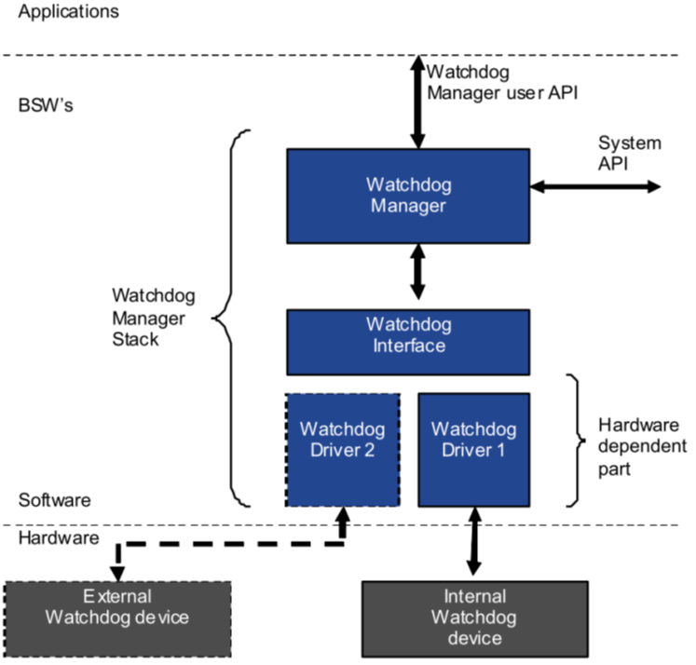

**Wdg MCAL configuration**

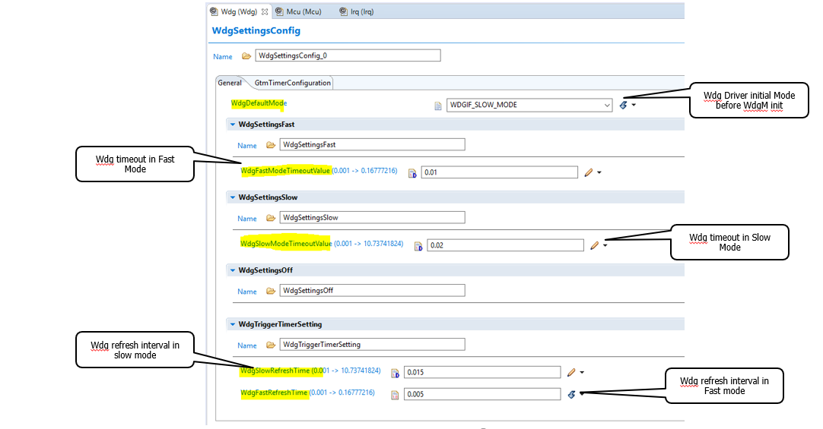

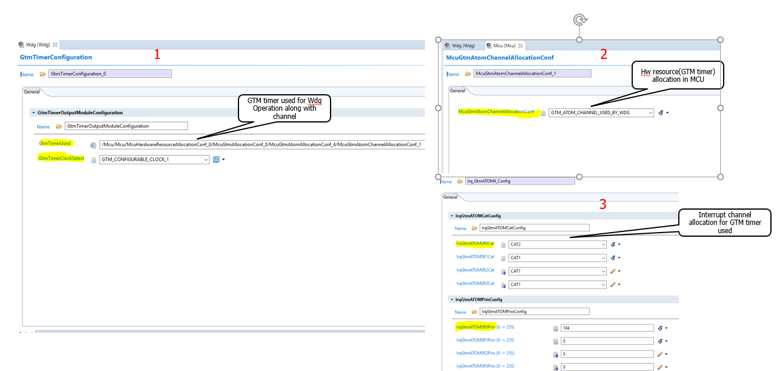

**WdgM Alive monitor Parameter**

**What is supervised entity?**

-- A supervised entity is a software part that is monitored by the WdgM.

A supervised entity can represent an algorithm, a function, or – in the case of an operating

system – an entire task.

**What is checkpoint?**

-- Checkpoints are representation for supervised entity to intimate that it has reached

**What is supervision cycle?**

-- The supervision cycle is the period in which the cyclic supervision is executed to evaluate checkpoints and

at the end decides to trigger Wdg based on alive monitoring status

**What is supervision reference cycle?**

-- The number of supervision cycles used as a reference by Alive monitoring for periodic supervision.

**What is local status?**

-- Every supervised entity has a local state that expresses the occurrence of detected violations

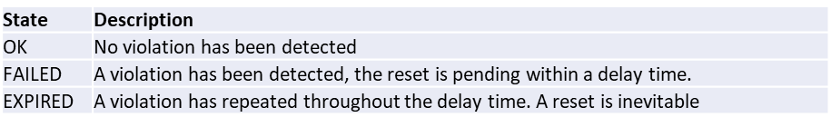

**What is global status?**

-- The local states are periodically summarized in a WdgM global status. If all supervised entities have the state

OK, then the global status is OK.

When at least one supervised entity changes to the state FAILED, then the global status becomes FAILED.

When at least one supervised entity changes to the state EXPIRED, the global status becomes EXPIRED.

Once the global status is EXPIRED, the WdgM continues the delay until it enters the state STOPPED.

This is when the WdgM stops triggering the Watchdog.

The delay is the supervision cycle multiplied by the configurable expired supervision cycle tolerance.

**Setting up WdgIF**

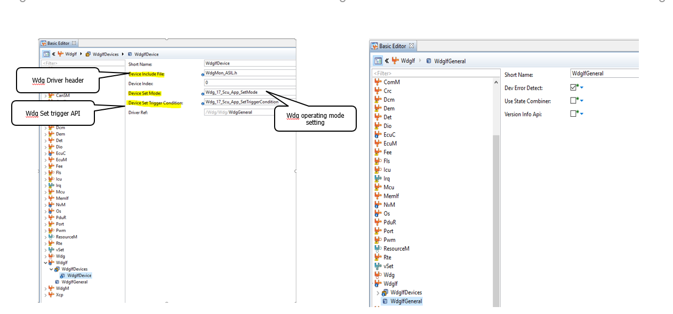

**Setting up WdgM General configuration**

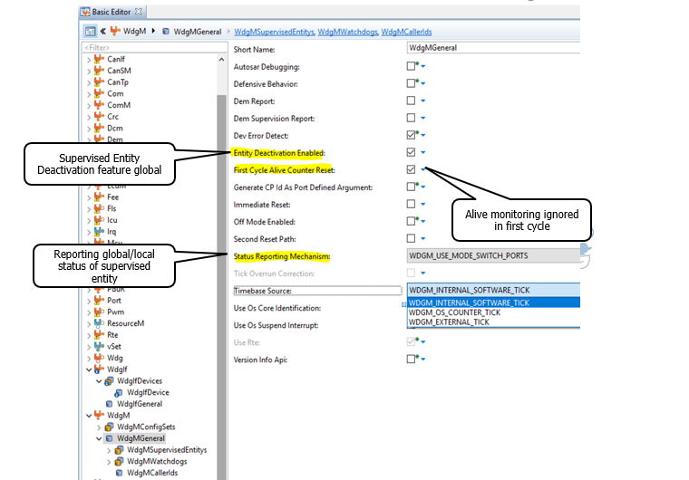

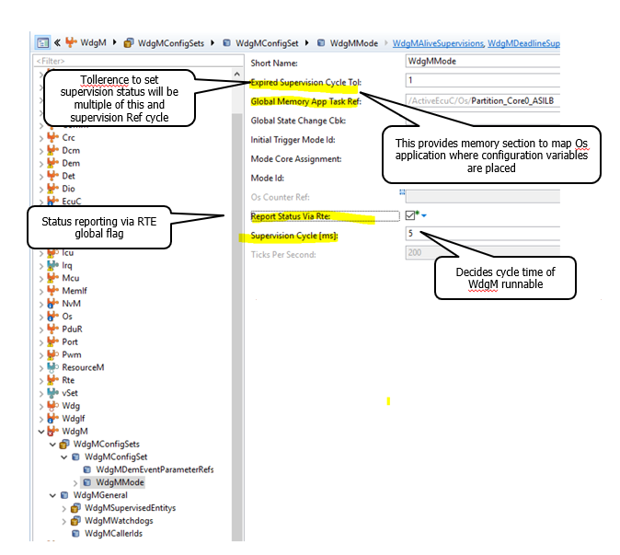

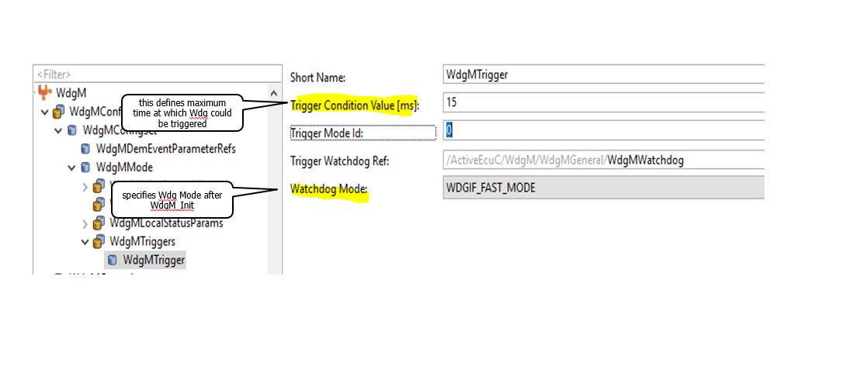

**Setting up Supervised Entity Alive supervision Parameter**

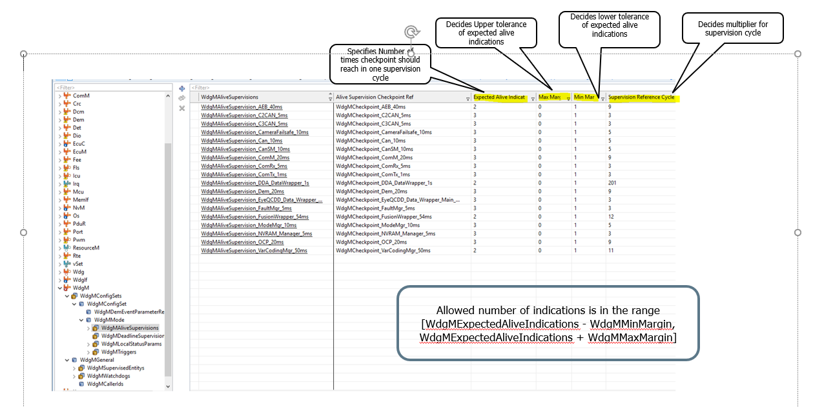

**Setting up Local status parameter for Supervised Entity**

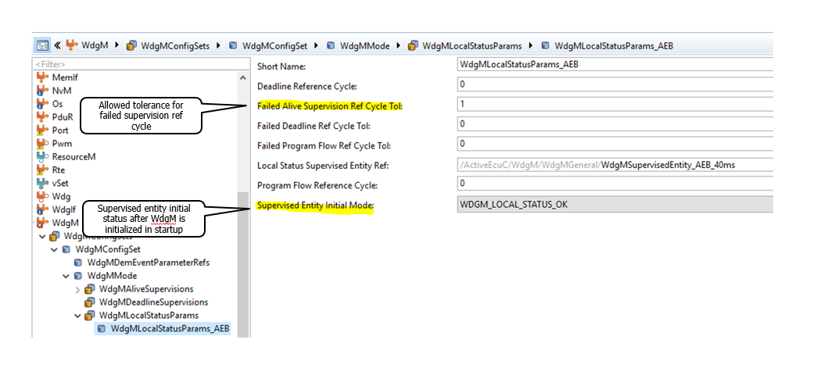

**Individual Supervised entity configuration**

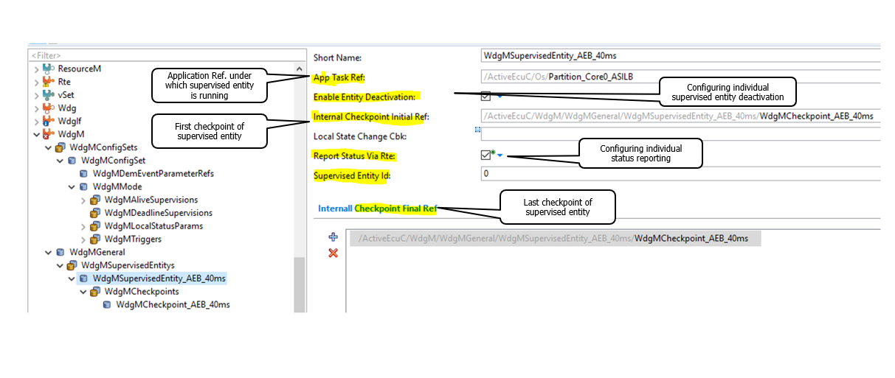

**Alive monitoring Checkpoint configuration**

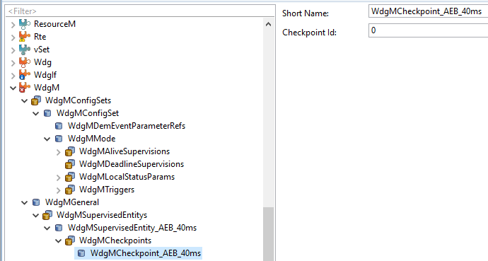

**Reaction after Alive monitoring failure**

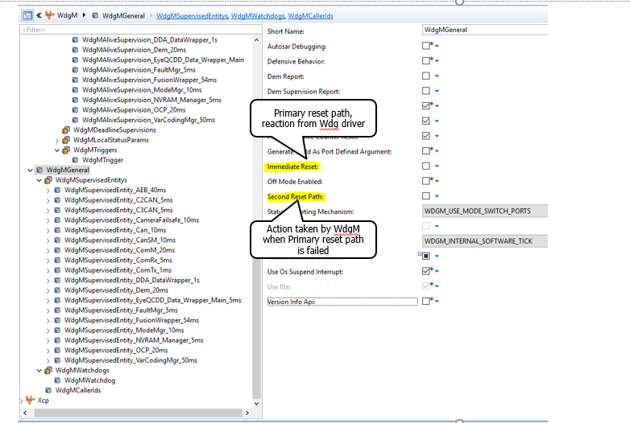

Another option for setting Reaction is SMU alarm

--Wdg will generate Alarm when it is stopped triggering

--SMU reads this Alarm and request preconfigured reset to MCU

**Wdg Alive monitoring in Multicore**

There are two possible options for Wdg configuration in Multicore:

1. Independent Wdg devices
2. State Combiner

**Independent Wdg devices**

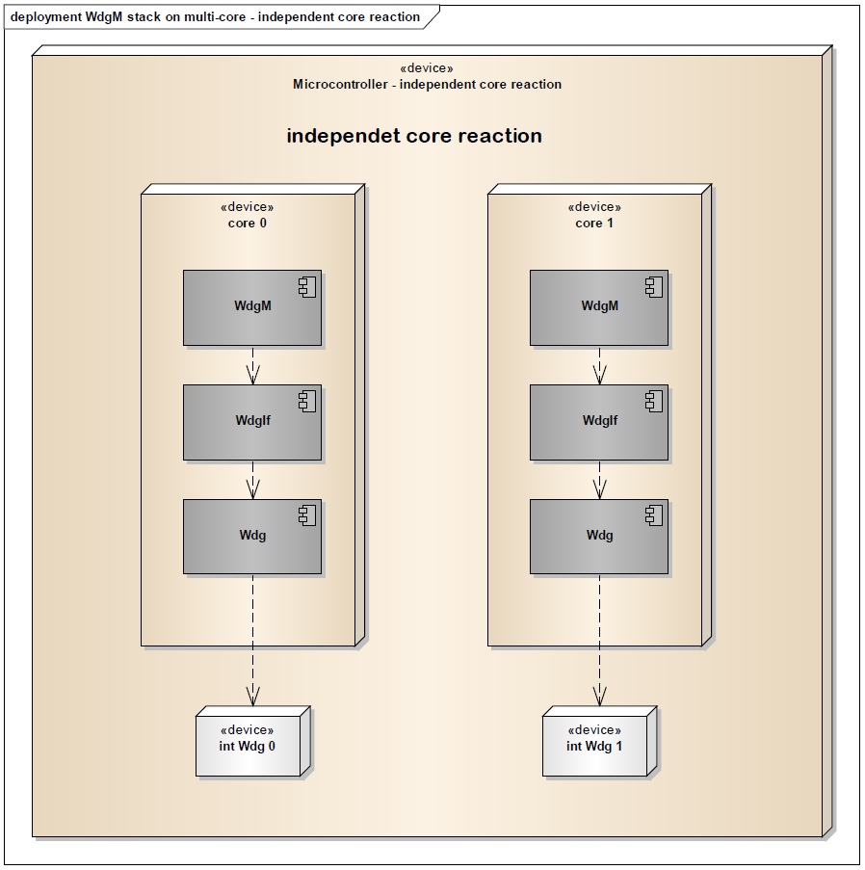

--The WdgIf is configured to enable each WdgM instance running on a separate processor core to trigger its own wdg device

-- A fault on a certain core results in a watchdog reaction from the core's own watchdog device

-- Depending on its setup this might be a processor reset or only a single core reset

**State Combiner**

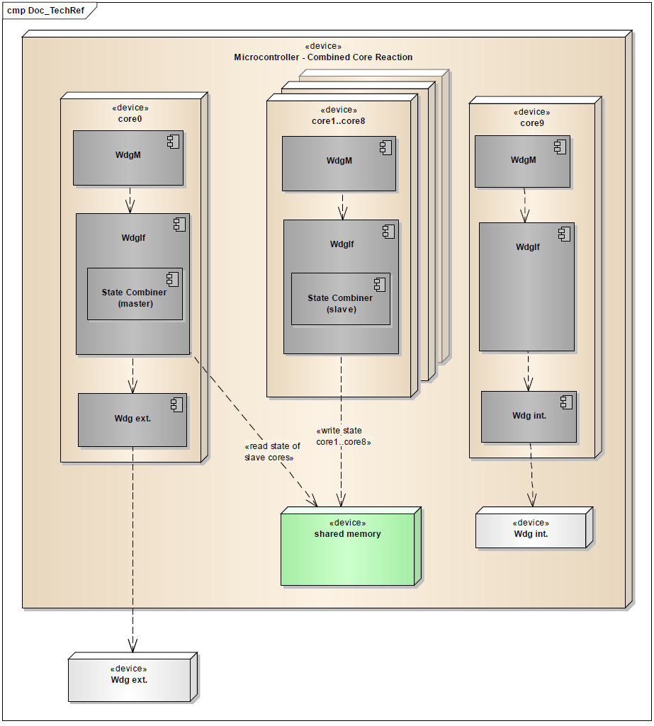

-- Configuring the WdgIf module with a State Combiner so that the WdgM instances

running on different processor cores can share one watchdog device

-- The watchdog device will be triggered

only if no WdgM instance reports any error

**Reference**

* TechnicalReference_WdgIf.pdf
* TechnicalReference_WdgM.pdf
* TC3xx_SW_MCAL_UM_Basic.pdf
* AURIXTC3XX_um_part1_V1.0.0.pdf