2022-03-30 11:25:08,161 [main] INFO org.apache.pig.Main - Pig script completed in 13 minutes, 54 seconds and 199 milliseconds (834199 ms)

root@f2a0c4f7dec5:/# $ hdfs dfs -ls /

bash: $: command not found

root@f2a0c4f7dec5:/# hdfs dfs -ls /

Found 2 items

drwxr-xr-x - root supergroup 0 2022-03-30 11:25 /tmp

drwxr-xr-x - root supergroup 0 2021-08-23 10:43 /user

root@f2a0c4f7dec5:/# 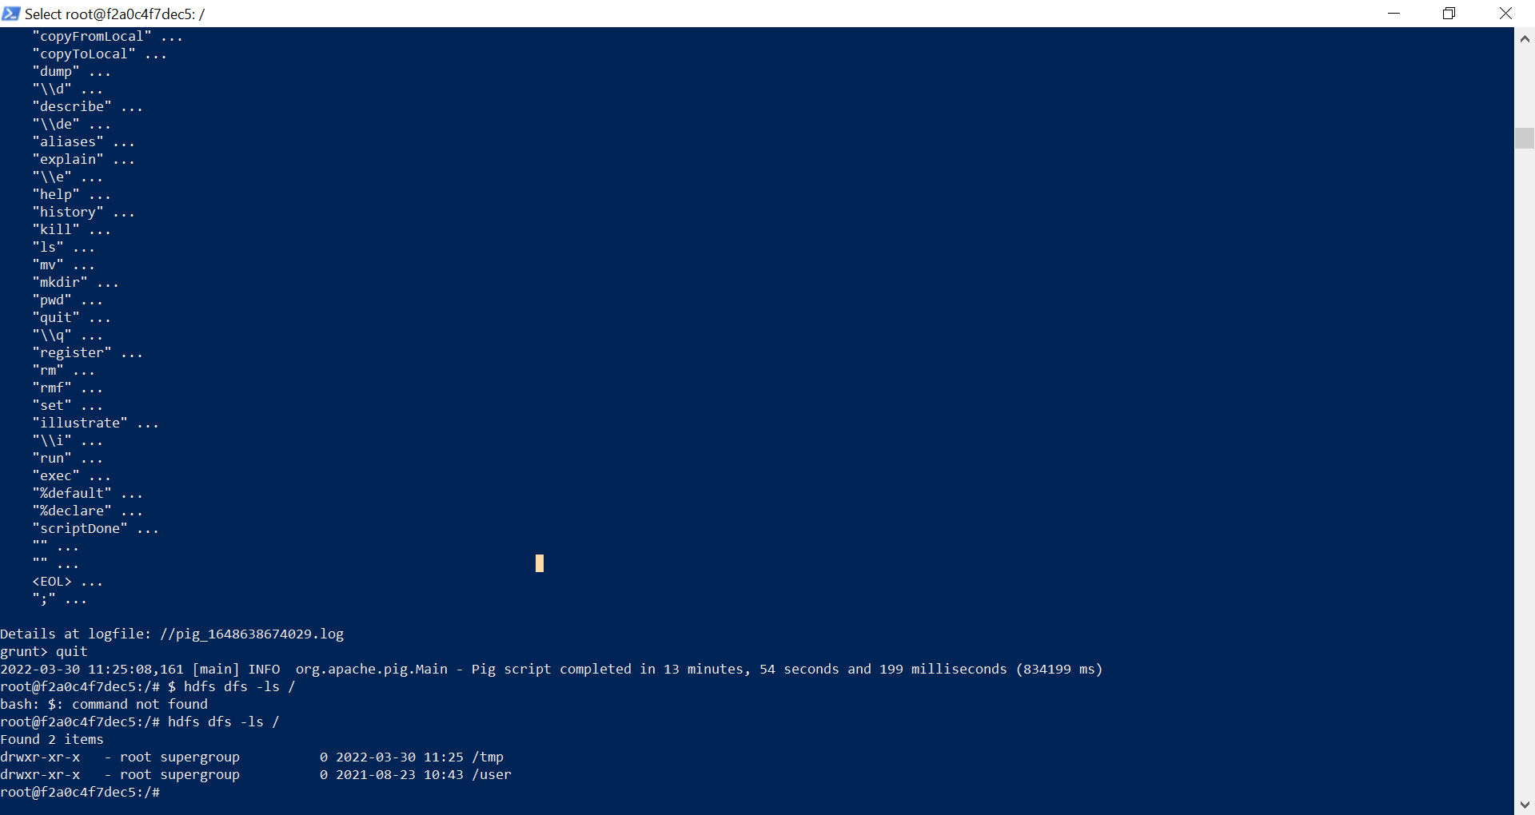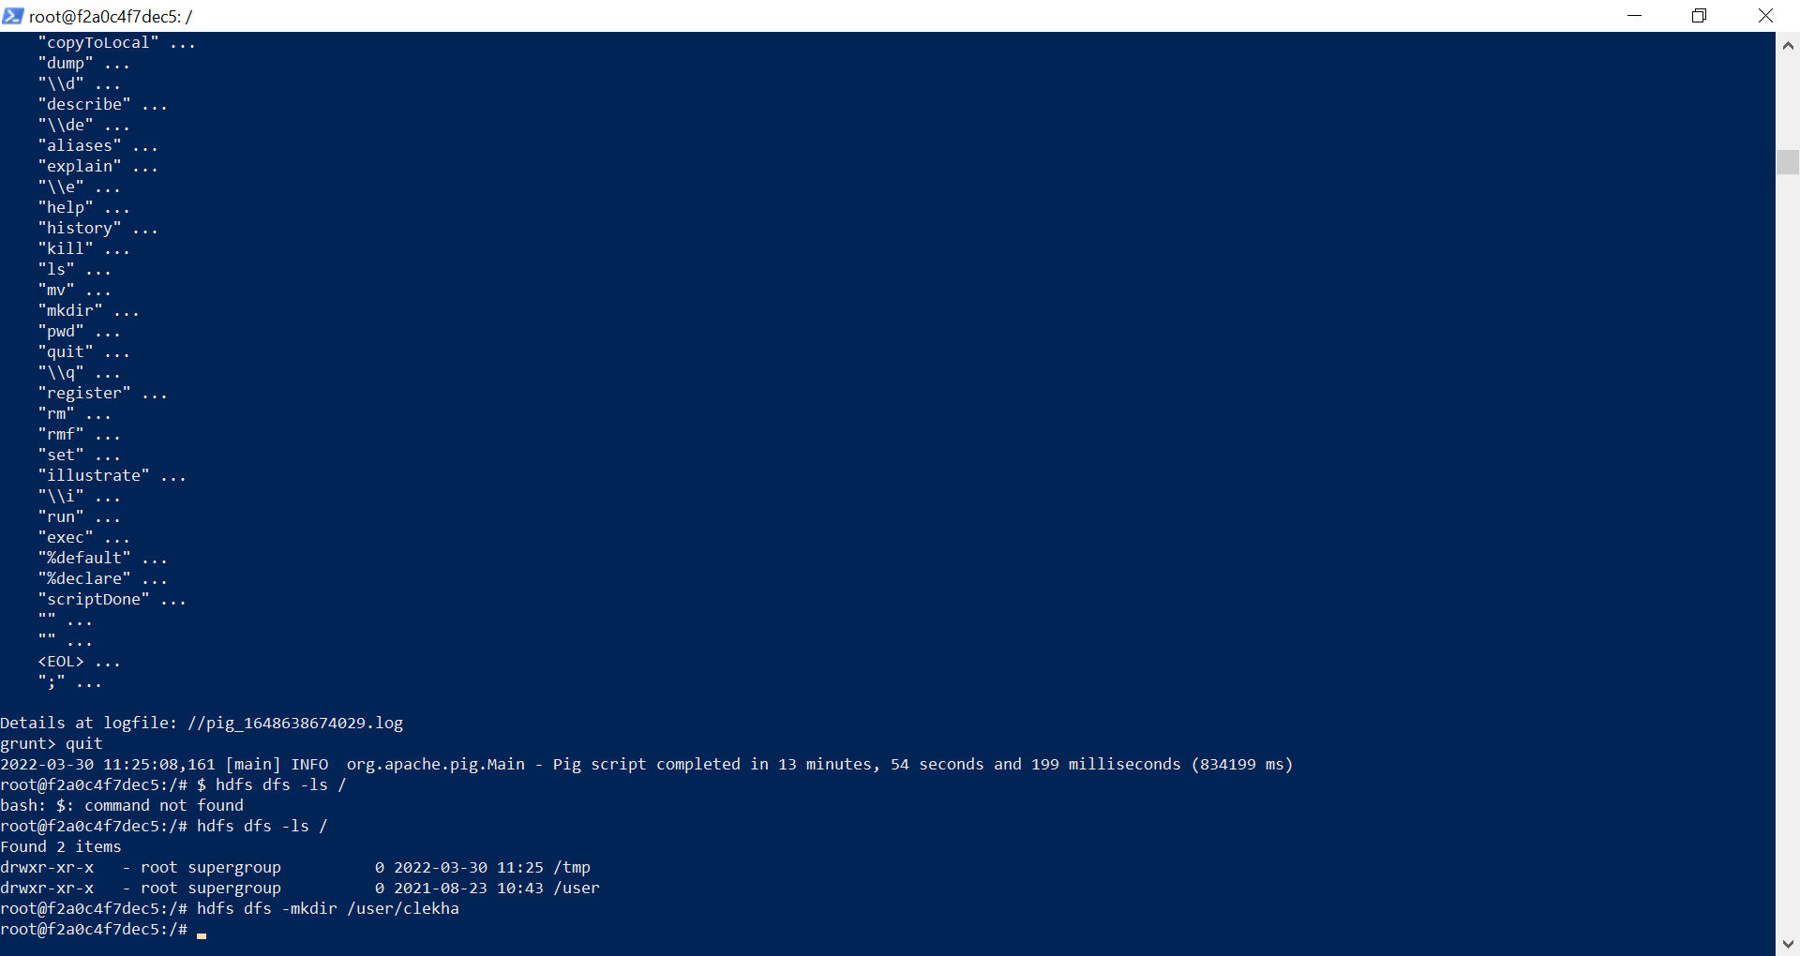 hdfs dfs -mkdir /user/clekha

root@f2a0c4f7dec5:/# hdfs dfs -touchz /user/clekha/myfile.txtdrwxr-xr-x - root supergroup 0 2022-03-30 11:25 /tmp

drwxr-xr-x - root supergroup 0 2021-08-23 10:43 /user

root@f2a0c4f7dec5:/# hdfs dfs -mkdir /user/clekha

root@f2a0c4f7dec5:/# hdfs dfs -touchz /user/clekha/myfile.txt

root@f2a0c4f7dec5:/# hdfs dfs -copyFromLocal ~/myFiles/input.txt /user/clekha

copyFromLocal: `/root/myFiles/input.txt': No such file or directory

root@f2a0c4f7dec5:/# hdfs dfs -touchz /user/root/input.txt

root@f2a0c4f7dec5:/# hdfs dfs -ls /user/root

Found 2 items

drwxr-xr-x - root supergroup 0 2021-08-23 10:44 /user/root/input

-rw-r--r-- 1 root supergroup 0 2022-03-30 11:40 /user/root/input.txt

root@f2a0c4f7dec5:/# 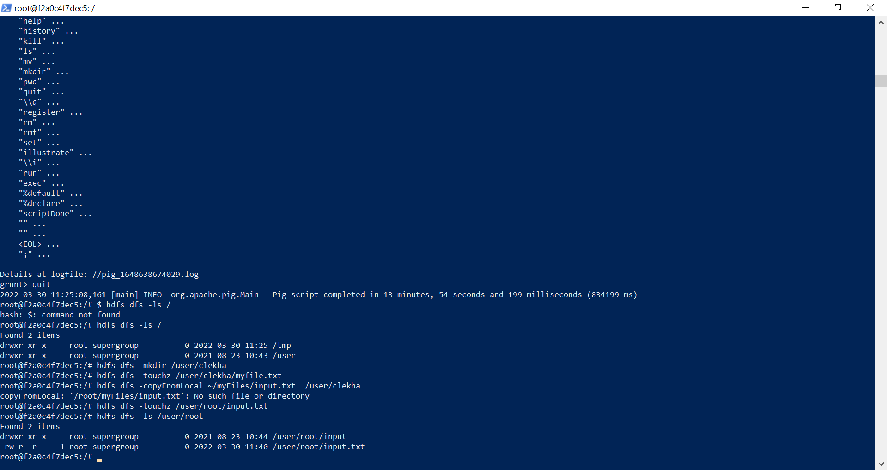root@f2a0c4f7dec5:/# hdfs dfs -cp /user/clekha/file1.txt /user/clekha/file2.txt

cp: `/user/clekha/file1.txt': No such file or directory

root@f2a0c4f7dec5:/# hdfs dfs -touchz /user/clekha/file1.txt

root@f2a0c4f7dec5:/# hdfs dfs -ls /uer/clekha

ls: `/uer/clekha': No such file or directory

root@f2a0c4f7dec5:/# hdfs dfs -ls /user/clekha

Found 2 items

-rw-r--r-- 1 root supergroup 0 2022-03-30 11:44 /user/clekha/file1.txt

-rw-r--r-- 1 root supergroup 0 2022-03-30 11:39 /user/clekha/myfile.txt

root@f2a0c4f7dec5:/# hdfs dfs -touchz /user/clekha/file2.txt

root@f2a0c4f7dec5:/# hdfs dfs -ls /user/clekha

Found 3 items

-rw-r--r-- 1 root supergroup 0 2022-03-30 11:44 /user/clekha/file1.txt

-rw-r--r-- 1 root supergroup 0 2022-03-30 11:44 /user/clekha/file2.txt

-rw-r--r-- 1 root supergroup 0 2022-03-30 11:39 /user/clekha/myfile.txt

root@f2a0c4f7dec5:/# 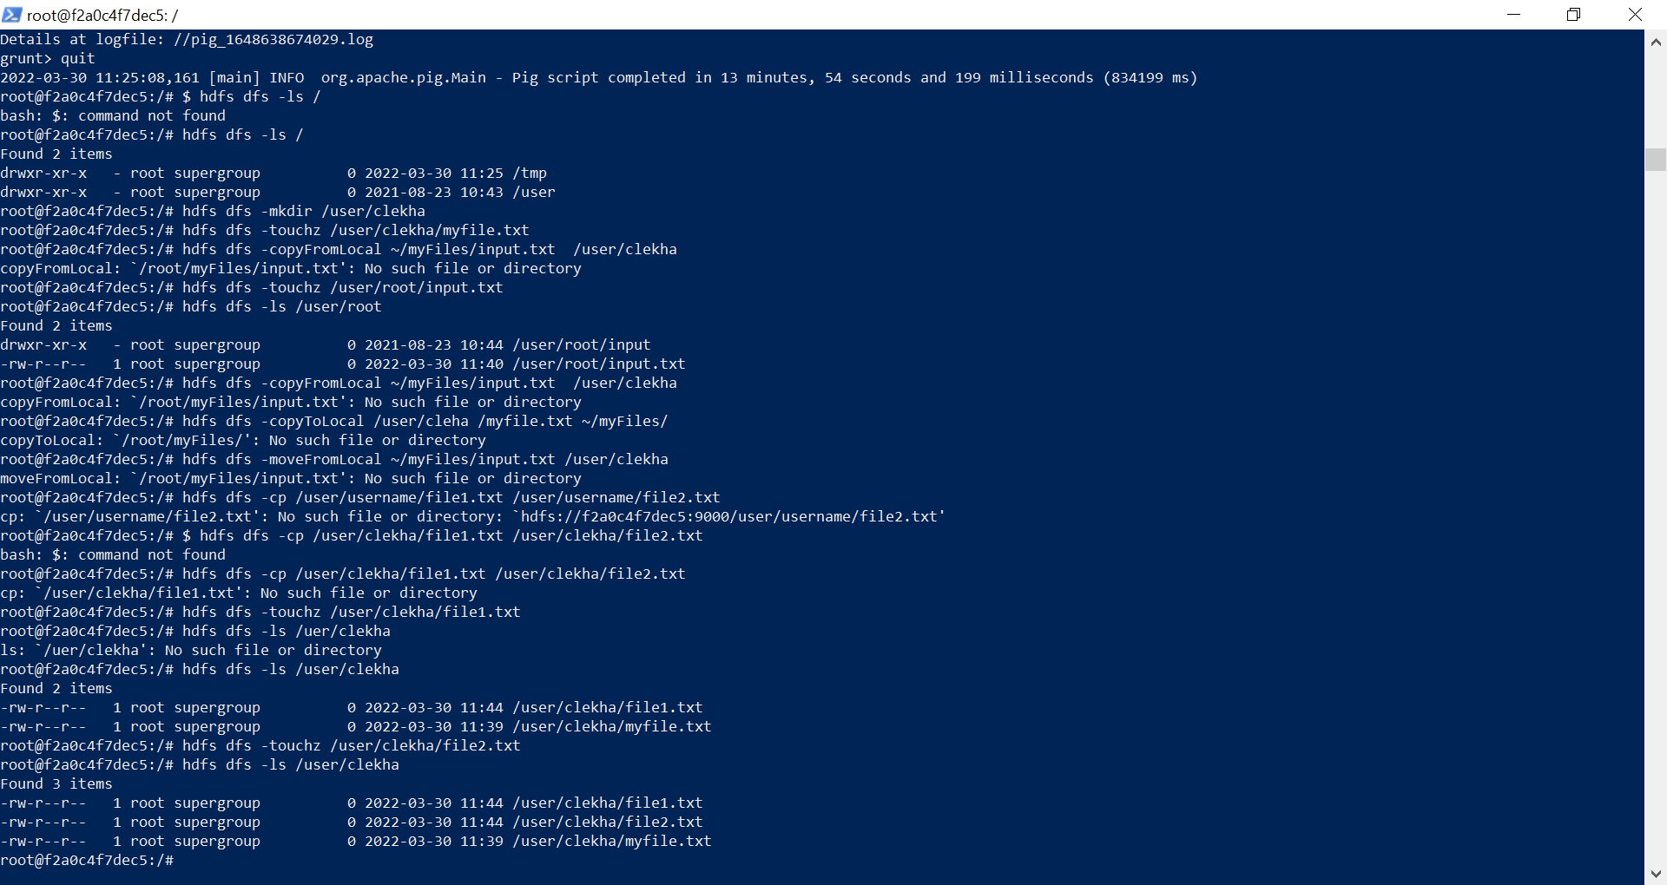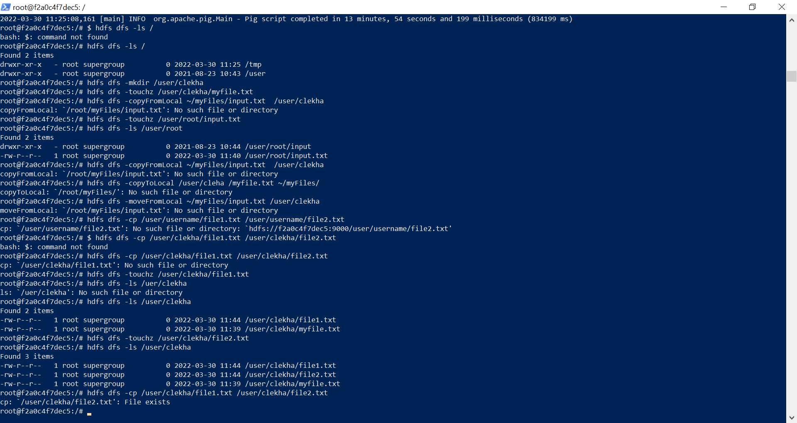root@f2a0c4f7dec5:/# hdfs dfs -cp /user/clekha/file1.txt /user/clekha/file2.txt

cp: `/user/clekha/file2.txt': File exists

root@f2a0c4f7dec5:/# root@f2a0c4f7dec5:/# hdfs dfs -mv /user/clekha/file1.txt /user/clekha/file2.txt

mv: `/user/clekha/file2.txt': File exists

root@f2a0c4f7dec5:/# 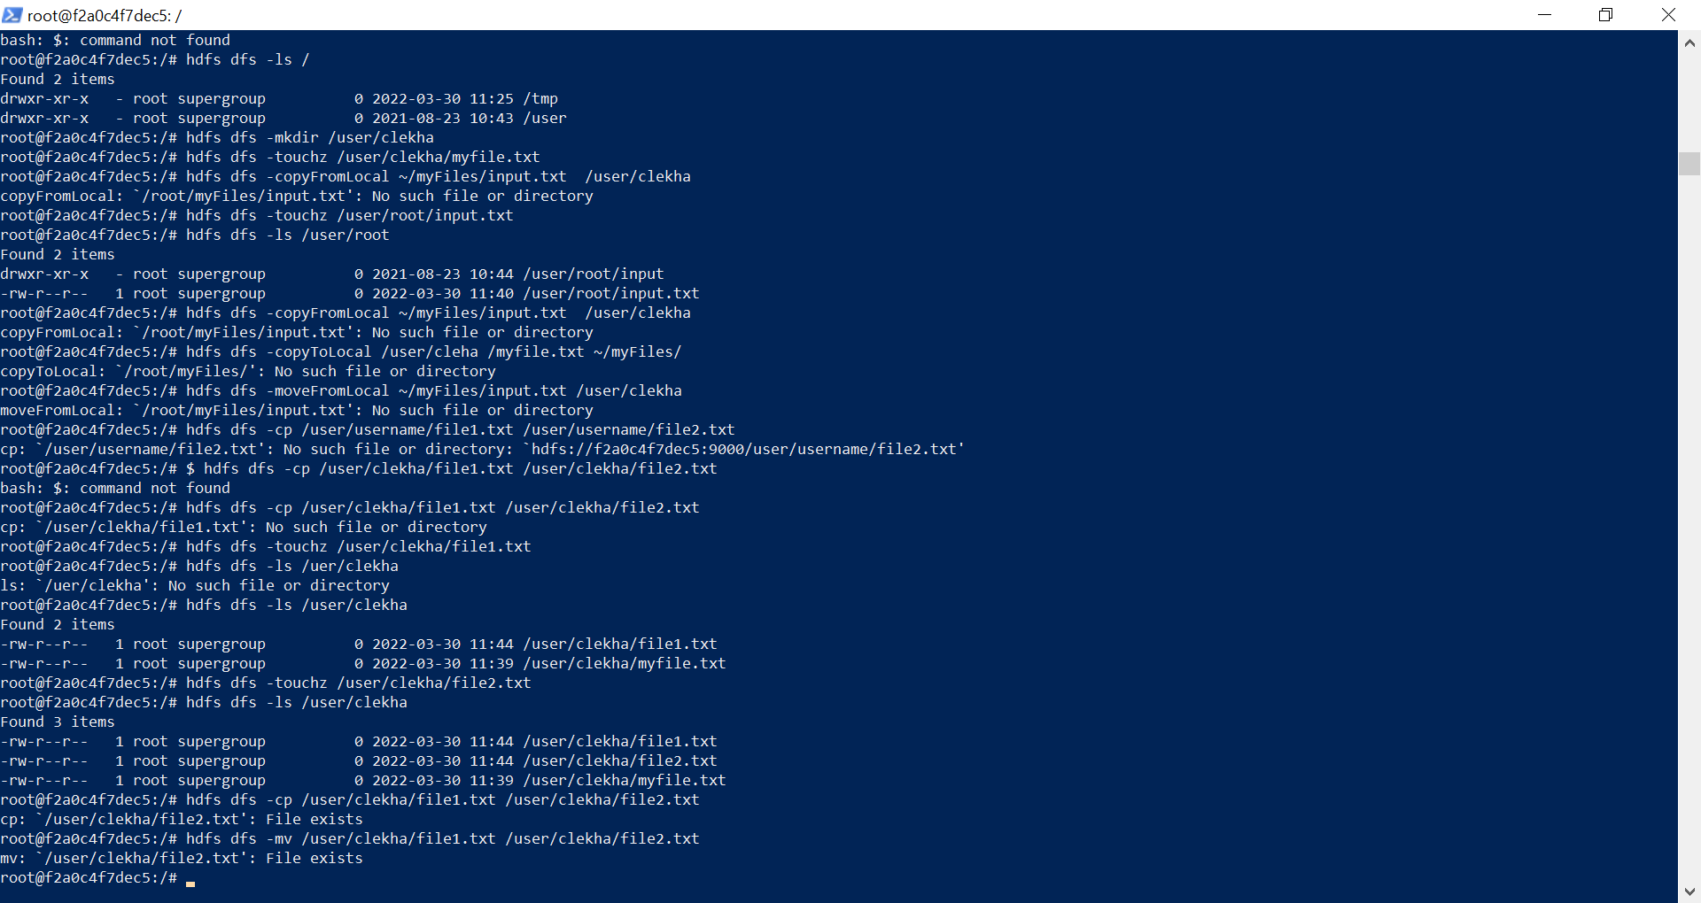

ACTIVITY1.  
hdfs dfs -touchz /user/clekha/txtFile.txt

root@f2a0c4f7dec5:/# 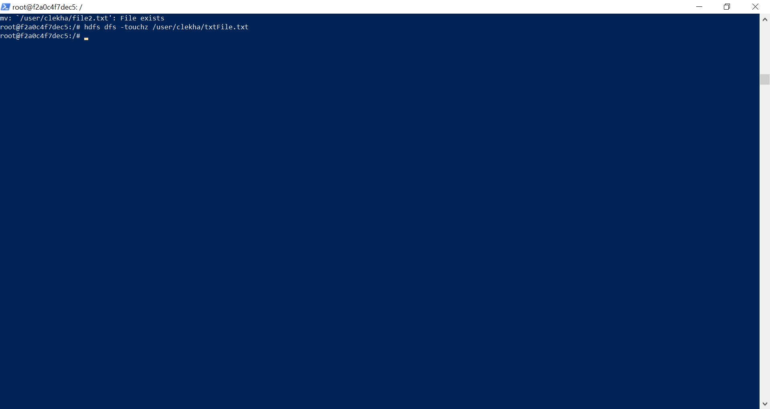viroot@f2a0c4f7dec5:/#

root@f2a0c4f7dec5:/# vim csvFile.csv

root@f2a0c4f7dec5:/# vim csvFile.csv

root@f2a0c4f7dec5:/# hdfs dfs -mkdir /user/root/textData

root@f2a0c4f7dec5:/# hdfs dfs -put ./csvFile.csv /user/root/textData

root@f2a0c4f7dec5:/# hdfs dfs -put ./csvFile.csv /user/root/textData

put: `/user/root/textData/csvFile.csv': File exists

root@f2a0c4f7dec5:/# hdfs dfs -stat "type:%F permissions:%a %u:%g size:%b name:%n" /user/root/textData/csvFile.csv

type:regular file permissions:644 root:supergroup size:527 name:csvFile.csv

root@f2a0c4f7dec5:/# hdfs dfs -stat "type:%F permissions:%a %u:%g size:%b name:%n" /user/root/textData/txtFile.txt

stat: `/user/root/textData/txtFile.txt': No such file or directory

root@f2a0c4f7dec5:/# hdfs dfs -stat "type:%F permissions:%a %u:%g size:%b name:%n" /user/clekha/textData/txtFile.txt

stat: `/user/clekha/textData/txtFile.txt': No such file or directory

root@f2a0c4f7dec5:/# hdfs dfs -put ./txtFile.txt /user/root/textData

root@f2a0c4f7dec5:/# hdfs dfs -stat "type:%F permissions:%a %u:%g size:%b name:%n" /user/root/textData/txtFile.txt

type:regular file permissions:644 root:supergroup size:157 name:txtFile.txt

root@f2a0c4f7dec5:/# 