ACTIVITY 2:

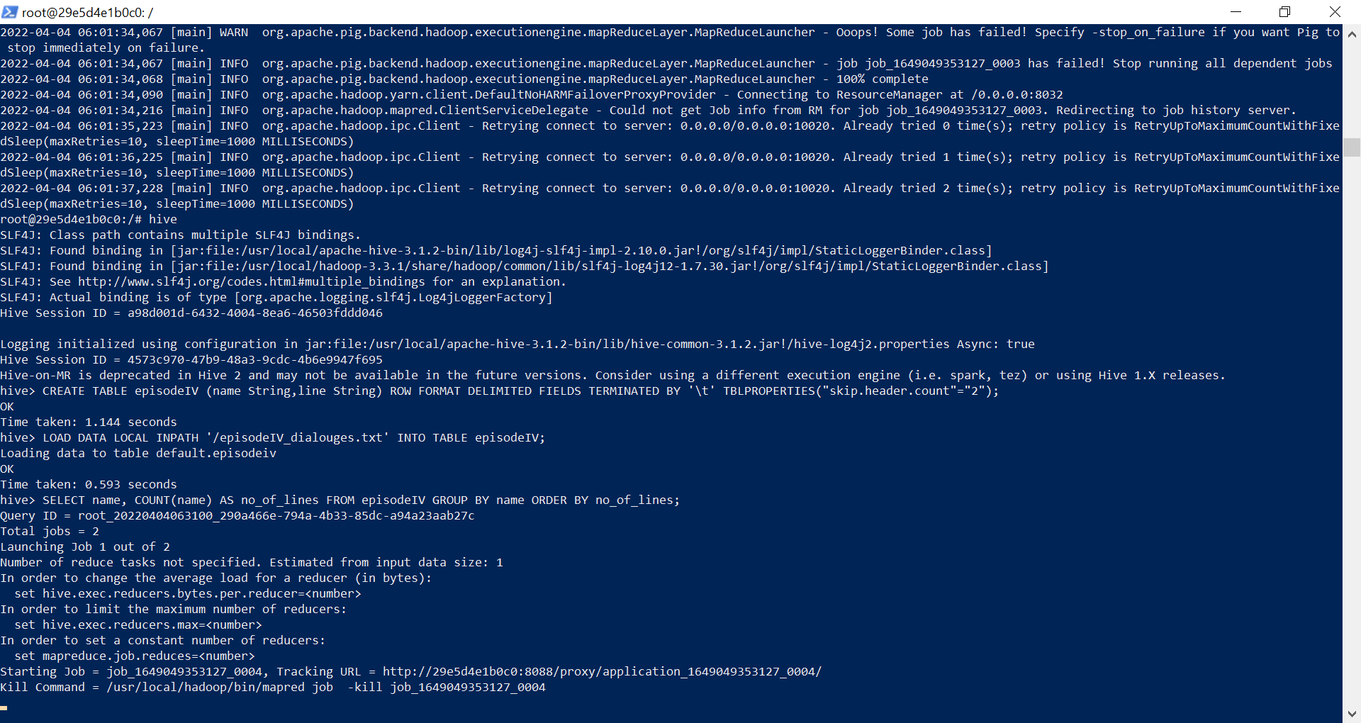

Logging initialized using configuration in jar:file:/usr/local/apache-hive-3.1.2-bin/lib/hive-common-3.1.2.jar!/hive-log4j2.properties Async: true

Hive Session ID = 4573c970-47b9-48a3-9cdc-4b6e9947f695

Hive-on-MR is deprecated in Hive 2 and may not be available in the future versions. Consider using a different execution engine (i.e. spark, tez) or using Hive 1.X releases.

hive> CREATE TABLE episodeIV (name String,line String) ROW FORMAT DELIMITED FIELDS TERMINATED BY '\t' TBLPROPERTIES("skip.header.count"="2");

OK

Time taken: 1.144 seconds

hive> LOAD DATA LOCAL INPATH '/episodeIV_dialouges.txt' INTO TABLE episodeIV;

Loading data to table default.episodeiv

OK

Time taken: 0.593 seconds

hive> SELECT name, COUNT(name) AS no_of_lines FROM episodeIV GROUP BY name ORDER BY no_of_lines;

Query ID = root_20220404063100_290a466e-794a-4b33-85dc-a94a23aab27c

Total jobs = 2

Launching Job 1 out of 2

Number of reduce tasks not specified. Estimated from input data size: 1

In order to change the average load for a reducer (in bytes):

set hive.exec.reducers.bytes.per.reducer=<number>

In order to limit the maximum number of reducers:

set hive.exec.reducers.max=<number>

In order to set a constant number of reducers:

set mapreduce.job.reduces=<number>

Starting Job = job_1649049353127_0004, Tracking URL = http://29e5d4e1b0c0:8088/proxy/application_1649049353127_0004/

Kill Command = /usr/local/hadoop/bin/mapred job -kill job_1649049353127_0004

Hadoop job information for Stage-1: number of mappers: 1; number of reducers: 1

2022-04-04 06:31:13,068 Stage-1 map = 0%, reduce = 0%

2022-04-04 06:31:17,301 Stage-1 map = 100%, reduce = 0%, Cumulative CPU 2.6 sec

2022-04-04 06:31:22,473 Stage-1 map = 100%, reduce = 100%, Cumulative CPU 5.05 sec

MapReduce Total cumulative CPU time: 5 seconds 50 msec

Ended Job = job_1649049353127_0004

Launching Job 2 out of 2

Number of reduce tasks determined at compile time: 1

In order to change the average load for a reducer (in bytes):

set hive.exec.reducers.bytes.per.reducer=<number>

In order to limit the maximum number of reducers:

set hive.exec.reducers.max=<number>

In order to set a constant number of reducers:

set mapreduce.job.reduces=<number>

Starting Job = job_1649049353127_0005, Tracking URL = http://29e5d4e1b0c0:8088/proxy/application_1649049353127_0005/

Kill Command = /usr/local/hadoop/bin/mapred job -kill job_1649049353127_0005

Hadoop job information for Stage-2: number of mappers: 1; number of reducers: 1

2022-04-04 06:31:35,307 Stage-2 map = 0%, reduce = 0%

2022-04-04 06:31:39,447 Stage-2 map = 100%, reduce = 0%, Cumulative CPU 1.6 sec

2022-04-04 06:31:44,624 Stage-2 map = 100%, reduce = 100%, Cumulative CPU 3.82 sec

MapReduce Total cumulative CPU time: 3 seconds 820 msec

Ended Job = job_1649049353127_0005

MapReduce Jobs Launched:

Stage-Stage-1: Map: 1 Reduce: 1 Cumulative CPU: 5.05 sec HDFS Read: 79772 HDFS Write: 2085 SUCCESS

Stage-Stage-2: Map: 1 Reduce: 1 Cumulative CPU: 3.82 sec HDFS Read: 9605 HDFS Write: 1815 SUCCESS

Total MapReduce CPU Time Spent: 8 seconds 870 msec

OK

1

WINGMAN'S VOICE 1

WINGMAN 1

VOICE OVER DEATH STAR INTERCOM 1

TROOPER VOICE 1

TECHNICIAN 1

STAR WARS - EPISODE 4: STAR WARS 1

SECOND OFFICER 1

RED TEN'S VOICE 1

RED SEVEN 1

RED NINE'S VOICE 1

RED NINE 1

RED LEADER'S VOICE 1

RED ELEVEN 1

REBEL OFFICER 1

PORKINS 1

OFFICER CASS 1

MAN'S VOICE 1

LUKE'S VOICE 1

WOMAN 1

HAN'S VOICE 1

FIRST OFFICER 1

DEAK 1

CREATURE 1

CONTROL OFFICER 1

CHIEF PILOT 1

CAPTAIN 1

BERU 1

BASE VOICE 1

ASTRO-OFFICER 1

GANTRY OFFICER 2

CHIEF 2

IMPERIAL OFFICER 2

CAMIE 2

WILLARD 2

GOLD TWO 2

FIXER 2

VOICE 3

BARTENDER 3

MASSASSI INTERCOM VOICE 3

COMMANDER 3

SECOND TROOPER 3

MOTTI 4

TAGGE 4

HUMAN 4

INTERCOM VOICE 6

AUNT BERU 6

DEATH STAR INTERCOM VOICE 6

GREEDO 6

DODONNA 6

FIRST TROOPER 6

BEN'S VOICE 6

JABBA 6

GOLD FIVE 7

RED TEN 7

OFFICER 11

GOLD LEADER 14

WEDGE 14

TROOPER 19

OWEN 25

TARKIN 28

BIGGS 34

RED LEADER 36

VADER 41

LEIA 57

BEN 76

THREEPIO 119

HAN 152

LUKE 253

Time taken: 45.077 seconds, Fetched: 69 row(s)

hive>

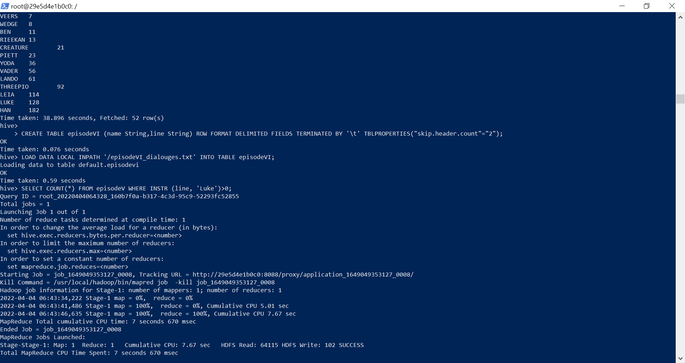

Time taken: 45.077 seconds, Fetched: 69 row(s)

hive> CREATE TABLE episodeV (name String,line String) ROW FORMAT DELIMITED FIELDS TERMINATED BY '\t' TBLPROPERTIES("skip.header.count"="2");

OK

Time taken: 0.077 seconds

hive> LOAD DATA LOCAL INPATH '/episodeV_dialouges.txt' INTO TABLE episodeV;

Loading data to table default.episodev

OK

Time taken: 0.154 seconds

hive> SELECT name, COUNT(name) AS no_of_lines FROM episodeV GROUP BY name ORDER BY no_of_lines;

Query ID = root_20220404063304_b895cb84-8d6f-4f14-bf3f-22732ac15282

Total jobs = 2

Launching Job 1 out of 2

Number of reduce tasks not specified. Estimated from input data size: 1

In order to change the average load for a reducer (in bytes):

set hive.exec.reducers.bytes.per.reducer=<number>

In order to limit the maximum number of reducers:

set hive.exec.reducers.max=<number>

In order to set a constant number of reducers:

set mapreduce.job.reduces=<number>

Starting Job = job_1649049353127_0006, Tracking URL = http://29e5d4e1b0c0:8088/proxy/application_1649049353127_0006/

Kill Command = /usr/local/hadoop/bin/mapred job -kill job_1649049353127_0006

Hadoop job information for Stage-1: number of mappers: 1; number of reducers: 1

2022-04-04 06:33:09,665 Stage-1 map = 0%, reduce = 0%

2022-04-04 06:33:14,855 Stage-1 map = 100%, reduce = 0%, Cumulative CPU 2.89 sec

2022-04-04 06:33:19,994 Stage-1 map = 100%, reduce = 100%, Cumulative CPU 5.1 sec

MapReduce Total cumulative CPU time: 5 seconds 100 msec

Ended Job = job_1649049353127_0006

Launching Job 2 out of 2

Number of reduce tasks determined at compile time: 1

In order to change the average load for a reducer (in bytes):

set hive.exec.reducers.bytes.per.reducer=<number>

In order to limit the maximum number of reducers:

set hive.exec.reducers.max=<number>

In order to set a constant number of reducers:

set mapreduce.job.reduces=<number>

Starting Job = job_1649049353127_0007, Tracking URL = http://29e5d4e1b0c0:8088/proxy/application_1649049353127_0007/

Kill Command = /usr/local/hadoop/bin/mapred job -kill job_1649049353127_0007

Hadoop job information for Stage-2: number of mappers: 1; number of reducers: 1

2022-04-04 06:33:32,483 Stage-2 map = 0%, reduce = 0%

2022-04-04 06:33:36,673 Stage-2 map = 100%, reduce = 0%, Cumulative CPU 1.57 sec

2022-04-04 06:33:41,817 Stage-2 map = 100%, reduce = 100%, Cumulative CPU 3.74 sec

MapReduce Total cumulative CPU time: 3 seconds 740 msec

Ended Job = job_1649049353127_0007

MapReduce Jobs Launched:

Stage-Stage-1: Map: 1 Reduce: 1 Cumulative CPU: 5.1 sec HDFS Read: 61980 HDFS Write: 1614 SUCCESS

Stage-Stage-2: Map: 1 Reduce: 1 Cumulative CPU: 3.74 sec HDFS Read: 9130 HDFS Write: 1409 SUCCESS

Total MapReduce CPU Time Spent: 8 seconds 840 msec

OK

FIRST CONTROLLER 1

WOMAN CONTROLLER 1

ASSISTANT OFFICER 1

CAPTAIN 1

STRANGE VOICE 1

STAR WARS - EPISODE 5: THE EMPIRE STRIKES BACK 1

SECOND THREEPIO 1

SECOND OFFICER 1

SECOND CONTROLLER 1

REBEL FIGHTER 1

REBEL CAPTAIN 1

PILOTS 1

PILOT 1

OFFICER 1

MAN'S VOICE 1

1

IMPERIAL SOLDIER 1

HOBBIE 1

HEAD CONTROLLER 1

MEDICAL DROID 2

INTERCOM VOICE 2

COMMUNICATIONS OFFICER 2

SENIOR CONTROLLER 2

IMPERIAL OFFICER 2

LIEUTENANT 2

TRACKING OFFICER 2

DERLIN 3

CONTROLLER 3

TRENCH OFFICER 3

ANNOUNCER 3

BOBA FETT 4

BEN'S VOICE 4

JANSON 4

DACK 4

OZZEL 5

EMPEROR 5

NEEDA 5

ZEV 6

DECK OFFICER 7

VEERS 7

WEDGE 8

BEN 11

RIEEKAN 13

CREATURE 21

PIETT 23

YODA 36

VADER 56

LANDO 61

THREEPIO 92

LEIA 114

LUKE 128

HAN 182

Time taken: 38.896 seconds, Fetched: 52 row(s)  
  
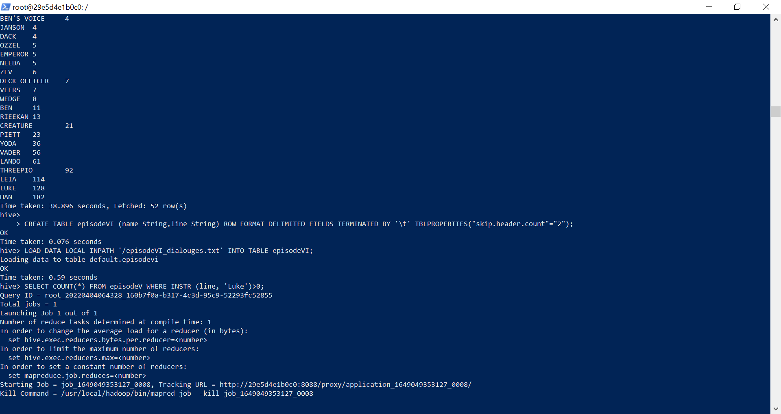

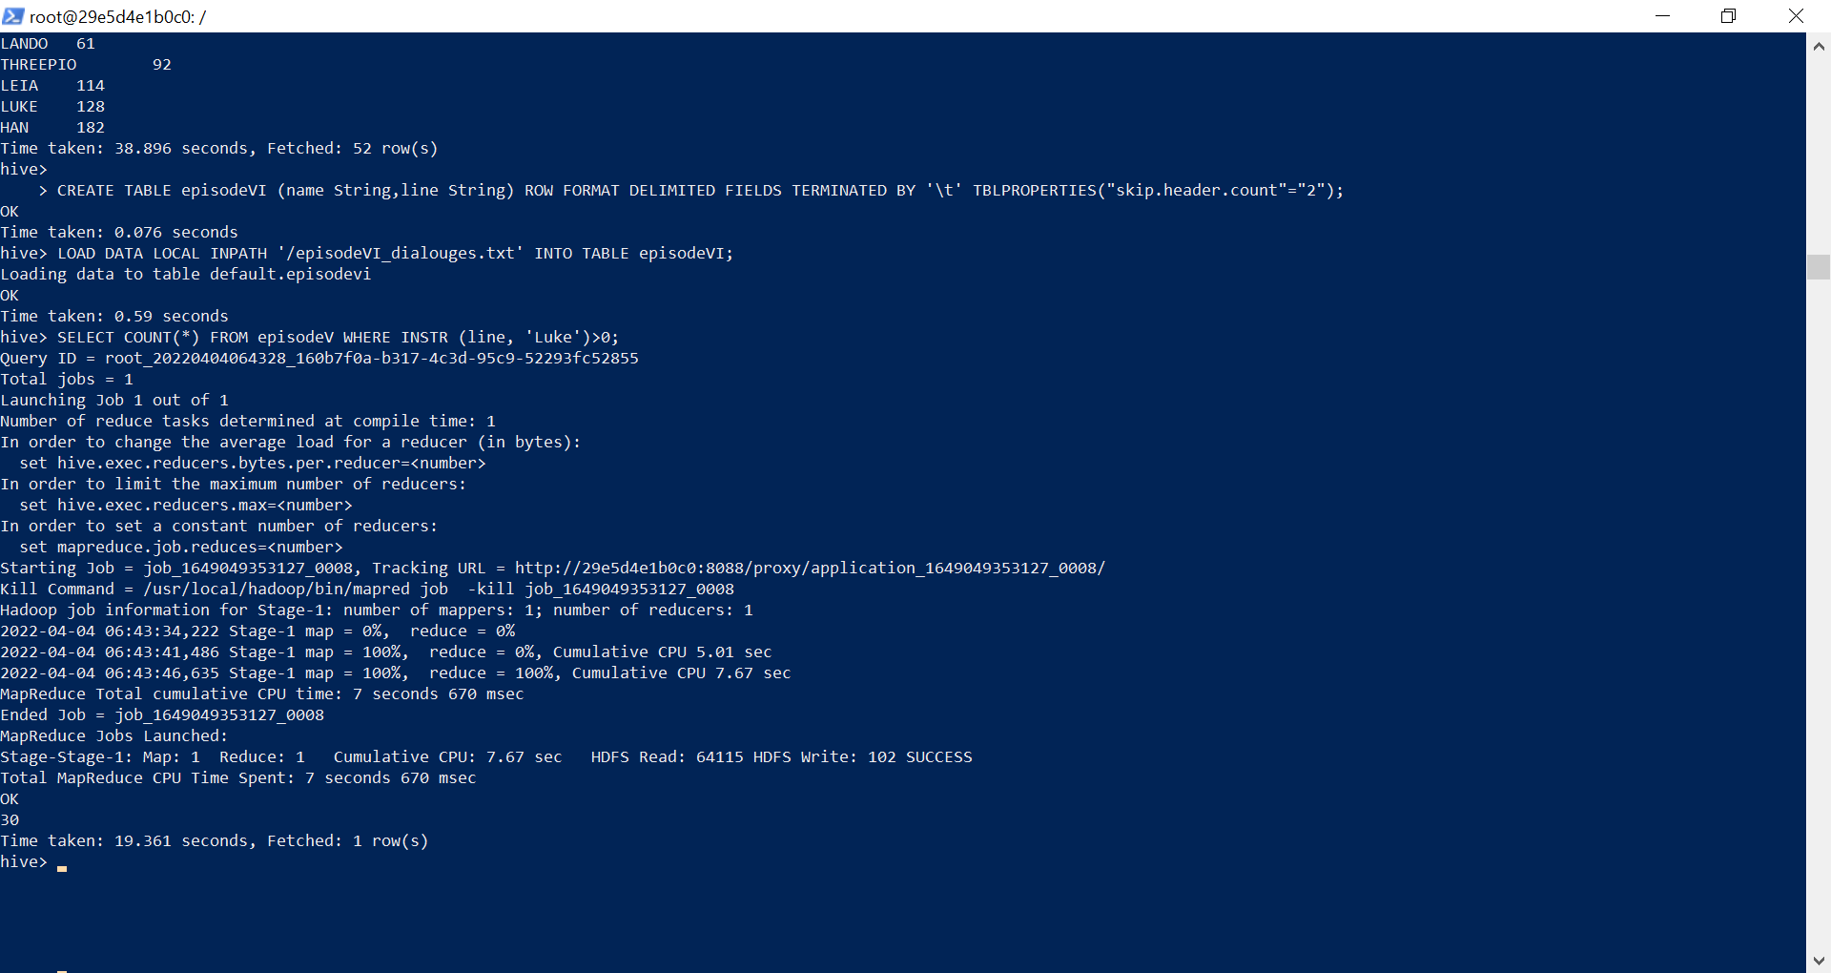hive>

> CREATE TABLE episodeVI (name String,line String) ROW FORMAT DELIMITED FIELDS TERMINATED BY '\t' TBLPROPERTIES("skip.header.count"="2");

OK

Time taken: 0.076 seconds

hive> LOAD DATA LOCAL INPATH '/episodeVI_dialouges.txt' INTO TABLE episodeVI;

Loading data to table default.episodevi

OK

Time taken: 0.59 seconds

hive> SELECT COUNT(*) FROM episodeV WHERE INSTR (line, 'Luke')>0;

Query ID = root_20220404064328_160b7f0a-b317-4c3d-95c9-52293fc52855

Total jobs = 1

Launching Job 1 out of 1

Number of reduce tasks determined at compile time: 1

In order to change the average load for a reducer (in bytes):

set hive.exec.reducers.bytes.per.reducer=<number>

In order to limit the maximum number of reducers:

set hive.exec.reducers.max=<number>

In order to set a constant number of reducers:

set mapreduce.job.reduces=<number>

Starting Job = job_1649049353127_0008, Tracking URL = http://29e5d4e1b0c0:8088/proxy/application_1649049353127_0008/

Kill Command = /usr/local/hadoop/bin/mapred job -kill job_1649049353127_0008

Hadoop job information for Stage-1: number of mappers: 1; number of reducers: 1

2022-04-04 06:43:34,222 Stage-1 map = 0%, reduce = 0%

2022-04-04 06:43:41,486 Stage-1 map = 100%, reduce = 0%, Cumulative CPU 5.01 sec

2022-04-04 06:43:46,635 Stage-1 map = 100%, reduce = 100%, Cumulative CPU 7.67 sec

MapReduce Total cumulative CPU time: 7 seconds 670 msec

Ended Job = job_1649049353127_0008

MapReduce Jobs Launched:

Stage-Stage-1: Map: 1 Reduce: 1 Cumulative CPU: 7.67 sec HDFS Read: 64115 HDFS Write: 102 SUCCESS

Total MapReduce CPU Time Spent: 7 seconds 670 msec

OK

30

Time taken: 19.361 seconds, Fetched: 1 row(s)  
  
  
  
ACTIVITY1:  
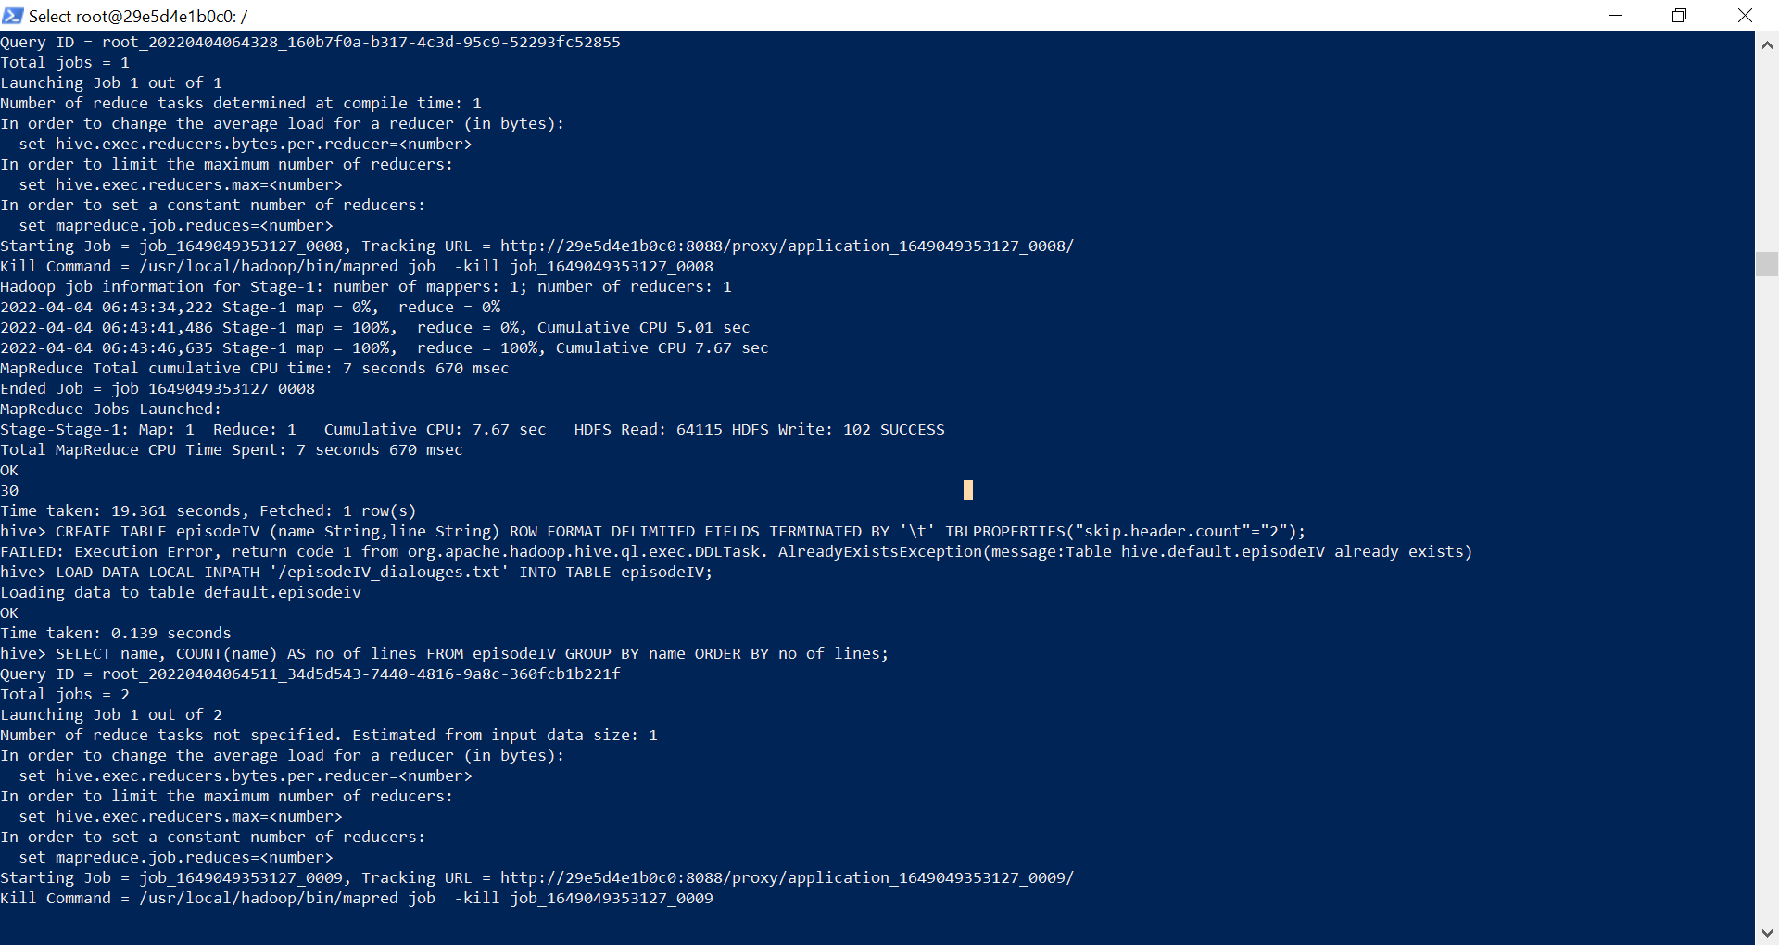hive> LOAD DATA LOCAL INPATH '/episodeIV_dialouges.txt' INTO TABLE episodeIV;

Loading data to table default.episodeiv

OK

Time taken: 0.139 seconds

hive> SELECT name, COUNT(name) AS no_of_lines FROM episodeIV GROUP BY name ORDER BY no_of_lines;

Query ID = root_20220404064511_34d5d543-7440-4816-9a8c-360fcb1b221f

Total jobs = 2

Launching Job 1 out of 2

Number of reduce tasks not specified. Estimated from input data size: 1

In order to change the average load for a reducer (in bytes):

set hive.exec.reducers.bytes.per.reducer=<number>

In order to limit the maximum number of reducers:

set hive.exec.reducers.max=<number>

In order to set a constant number of reducers:

set mapreduce.job.reduces=<number>

Starting Job = job_1649049353127_0009, Tracking URL = http://29e5d4e1b0c0:8088/proxy/application_1649049353127_0009/

Kill Command = /usr/local/hadoop/bin/mapred job -kill job_1649049353127_0009

Hadoop job information for Stage-1: number of mappers: 1; number of reducers: 1

2022-04-04 06:45:18,137 Stage-1 map = 0%, reduce = 0%

2022-04-04 06:45:23,325 Stage-1 map = 100%, reduce = 0%, Cumulative CPU 2.48 sec

2022-04-04 06:45:27,453 Stage-1 map = 100%, reduce = 100%, Cumulative CPU 4.63 sec

MapReduce Total cumulative CPU time: 4 seconds 630 msec

Ended Job = job_1649049353127_0009

Launching Job 2 out of 2

Number of reduce tasks determined at compile time: 1

In order to change the average load for a reducer (in bytes):

set hive.exec.reducers.bytes.per.reducer=<number>

In order to limit the maximum number of reducers:

set hive.exec.reducers.max=<number>

In order to set a constant number of reducers:

set mapreduce.job.reduces=<number>

Starting Job = job_1649049353127_0010, Tracking URL = http://29e5d4e1b0c0:8088/proxy/application_1649049353127_0010/

Kill Command = /usr/local/hadoop/bin/mapred job -kill job_1649049353127_0010

Hadoop job information for Stage-2: number of mappers: 1; number of reducers: 1

2022-04-04 06:45:40,524 Stage-2 map = 0%, reduce = 0%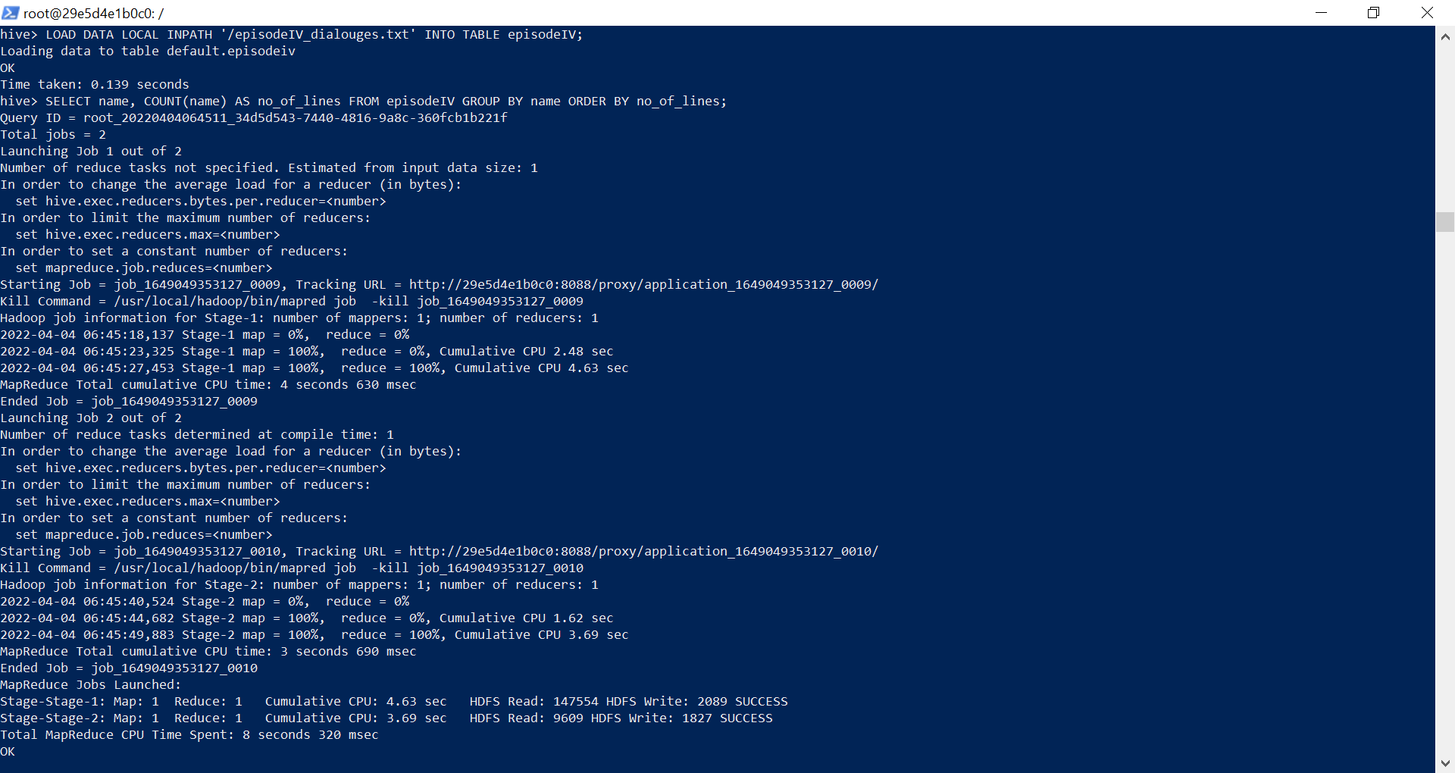Time taken: 0.139 seconds

hive> SELECT name, COUNT(name) AS no_of_lines FROM episodeIV GROUP BY name ORDER BY no_of_lines;

Query ID = root_20220404064511_34d5d543-7440-4816-9a8c-360fcb1b221f

Total jobs = 2

Launching Job 1 out of 2

Number of reduce tasks not specified. Estimated from input data size: 1

In order to change the average load for a reducer (in bytes):

set hive.exec.reducers.bytes.per.reducer=<number>

In order to limit the maximum number of reducers:

set hive.exec.reducers.max=<number>

In order to set a constant number of reducers:

set mapreduce.job.reduces=<number>

Starting Job = job_1649049353127_0009, Tracking URL = http://29e5d4e1b0c0:8088/proxy/application_1649049353127_0009/

Kill Command = /usr/local/hadoop/bin/mapred job -kill job_1649049353127_0009

Hadoop job information for Stage-1: number of mappers: 1; number of reducers: 1

2022-04-04 06:45:18,137 Stage-1 map = 0%, reduce = 0%

2022-04-04 06:45:23,325 Stage-1 map = 100%, reduce = 0%, Cumulative CPU 2.48 sec

2022-04-04 06:45:27,453 Stage-1 map = 100%, reduce = 100%, Cumulative CPU 4.63 sec

MapReduce Total cumulative CPU time: 4 seconds 630 msec

Ended Job = job_1649049353127_0009

Launching Job 2 out of 2

Number of reduce tasks determined at compile time: 1

In order to change the average load for a reducer (in bytes):

set hive.exec.reducers.bytes.per.reducer=<number>

In order to limit the maximum number of reducers:

set hive.exec.reducers.max=<number>

In order to set a constant number of reducers:

set mapreduce.job.reduces=<number>

Starting Job = job_1649049353127_0010, Tracking URL = http://29e5d4e1b0c0:8088/proxy/application_1649049353127_0010/

Kill Command = /usr/local/hadoop/bin/mapred job -kill job_1649049353127_0010

Hadoop job information for Stage-2: number of mappers: 1; number of reducers: 1

2022-04-04 06:45:40,524 Stage-2 map = 0%, reduce = 0%

2022-04-04 06:45:44,682 Stage-2 map = 100%, reduce = 0%, Cumulative CPU 1.62 sec

2022-04-04 06:45:49,883 Stage-2 map = 100%, reduce = 100%, Cumulative CPU 3.69 sec

MapReduce Total cumulative CPU time: 3 seconds 690 msec

Ended Job = job_1649049353127_0010

MapReduce Jobs Launched:

Stage-Stage-1: Map: 1 Reduce: 1 Cumulative CPU: 4.63 sec HDFS Read: 147554 HDFS Write: 2089 SUCCESS

Stage-Stage-2: Map: 1 Reduce: 1 Cumulative CPU: 3.69 sec HDFS Read: 9609 HDFS Write: 1827 SUCCESS

Total MapReduce CPU Time Spent: 8 seconds 320 msec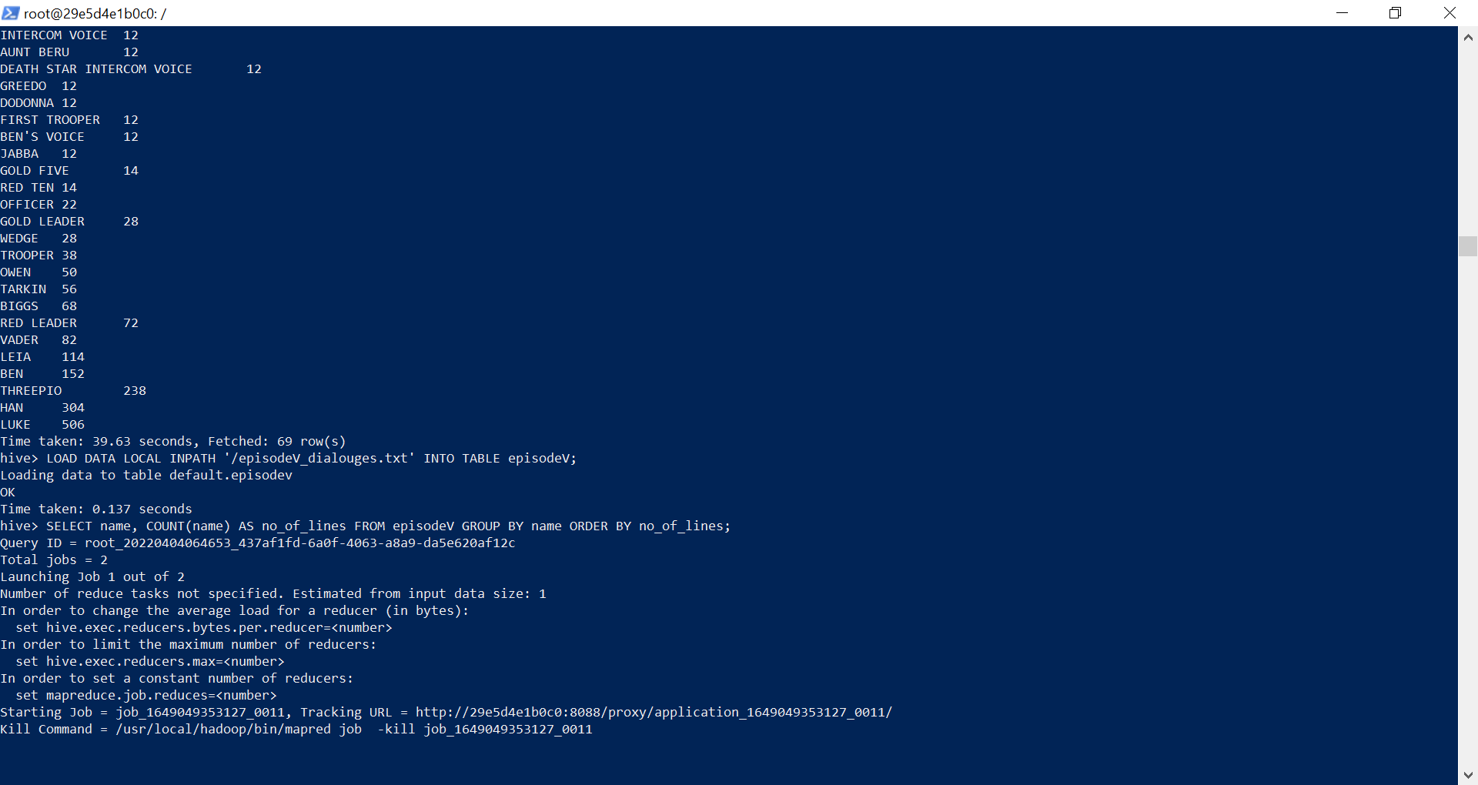

hive> SELECT name, COUNT(name) AS no_of_lines FROM episodeV GROUP BY name ORDER BY no_of_lines;

Query ID = root_20220404064653_437af1fd-6a0f-4063-a8a9-da5e620af12c

Total jobs = 2

Launching Job 1 out of 2

Number of reduce tasks not specified. Estimated from input data size: 1

In order to change the average load for a reducer (in bytes):

set hive.exec.reducers.bytes.per.reducer=<number>

In order to limit the maximum number of reducers:

set hive.exec.reducers.max=<number>

In order to set a constant number of reducers:

set mapreduce.job.reduces=<number>

Starting Job = job_1649049353127_0011, Tracking URL = http://29e5d4e1b0c0:8088/proxy/application_1649049353127_0011/

Kill Command = /usr/local/hadoop/bin/mapred job -kill job_1649049353127_0011

Hadoop job information for Stage-1: number of mappers: 1; number of reducers: 1

2022-04-04 06:47:00,279 Stage-1 map = 0%, reduce = 0%

2022-04-04 06:47:05,461 Stage-1 map = 100%, reduce = 0%, Cumulative CPU 2.82 sec

2022-04-04 06:47:10,652 Stage-1 map = 100%, reduce = 100%, Cumulative CPU 5.08 sec

MapReduce Total cumulative CPU time: 5 seconds 80 msec

Ended Job = job_1649049353127_0011

Launching Job 2 out of 2

Number of reduce tasks determined at compile time: 1

In order to change the average load for a reducer (in bytes):

set hive.exec.reducers.bytes.per.reducer=<number>

In order to limit the maximum number of reducers:

set hive.exec.reducers.max=<number>

In order to set a constant number of reducers:

set mapreduce.job.reduces=<number>

Starting Job = job_1649049353127_0012, Tracking URL = http://29e5d4e1b0c0:8088/proxy/application_1649049353127_0012/

Kill Command = /usr/local/hadoop/bin/mapred job -kill job_1649049353127_0012

Hadoop job information for Stage-2: number of mappers: 1; number of reducers: 1

2022-04-04 06:47:23,623 Stage-2 map = 0%, reduce = 0%

2022-04-04 06:47:28,796 Stage-2 map = 100%, reduce = 0%, Cumulative CPU 1.52 sec

2022-04-04 06:47:32,931 Stage-2 map = 100%, reduce = 100%, Cumulative CPU 3.63 sec

MapReduce Total cumulative CPU time: 3 seconds 630 msec

Ended Job = job_1649049353127_0012

MapReduce Jobs Launched:

Stage-Stage-1: Map: 1 Reduce: 1 Cumulative CPU: 5.08 sec HDFS Read: 111969 HDFS Write: 1618 SUCCESS

Stage-Stage-2: Map: 1 Reduce: 1 Cumulative CPU: 3.63 sec HDFS Read: 9134 HDFS Write: 1419 SUCCESS

Total MapReduce CPU Time Spent: 8 seconds 710 msec

OK

FIRST CONTROLLER 2

WOMAN CONTROLLER 2

ASSISTANT OFFICER 2

CAPTAIN 2

STRANGE VOICE 2

STAR WARS - EPISODE 5: THE EMPIRE STRIKES BACK 2

SECOND THREEPIO 2

SECOND OFFICER 2

SECOND CONTROLLER 2

REBEL FIGHTER 2

REBEL CAPTAIN 2

PILOTS 2

PILOT 2

OFFICER 2

MAN'S VOICE 2

2

IMPERIAL SOLDIER 2

HOBBIE 2

HEAD CONTROLLER 2

MEDICAL DROID 4

INTERCOM VOICE 4

COMMUNICATIONS OFFICER 4

SENIOR CONTROLLER 4

IMPERIAL OFFICER 4

LIEUTENANT 4

TRACKING OFFICER 4

DERLIN 6

CONTROLLER 6

TRENCH OFFICER 6

ANNOUNCER 6

BOBA FETT 8

BEN'S VOICE 8

JANSON 8

DACK 8

OZZEL 10

EMPEROR 10

NEEDA 10

ZEV 12

DECK OFFICER 14

VEERS 14

WEDGE 16

BEN 22

RIEEKAN 26

CREATURE 42

PIETT 46

YODA 72

VADER 112

LANDO 122

THREEPIO 184

LEIA 228

LUKE 256

HAN 364

Time taken: 41.683 seconds, Fetched: 52 row(s) 

hive>

>

> LOAD DATA LOCAL INPATH '/episodeVI_dialouges.txt' INTO TABLE episodeVI;

Loading data to table default.episodevi

OK

Time taken: 0.128 seconds

hive> SELECT name, COUNT(name) AS no_of_lines FROM episodeVI GROUP BY name ORDER BY no_of_lines;

Query ID = root_20220404064932_f0e44a2e-8d64-4497-8753-9fa18bfce93f

Total jobs = 2

Launching Job 1 out of 2

Number of reduce tasks not specified. Estimated from input data size: 1

In order to change the average load for a reducer (in bytes):

set hive.exec.reducers.bytes.per.reducer=<number>

In order to limit the maximum number of reducers:

set hive.exec.reducers.max=<number>

In order to set a constant number of reducers:

set mapreduce.job.reduces=<number>

Starting Job = job_1649049353127_0013, Tracking URL = http://29e5d4e1b0c0:8088/proxy/application_1649049353127_0013/

Kill Command = /usr/local/hadoop/bin/mapred job -kill job_1649049353127_0013

Hadoop job information for Stage-1: number of mappers: 1; number of reducers: 1

2022-04-04 06:49:40,134 Stage-1 map = 0%, reduce = 0%

2022-04-04 06:49:44,293 Stage-1 map = 100%, reduce = 0%, Cumulative CPU 2.63 sec

2022-04-04 06:49:49,454 Stage-1 map = 100%, reduce = 100%, Cumulative CPU 4.73 sec

MapReduce Total cumulative CPU time: 4 seconds 730 msec

Ended Job = job_1649049353127_0013

Launching Job 2 out of 2

Number of reduce tasks determined at compile time: 1

In order to change the average load for a reducer (in bytes):

set hive.exec.reducers.bytes.per.reducer=<number>

In order to limit the maximum number of reducers:

set hive.exec.reducers.max=<number>

In order to set a constant number of reducers:

set mapreduce.job.reduces=<number>

Starting Job = job_1649049353127_0014, Tracking URL = http://29e5d4e1b0c0:8088/proxy/application_1649049353127_0014/

Kill Command = /usr/local/hadoop/bin/mapred job -kill job_1649049353127_0014

Hadoop job information for Stage-2: number of mappers: 1; number of reducers: 1

2022-04-04 06:50:01,457 Stage-2 map = 0%, reduce = 0%

2022-04-04 06:50:06,606 Stage-2 map = 100%, reduce = 0%, Cumulative CPU 1.62 sec

2022-04-04 06:50:11,753 Stage-2 map = 100%, reduce = 100%, Cumulative CPU 3.72 sec

MapReduce Total cumulative CPU time: 3 seconds 720 msec

Ended Job = job_1649049353127_0014

MapReduce Jobs Launched:

Stage-Stage-1: Map: 1 Reduce: 1 Cumulative CPU: 4.73 sec HDFS Read: 99517 HDFS Write: 4874 SUCCESS

Stage-Stage-2: Map: 1 Reduce: 1 Cumulative CPU: 3.72 sec HDFS Read: 12394 HDFS Write: 4333 SUCCESS

Total MapReduce CPU Time Spent: 8 seconds 450 msec

OK

YODA (tickled, chuckles) 2

YODA (shakes his head) 2

YODA (gathering all his strength) 2

Y-WING PILOT 2

WEDGE (VO) 2

WALKER PILOT #1 2

VOICE (OS) 2

VADER (turning to face him) 2

VADER (skeptical) 2

VADER (indicating lightsaber) 2

VADER (bows) 2

VADER (after a beat) 2

VADER (a whisper) 2

THREEPIO (to Wicket) 2

THREEPIO (to Artoo) 2

THREEPIO (still shaken) 2

THREEPIO (instantly) 2

THREEPIO (disappearing) 2

THREEPIO (cont) 2

STRANGE VOICE 2

STORMTROOPER (OS) 2

STAR WARS - EPISODE 6: RETURN OF THE JEDI 2

SECOND COMMANDER 2

SCOUT #l 2

SCOUT #2 2

SCOUT 2

RED TWO 2

RED THREE 2

RED LEADER (VO) 2

PILOT VOICE (HAN)(filtered) 2

PILOT #2 2

PILOT 2

PIETT (surprised) 2

PIETT (into comlink) 2

OPERATOR 2

OOLA 2

OFFICER 2

NINEDENINE (to a Gamorrean guard) 2

NAVIGATOR 2

MON MOTHMA (cont) 2

LURE 2

LUKE (with sadness) 2

LUKE (turning away, derisive) 2

LUKE (to Leia) 2

LUKE (shrugging it off) 2

LUKE (sarcastic) 2

LUKE (pointing to the controls) 2

LUKE (moving to his ship) 2

LUKE (indicating the one ahead) 2

LUKE (hesitant) 2

LUKE (groans) 2

LUKE (cont) 2

LUKE (concerned) 2

LEIA (to Han) 2

LEIA (softly) 2

LEIA (over comlink) 2

LEIA (into comlink) 2

LEIA (alarmed) 2

LANDO (to himself) 2

LANDO (smiling) 2

LANDO (over comlink) 2

LANDO (into comlink) 2

LANDO (desperately) 2

JERJERROD (aghast) 2

JABBA (cont Huttese subtitled) 2

HAN/PILOT (VO) 2

HAN and LUKE 2

HAN (with self-confident grin) 2

HAN (whispering to himself) 2

HAN (turning to Luke) 2

HAN (to Luke) 2

HAN (to Leia) 2

HAN (smiles) 2

HAN (sighs) 2

HAN (sarcastic) 2

HAN (over comlink) 2

HAN (loses his temper) 2

HAN (looks at him warmly) 2

HAN (grins) 2

HAN (gravely) 2

HAN (chuckles) 2

HAN (blinking) 2

HAN (angry) 2

HAN (OS) 2

GREEN LEADER 2

GRAY LEADER 2

EMPEROR (very cool) 2

EMPEROR (to Vader) 2

EMPEROR (to Luke) 2

EMPEROR (no surprise) 2

EMPEROR (laughs) 2

EMPEROR (laughing) 2

EMPEROR (cont) 2

EMPEROR (angry) 2

DEATH STAR CONTROLLER(filtered VO) 2

CONTROLLER (filtered) 2

CONTROL ROOM COMMANDER 2

BUNKER COMMANDER 2

BIB (in Huttese subtitled) 2

BEN (grinning at Luke's indignation) 2

BEN (continuing his narrative) 2

BEN (attempting to give solace with his words) 2

BEN (OS) 2

ANAKIN (very weak) 2

ANAKIN 2

ACKBAR (cont) 2

2

GENERAL MADINE 4

ACKBAR (VO) 4

BOUSHH (in Ubese subtitled) 4

CONTROLLER 4

CONTROLLER (over radio) 4

MON MOTHMA 4

GUARD 4

SHUTTLE CAPTAIN 4

SCOUT #1 4

REBEL PILOT 6

HAN (cont) 6

JABBA 8

STORMTROOPER 10

BIB 10

BOUSHH 10

NINEDENINE 10

PIETT 12

JERJERROD 12

COMMANDER 14

YODA 20

WEDGE 20

ACKBAR 22

BEN 28

JABBA (in Huttese subtitled) 30

EMPEROR 62

LANDO 70

VADER 74

LEIA 102

THREEPIO 168

LUKE 200

HAN 208

Time taken: 40.2 seconds, Fetched: 138 row(s)

hive>