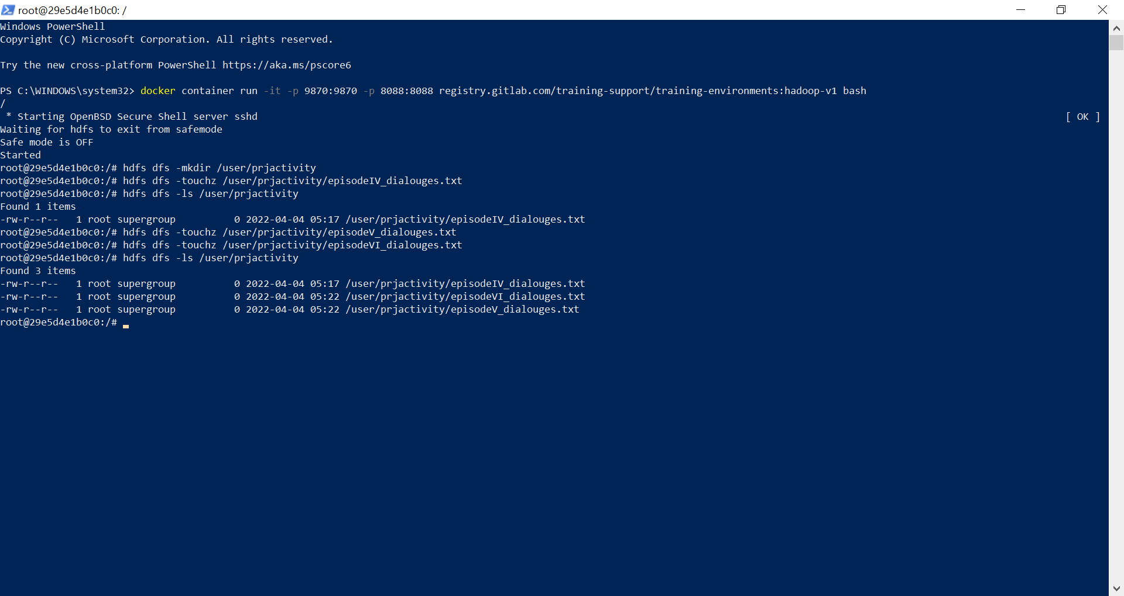Waiting for hdfs to exit from safemode

Safe mode is OFF

Started

root@29e5d4e1b0c0:/# hdfs dfs -mkdir /user/prjactivity

root@29e5d4e1b0c0:/# hdfs dfs -touchz /user/prjactivity/episodeIV_dialouges.txt

root@29e5d4e1b0c0:/# hdfs dfs -ls /user/prjactivity

Found 1 items

-rw-r--r-- 1 root supergroup 0 2022-04-04 05:17 /user/prjactivity/episodeIV_dialouges.txt

root@29e5d4e1b0c0:/# hdfs dfs -touchz /user/prjactivity/episodeV_dialouges.txt

root@29e5d4e1b0c0:/# hdfs dfs -touchz /user/prjactivity/episodeVI_dialouges.txt

root@29e5d4e1b0c0:/# hdfs dfs -ls /user/prjactivity

Found 3 items

-rw-r--r-- 1 root supergroup 0 2022-04-04 05:17 /user/prjactivity/episodeIV_dialouges.txt

-rw-r--r-- 1 root supergroup 0 2022-04-04 05:22 /user/prjactivity/episodeVI_dialouges.txt

-rw-r--r-- 1 root supergroup 0 2022-04-04 05:22 /user/prjactivity/episodeV_dialouges.txt

root@29e5d4e1b0c0:/# vim episodeIV_dialouges.txt

root@29e5d4e1b0c0:/# vim episodeIV_dialouges.txt

root@29e5d4e1b0c0:/# vim episodeV_dialouges.txt

root@29e5d4e1b0c0:/# vim episodeV_dialouges.txt

root@29e5d4e1b0c0:/# vim episodeVI_dialouges.txt

root@29e5d4e1b0c0:/# vim episodeVI_dialouges.txt

root@29e5d4e1b0c0:/# 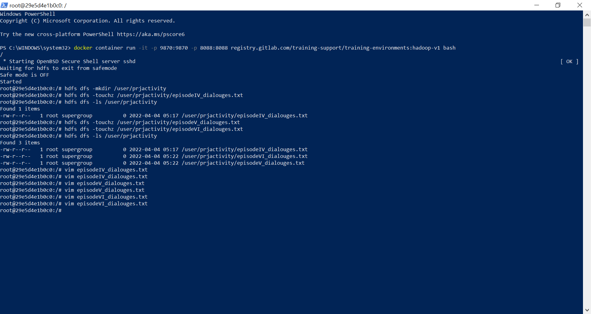

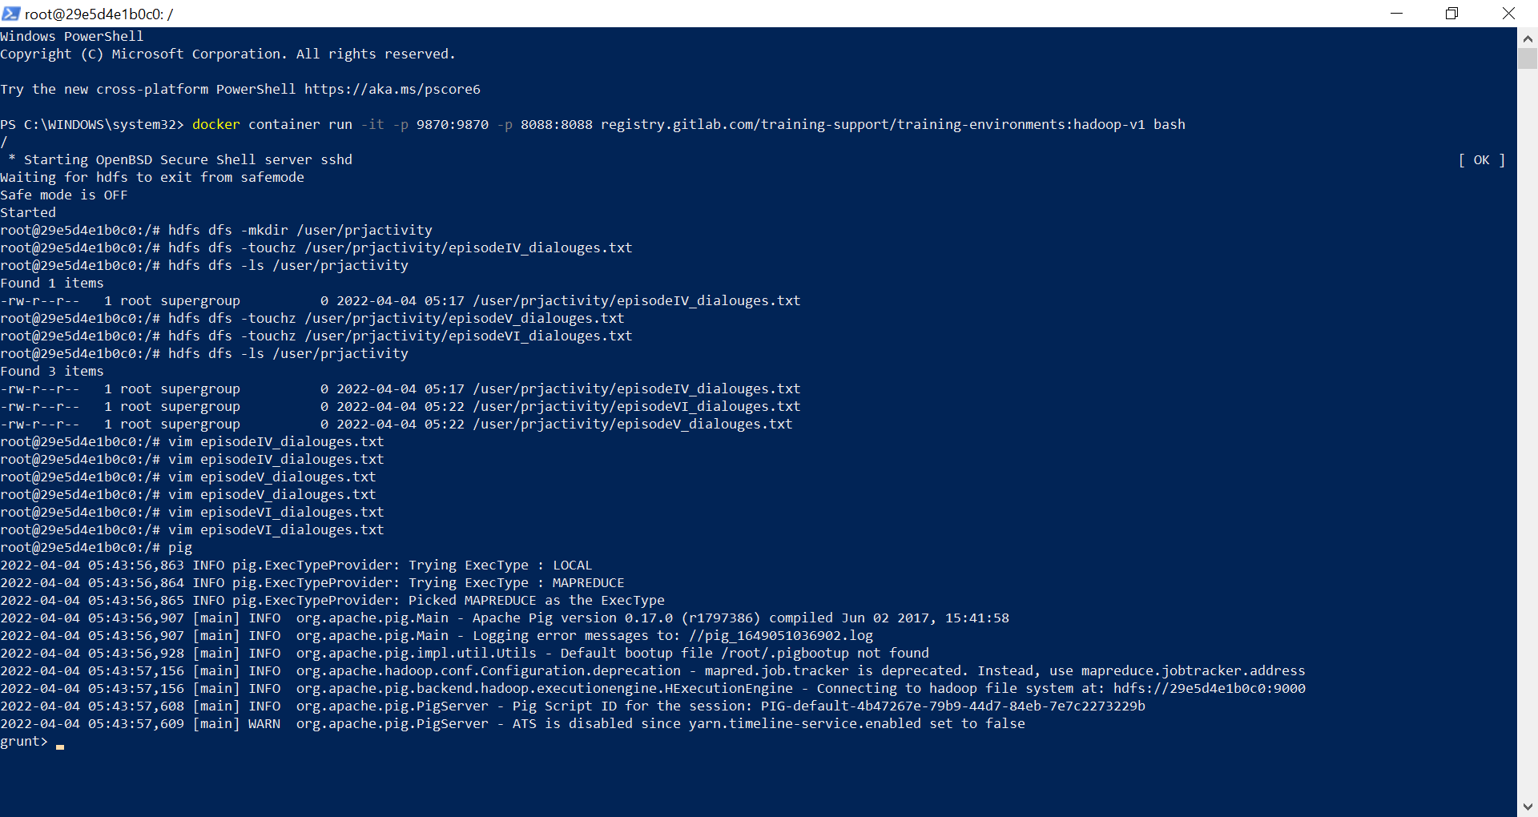

inputFile = LOAD 'hdfs:///user/Prjactivity/episodeIV_dialouges.txt' USING PigStorage('\t') AS (name:chararray,dial:chararray);

--ranked = RANK inputFile;

--onlydia = FILTER ranked BY (rank_inputFile >2);

GroupByName = GROUP inputFile BY name;

-- Generate result format

CountDia = FOREACH GroupByName GENERATE $0 as name, COUNT($1) AS CountVal;

name_order = ORDER CountDia BY CountVal DESC;

-- Store the result in HDFS

STORE name_order INTO 'hdfs:///user/Prjactivity/episodeIVResult' USING PigStorage('\t');

inputFile = LOAD 'hdfs:///user/Prjactivity/episodeV_dialouges.txt' USING PigStorage('\t') AS (name:chararray,dial:chararray);

--ranked = RANK inputFile;

--onlydia = FILTER ranked BY (rank_inputFile >2);

GroupByName = GROUP inputFile BY name;

-- Generate result format

CountDia = FOREACH GroupByName GENERATE $0 as name, COUNT($1) AS CountVal;

name_order = ORDER CountDia BY CountVal DESC;

-- Store the result in HDFS

STORE name_order INTO 'hdfs:///user/Prjactivity/episodeVResult' USING PigStorage('\t');

inputFile = LOAD 'hdfs:///user/Prjactivity/episodeVI_dialouges.txt' USING PigStorage('\t') AS (name:chararray,dial:chararray);

--ranked = RANK inputFile;

--onlydia = FILTER ranked BY (rank_inputFile >2);

GroupByName = GROUP inputFile BY name;

-- Generate result format

CountDia = FOREACH GroupByName GENERATE $0 as name, COUNT($1) AS CountVal;

name_order = ORDER CountDia BY CountVal DESC;

-- Store the result in HDFS

STORE name_order INTO 'hdfs:///user/Prjactivity/episodeVIResult' USING PigStorage('\t');

