Aquila Eye: A Smart Real-time Surveillance System for SOS Hand Gesture Recognition
Hemlathadhevi A^{1*}, Chandramohith P², Nikitha R G³, Nikhitha K V⁴, and Raja Meenakshi Sundaram G⁵
¹Dept. of Computer Science and Engineering, Panimalar Engineering College, Chennai, India
²Dept. of Computer Science and Engineering, Panimalar Engineering College, Chennai, India
³Dept. of Computer Science and Engineering, Panimalar Engineering College, Chennai, India
⁴Dept. of Computer Science and Engineering, Panimalar Engineering College, Chennai, India
⁵Dept. of Computer Science and Engineering, Panimalar Engineering College, Chennai, India

Abstract: Traditional surveillance technologies do not fully address silent distress cases, and victims cannot talk, scream, or use personal communication gadgets when they need help. Traditional CCTV is mainly confined to visual recording and does not proactively identify intentional non-verbal expressions indicating threat. To address this, the paper presents Aquila Eye, a smart real-time surveillance system that enables silent emergency transmission using analysis of hand landmarks on live video streams. The system uses MediaPipe-driven hand landmark modeling to track finger and palm movements. A temporal gesture validation mechanism ensures that only intentional SOS signals are recognized. When an SOS gesture is authenticated, the system sends an emergency notification through Firebase Realtime Database, including metadata such as event time and camera location for quick response. Evaluation results show high gesture recognition reliability, low false detection rate, and sub-second alert generation latency. These results validate the system’s effectiveness for deployment in modern surveillance systems. Aquila Eye enhances traditional CCTV from passive monitoring to active public safety systems by enabling intentional non-verbal distress communication.
Keywords: SOS Gesture Recognition, Computer Vision, Public Safety, Real-time surveillance, Media pipe, Firebase alert

1. Introduction
The high rate of urbanization and population density has increased the security issue on the open spaces such as transportation infrastructure, roads, industrial places, and streets. Most of the current surveillance systems are just in the observatory mode of operation, recording what is going on as opposed to preventing or reacting on these events, despite the fact that surveillance cameras are vastly installed to monitor such areas. In high-risk events where the person feels intimidated, confined or physically at risk, it is common that these people cannot mouth words to seek help, access personal devices, or communicate their distress without becoming more vulnerable. Due to this, there is still a significant gap between surveillance visibility and real-time response to an emergency, with conventional solutions to computer vision centered on motion analysis, object recognition, or post-factum review of incidents. As much as recent studies have delved into automated violence recognition and anomaly detection, these approaches are mostly reactive, computationally intensive as well as prone to misidentify in the event of a crowd or a highly dynamic environment. Most importantly, such systems do not have a reliable way of people intentionally communicating to monitoring infrastructure in a non-verbal and controlled way the intent of emergency.
To address this weakness, researchers and other programs aimed at the safety of the population have increasingly advocated hand-based SOS gestures as a common non-verbal communication of distress. Hand gestures are also especially adaptive to surveillance settings since they are covert, can be universally interpreted, do not depend on spoken language and do not require auxiliary devices. However, the use of SOS gestures in real-life surveillance video is not easily identified because of the variables of lighting, different camera angles, variability in hand posture, partial covering, and the widespread number of casual hand movements that may result in false alarms.In retort, this paper presents Aquila Eye, a vision-based surveillance platform that supports intentional silent communication using emergency hand gestures. The system uses hand landmark modeling to obtain detailed finger configurations and it incorporates a temporal gesture cycle validation plan in order to distinguish actual SOS signals from routine hand activity. In contrast to frame level or non-moving gesture classifier, Aquila Eye will confirm emergency intent not just by the presence of a sequence of hand open-close gestures but by numerous repetitions of these gestures within a specific temporal window, which in turn dramatically increases its robustness and reduces false alarms.
As soon as an SOS gesture sequence is recognized, the framework will send out an alert through a cloud-based notification system, which can further enhance awareness and speedy reaction by security or emergency response units. The main contribution of this work is the creation and experimentally proven technology of a surveillance-based SOS hand gesture recognition system, which transforms the passive camera installations into the active, responsive safety systems. The results of the experiment prove that the given solution provides high recognition accuracy, low response latency, and consistent performance under various environmental conditions, which proves its preparedness to practical, real-world application.

2. Related work
Vision-based monitoring technologies have taken root as an essential part of the security policies of cities, transport hubs, and the systems of highways. Even though they have been extensively utilized, traditional CCTV has more of a viewing tool because it provides video logs, but very minimal real time intelligence to take action on emergencies or take proactive steps to avert emergencies. To supplement the surveillance potential, the recent study has considered the intelligent analysis techniques, such as anomaly detection, suspicious behavior detection, and automated understanding of activities [1], [2], [3]. These techniques are useful to improve situational awareness but in a post-event or reactive manner and they have increased false-alarm. The use of hand gesture recognition has been widely researched regarding human-computer interaction, sign language translation, and virtual or augmented reality. The first solutions were largely based on the visual descriptions, which were obtained manually and using the classical machine learning classifiers. On the other hand, the recent approaches are becoming more accurate and robust by relying on the deep learning framework and landmarks-based representations [4], [5], [6]. Since the development of real time hand keypoint extraction system such as MediaPipe, this has remained a wave of progress in the speed at which hand landmarks can be recognized using lightweight models able to complete real time hand landmark detection [7]. Even though they may be used under special circumstances, those mechanisms may be normally activated by humans, demand additional equipment, or regular network connectivity, which may not be available in situations of physical threat, duress, or restricted mobility. Other techniques that have been proposed in the process of detecting incidences such as an emergency include vision-based techniques like collisions, violent acts in the streets, or falls [8]. They however identify emergencies when they occur unlike the other feature which is the use of predefined hand gestures to indicate an emergency situation before it goes out of hand. Minimal past studies have taken into account the application of predetermined hand gestures as non-verbal indicators of an emergency situation. The existing techniques largely use the principle of the fixed pose-identification or single image-detecting gestures that are easily interfered by the unintended hand movements and non-signals of the environment thus leading to the high false-positive identifications [9], [10], [11]. In addition, the proposed Aquila Eye framework does not take into account the inherent problems of real-life surveillance video, including changing light, varying levels of occlusions, varying camera views, and activity in the background. On the other hand, Aquila Eye framework offers an intent-sensitive SOS hand gesture recognition system that is to be implemented in unmonitored surveillance environments. Rather than frame based predictions, the system checks temporal validations of gesture cycles to ensure that only during some time period, repetitive patterns of intentional hand motion are realised to assert the presence of emergency intent. The specified design choice allows differentiating between actual and possible SOS gestures and normal hand movements with an extremely high level of accuracy that will reduce the issue of the false alarms. Therefore, Aquila Eye is an addition that can be expanded to the existing surveillance systems and it is a direct reaction to the decades of problems of delivering silent, intentional and emergency communication to the infrastructures of surveillance that belongs to the security structure and is offered to the populace.

3. Proposed system
The Aquila Eye is designed to facilitate covert emergency signalling in the context of the general surveillance system by detecting the SOS hand signatures automatically. The system takes in uninterrupted video feeds obtained on the CCTV systems or regular camera systems and real-time video is analyzed visually to recognize any intentional distress signals. When an SOS gesture has been reliably confirmed, the framework immediately sends an emergency notification by a cloud-based notification channel, which allows rapid action by response law enforcement. The general system design focuses on real-time operation, minimizing false alarms, and does not need special equipment to integrate with other surveillance systems.

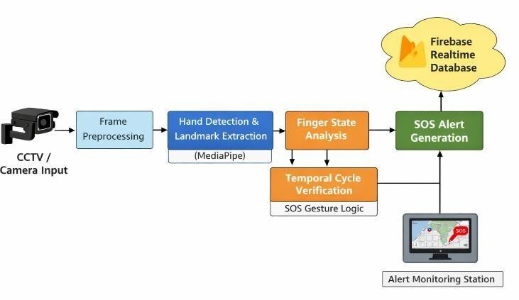
Fig. 1. Architecture Diagram

1.1 Video Acquistion and Preprocessing
The system is constantly receiving visual information of various surveillance systems such as closed-circuit television, conventional webcams, and video streaming. Video frames are sampled at a variable capture rate, usually in the range of 20 to 30 frames each second, to ensure a good trade-off between recognition performance and computation. Each frame will undergo preprocessing steps before analysis, which include the standardization of spatial resolution to ensure similar input properties to the hand detection module, and conversion of color space to color space would be utilized. These preprocessing operations are used to ensure that the accuracy of detection remains constant, and the overhead of processing in real time is kept to a minimum.

1.2 Hand Detection and Landmark Extraction
Hand localization and tracking is performed by a real- time landmark extraction framework that is constructed based on the Media Pipe pipeline. In each identified instance of the hand, the model determines a collection of 21 key points that represent reference points of the palm, joints in fingers, and locations of fingertips. The emphasis is laid on the single-hand tracking, which suffices in the acknowledgment of SOS gestures in a standard surveillance setup. To improve the reliability of detection, single hand instances with low scores in confidence or poor spatial coverage are removed during the processing. The resulting landmark coordinates are then normalized relative to the surrounding hand region making them scale independent.


1.3 SOS Hand Gesture Definition and Recognition Logic

Fig. 2. SOS hand gesture sequence used in the proposed system
SOS Hand gesture definition and recognition logic In the proposed framework, an SOS gesture will be defined as a well-planned series of repeated opening and closing hand motions performed within a restricted time range. Instead of posing against a wall, the system uses the pattern of motion in time to make sure that emergency alerts are raised only in response to intentional signs of distress. This time-conscious update gives a significant protection against accidental activations.

1.4 SOS recognition process is effected in the following stages:
(1) Sequence Initiation:
Starting the detection process occurs when a folded posture of the thumb is detected, which is the potential start of an SOS gesture sequence.
(2) Finger Configuration Evaluation:
The system identifies the open or folded state of the rest of the fingers based on relative landmark positions and geometric relationships.
(3) Motion Cycle Identification:
Each full movement of the open hand to a closed one is counted as one SOS motion cycle.
(4) Time-Based Validation:
Only after a predetermined minimum amount of motion cycles (say, three times) are detected within a given period of time (say five seconds), an emergency signal is confirmed. The system implements temporal cycle validation in order to discriminate between meaningful and insignificant SOS gestures and non-purposeful or unintentional movements of the hands, which significantly alleviates the possibility of false alarm triggered.
(5) Generation and Notification of Alerts Pipeline:
The system creates an alert, which includes the information about the detection time and place, when an SOS gesture is verified. Online warning messages are sent to a Firebase Realtime Database, and they are immediately synchronized with surveillance monitors or mobile apps that security officers can use. This pipeline on the cloud guarantees low-latency alerts delivery and has the capacity to support multiple clients to the monitor at the same time.
(6) System Workflow:
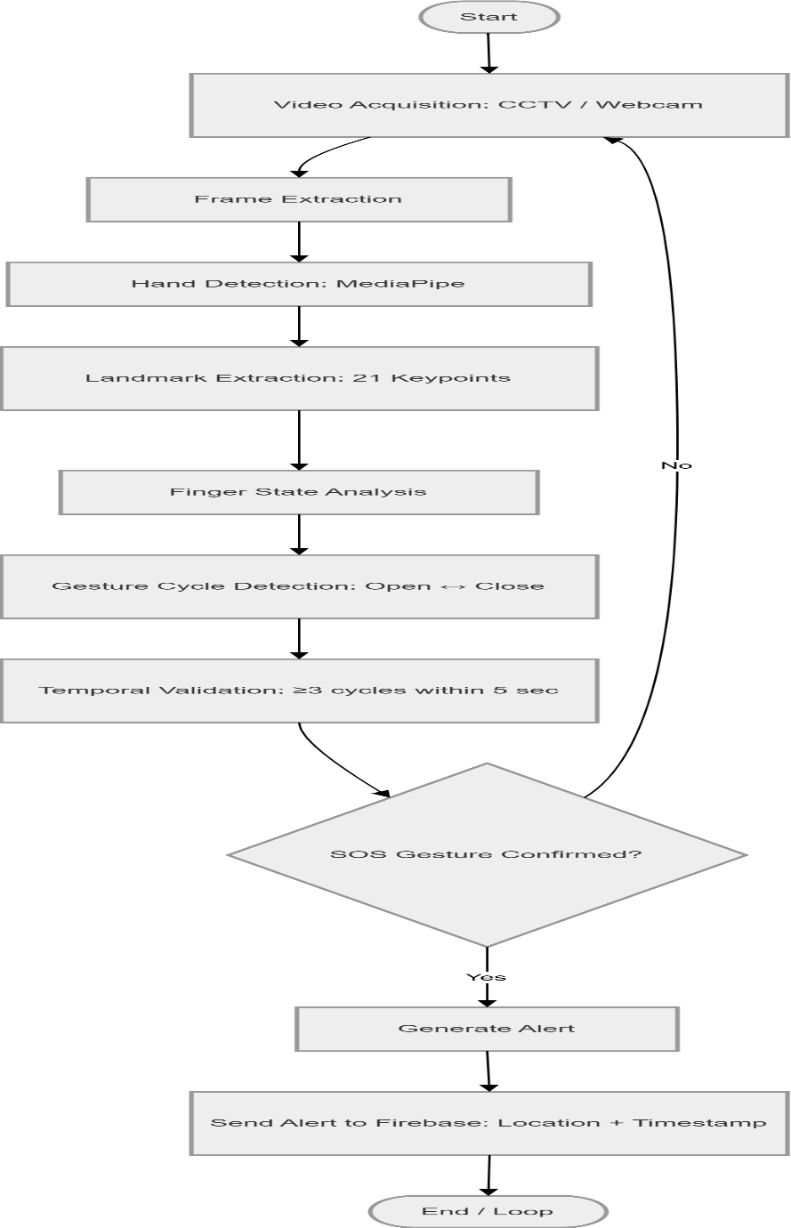
Fig. 3. System workflow diagram of Aquila Eye framework
The entire work process of the proposed system is the following:
1. Get video frames of surveillance cameras.
2. Identify hands and feature landmarks.
3. Record the finger states and follow the cycle of gestures.
4. Check SOS intent by temporal constraints.
5. Send an alert and deliver information on Firebase.
The modular construction enables the system to work in real time and remain highly reliable and scalable to many camera feeds.
(7) Evaluation Metrics:
The evaluation of the system is based on the following metrics:
1. Accuracy Accuracy = Correct SOS detections + Correct normal detections/Total frames
2. Precision= True SOS errors Precision / All SOS alerts
3. Recall= Recall / correct SOS detections Recall / Total actual SOS gestures
4. False Positive Rate (FPR)= Normal frames are wrongly identified as SOS FPR / Total normal frames
5. F1 score f1= 2(precision recall/precision +recall).

4. Results
Aquila Eye framework was tested using real-time testing on live video streams obtained using camera devices to determine the effectiveness of the framework. The evaluation criteria were accuracy of the SOS gesture detection, overall alert latency, the robustness of the system with the change in environmental conditions, and operational performance in a multi-channel and multi-concurrent camera environment

1.1 Experimental Setup
This experimental analysis was conducted through a webcam-controlled surveillance setup of an image resolution of 640480 pixels and average frame rate of approximately 25. Frames per second. The system will constantly analyze the video feed to detect SOS hand gesture patterns in real time and, when valid, sends emergency signals through Firebase that contain relevant metadata on location. The performance testing was done both indoors and semi outdoors including an array of light conditions to determine the environmental strength

1.2 Gesture Recognition Performance
The performance of the SOS gesture recognition system was evaluated using standard metrics including accuracy, precision, recall, and F1-score.
Table 1 presents the evaluation results of the proposed system.

Table 1: SOS Gesture Recognition Performance
Metric | Value (%)
Accuracy | 96.8
Precision | 97.5
Recall | 95.9
F1-Score | 96.7

The results demonstrate that the proposed system achieves high accuracy and precision, indicating reliable detection of intentional SOS gestures while minimizing false alarms. The high recall value further confirms the system’s effectiveness in identifying actual distress signals.

1.3 Environmental Robustness Analysis.

Suggested system was tested in various real-life situations, such as variations in light, partial visibility of hand because of occlusion, and variations in camera position or tilt so as to determine its strength in practical operating conditions.

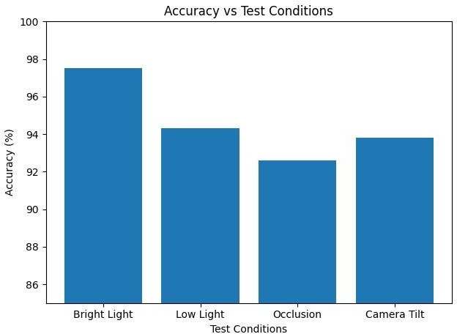
Fig.4. Accuracy vs. Cameras used
Despite the observed small degradation in performance under bad illumination and partial occlusion conditions, the system continued to give recognition accuracy of over 90, which is an indication of robustness that can be useful in the practical application of the system in the real-world scenario.
The system attains an average total response time of about 0.37 seconds which is sufficient to transmit emergency alerts in a timely manner.

1.4 Multi-Camera Scalability Analysis

The scalability of the system was tested by having several camera feeds at the same time.
Scalability testing was performed by gradually increasing the number of camera streams.
Observations:
- 1 Camera → 0.30s latency
- 5 Cameras → 0.45s latency
- Latency increase remains linear
- No crash or memory overflow observed

Table 2: Number of Cameras vs Average Latency
Number of Cameras | Average Latency (s)
1 | 0.30
2 | 0.32
3 | 0.35
4 | 0.39
5 | 0.45

This table shows that the average latency increases as the number of cameras increases, indicating higher processing time with more camera inputs.

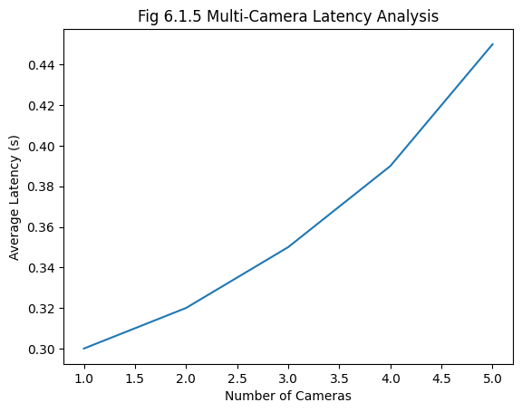
Fig. 5. Multi-Camera Latency Analysis.

1.5 Precision-Recall Analysis

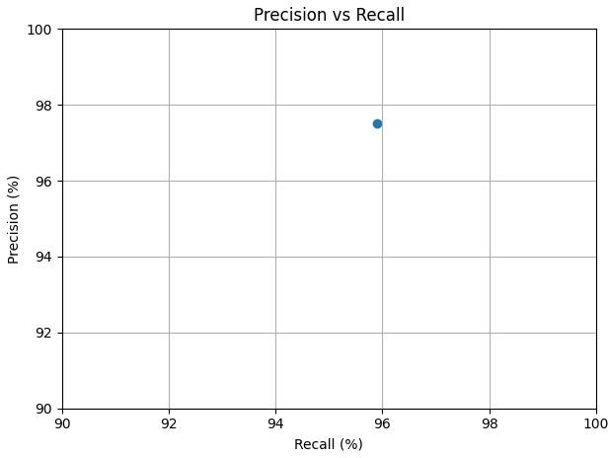
Fig.5. Precision vs Recall
Precision and recall analysis were also used to determine the reliability of SOS detection

1.6 Discussion

Aquila Eye can effectively be applied to expand the conventional surveillance systems by introducing intelligent and non-human decision making tasks as it is demonstrated in the experiments. With Aquila Eye, unlike traditional CCTV applications, active safety monitoring can be conducted rather than passive surveillance, which makes the deployment of the Aquila Eye a possible solution to smart city applications and safety programs tailored to women. The experimental findings also suggest that temporal gesture validation integration enhances the accuracy of SOS detection by decreasing the false positives due to random movements of the hands. This idea makes sure that only deliberate and recurrent patterns of gesture are treated as emergency signals and this makes the system much stronger than the traditional frame-based gesture recognition systems. Moreover, the system has proven to be stable in various environmental conditions including indoor and semi-outdoor environment. The fact that the suggested methodology can be able to ensure a good degree of consistency in accuracy in different lighting and background conditions shows that the presented methodology can be readily adjusted to real-life deployment environments. The fact that the latency is low when generating the alerts further confirms the ability of the system to respond in real-time which is an important aspect in emergency cases because immediate response is required. Nevertheless, there are some deficiencies witnessed in evaluation. Its performance in the system is slightly reduced during low-light conditions and conditions of partial hand covering or complicated settings. Also, the existing version is oriented towards single-hand gesture recognition, which can be limiting in a multi-user or rather a busy setting. These constraints demonstrate the necessity of additional optimization of the management of problematic real-world situations. In other scenarios, a quick or partial gesture performance can fail to meet the temporal validation threshold, which can result in false negative detections. These remarks indicate that even though the system is dependable, it still needs to be improved to accommodate various human behaviors and uncertain environmental factors in a better way. In spite of these constraints, the suggested system offers an excellent base to the intelligent surveillance applications. It is cost-effective and scalable because of its functionality without extra hardware needs and its capability to work with the existing camera infrastructure. The design of the system also facilitates this, as it can create continuous monitoring and generate automated alerts, which could help much in improving the response time in case of an emergency. Altogether, Aquila Eye displays the feasible and efficient strategy of turning the traditional surveillance systems into proactive safety measures. The real-time processing combined with the accurate gesture recognition and scalable framework show that it can be used in the public safety systems, transportation systems, and urban surveillance networks.
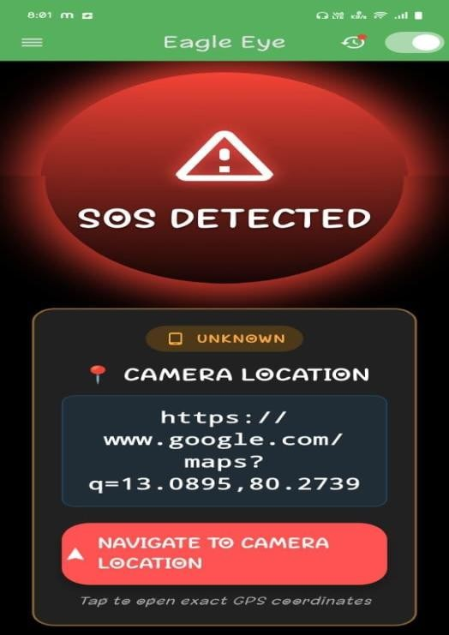
Fig.6. The proposed Eagle Eye system output screen displaying the real time SOS detection and alert generation.

Demonstrates a real-time performance of the proposed system, according to which the SOS gesture will cause an immediate alert on the monitoring interface Despite these challenges, the proposed system provides a practical and scalable solution for enhancing public safety infrastructure. Its ability to integrate with existing surveillance systems without requiring additional hardware makes it cost-effective and suitable for large-scale deployment in urban environments, transportation systems, and public safety monitoring applications.

6. Conclusion and future works

1.1 Conclusion:
This publication proposed Aquila Eye - AI on Smarter and Safer Streets an intelligent vision-based surveillance system that was developed to tackle the nagging safety issues on the public streets as well as urban streets. The modern cities are increasingly confronted with the problems of delayed response of the emergency rescue team, the lack of a discreet method of expressing the distress, and overreliance on the surveillance apparatus that only records the emergency but does not intervene to reduce the threat. The Aquila Eye was developed to fill those voids with real-time, proactive, and human-centered safety surveillance, with a specific focus on the safety of women, children, and other vulnerable groups.The core functionality of the system is the ability to detect SOS hand signs to be used by the user as a means of attracting unwanted attention. It is a significant improvement over conventional surveillance methods, which are based on behavioral inference only, since it enables those who are affected to purposely seek assistance even in the situations when nondemanding means of communication or using a mobile phone is unsafe or unattainable. In addition to SOS gesture detection, Aquila Eye is a real-time video analyzer of smart CCTV cameras and road cameras, analyzing patterns of hand movements, posture, and situational indicators, with multiple layers of analytics, such as distress behavior, gender and situation, along with medical emergency awareness, all the system provides a complete picture of the possible risk situations. It is able to detect isolated people in isolated environments and notice abnormal behavioral signals that could indicate danger, disease, and vulnerability. The addition of a human-in-the-loop verification system is a major differentiating aspect of Aquila Eye, which ensures meaningful use of complex urban content by providing value in form of actionable intelligence. The proposed framework provides a controlled confirmation phase with trained surveillance personnel unlike fully autonomous system which is subject to excessive false alarms. In case of a possible SOS gesture or distress condition, alerts are displayed in the control room in the form of visual messages and sound. Human confirmation leads to escalation to the emergency response units, so that the reliability, the responsibility and the responsible use of the emergency resources is achieved and, consequently, the patrols and response units are also able to be informed of the current situation and arrive at the site of the disaster in a short period of time. Such a smooth process of work, detection, and response, proves the successful integration of artificial intelligence and human judgment to create reliable systems of public safety. The integrated design also helps to react much faster with the emergencies with the projected response time to decrease up to 50 years, which enhances the likelihood of timely response and the safety of the victims.Besides single incident detection, this framework has the benefits of intelligent traffic handling. Aquila Eye is supporting emergency vehicle signal prioritization, congestion detection and rerouting, dynamic emergency corridor activation, and AI-based learning of the traffic flow using the concept of real-time surveillance intelligence. These characteristics guarantee the ability of ambulances, patrol cars, and rescue teams to reach the SOS places effectively, even in the areas that are extremely.

1.2 Future Works:
Despite the fact that Aquila Eye manages to address its fundamental mission of enhancing the safety of the masses by improving the use of smart surveillance, two opportunities can still be pursued to develop and expand it. The above developments can greatly expand the potential of the system in the future by improving the reliability of SOS gesture recognition by adding temporal deep learning architectures that can adjust to the differences in the speed, orientation, and execution patterns of gestures in different individuals. The supported set of gestures might be extended to region-specific emergency signals and accessibility-oriented gestures to further ensure inclusiveness and globalization further, the inclusion of multimodal visual intelligence to the system, e.g., analyzing body posture details, estimating crowd density, and understanding the context, can enhance the distress behavior and medical emergency recognition modules. These improvements would enhance the system to better distinguish between routine anomalies and actual emergencies to enhance accuracy and minimise false alarms.Infrastructure wise, future versions of Aquila Eye could be used to enable multi-camera intelligence co-ordination where people can be tracked on several surveillance areas simultaneously. The traffic intelligence component would allow further refinement with closer integration with law enforcement control rooms, emergency dispatch centers, and smart city command platforms providing the ability to apply predictive congestion modeling to have the system in a position to predict traffic bottlenecks before an emergency situation occurs. Better integration with the navigation services and municipal traffic management APIs would enable quicker response to emergencies by activating emergency corridors sooner and reducing delays of response vehicles to the larger extent. Regarding deployment strategy, future versions can consider edge-based processing infrastructure to minimize latency and minimize dependency on centralized clouding infrastructure. Moreover, by implementing the principles of continuous and adaptive learning, the system would have the ability to adapt to the changing conditions, patterns of behavior among people, and fresh threat situations, thereby contributing to the overall crime-fighting strategies, higher public confidence, and data-driven governance in the context of smart cities

References
[1] M. Patel, D. Shah and A. Patel, A real-time gesture recognition system with Media Pipe and deep learning, in Proc. IEEE Int. Conf. Comput. Vis. Workshops (ICCVW), pp. 112–119, (2023).

[2] Y. Zhou, J. Chen and K. Li, Robust hand keypoint detection and tracking in real-time applications IEEE Trans. Pattern Anal. Mach. Intell., vol. 45, pp. 10534–10548, (2023).

[3] R. Singh and P. Kumar, AI-based Smart surveillance system to observe the safety of the people, IEEE Access, vol. 12, pp. 30211–30224, (2024).

[4] A. Sharma, R. Jain and P. Gupta, “Hand gesture recognition to smart surveillance systems with CNN models, in Proc. IEEE Int. Conf. Image Process. (ICIP), pp. 215–220,( 2024).

[5] M. Ali, S. Khan and H. Rahman, Deep learning-based gesture recognition in hand landmarks to execute real-time applications, IEEE Access, vol. 13, pp. 3452–3463,( 2025).

[6] Y. Chen and X. Liu, Edge-AI empowered smart surveillance in real-time event detection, IEEE Internet Things J., vol. 12, pp. 245–256, (2025).

[7] J. Park, S. Lee and H. Kim, Proc., Transformer-based vision models Real-time hand gesture recognition, IEEE Conf. Comput. Vis. Pattern Recognit. Workshops (CVPRW), pp. 331–338, (2025).

[8] D. Li, M. Zhou and Y. Wang, Intelligent cities surveillance architecture with AI with edge computing, IEEE Internet Things J., vol. 12, pp. 5201–5212, (2025).

[9] H. Sun, Z. Wu and K. Lin, Strong hand landmark detection in unconstrained settings, IEEE Trans. Pattern Anal. Mach. Intell., vol. 47, pp. 210–223, (2025).

[10] S. Kumar, R. Gupta and A. Sharma, Deep learning-based smart city intelligent surveillance systems, IEEE Internet Things J., vol. 10, pp. 4187–4198, (2023).

[11] R. Gupta, A. Mishra and K. Tiwari, Vision-based intelligent monitoring systems in urban public safety, IEEE access, vol. 13, pp. 7541–7554, (2025).

[12] S. Roy and A. Banerjee, Activity recognition on intelligent surveillance systems, IEEE Internet Things J., vol. 10, pp. 11230–11241, (2023).

[13] H. Ibrahim and M. Rahman, Edge AI to real-time surveillance video analytics, IEEE Internet Things J., vol. 11, pp. 8123–8134, (2024).

[14] B. Kumar and P. Singh, Gesture recognition with Media Pipe and CNN models , IEEE Access, vol. 12, pp. 17821–17833, (2024).

