**EXERCISE 1&2**

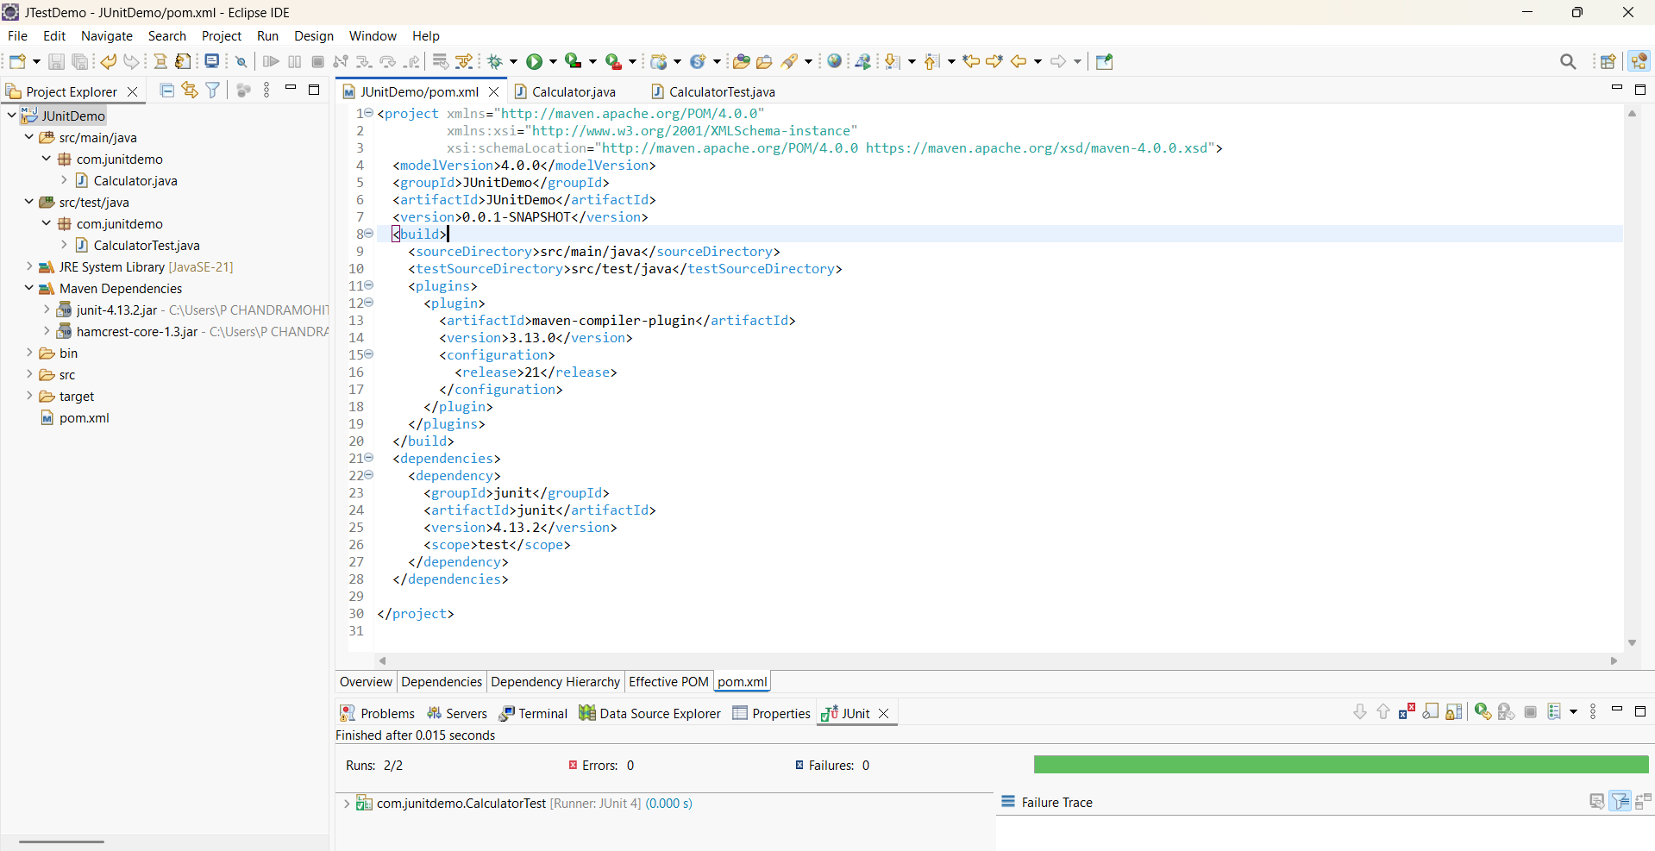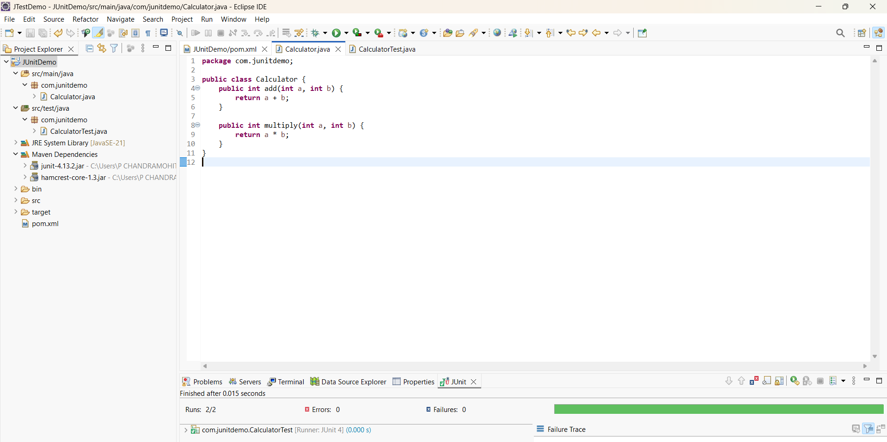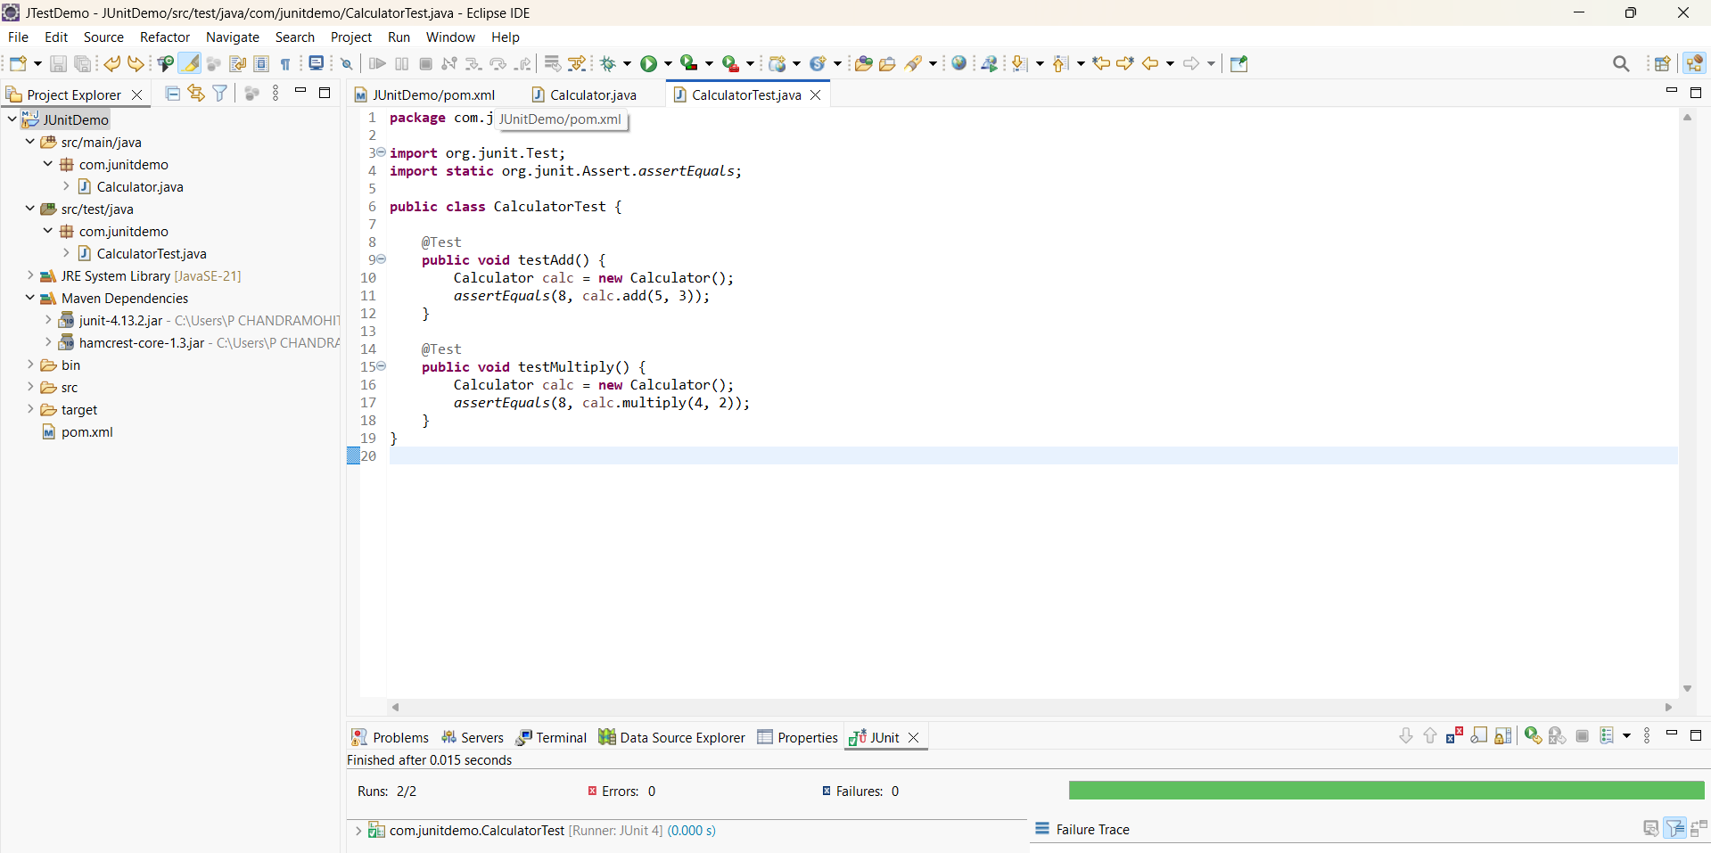**Setting Up Junit && Writing Basic JUnit Tests**

**Exercise 3**

**Assertions in Junit:**

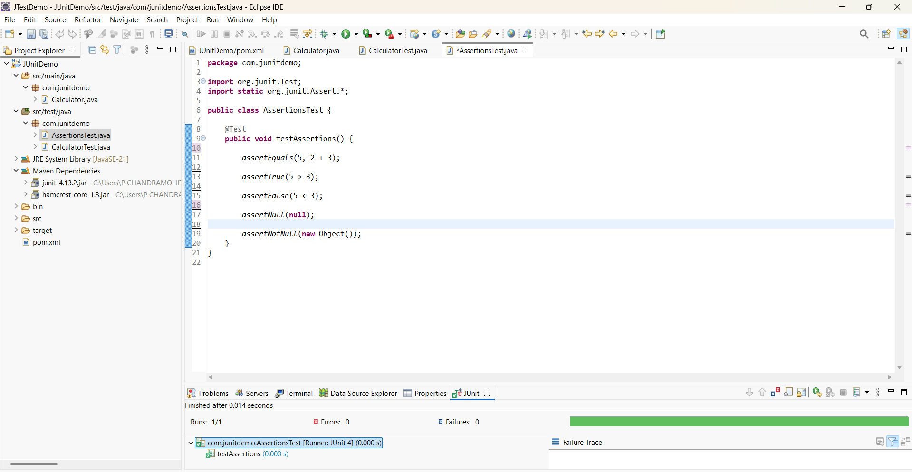

**Exercise 4: Arrange-Act-Assert (AAA) Pattern, Test Fixtures, Setup and Teardown Methods in JUnit**

