**Mockito Hands-On Exercises Exercise 1: Mocking and Stubbing** 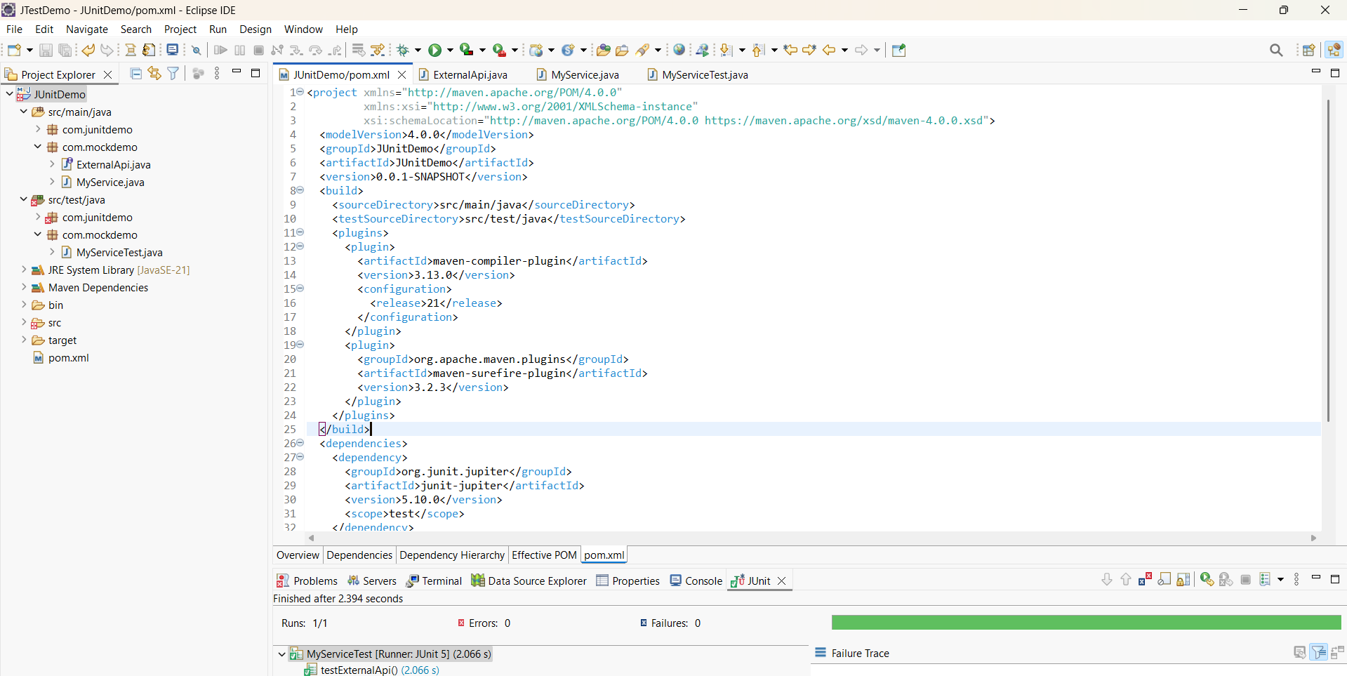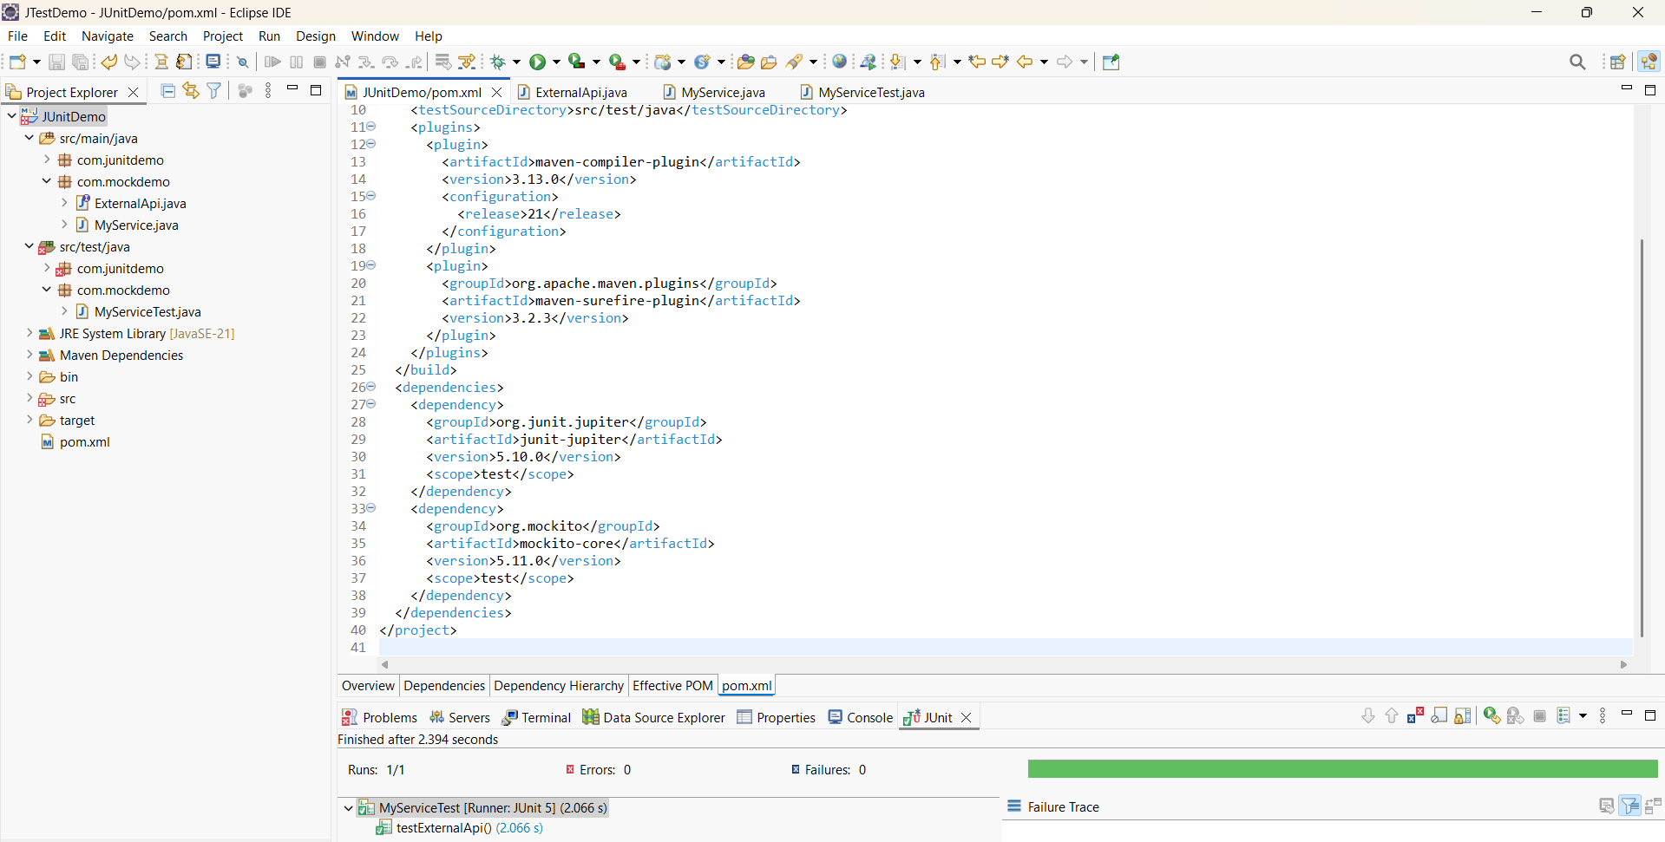

**Steps:**

**1. Create a mock object for the external API.**

**2. Stub the methods to return predefined values.**

**3. Write a test case that uses the mock object.**

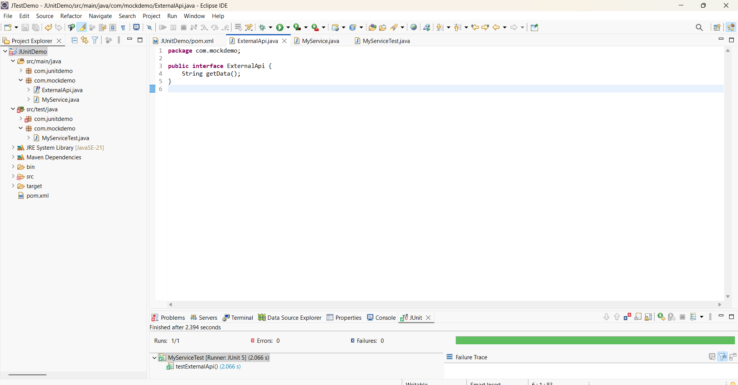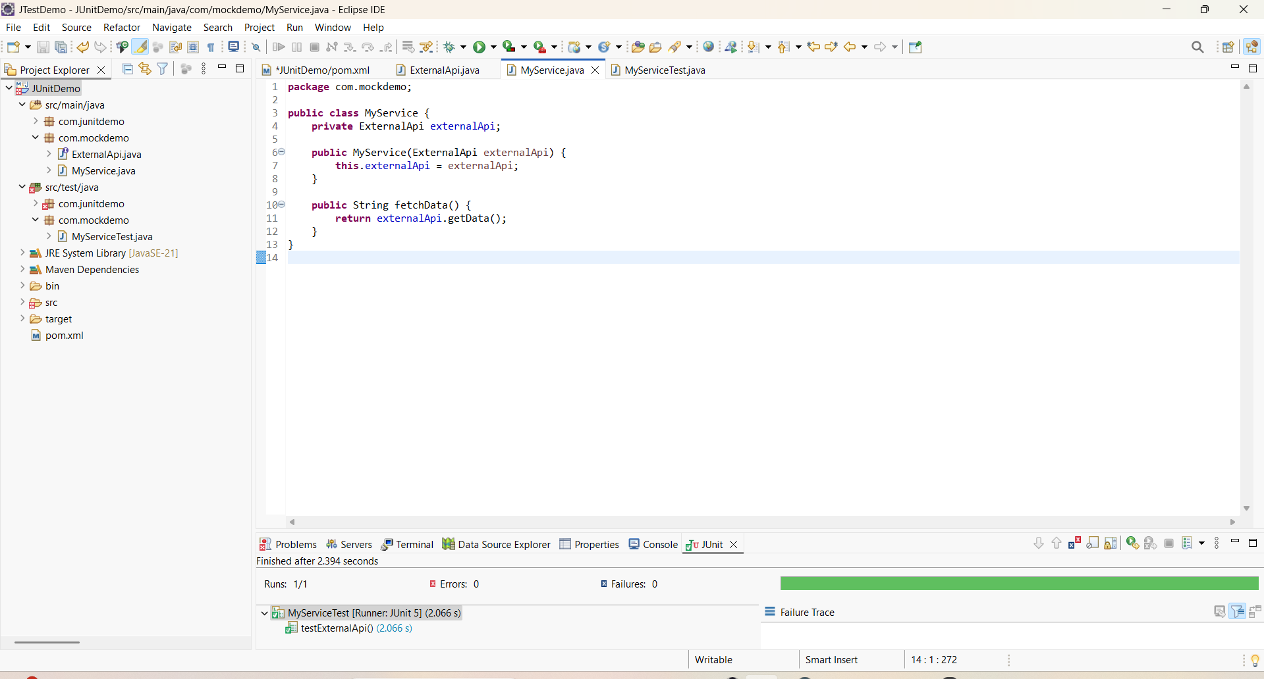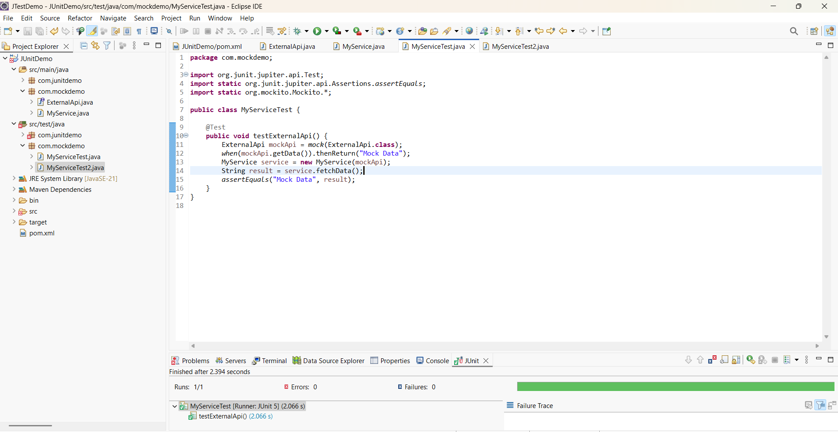

**TEST PASSED!!**

**Exercise 2: Verifying Interactions**

**MyServiceTest2.java – Verifying Method Call with Mockito**

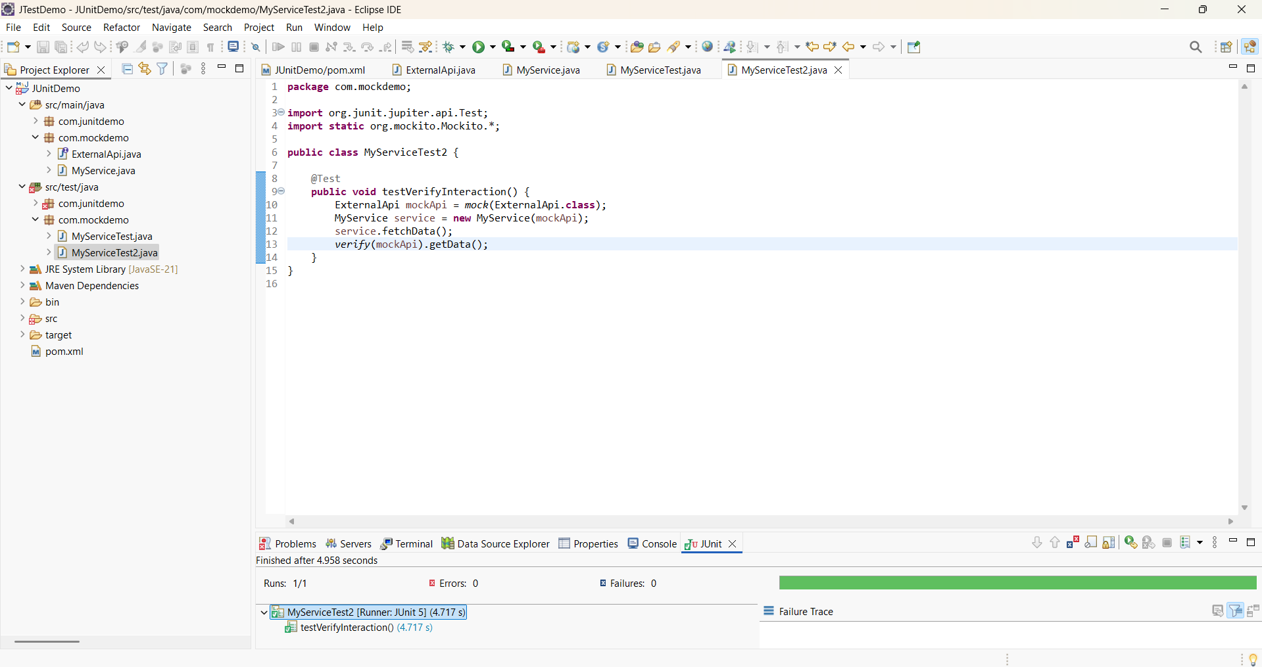

**TEST PASSED!!!....**